**Error Control:**

**Error control is basically process in data link layer of detecting or identifying and re-transmitting data frames that might be lost or corrupted during transmission. In both of these cases, receiver or destination does not receive correct data frame and sender or source does not even know anything about any such loss regarding data frames. Therefore, in such type of cases, both sender and receiver are provided with some essential protocols that are required to detect or identify such types of errors as loss of data frames.**

**Purpose of Error Control**

**Error control is a vital function of the data link layer that detects errors in transmitted frames and retransmits all the erroneous frames. Error discovery and amendment deal with data frames damaged or lost in transit and the acknowledgment frames lost during transmission. The method used in noisy channels to control these errors is ARQ or Automatic Repeat Request.**

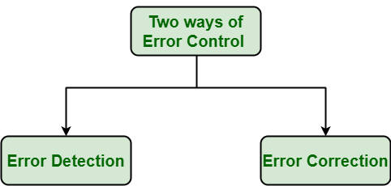

1. **Error Detection :**Error detection, as the name suggests, simply means detection or identification of errors. These errors may occur due to noise or any other impairments during transmission from transmitter to the receiver, in communication system. It is a class of techniques for detecting garbled i.e. unclear and distorted data or messages.
2. **Error Correction :**Error correction, as the name suggests, simply means correction or solving or fixing of errors. It simply means reconstruction and rehabilitation of original data that is error-free. But error correction method is very costly and very hard.

**Various Techniques for Error Control :** There are various techniques of error control as given below :

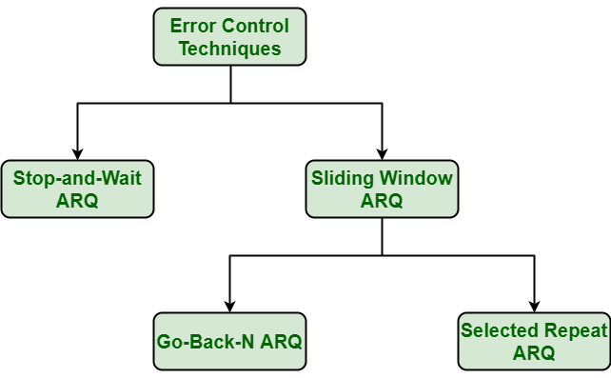

**Types of errors**

These interferences can change the timing and shape of the signal. If the signal is carrying binary encoded data, such changes can alter the meaning of the data.  
These errors can be divided into two types :  
1. Single-bit error  
2. Burst error.

**Single-bit Error**

The term single-bit error means that only one bit of given data unit (such as a byte, character, or data unit) is changed from 1 to 0 or from 0 to 1

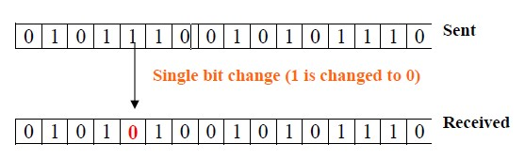

**Single bit error**

Single bit errors are least likely type of errors in serial data transmission. To see why, imagine a sender sends data at 10 Mbps. This means that each bit lasts only for 0.1 μs (micro-second). For a single bit error to occur noise must have duration of only 0.1 μs (micro-second), which is very rare. However, a single-bit error can happen if we are having a parallel data transmission. For example, if 16 wires are used to send all 16 bits of a word at the same time and one of the wires is noisy, one bit is corrupted in each word.

**Burst Error**

The term burst error means that two or more bits in the data unit have changed from 0 to 1 or vice-versa. Note that burst error doesn’t necessary means that error occurs in consecutive bits. The length of the burst error is measured from the first corrupted bit to the last corrupted bit. Some bits in between may not be corrupted.

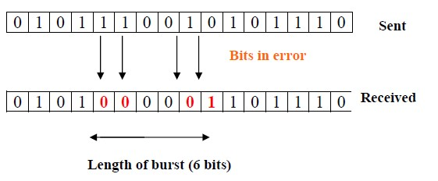

**Burst Error**

Burst errors are mostly likely to happen in serial transmission. The duration of the noise is normally longer than the duration of a single bit, which means that the noise affects data; it affects a set of bits. The number of bits affected depends on the data rate and duration of noise.

**Error Detecting Codes (Implemented either at Data link layer or Transport Layer of OSI Model):** To avoid this, we use error-detecting codes which are additional data added to a given digital message to help us detect if any error has occurred during transmission of the message. . Some popular techniques for error detection are: 1. Simple Parity check 2. Two-dimensional Parity check 3. Checksum 4. Cyclic redundancy check

1. **Simple Parity check:** 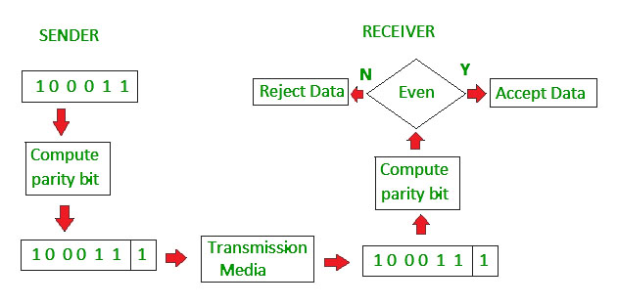
2. **Two-dimensional Parity check:** 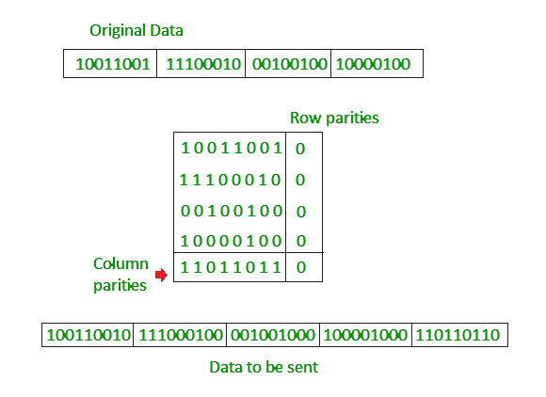
3. **Checksum:** 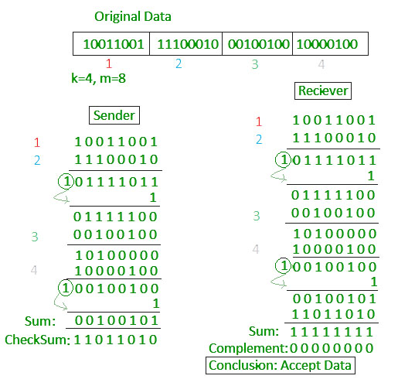
4. **Cyclic redundancy check :** 