Requirement list: -

Spark is the largest network provider of the New Zealand. It contains lots of branches and have different supplier around the world. There are different subject areas in this company but we only focused on three which are Inventory, Popularity and Sales. For to secure the business there are different areas which we must update time by and study all the data so that we can make the business more profitable and more effective. Since this is the big organisations there are different sources which hold the data. This data helps to improve the business.

There are lots of the question that requires data to answer

1. How many products are being imported to the inventory?
2. How many products are distributed to the branches?
3. Are the offered plans are doing well?
4. Which plan is most effective?
5. Which product is most imported?
6. Which product is most distributed to the branches?
7. Which product is most popular?
8. In which location product are being distributed?
9. From where the supplier supply the products?

The list of the facts in the Spark organisations are: -

1. Inventory
2. Sales
3. Popularity
4. Broadband
5. Finance

The dimensions required for the facts are

1. Products
2. Customer
3. Date
4. Branch
5. Supplier
6. Location
7. Plan Mode
8. Plan Name

Inventory(Showan): -

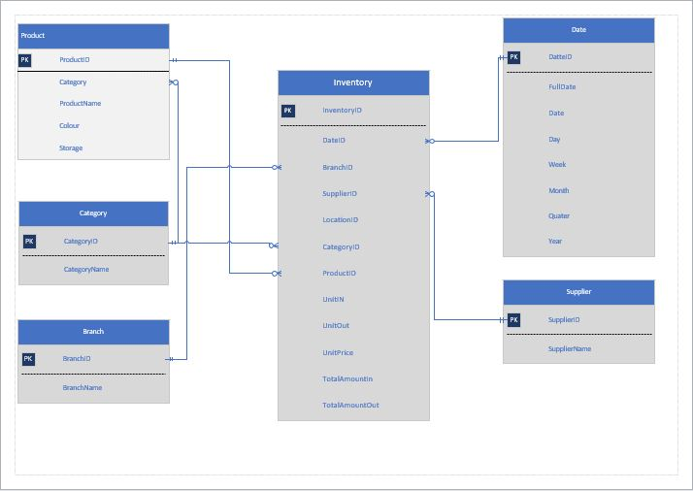

This is snow flake model. This model is best for drilling down the data in the different dimensions and we can use the slice and dice for to create the report which is not possible in the star model. In this model we can link the two dimensions but in star we can link only dimension with fact tables. This model is great for creating the quires related to the different subject areas. There are six tables in my data marts which are listed below: -

1. Inventory: -

This table acts as the facts which is linked to the other dimensions. In this table there is the numeric attributes like unit in, unit out, price, total amount of unit in and total amount of unit out. This table helps to find how the business is going. It includes all the foreign keys which makes the relationship between this table.

1. Date: -

This table is used to hold the date data so that by using the date id we can find the full date, date, days, week, month, quarter or year. This helps to track the history of all subject areas and can filter the data by week, month, quarter or year.

1. Supplier: -

This table contains the data of the suppliers which supplies the products required for the running business of the spark. We can filter the data by main supplier for the Spark.

1. Branch: -

With this table we can look for the different branches in the New Zealand which is providing the services for the Sparks. This table helps to filter the most popular branches in the New Zealand.

1. Product: -

This table contains the descriptions about the products that are in the inventory. With this we can find the most distributed products and imported products for the Spark.

1. Location: -

To filter the dimension, we can use location and can find out the most imported location or most distributed area for the product.

1. Category: -

To differentiate the products and we have the dimension category we also can find out which category is most popular.

For inventory we are reporting on the units in, units out. Which product is most imported or which product is most distributed? (filtering by supplier, branch and location) which category is imported most? What is the total amount of units in and units out (filtered by sum)? Which one is the highest and which one is the lowest supplier (filter by supplier and time and slicing by the location)?