BUSINESS INTELLIGENCE REPORT (SPARK)

**Content**

*1. Case Study – Data Communication(Spark) Page 2*

*2. List of Business Intelligence Questions Page 3*

*3. Data Warehouse Analysis [SSAS] Page 4- 5*

*4. Data Warehouse Reporting [SSRS] Page 6- 15*

*5. Business Intelligence Dashboard Page 16-18*

*6. Report Page 19*

1. **Case Study – Data Communication(Spark): -**

Spark is the largest network provider of the New Zealand. There are different subject areas in this company, but we only focused on three data marts Sales, Inventory and Popularity.

The data mart Inventory is the place where the products from supplier are stored and the exported to the many branches of the Spark. Before designing the data warehouses, I look for the list of business questions so that I can choose the required data from the production database and make my data mart according to the requirement of business intelligence questions.

With help of the business intelligence question I can easily focus on the improvement of the business and it also helps to make the decisions according to the past data records for the future. Using the tools like SSAS, SSRS and BI I can find out how the business is doing and in what part I must focus so that I can improve the business and make more profit.

Here, my data mart is Inventory and it focuses on the imported product (Unit IN), exported product (Unit Out), total amount of imported product (Total Amount IN) and amount of exported product (Total Amount Out).

To improve and make it effective I must analyse these field so that I can make better decision for the future which will help to increase the level of the business.

1. **List of Business Intelligence Questions: -**

Based on the questions you identified for the organization

Attach Designs

The Business Intelligences Questions for my data mart are as follows: -

1. Most imported Supplier products per year, category name, colour?
2. Total amount imported from Supplier per year, country?
3. Most exported product per city, Supplier, year, colour, storage?
4. Total amount exported from Inventory per city, category name?

Design

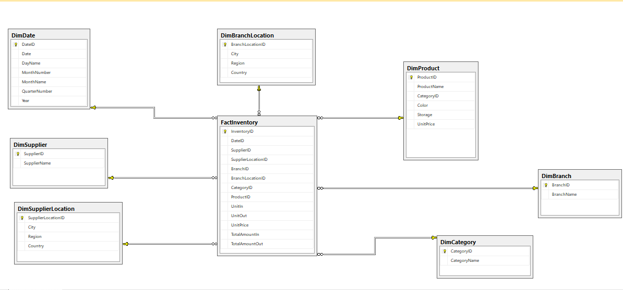

1. **Date Warehouse Analysis [SSAS]: -**

Cube

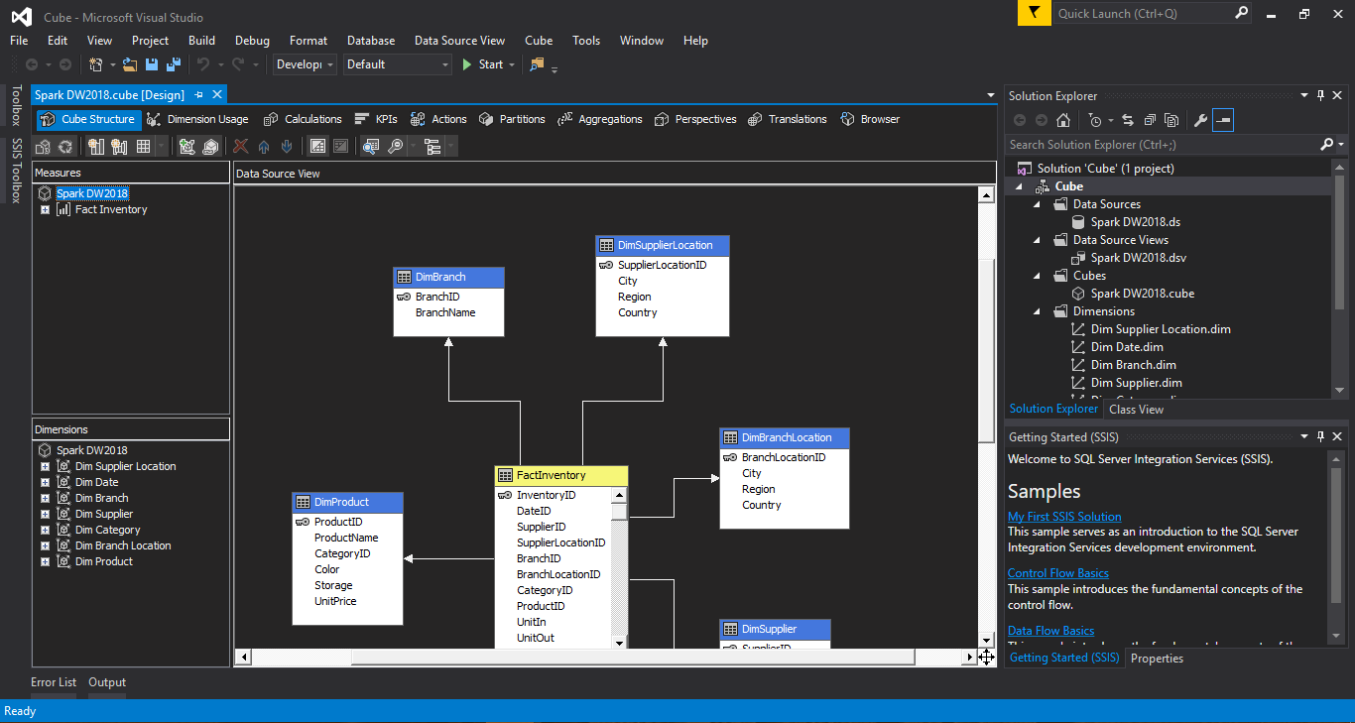

Tabular analysis

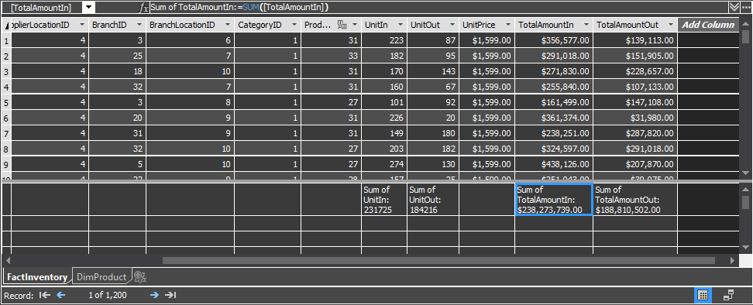

Pivot table and Pivot chart using the tabular analysis

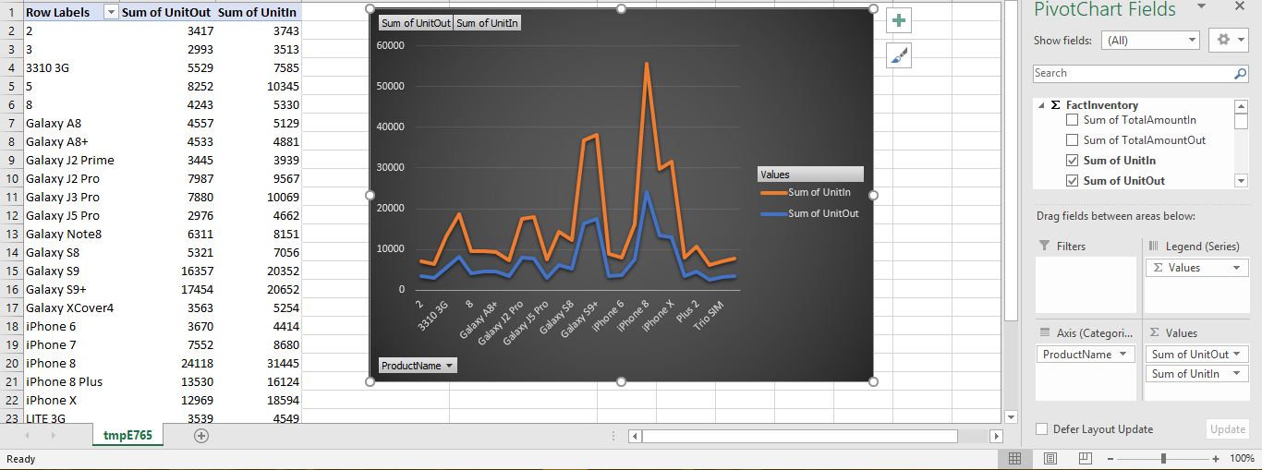

1. **Data Warehouse Reporting [SSRS]: -**

At first add the new Data Source

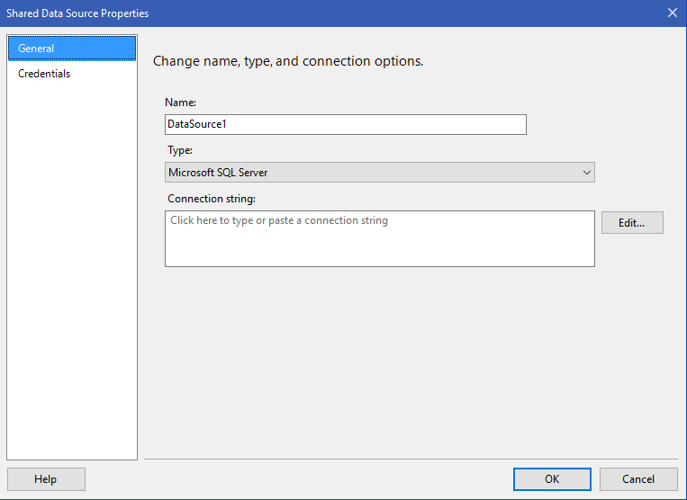

Click on the Edit

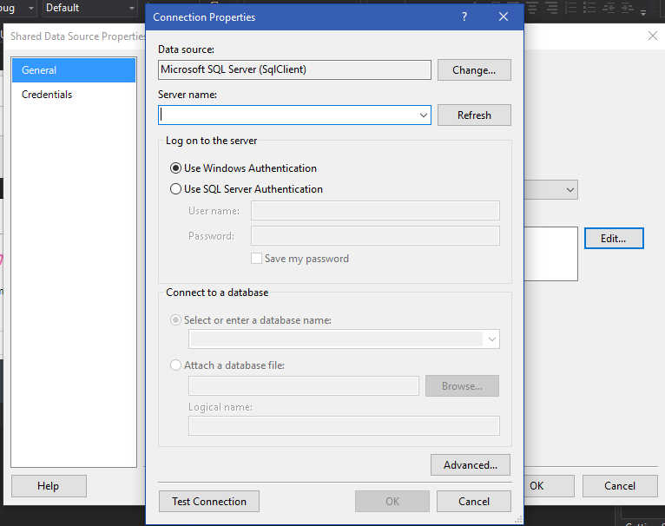

Choose the Server Name

Click on Use SQL Server Authentication (Note use the username and the password that was created during the installation of the SQL Server)

After that select the database

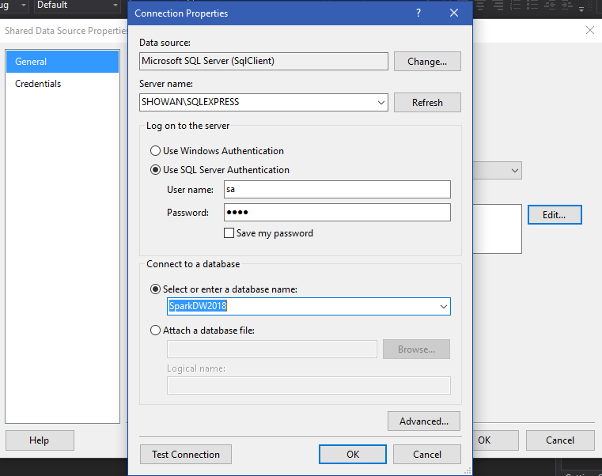

For preview of the report

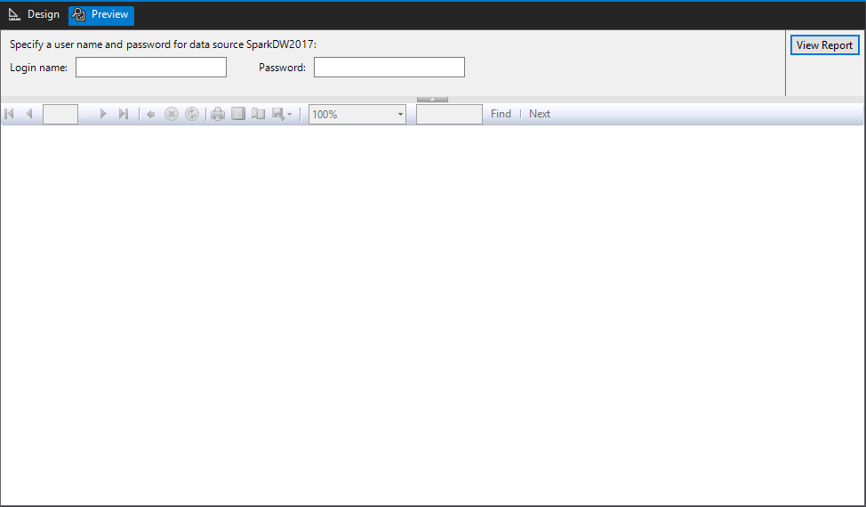

Use the Username and the password

Shared Data Source and Data Set

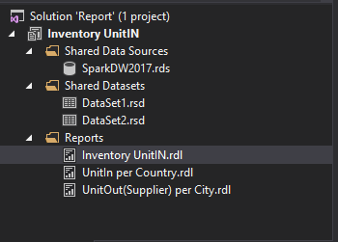

Tabular report for inventory

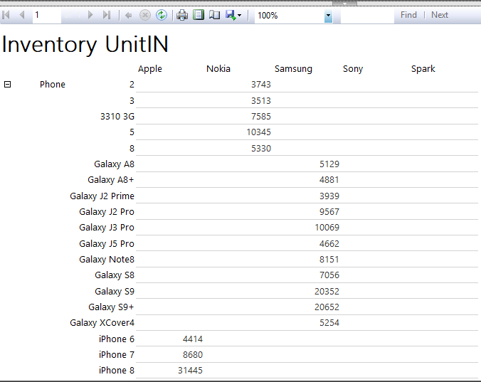

Formatting and styling

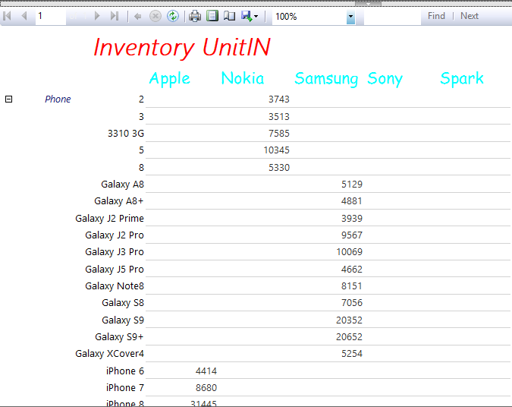

Create two charts using custom reporting (using the shared data source and set)

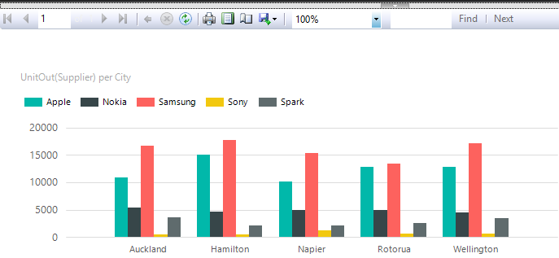

After filtering

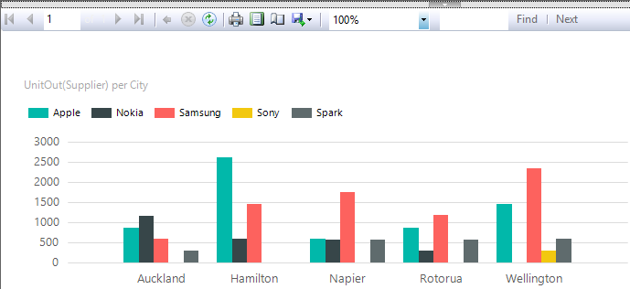

Formatting and styling

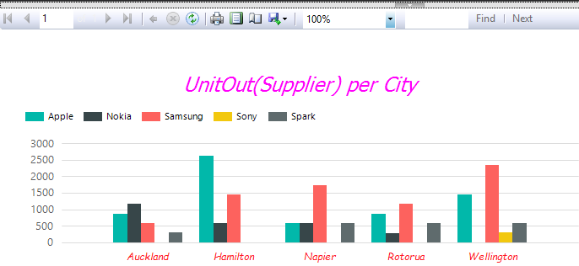

Unit In per Country

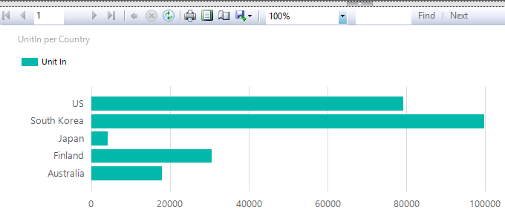

Adding filters

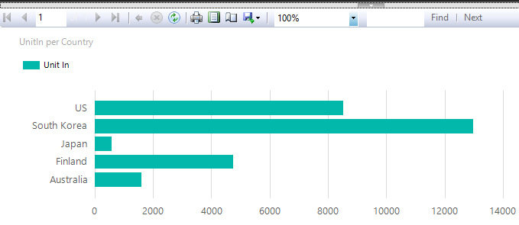

Formatting and Styling

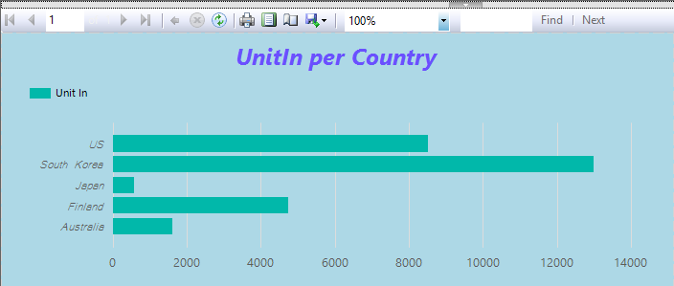

Matrix report

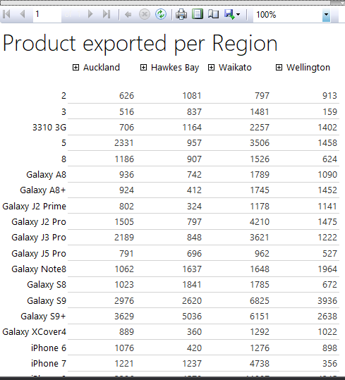

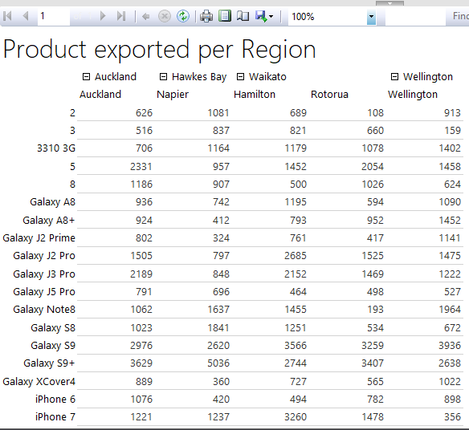

Formatting

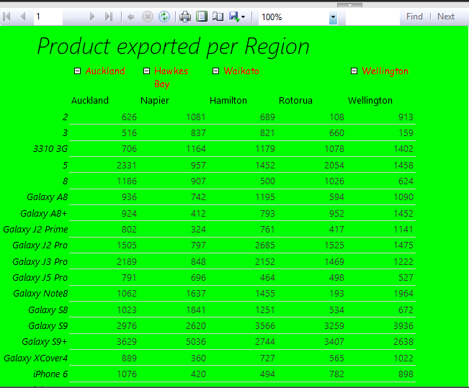

1. **Business Intelligence Dashboard: -**

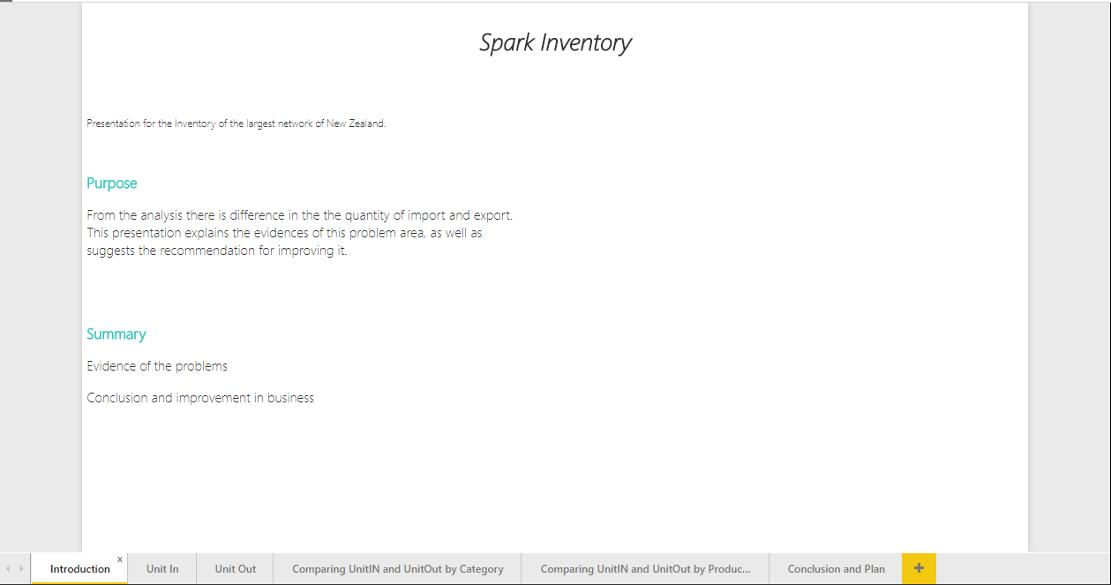

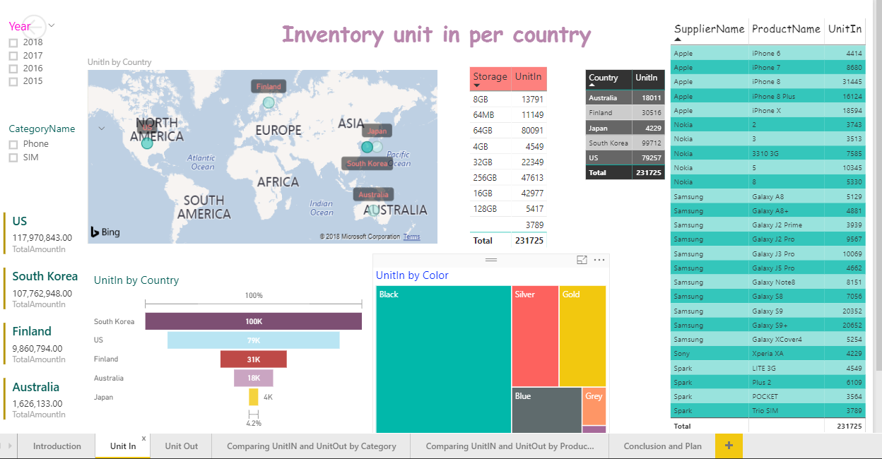

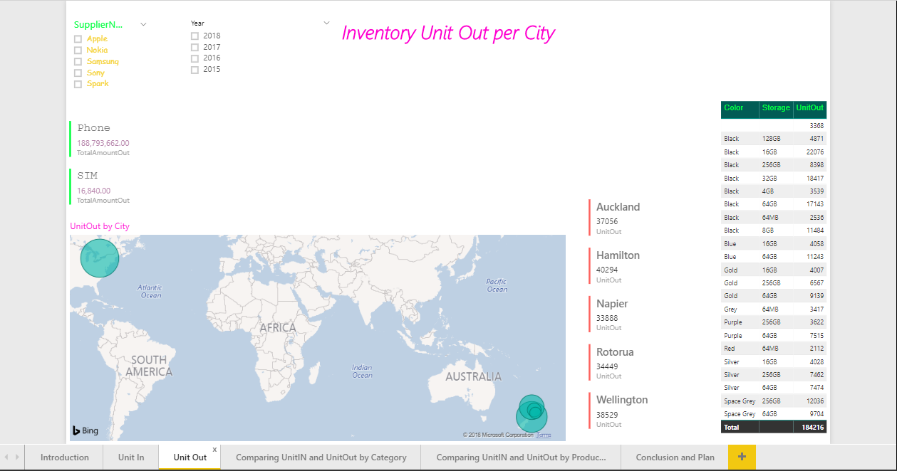

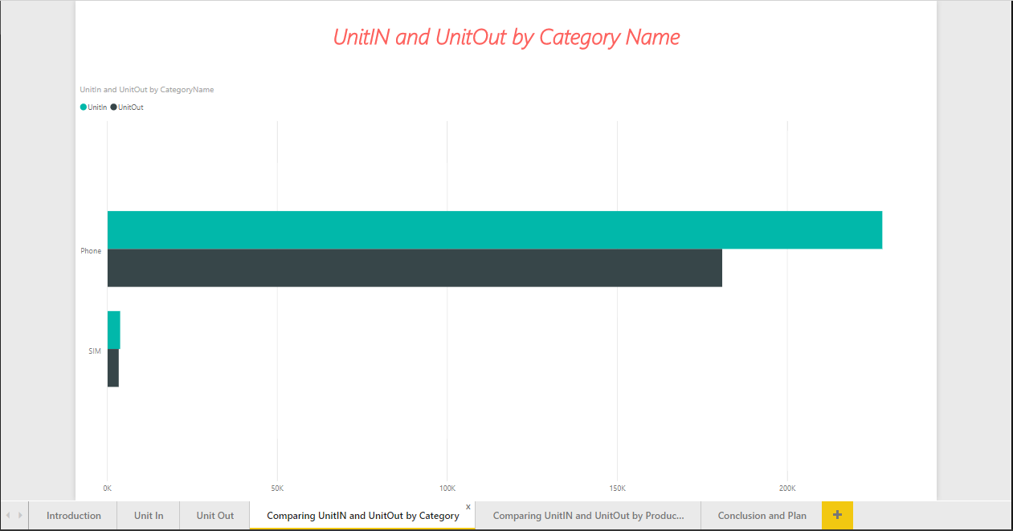

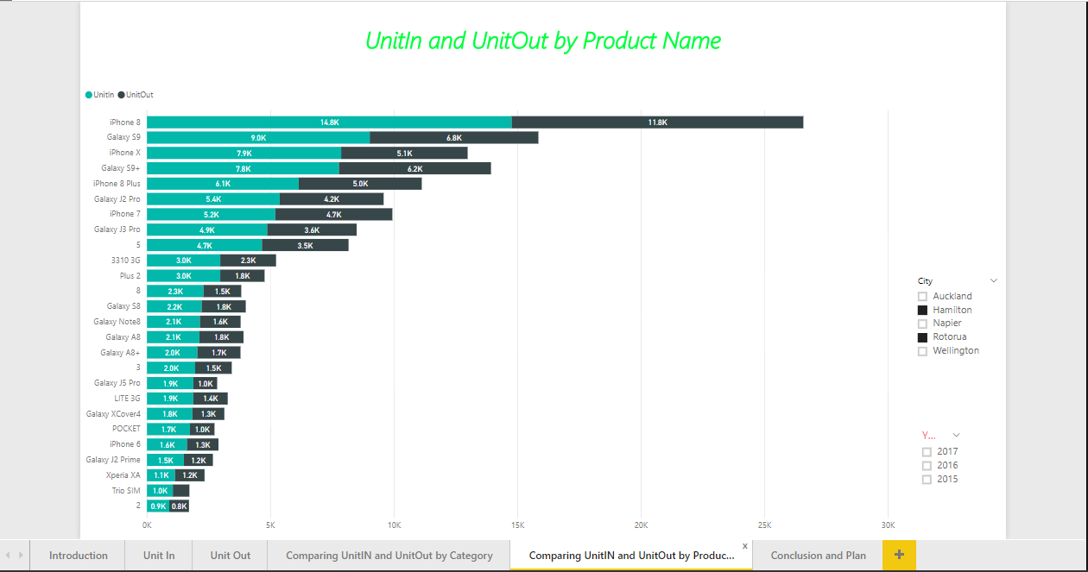

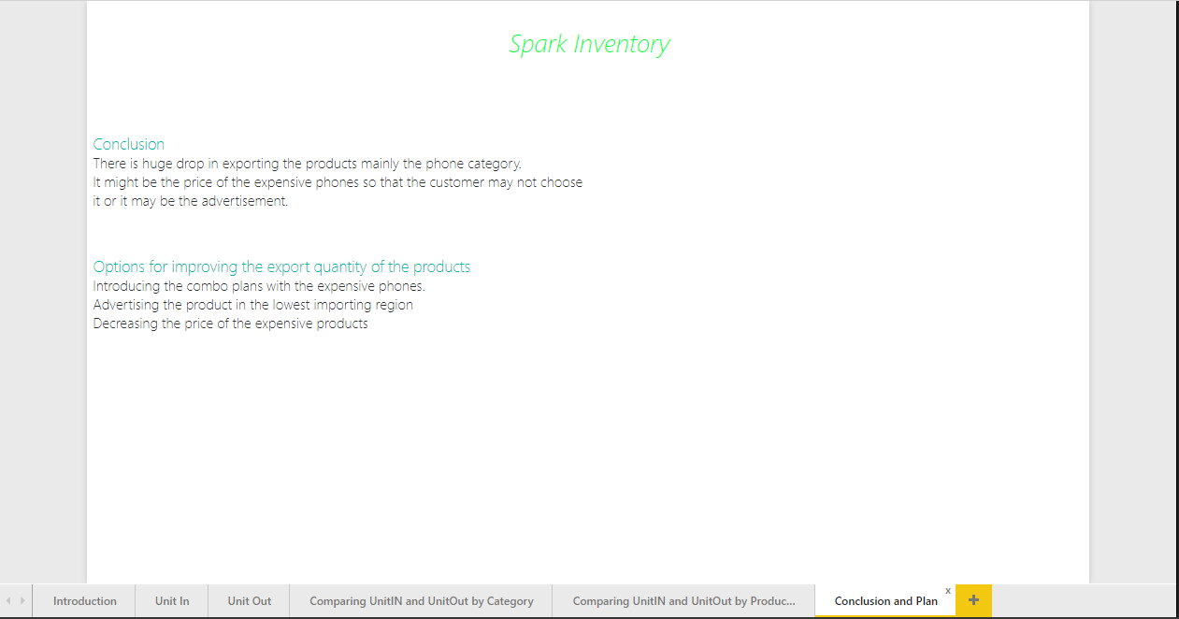

1. **Report: -**

For the analysis of the data warehouse I use the SSAS tool. After using this tool, I found that in the Inventory of the Spark there is large difference between the quantity of import and export. Tabular analysis shows that quantity of the import (231725) is far more than that of the export (184216) one. To find out problem in better way pivot table and chart is used to compare the products import and export.

After using the SSRS tool, for creating the report for the Inventory I found that there was the drop in the quantity for the export in the Waikato region as well as I also found that expensive phones are going out slowly compared to the other phones. Here, to improve the performance and to increase the quantity of the export following are the suggestions: -

1. Introduce the new plans with the expensive phone which attract the customers.
2. Advertise the expensive phones in the lowest exporting region.
3. Add extras to the expensive phones like (headset, cover, speakers etc)

To present the detail information about the Inventory import and export the Business Intelligence dashboard is very useful. With the help of the BI dashboard we can drilldown the information and explain it in more detail. In BI as we choose the drilldown options the visual in the dashboard automatically changes this make the presentation more interesting than only then only with the note.

For the presentation the BI dashboard for the Inventory contains the following pages with brief information: -

1. Introduction: -

Spark is the largest network company of the New Zealand. From the analysis I found that there is difference in the quantity of products in import and export. Other pages help to find the evidences of the problem that we are facing on the inventory so that we can make it right and improve the business.

1. Unit IN: -

This dashboard only focusses on the product import from the different supplier. From this dashboard we can answer the question a and b listed in the task 2.

1. Unit Out: -

This dashboard only focusses on the product import from the different supplier. From this dashboard we can answer the question c and d listed in the task 2.

1. Comparison between Unit IN and Unit Out by Category Name: -

I compare the import and export only by the category name so that I can easily find the problem.

1. Comparing between Unit IN and Unit Out by Product Name: -

This dashboard helps to find which product is most exported and the least exported.

1. Conclusion and Plan: -

It contains the information what we should do so that we can improve the export of the Inventory.