Please note that incorrect details on this sheet may

lead to delays in your tutor receiving your assignment.

## Centre for Business, Information Technology and Enterprise

## 

**Assignment Cover Sheet**

|  |  |  |
| --- | --- | --- |
| Assignment Title/No: | 1 | |
| Module Code: | INFO701/1704 | |
| Module/Subject Name: | Professional Certification: Project Management | |
| Submission Date |  | |
| Tutor Name | Monjur Ahmed | |
| Due Date | 12/01/2018 | |
| Student Name(s)& ID(s)  (please print clearly)  List all members for group assessment. | **Name**  Showan Simkhada | **ID**  17459655 |

**Important**

*Submitting work which is not your own will be treated as academic misconduct and may result in exclusion from Wintec (Waikato Institute of Technology). Penalties are identified in the Institution’s Academic Regulations (a copy is available at the Library).*

I certify that this is all my own work, except for those parts identified for which references have been made.

Student Signature:

For group work, one signature is sufficient.

**Introduction:**

Temporary organization involved in research which is planned by a project team to create an output as stated in business case. Project are always based on the business case and always finished when it meets the final output. For the smooth management of different body in business case (such as time, cost, scope, human resource management, costs) project management is done. Hereby, for the effective development of an integrated QOS project management is very important. To achieve the perfect output as seek by the stakeholders, as a project manager I must create the project with different teams and always make sure to deliver the expected results within the time periods. Most of the project managers follow the PRINCE 2 guideline to create a project causes it is practiced for the period of long time with lots of team member around the world.

**Project Schedule:**

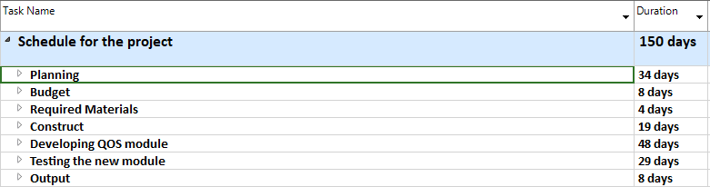

Figure 01

Project schedule is the most important for the project manager which helps to create the project in all knowledge areas. It is also one type of tools and techniques which are mostly used by the project manager at the starting of the project. In my project schedule there are all together 8 tasks which is as shown in the figure 1. Project schedule helps to create the activities in sequence form for the any kind of project. With the help of project schedule, it is easy to know the duration of the tasks and which activity can be started after the another one, so it is also a kind of planning done before the actual start of the work.

**Gantt Chart:**

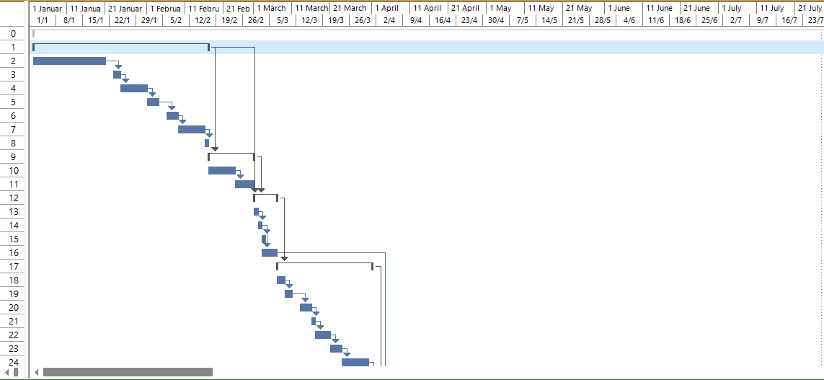

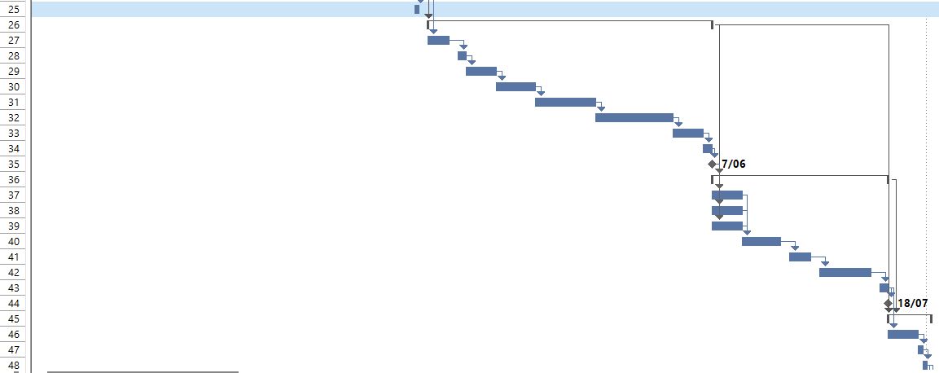



Figure 02

The Gantt chart is used to present the summary of the tasks while in the other hands it also shows the milestone of the project as shown in figure 02. With the help of this chart i can clearly understand the relation of the tasks and sub-tasks in other word dependency in the short period of time. For example, to start the developing of the QOS module first three tasks should be finished otherwise, I cannot start the task at any time. Milestone are only set which have direct effect on the output of the project. For example, to start the testing of the new module project manager must make sure that the development of the QOS module has already finished. Here the sub-task 50 is also marked by the milestone it means that the project will be completed in 27th July of 1995.

**Work Breaking Structure (WBS):**

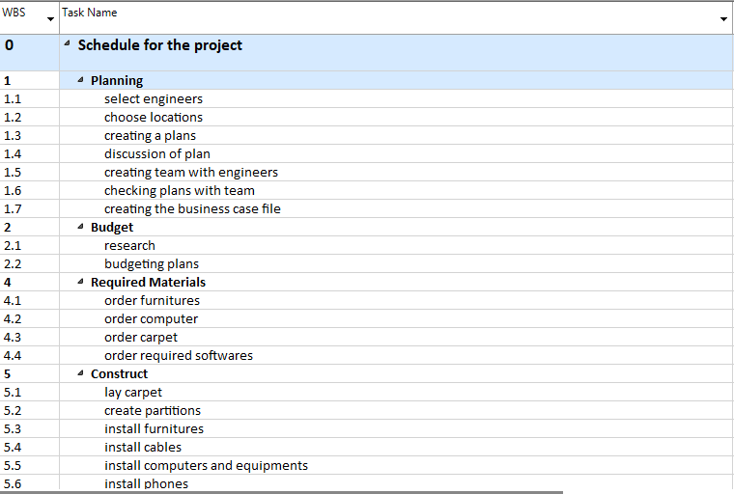

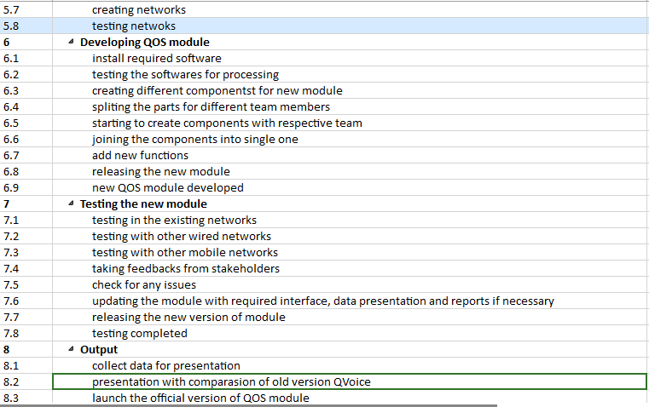



Figure 03

The figure 03 shows the WBS of all work I have assume in my project. It helps me to break down my project into the list of work that must be done. It also separates the works in different teams, so the task can be started if it doesn’t depend in any other tasks. Without WBS there will be difficult to control the overall process of project. For example, let me say sub-task add new function is not done then the delivery expected by the stakeholder is missing some part which obviously makes the project failure and to, make the project more effective and successful WBS is very important.

**Project duration:**

The project will start on the date of 2nd January 1995 and expected to end in 28th July 1995 which will take an about 150 days to complete the project. There is different task which will take different number of days to complete. The longest activity in this project Is developing the QOS module which will take 48 days for the completion which is the main task of the project while on the other hand it will take 34 days to complete the task plan which is important to start the project. After the development of the QOS module testing is necessary which will take 19 days. The tasks budget and output will take an equal day (8) to complete. In this project required materials is the only one activity which can be done in shortest period of the days i.e. 4.

**Network Diagram:**

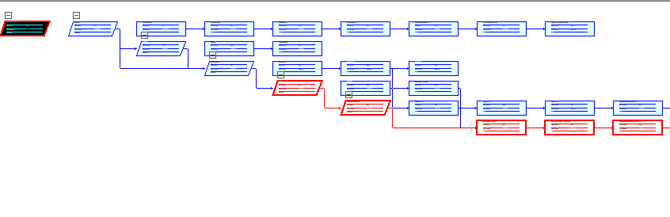

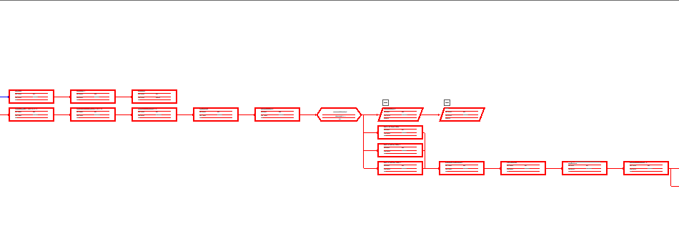

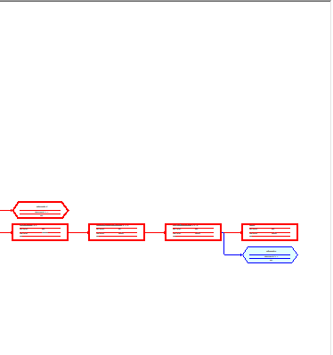

Figure 04

(The program (or project) evaluation and review technique, commonly abbreviated PERT, is a statistical tool, used in [project management](https://en.wikipedia.org/wiki/Project_management), which was designed to analyse and represent the [tasks](https://en.wikipedia.org/wiki/Task_(project_management)) involved in completing a given [project](https://en.wikipedia.org/wiki/Project).)

The figure 04 is the result of the work done in creating the network diagram as required by the case study with my assumption. With the help of the network diagram it is easy to analyse the critical path of the project. It also clearly shows the relation of tasks and sub-tasks.

**Critical Path Method (CPM):**

|  |  |  |  |
| --- | --- | --- | --- |
| **Tasks Name** | **Symbols** | **Days** | **Dependency** |
| Plan | A | 34 | - |
| Budget | B | 8 | A |
| Required Materials | C | 4 | A, B |
| Construct | D | 19 | C |
| Developing QOS Module | E | 48 | D |
| Testing the new Module | F | 29 | E |
| Output | G | 8 | E, F |

Table 01

To find the critical path of my project I had assume tasks as tabulated in the table 01 and also draw arrow on arrow (AOA) diagram (figure 05) for the calculation of critical path.

B=8

A=34

C=4

G=8

D=19

E=48

F=29

Figure 05

In this figure 05 the path from 2-4 and 6-8 are drawn as dummy because we cannot start the activity 4 and 8 until the activity 2 and 6 are completed respectively. As we observe in the above diagram there is only one path in the project from start to the end so there will be only one path which is obviously the longest path for the entire project so the path for the critical path is

= A+B+C+D+E+F+G

=34+8+4+19+48+29+8

=150 days

Therefore, the longest path to complete the project will be 150 days. If the project is completed less than 150 days than it suggests that we have missed some of the tasks or sub-task in result it always helps to minimize the risks involved in the project.

**Conclusion:**

As a project manager, I have supposed all the tasks and sub-tasks required for the project form the given case study and carried all the required process project schedule, Gantt chart, WBS, network diagram and critical path method (with the help of AOA diagram) so that the project will be completed in the exact time. Therefore, with the help of the project schedule, Gantt chart and WBS we can clearly achieve the required goals by focusing in the main areas such as scope, time, cost, human resources, quality, procurement, risk management, integrations. Without this as a project manager it will be very difficult to have a clear idea and it may ruin the output of the whole project.

**Referencing:**

(The program (or project) evaluation and review technique, commonly abbreviated PERT, is a statistical tool, used in [project management](https://en.wikipedia.org/wiki/Project_management), which was designed to analyse and represent the [tasks](https://en.wikipedia.org/wiki/Task_(project_management)) involved in completing a given [project](https://en.wikipedia.org/wiki/Project).) Retrieved from www.wikipedia.com