**Basic Science-Semester 1**

**Assignment 1**

**Section A - Biology (35 Marks)**

**Question 1 (13 Marks)**

* 1. Classification is the arrangement of living organisms into orderly groups based on their commonalities. While binomial nnomenclature refers to the classification of organisms only according to their morphology, meaning their structure and functions.
  2. Viruses do not have all 7 characteristics of living organisms such as nutrition, reproduction, respiration – unless they are inside the cells of another living organism. Thus, they are classified as parasites as they cause harm to their living host.
  3. Protists have a cell type that is eukaryotic, while archaebacterial organisms have a prokaryotic cell type.
  4. Monoecious plants have flower parts in 3’s and dioecious plants have flower parts which are in 4’s or 5’s.
  5. Gymnosperms have naked seeds, which grow in cones, and they lack fruits and flowers, while protective fruits usually enclose angiosperms’ seeds.
  6. Living organisms grow by producing new cells and by cell enlargement. Cell enlargement and growth overall usually stops around maturity, but they continue to produce cells for repair and maintenance.

**Question 2 (12 Marks)**

**2.1** Plants need pollination to ensure the survival of their species, as they are unable to reproduce on their own. Furthermore, it also ensures the survival of all ecosystems on earth.

**2.2**

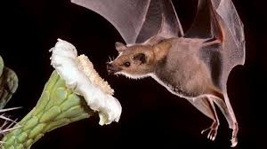

Figure 1. Agave flower pollinated by bat.

Agave plants have a strong, fruity or musky fragrance that attract many animals, including bats. These flowers produce large amounts of nectar and they are naturally large to accommodate the head of bats. When the bats feed on the nectar their mouths are covered with pollen, they then transfer pollen to the next flower the bat visits, pollinating it in the process.

**2.3** The first class of flowering plants aremonocots and they have seeds with one cotyledon in their embryo, and the other class of flowering plants is dicots, which has a seed with two cotyledons.

**2.4** Oak trees and squirrels. Squirrels benefit from oak trees because they eat the fruit that it produces which is acorns. In turn, the oak trees benefit as the squirrel will often bury the fruit/seed in the ground for ‘safe keeping’, allowing for a new oak tree to grow if the squirrel does not come back for the buried seed. In this relationship, both parties benefit to some extent.

2.5 Endangered species have a population that is very low in number making it unlikely for them to repopulate and survive in the wild. Extinct species are no longer found in the wild and have completely died out, e.g. dinosaurs.

**Question 3 (10 Marks)**

**3.1** Its a variety of interacting and interbreeding organisms

**3.2 .1** Parasitism

**3.2.2** Commensalism

**3.2.3** Parasitism

**3.3** Heterotrophs have to eat other organisms in order to survive; they cannot produce their own food like plants.

**3.4** Because they devour dead organisms by secreting enzymes onto them breaking down their structure in order to absorb the organisms’ nutrients.

**3.5** A food chain defines who eats whom and has a direct energy flow from one trophic level to another, at each level often-involving only one organism. A food web is much more complex where all the food chains circulate in an ecosystem, involving multiple organisms. Each organism takes a specific trophic position in the food chain or web.

**3.6** Scavengers feed on the remains of dead organisms, which were killed by predators or other factors such as old age or diseases, e.g. Vultures. Decomposers break down dead plants or animals often by chemical or biological means, e.g. bacteria.

**Section B – Chemistry (35 Marks)**

**Question 4 (17 Marks)**

**4.1.1** Deposition

**4.1.2** Melting

**4.2** An exothermic process releases energy into its surroundings in the form of heat or light. An endothermic process absorbs energy from its surroundings and turns it into a product.

**4.3.1** Intensive

**4.3.2** Extensive

**4.3.3** Intensive

**4.4** State of matter is dependent on temperature and pressure conditions of the environment.

**4.5** The reactants are Sodium and Chlorine. The product is two ionic units of Sodium Chloride.

**4.6** A solution is a liquid mixture where the least significant component disperses into the most significant component. A solute is the component that is dispersed into the most significant component. A solvent is the component that allows the least significant component to occupy or densify some of its matter.

**4.7** Simple distillation separates substances that have disparate boiling points, while fractional distillation does separation based on similar boiling points.

**4.8** Sara will make use of simple distillation, since the boiling point of water is 100 degrees Celsius and for sand its 2230 degrees Celsius. She can pour the water into another container and use something like a T-shirt to filter out most of the sand particles.

**Question 5 (18 Marks)**

**5.1** A value is a numeric description that involves both a number and a unit.

**5.2.1** Fahrenheit equivalent is -227.2

Kelvin equivalent is 129.15

**5.2.2** Fahrenheit equivalent is 177.332

Celsius equivalent is 80.74

**5.3** True value refers to the actual value of the same quantity that is properly measured, this value remains relatively in the same range. Measured value is the value of an object measured using any method e.g. your bare hands or a ruler.

**5.4** The first sample 1.974 g has a precision and accuracy close to the true mass of sand, which is 1.975 g.

**5.5.1** 900

**5.5.2** 900

**5.6.1** 4 significant figures

**5.6.2** 3 significant figures

**5.6.3** 4 significant figures

**5.7.1** 158.54

**5.7.2** 1155.96

**5.7.3** (6.427 x 10^28)

**Section C-Physics (30 Marks)**

**Question 6 (14 Marks)**

**6.1.1** X-axis: Year

Y-axis: Fish caught (kg)

**6.1.2** X-axis: Sales (month)

Y-axis: Paint (red or blue)

**6.2**  X-axis: Y-axis:

minimum=0 minimum=2

maximum=15 maximum=12

**6.3**

Figure 2. Velocity-Time graph

**Question 7 (16 Marks)**

**7.1** The water power station *Ruacana* located near the Kunene River in northern Namibia operates with water dropping 134m down vertical shafts, at which this water drives the turbines before returning to the Kunene river from a discharge tunnel. These turbines can generate about 330 Megawatts which is supplied to the Namibian Power Grid at 330 000 volts. However, this differs from tidal energy, which generates electricity from the energy within ocean tides. Ocean tides are produced because the Earth uses the gravitational force of the sun and moon every day.

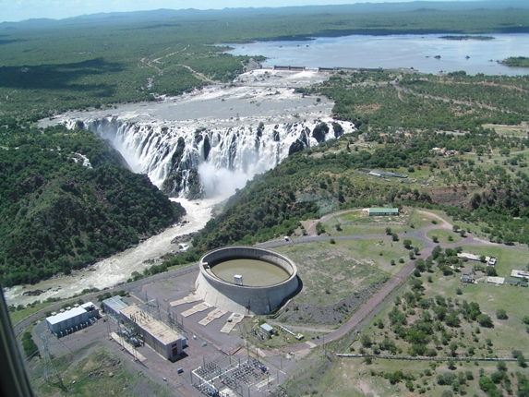

Figure 3. Ruacana Power Station

**7.2** Coal and Petrol

**7.3**

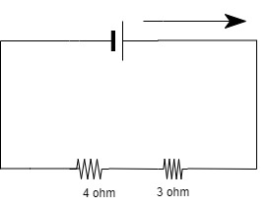

Figure 4.1 Series resistor

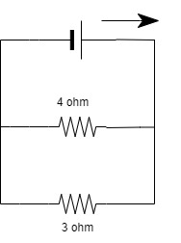

Figure 4.2 Parallel resistors

**7.4.1** Switch open: RT= 2

Switch closed: RT= 2 + 4 = 6

**7.4.2** Current with switch closed:

$I=\frac{V}{R}$

$I=\frac{12}{2}$

* $I=6$ A

Current with switch open:

$I=\frac{V}{R}$

$I=\frac{12}{2+4}$

* $I=2$ A

**7.4.3** Total charge with switch open:

$Q=I x t$

$Q=2*\left(4*60\right)$

$Q=2*240$

$Q=480 C$

**End of Assignment 1**

**References:**

1. Basic Science – BSC410S. (n.d.). Retrieved February 24, 2023, from <https://online.fliphtml5.com/mjraa/uqef/index.html#p=22>
2. Mindy, B. (N/A). Biology, Plant Structure and Function, Plant Reproduction, Pollination and Fertilization. Retrieved February 24, 2023, from <https://vivaopen.oercommons.org/courseware/lesson/599/overview>
3. Food Chains and Webs. (n.d.). Retrieved February 24, 2023, from <https://education.nationalgeographic.org/resource/resource-library-food-chains-and-webs/>
4. What are Exothermic Reactions?. (n.d.). Retrieved March 7, 2023, from <https://byjus.com/chemistry/exothermic-reaction/#:~:text=An%20exothermic%20reaction%20is%20a%20reaction%20in%20which%20energy%20is,as%20in%20an%20endothermic%20reaction>.
5. What is a Solution?. (n.d.). Retrieved March 7, 2023, from <https://www.chem.purdue.edu/gchelp/solutions/whatis.html>
6. Fractional Distillation – Detailed Explanation Along With Diagrams. (n.d.). Retrieved March 7, 2023, from <https://byjus.com/chemistry/fractional-distillation/#:~:text=What%20is%20the%20difference%20between,chemicals%20with%20similar%20boiling%20points>.
7. NamPower – Ruacana Power Station (n.d.). Retrieved March 13, 2023, from <https://www.nampower.com.na/Page.aspx?p=184>