**Unit 12: Electricity**

**Relation between current and flow of charge**

Current is the ***rate*** at which ***electric charge*** flows in a circuit, the flow of charge indicates the ***amount*** of ***electric charge*** which is ***supplied to*** or ***lost*** from an object or circuit in a given current.

**Difference between alternating and direct current**

**Alternating current (AC) -** refers to the amount of times the ***direction is changed*** within a current, measured per second in *Hertz.*

**Direction current (DC) –** is when the current ***never changes direction*** and always stays in the same direction.

**Simple circuit diagrams containing power sources, switches, resistors, ammeters and voltmeters**

**Power source**

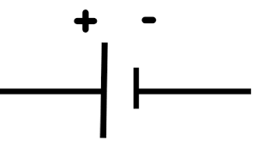

e.g. Single cell

**Switch**

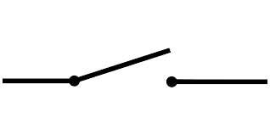

**Resistors**

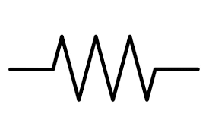

**Ammeters**

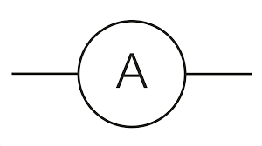

**Voltmeters**

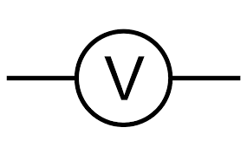

***The load***

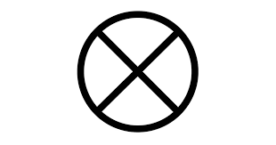

e.g. Single bulb

**Ammeters**

An ammeter is a device used to ***measure*** the electric current in a circuit.

* It does this by ***counting*** the ***number of electrons*** that go through the device.
* To achieve this it is made out of ***material*** that ***allows*** electrons to go through it, thus we say that an ammeter has ***low*** resistance i.e. it makes electricity flow easier.
* Ammeter has ***almost no effect*** on the current.
* ***Positive terminal*** of ammeter is connected to the ***positive pole*** of the battery. The same goes for the *opposite i.e. negative*

**Voltmeters**

A voltmeter ***measures*** the ***potential difference***(***PD)*** (*scientific name for energy)* ***between two***points in an electric circuit.

**Symbols**

$$Current- I$$

$$Voltage-V$$

$Resistance- Ω$/ R

**Formulas**

$Rt \left(series\right)=$ R1 + R2 + … + Rn

$$Rt \left(parallel\right)=\frac{1}{R1}+\frac{1}{R2}+…+\frac{1}{Rn}$$

$$Current=\frac{charge}{time}$$

$$Current(I)=\frac{V}{R}$$

$$Voltage \left(V\right)across the resistor=I \left(through resistor\right)*R$$

**Uses of electricity in heating and lighting**

Electricity is often used to power appliances in our houses.

For heat:

* A ***stove*** needs electricity to generate heat.
* ***Heater***

For light:

* ***Light bulbs***
* ***TV screen***

**How to correctly do the wiring of an electric plug**

* There are **3** different colored wires in lead ***blue, brown and green-and-yellow.***
* ***Each*** of these is ***connected*** to ***one*** of the pins in a three-pin plug.
* The bluewire is the ***neutral,*** brown is the ***live*** and green-and-yellow is **earth.** These are indications of which color should go where.
* A ***fuse*** is a safety device included in circuits so that if ***fault occurs*** and the current is high, the fuse wire ***melts.***

**Safety devices**

A safety device is a component that protects you from electrocution or prevent or prevent fires.