Heaven's Light Is Our Guide

Rajshahi University of Engineering & Technology
Department of Electrical & Computer Engineering
Course Title
Digital Techniques Sessional
Course No: ECE 2112
Lab No: 01
Report Title:
Realizing Basic Logic Gates with Universal Gates, a Full Adder, and a Binary-to-BCD Converter
Date of Submission: 31 July, 2026
Submitted To | Submitted By
MST. Mazeda Noor Tasnim  Lecturer,  Department of Electrical & Computer  Engineering, RUET | Showmee Ahmed  Roll: 2410037  ECE-24 Series

Problem: 01
Problem Definition:
Build an OR gate using nothing but NOR gates.
Objective:
To wire an OR gate out of two NOR gates and check its response against the OR truth table, showing how a universal gate can stand in for another basic gate.
Theory:
A NOR gate is called "universal" because every other gate can be built from NOR gates alone. On its own, a NOR gate already outputs the complement of OR, i.e. the complement of (A+B). Sending that signal into a second NOR gate whose two inputs are tied to the same wire turns that second gate into a plain inverter, because shorting a NOR gate's inputs together reduces it to complement(X+X) = complement(X). Inverting the first stage's output a second time therefore restores the original OR relationship.
G1 = complement(A+B), Y = complement(G1) = A+B
Truth Table:
A | B | G1 | Y = A+B
0 | 0 | 1 | 0
0 | 1 | 0 | 1
1 | 0 | 0 | 1
1 | 1 | 0 | 1
Circuit Diagram:
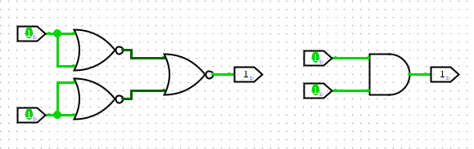
Fig. 1: OR gate realized with two NOR gates
Discussion:
The first NOR gate produces the complement of (A+B); that signal is applied to both inputs of the second NOR gate, which as a result behaves purely as an inverter rather than as a combining gate. The second inversion cancels the first, so the circuit's final output equals A+B for every input pair, exactly matching the standard OR truth table. Only two NOR gates were needed, which is the smallest possible NOR-only realization of an OR gate and demonstrates why NOR is classified as a universal gate.
Conclusion:
An OR gate was successfully built using only two NOR gates; simulated outputs matched the OR truth table for all four input combinations.

Problem: 02
Problem Definition:
Build an OR gate using nothing but NAND gates.
Objective:
To realize an OR gate with three NAND gates by applying De Morgan's theorem and to confirm the result experimentally.
Theory:
De Morgan's theorem gives A+B = complement( complement(A) · complement(B) ), and the right-hand side is precisely a NAND operation carried out on complement(A) and complement(B). A NAND gate whose inputs are shorted together behaves as an inverter, since complement(X·X) = complement(X). So two NAND gates, each with their input pins tied together, generate complement(A) and complement(B); feeding these two signals into a third NAND gate then yields the OR function.
complement(A) = complement(A·A), complement(B) = complement(B·B), Y = complement( complement(A)·complement(B) ) = A+B
Truth Table:
A | B | A' | B' | Y = A+B
0 | 0 | 1 | 1 | 0
0 | 1 | 1 | 0 | 1
1 | 0 | 0 | 1 | 1
1 | 1 | 0 | 0 | 1
Circuit Diagram:
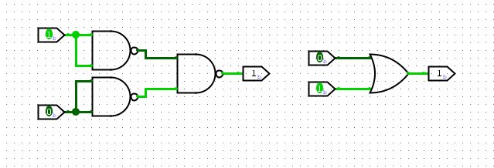
Fig. 2: OR gate realized with three NAND gates
Discussion:
Two of the NAND gates have their input pins tied together, so each acts only as an inverter, producing complement(A) and complement(B) respectively. The third NAND gate then combines these inverted signals; by De Morgan's theorem, NANDing two complemented variables reproduces their OR. Because a NAND gate is naturally suited to AND-type combinations, an extra inverting stage is needed to reach OR, which is why this design needs one more gate than the equivalent NOR-based circuit in Problem 1.
Conclusion:
An OR gate was successfully built from three NAND gates; the resulting truth table matched the expected OR behaviour for every input combination.

Problem: 03
Problem Definition:
Build an AND gate using nothing but NOR gates.
Objective:
To realize an AND gate with three NOR gates by applying De Morgan's theorem.
Theory:
By De Morgan's theorem, A·B = complement( complement(A) + complement(B) ), which is exactly what a NOR gate computes when its inputs are complement(A) and complement(B). A NOR gate with its inputs shorted together acts as an inverter, since complement(X+X) = complement(X). Two NOR gates configured this way generate complement(A) and complement(B), and a third NOR gate combines them to produce the AND output.
complement(A) = complement(A+A), complement(B) = complement(B+B), Y = complement( complement(A)+complement(B) ) = A·B
Truth Table:
A | B | A' | B' | Y = A·B
0 | 0 | 1 | 1 | 0
0 | 1 | 1 | 0 | 0
1 | 0 | 0 | 1 | 0
1 | 1 | 0 | 0 | 1
Circuit Diagram:
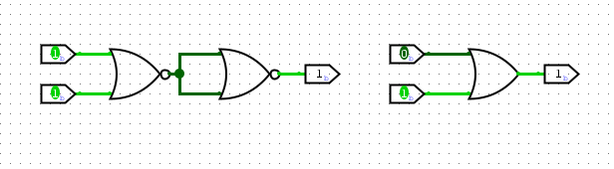
Fig. 3: AND gate realized with three NOR gates
Discussion:
The first two NOR gates, each wired as an inverter, turn A and B into their complements. The third NOR gate combines complement(A) and complement(B); De Morgan's theorem shows this is equivalent to A·B. Just as with the NAND-based OR gate in Problem 2, three gates are required here because a NOR gate is naturally OR-like, so an additional inversion stage is necessary to obtain an AND function.
Conclusion:
An AND gate was successfully built using three NOR gates, and the truth table confirmed correct AND behaviour across all input combinations.

Problem: 04
Problem Definition:
Build an AND gate using nothing but NAND gates.
Objective:
To realize an AND gate using two NAND gates.
Theory:
A NAND gate directly outputs the complement of AND, i.e. complement(A·B). Passing that result into a second NAND gate whose inputs are shorted together inverts it once more, since a NAND gate with tied inputs behaves as a plain inverter. The double inversion restores the original AND relationship.
G1 = complement(A·B), Y = complement(G1) = A·B
Truth Table:
A | B | G1 = complement(A·B) | Y = A·B
0 | 0 | 1 | 0
0 | 1 | 1 | 0
1 | 0 | 1 | 0
1 | 1 | 0 | 1
Circuit Diagram:
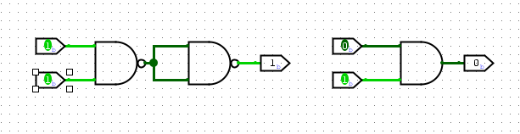
Fig. 4: AND gate realized with two NAND gates
Discussion:
The first NAND gate outputs complement(A·B); feeding this into the second NAND gate, whose inputs are shorted together, forces that gate to act purely as an inverter, restoring the AND relationship. Since NAND is itself a universal gate, only two NAND gates are required here — the AND-gate mirror image of the two-NOR OR gate built in Problem 1.
Conclusion:
An AND gate was successfully built using two NAND gates; the resulting truth table matched the standard AND truth table for every input combination.

Problem: 05
Problem Definition:
Build a NOT gate using only a single NOR gate.
Objective:
To realize an inverter using one NOR gate.
Theory:
A NOR gate computes complement(A+B). If both inputs are wired to the same signal A, the expression collapses to complement(A+A) = complement(A), which is exactly the NOT operation.
Truth Table:
A | Y = complement(A)
0 | 1
1 | 0
Circuit Diagram:
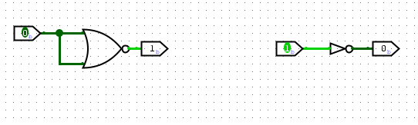
Fig. 5: NOT gate realized with a single NOR gate
Discussion:
Tying both inputs of the NOR gate to a common signal removes any genuine OR combination, leaving only the inversion that is inherent in the NOR operation. This is the simplest possible universal-gate construction — a single gate — and it is the same inverter building block relied on in the designs for Problems 1 and 3.
Conclusion:
A NOT gate was successfully realized with a single NOR gate wired as an inverter; the truth table confirmed correct inversion for both input states.

Problem: 06
Problem Definition:
Build a NOT gate using only a single NAND gate.
Objective:
To realize an inverter using one NAND gate.
Theory:
A NAND gate computes complement(A·B). If both inputs are driven by the same signal A, this reduces to complement(A·A) = complement(A), which is the NOT function.
Truth Table:
A | Y = complement(A)
0 | 1
1 | 0
Circuit Diagram:
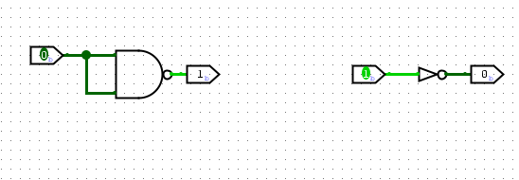
Fig. 6: NOT gate realized with a single NAND gate
Discussion:
As with the NOR-based inverter above, shorting the two inputs of the NAND gate to a single signal removes its AND-combining behaviour and leaves only inversion. This construction is the basic inverter used inside the designs for Problems 2 and 4, and together with Problem 5 it confirms that NOR and NAND are each, on their own, sufficient to build every basic logic gate.
Conclusion:
A NOT gate was successfully realized with a single NAND gate wired as an inverter; the truth table confirmed correct inversion for both input states.

Problem: 07
Problem Definition:
Build a full adder circuit and check it against its truth table.
Objective:
To design a full adder from basic logic gates and verify its Sum and Carry-out outputs across all eight input combinations of A, B, and Cin.
Theory:
A full adder is a combinational circuit that adds three single-bit inputs — the operand bits A and B along with an incoming carry Cin — and produces a Sum bit together with an outgoing carry Cout. Unlike a half adder, which handles only two bits and has no way to accept an incoming carry, a full adder can be chained together to build adders of any width.
Sum = A ⊕ B ⊕ Cin, Cout = A·B + Cin·(A ⊕ B)
One way to build a full adder is from two half adders plus an OR gate. The first half adder produces the partial sum P = A ⊕ B along with the partial carry A·B. The second half adder combines P with Cin to give the final Sum and the term P·Cin. An OR gate then merges the two partial-carry terms, A·B and P·Cin, into the final Cout, since either condition on its own is enough to generate an outgoing carry.
Truth Table:
A | B | Cin | Sum | Cout
0 | 0 | 0 | 0 | 0
0 | 0 | 1 | 1 | 0
0 | 1 | 0 | 1 | 0
0 | 1 | 1 | 0 | 1
1 | 0 | 0 | 1 | 0
1 | 0 | 1 | 0 | 1
1 | 1 | 0 | 0 | 1
1 | 1 | 1 | 1 | 1
Circuit Diagram:
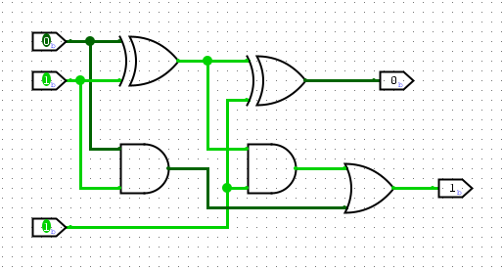
Fig. 7: Full adder circuit
Discussion:
The first XOR gate forms P = A ⊕ B, the sum of A and B before any carry is considered, while the first AND gate simultaneously produces A·B, the carry that A and B generate directly between themselves. The second XOR gate then combines P with Cin to give the final Sum bit, and the second AND gate produces P·Cin, the carry contributed by the interaction between Cin and P. Finally, an OR gate merges A·B and P·Cin into Cout, since a carry-out can arise from either source. Running the circuit through all eight rows of the truth table showed that Sum and Cout matched the expected values in every case.
Conclusion:
A full adder built from two XOR gates, two AND gates, and one OR gate was verified against its complete eight-row truth table, confirming that it correctly performs three-bit binary addition.

Problem: 08
Problem Definition:
Build a binary-to-BCD converter for a 4-bit binary input.
Objective:
To design a combinational circuit that converts a 4-bit binary number (0 through 15) into its two-digit Binary-Coded-Decimal equivalent.
Theory:
A 4-bit binary word B3B2B1B0 covers the decimal range 0–15. Because BCD encodes each decimal digit in 4 bits and only permits digit values 0–9, any binary value of 10 or above needs two BCD digits: a tens digit T, which is only ever 0 or 1 in this range, and a units digit U3U2U1U0 between 0 and 9. When the binary value is 9 or less, T = 0 and the units digit is simply equal to the binary input; when the value is 10 or more, T = 1 and the units digit is the binary value with 10 subtracted from it.
Listing all 16 input/output combinations and simplifying them with Karnaugh maps gives the following minimized expressions:
T = B3·(B2 + B1)
U3 = B3·B2·B1'
U2 = B2'·B3 + B2·B1'
U1 = B1·B3' + B2'·B1·B3
U0 = B0
U0 is always equal to B0 directly, because subtracting 10 — an even number — never changes the parity of the least significant bit.
Truth Table:
B3 | B2 | B1 | B0 | T | U3 | U2 | U1 | U0
0 | 0 | 0 | 0 | 0 | 0 | 0 | 0 | 0
0 | 0 | 0 | 1 | 0 | 0 | 0 | 0 | 1
0 | 0 | 1 | 0 | 0 | 0 | 0 | 1 | 0
0 | 0 | 1 | 1 | 0 | 0 | 0 | 1 | 1
0 | 1 | 0 | 0 | 0 | 0 | 1 | 0 | 0
0 | 1 | 0 | 1 | 0 | 0 | 1 | 0 | 1
0 | 1 | 1 | 0 | 0 | 0 | 1 | 1 | 0
0 | 1 | 1 | 1 | 0 | 0 | 1 | 1 | 1
1 | 0 | 0 | 0 | 0 | 1 | 0 | 0 | 0
1 | 0 | 0 | 1 | 0 | 1 | 0 | 0 | 1
1 | 0 | 1 | 0 | 1 | 0 | 0 | 0 | 0
1 | 0 | 1 | 1 | 1 | 0 | 0 | 0 | 1
1 | 1 | 0 | 0 | 1 | 0 | 0 | 1 | 0
1 | 1 | 0 | 1 | 1 | 0 | 0 | 1 | 1
1 | 1 | 1 | 0 | 1 | 0 | 1 | 0 | 0
1 | 1 | 1 | 1 | 1 | 0 | 1 | 0 | 1
Circuit Diagram:
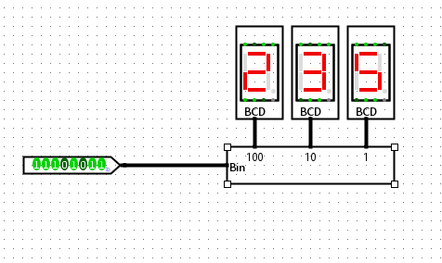
Fig. 8: Binary-to-BCD converter
Discussion:
Every output of the converter is an independent Boolean function of the four input bits B3B2B1B0, obtained straight from Karnaugh-map minimization of the 16-row truth table. The tens bit T works like a simple threshold detector, switching high only once the input reaches 10 or more. The units bits U3U2U1U0 effectively subtract 10 from the input whenever T = 1, which is why several of their expressions share terms with the expression for T. Because the input is restricted to 4 bits (0–15), the whole block can be built directly from AND, OR, and NOT gates using the minimized equations, without needing a separate adder–subtractor stage.
Conclusion:
A binary-to-BCD converter for 4-bit inputs (0–15) was designed successfully using combinational logic derived from Karnaugh-map simplification. The truth table confirmed that the circuit correctly splits every binary input into a tens bit T and a units nibble U3U2U1U0, matching the expected two-digit BCD output in every case.

References
1. M. M. Mano, Digital Design, 5th ed. Upper Saddle River, N.J.: Pearson, 2013.
2. R. J. Tocci, N. S. Widmer, and G. L. Moss, Digital Systems: Principles and Applications, 11th ed. Upper Saddle River, N.J.: Pearson, 2011.

