Heaven's Light Is Our Guide

Rajshahi University of Engineering & Technology
Department of Electrical & Computer Engineering
Course Title
Digital Techniques Sessional
Course No: ECE 2112
Lab No: 02
Report Title:
Reducing Boolean Expressions with Boolean Algebra and the Karnaugh Map, and Confirming the Results Through Logic-Circuit Simulation
Date of Submission: 31 July, 2026
Submitted To | Submitted By
MST. Mazeda Noor Tasnim  Lecturer,  Department of Electrical & Computer  Engineering, RUET | Showmee Ahmed  Roll: 2410037  ECE-24 Series

Problem: 01
Problem Definition:
Reduce the Boolean expression F(A, B, C) = A'BC + AB'C + ABC' + ABC using Boolean algebra and a Karnaugh map, then check both the original and the reduced circuits through simulation.
Objective:
To take a three-variable sum-of-minterms expression down to its minimal sum-of-products form, cross-check that reduction with a Karnaugh map, and confirm in Logisim that the unreduced and reduced circuits behave identically.
Algebraic Simplification:

F(A,B,C) = A'BC + AB'C + ABC' + ABC
= A'BC + ABC + AB'C + ABC + ABC' + ABC
= BC(A' + A) + AC(B' + B) + AB(C' + C)
= BC + AC + AB
= AB + AC + BC
Truth Table:
A | B | C | F = AB+AC+BC
0 | 0 | 0 | 0
0 | 0 | 1 | 0
0 | 1 | 0 | 0
0 | 1 | 1 | 1
1 | 0 | 0 | 0
1 | 0 | 1 | 1
1 | 1 | 0 | 1
1 | 1 | 1 | 1
Karnaugh Map:
A 2x4 map with A on one axis and BC on the other is filled in from the four minterms of the given expression; the cells at (A=0, BC=11), (A=1, BC=01), (A=1, BC=11), and (A=1, BC=10) hold 1s, all remaining cells hold 0.
A \ BC | 00 | 01 | 11 | 10
0 | 0 | 0 | 1 | 0
1 | 0 | 1 | 1 | 1
K-map for F(A,B,C) = A'BC + AB'C + ABC' + ABC
Three pairs of adjacent 1-cells can be grouped: the pair at BC = 11 (spanning both rows) yields BC; the pair with A = 1 and C = 1 (BC = 01 and 11) yields AC; and the pair with A = 1 and B = 1 (BC = 11 and 10) yields AB. Merging these three pairs gives the minimized form F = AB + AC + BC, which is the same result obtained algebraically.
Circuit Diagram:
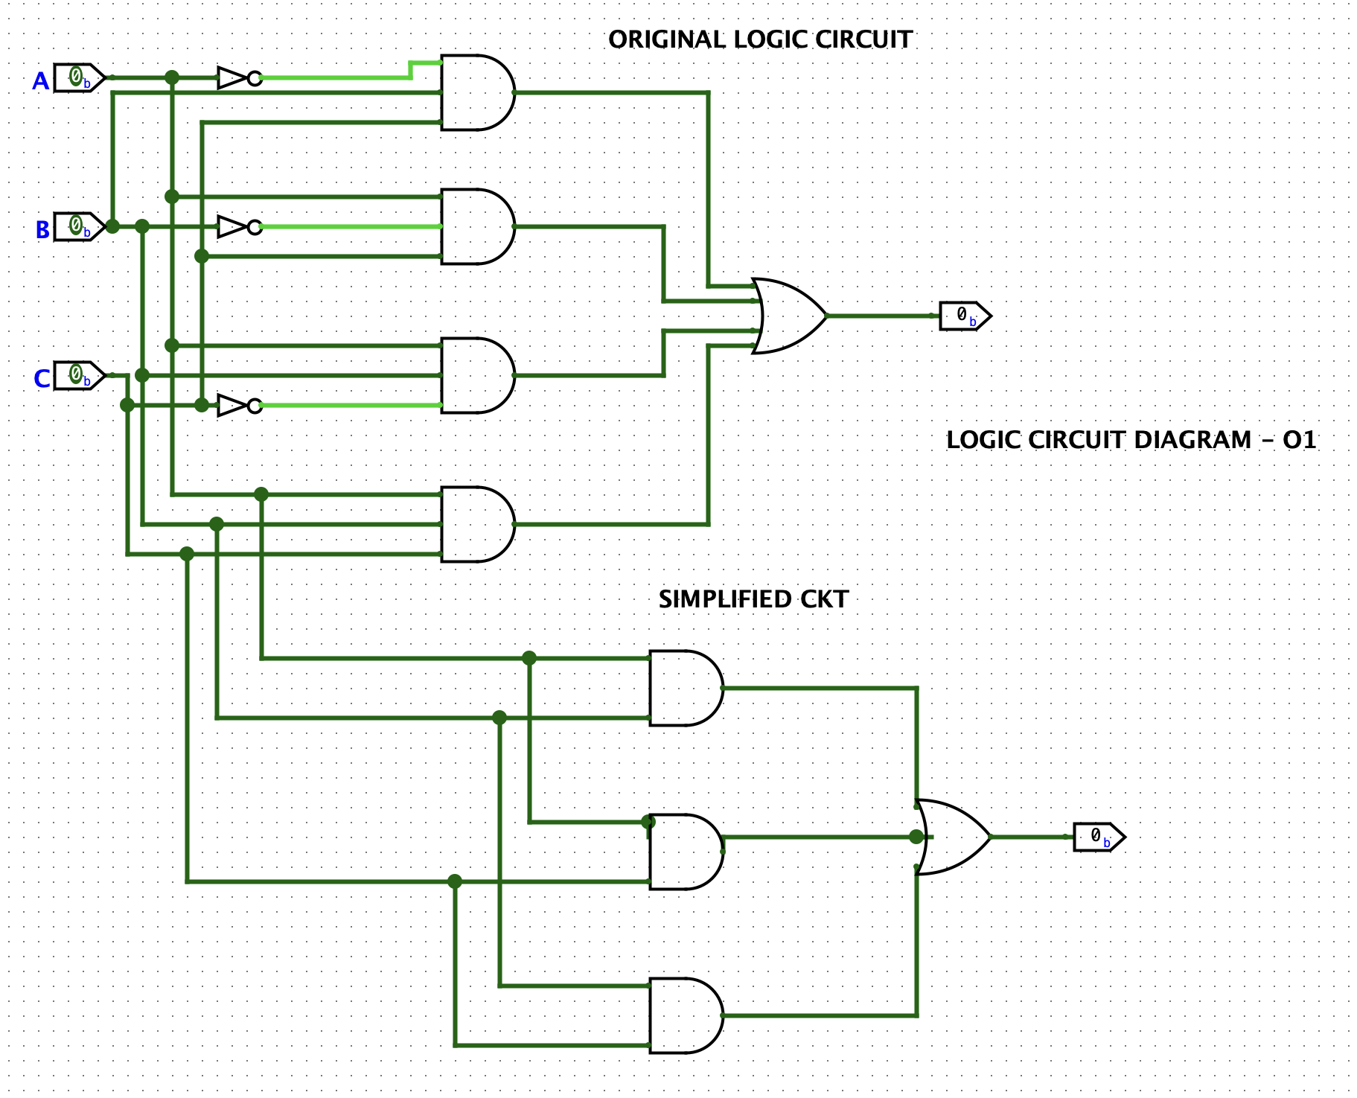
Fig. 1: Unreduced circuit (four 3-input AND gates feeding a 3-input OR gate, realizing A'BC+AB'C+ABC'+ABC) alongside the reduced circuit (three 2-input AND gates feeding an OR gate, realizing AB+AC+BC), both built in Logisim
Discussion:
The unreduced circuit follows the given expression literally: it needs four 3-input AND gates, one per product term, plus inverters wherever A', B', or C' appear, and a 3-input OR gate to sum the terms. The reduced circuit, by contrast, realizes AB + AC + BC with only three 2-input AND gates and a single OR gate, and needs no inverters at all. Both versions were driven with the same eight input patterns in Logisim, and their outputs agreed in every case, which validates both the algebraic manipulation and the Karnaugh-map grouping. The reduced version is clearly the more economical design, using fewer gates, fewer gate inputs overall, and eliminating inversion entirely.
Conclusion:
F = A'BC + AB'C + ABC' + ABC was reduced to F = AB + AC + BC through Boolean algebra and this was confirmed with a Karnaugh map. Logisim simulation of both the unreduced and reduced circuits gave matching outputs across every input combination, verifying that the simplification is correct.

Problem: 02
Problem Definition:
Reduce the Boolean expression F(A, B, C) = A(A + B)(A + B + C) using Boolean algebra and a Karnaugh map, then check both the original and reduced circuits through simulation.
Objective:
To simplify a three-variable expression written as a product of sum terms down to its simplest possible form, verify the reduction with a Karnaugh map, and confirm in Logisim that the unreduced and reduced circuits are equivalent.
Algebraic Simplification:

F(A,B,C) = A(A + B)(A + B + C)
= (A + AB)(A + B + C)
= A(A + B + C) + AB(A + B + C)
= A + AB + AC + AB + AB + ABC
= A + AB + AC + ABC
= A(1 + B + C + BC)
= A
Truth Table:
A | B | C | F = A
0 | 0 | 0 | 0
0 | 0 | 1 | 0
0 | 1 | 0 | 0
0 | 1 | 1 | 0
1 | 0 | 0 | 1
1 | 0 | 1 | 1
1 | 1 | 0 | 1
1 | 1 | 1 | 1
Karnaugh Map:
Every cell in the A = 1 row reads 1, while the whole A = 0 row reads 0. These four adjacent 1-cells form one large group spanning the entire row, so both B and C drop out of the grouped term entirely, leaving F = A — the same result reached algebraically.
A \ BC | 00 | 01 | 11 | 10
0 | 0 | 0 | 0 | 0
1 | 1 | 1 | 1 | 1
K-map for F(A,B,C) = A(A+B)(A+B+C)
Circuit Diagram:
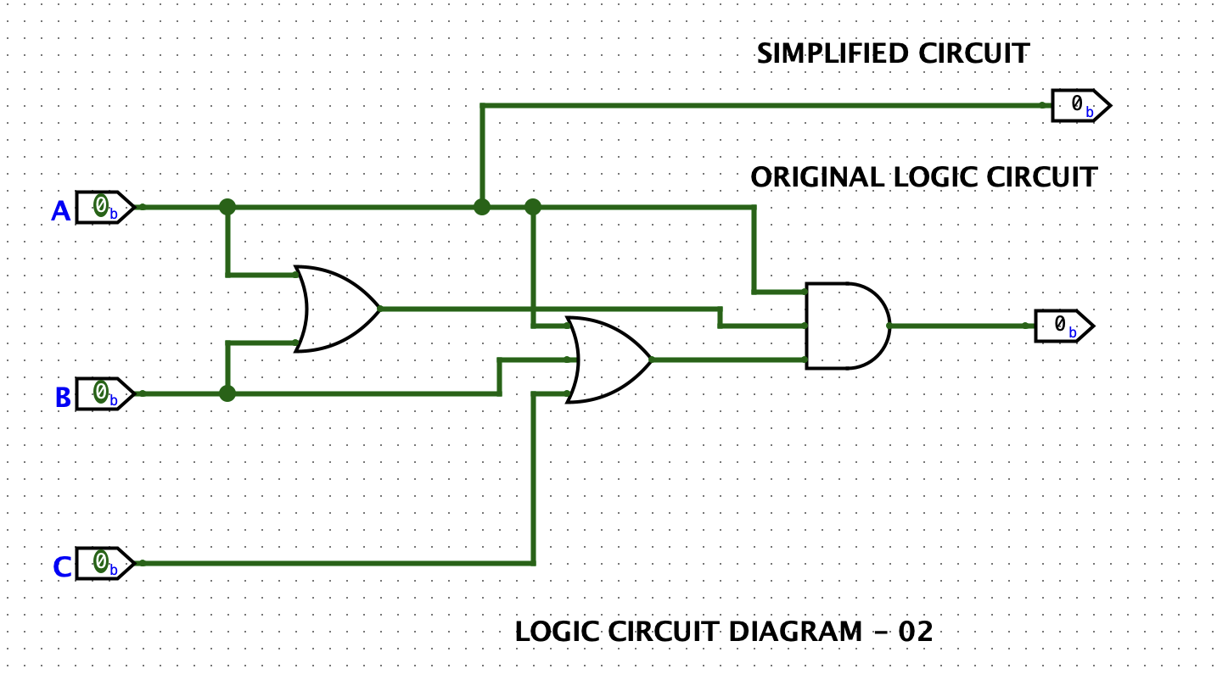
Fig. 2: Unreduced circuit (two OR gates forming A+B and A+B+C, ANDed with A) next to the reduced circuit (a direct wire representing F = A), built in Logisim
Discussion:
In the unreduced circuit, one OR gate first forms A + B, a second OR gate extends this to A + B + C, and an AND gate combines both results with A itself. Since A appears in every term, all of the higher-order terms get absorbed and the whole network reduces to the single literal A — so the reduced circuit is nothing more than a wire carrying input A straight to the output, with no gates at all. This is the absorption law, A + AB = A, applied twice in succession. Cycling both circuits through every combination of A, B, and C in Logisim confirmed that the output always tracks A exactly, regardless of what B and C are doing.
Conclusion:
F = A(A+B)(A+B+C) was shown to reduce to F = A by repeatedly applying the absorption law, and this was backed up by both the Karnaugh map and the Logisim simulation, both of which showed that B and C play no role in determining the output.

Problem: 03
Problem Definition:
Reduce the Boolean expression F(A, B, C) = (A + (BC)')'(AB + ABC) using Boolean algebra and a Karnaugh map, then check both the original and reduced circuits through simulation.
Objective:
To simplify a mixed AND-OR-complement expression by applying De Morgan's theorem and Boolean algebra, verify the result with a Karnaugh map, and confirm in Logisim that the reduced circuit behaves as a constant output.
Algebraic Simplification:

F(A,B,C) = (A + (BC)')'(AB + ABC)
= A' · BC · (AB + ABC) (De Morgan's theorem)
= A'BC · AB(1 + C)
= A'BC · AB
= (AA')·BC·B
= 0
Truth Table:
A | B | C | F = 0
0 | 0 | 0 | 0
0 | 0 | 1 | 0
0 | 1 | 0 | 0
0 | 1 | 1 | 0
1 | 0 | 0 | 0
1 | 0 | 1 | 0
1 | 1 | 0 | 0
1 | 1 | 1 | 0
Karnaugh Map:

A \ BC | 00 | 01 | 11 | 10
0 | 0 | 0 | 0 | 0
1 | 0 | 0 | 0 | 0
K-map for F(A,B,C) = (A+(BC)')'(AB+ABC)
Not a single cell in the map holds a 1, so there is nothing to group. A Karnaugh map that comes out completely empty represents the constant function F = 0, which is exactly what the algebraic derivation produced.
Circuit Diagram:
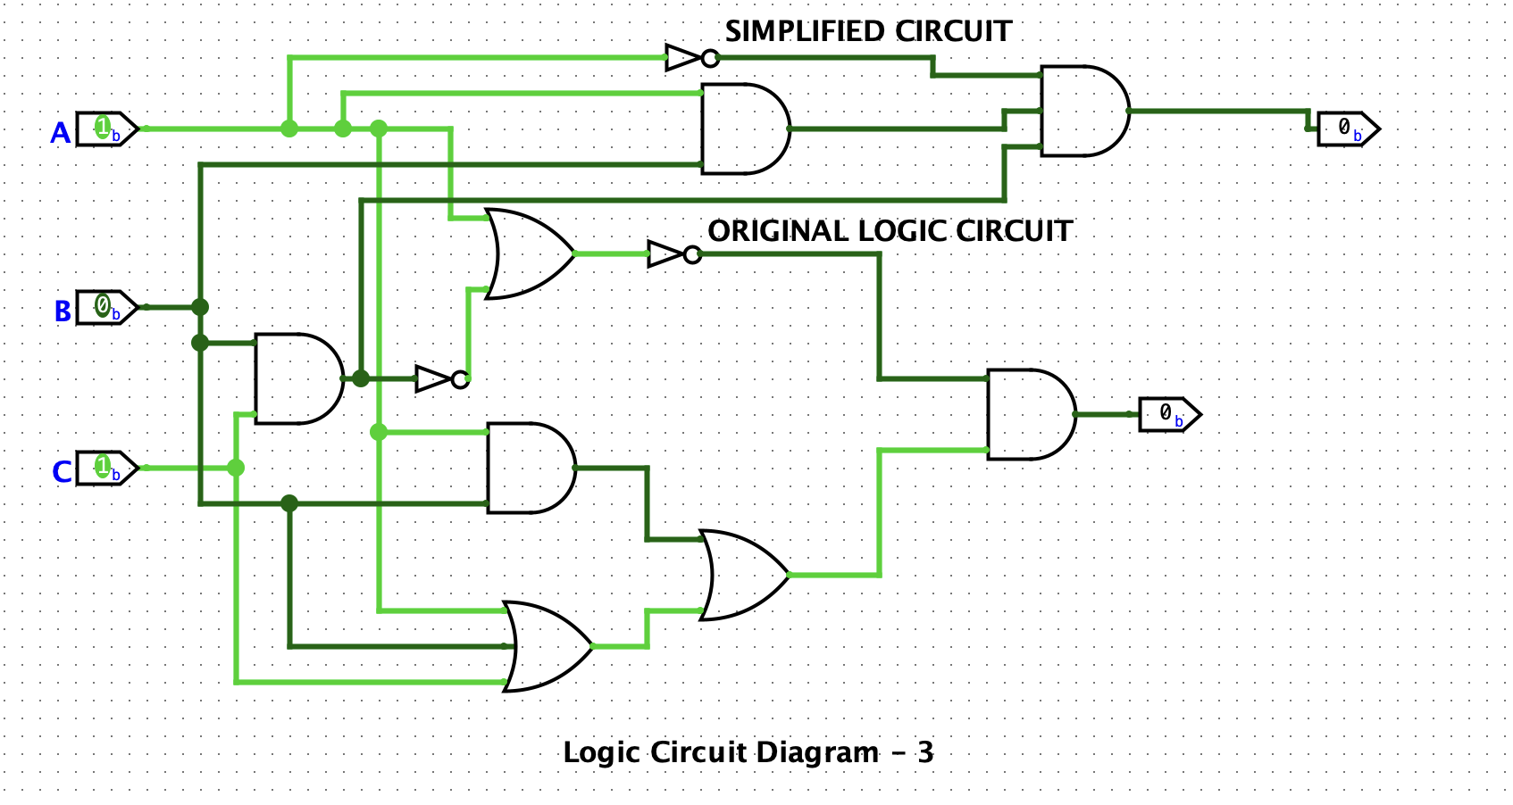
Fig. 3: Unreduced circuit realizing (A+(BC)')'(AB+ABC) with NAND-style and OR/AND stages, next to the reduced circuit showing a permanent logic-0 output, built in Logisim
Discussion:
Applying De Morgan's theorem to (A + (BC)')' turns it into A' · BC; the second factor, AB + ABC, then collapses to AB by absorption, since AB + ABC = AB(1 + C) = AB. Multiplying A'BC by AB brings in the term A · A', which is always 0, so the whole expression is forced to 0 no matter what A, B, and C are. Logisim confirmed this: stepping the unreduced circuit through all eight input patterns showed the output staying at logic 0 throughout, exactly as the all-zero Karnaugh map predicted.
Conclusion:
F = (A+(BC)')'(AB+ABC) was shown to equal 0 for every possible input. This was established algebraically, backed up by an empty Karnaugh map, and confirmed by Logisim simulation, which produced a constant logic-0 output regardless of A, B, and C.

Problem: 04
Problem Definition:
Reduce the Boolean expression F(A, B) = (B'(A + B) + (A + B)(A + B'))B' using Boolean algebra and a Karnaugh map, then check both the original and reduced circuits through simulation.
Objective:
To simplify a two-variable expression made up of nested OR and AND terms down to its minimal form, verify the reduction with a Karnaugh map, and confirm the equivalence of the unreduced and reduced circuits in Logisim.
Algebraic Simplification:

F(A,B) = (B'(A + B) + (A + B)(A + B'))B'
= (AB' + BB' + AA + AB' + AB' + BB')B'
= (A + AB' + AB' + AB')B'
= A(1 + B' + B' + B')B'
= AB'
Truth Table:
A | B | F = AB'
0 | 0 | 0
0 | 1 | 0
1 | 0 | 1
1 | 1 | 0
Karnaugh Map:

A \ B | 0 | 1
0 | 0 | 0
1 | 1 | 0
K-map for F(A,B) = (B'(A+B) + (A+B)(A+B'))B'
Only one cell, at A = 1, B = 0, holds a 1. A single isolated 1-cell has no neighbouring 1 to pair with, so it is simply read off as the product of its own coordinate literals, giving F = AB', matching the algebraic result.
Circuit Diagram:
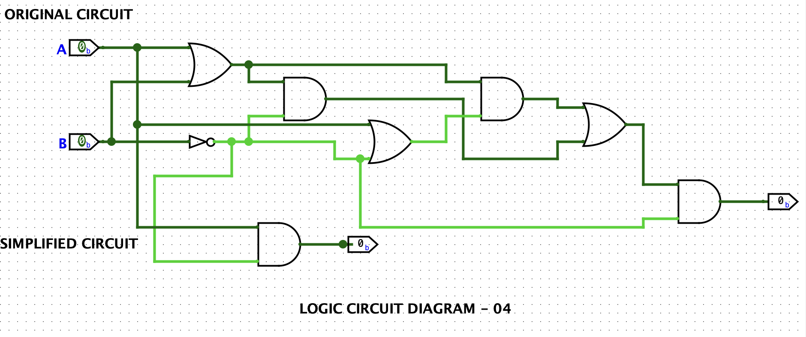
Fig. 4: Unreduced circuit realizing (B'(A+B)+(A+B)(A+B'))B' with OR, AND, and NOT stages, next to the reduced circuit collapsed to a single AND gate realizing AB', built in Logisim
Discussion:
Expanding the original expression term by term throws up several copies of AB' along with the terms A, BB', and AA. Since BB' = 0 and AA = A, and every term that survives is either A or AB', pulling the common factor B' out of the whole expression brings it down to the single term AB'. As a result, the four-gate unreduced network built from OR, AND, and NOT gates turns out to be functionally the same as one 2-input AND gate fed with A and an inverted B. Checking both circuits in Logisim across all four combinations of A and B confirmed that the output is 1 only when A = 1 and B = 0, matching F = AB' in every case.
Conclusion:
F = (B'(A+B)+(A+B)(A+B'))B' was successfully reduced to F = AB' using Boolean algebra, backed up by a Karnaugh map, and confirmed by Logisim simulation, which showed the unreduced and reduced circuits producing identical outputs across every input combination.

References
1. M. M. Mano, Digital Design, 5th ed. Upper Saddle River, N.J.: Pearson, 2013.
2. R. J. Tocci, N. S. Widmer, and G. L. Moss, Digital Systems: Principles and Applications, 11th ed. Upper Saddle River, N.J.: Pearson, 2011.

