High Level Design(HLD)

Big Mart sale prediction

**Contents**

[**Abstract**](https://docs.google.com/document/d/1RXbk3vCLueOtVfSIfenHxT5gXqnZMmzW/edit#heading=h.30j0zll)

1. Introduction

[1.1 Why this Low-Level Design Document?](https://docs.google.com/document/d/1RXbk3vCLueOtVfSIfenHxT5gXqnZMmzW/edit#heading=h.3znysh7)

[1.2 Scope](https://docs.google.com/document/d/1RXbk3vCLueOtVfSIfenHxT5gXqnZMmzW/edit#heading=h.2et92p0)

[1.3](https://docs.google.com/document/d/1RXbk3vCLueOtVfSIfenHxT5gXqnZMmzW/edit#heading=h.tyjcwt)

[1.4 1.3 Risks](https://docs.google.com/document/d/1RXbk3vCLueOtVfSIfenHxT5gXqnZMmzW/edit#heading=h.3dy6vkm)

[1.5 1.4 Out of Scope](https://docs.google.com/document/d/1RXbk3vCLueOtVfSIfenHxT5gXqnZMmzW/edit#heading=h.1t3h5sf)

[2 Technical specifications](https://docs.google.com/document/d/1RXbk3vCLueOtVfSIfenHxT5gXqnZMmzW/edit#heading=h.4d34og8)

[2.1 Predicting Disease](https://docs.google.com/document/d/1RXbk3vCLueOtVfSIfenHxT5gXqnZMmzW/edit#heading=h.2s8eyo1)

[2.2 Logging](https://docs.google.com/document/d/1RXbk3vCLueOtVfSIfenHxT5gXqnZMmzW/edit#heading=h.17dp8vu)

[2.3 Database](https://docs.google.com/document/d/1RXbk3vCLueOtVfSIfenHxT5gXqnZMmzW/edit#heading=h.3rdcrjn)

[3 Technology stack](https://docs.google.com/document/d/1RXbk3vCLueOtVfSIfenHxT5gXqnZMmzW/edit#heading=h.26in1rg)

[4 Proposed Solution](https://docs.google.com/document/d/1RXbk3vCLueOtVfSIfenHxT5gXqnZMmzW/edit#heading=h.lnxbz9)

[5 Model training/validation workflow](https://docs.google.com/document/d/1RXbk3vCLueOtVfSIfenHxT5gXqnZMmzW/edit#heading=h.35nkun2)

[6 User I/O workflow](https://docs.google.com/document/d/1RXbk3vCLueOtVfSIfenHxT5gXqnZMmzW/edit#heading=h.1ksv4uv)

[7 Exceptional scenarios](https://docs.google.com/document/d/1RXbk3vCLueOtVfSIfenHxT5gXqnZMmzW/edit#heading=h.44sinio)

**Abstract:**

With the increased of urban people the number of shop are increasing at a rapid speed. Although As the population increase the possibility of sale of Big mart is increasing but the competition is also increasing. Therefore learning from the sale of Big mart is so important. By using ML model we can understand different sale pattern among the big mart shop and we can make prediction how much an big mart sale can be.

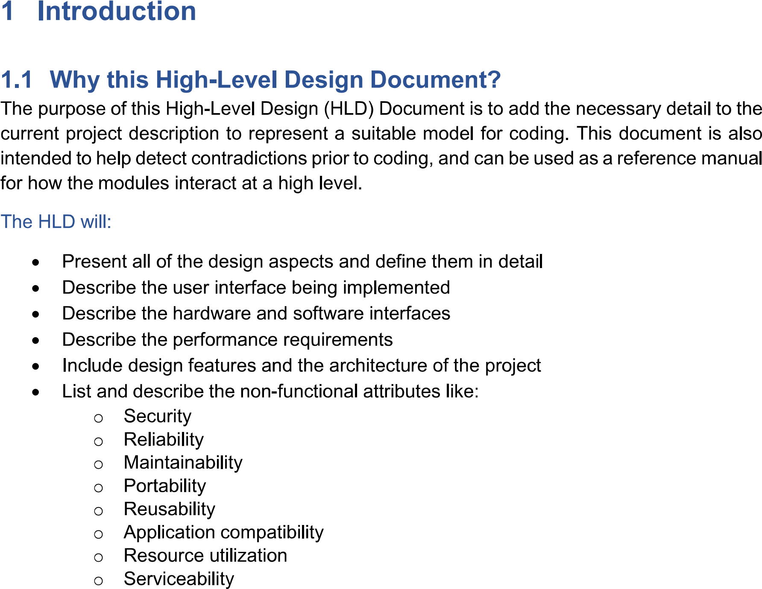

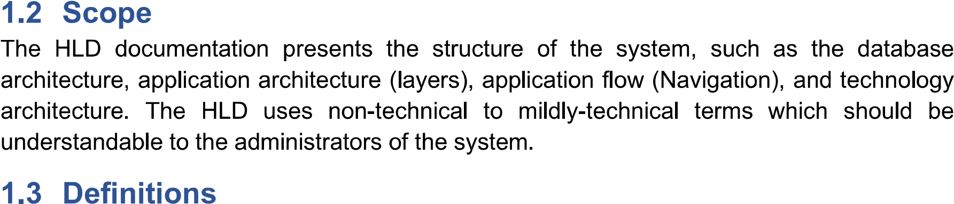

Term

|  |  |
| --- | --- |
| Term | Description |
| BMS | Big Mart sale |
| Database | Collection of all the information monitored by this system |
| IDE | Integreated Development Environment |

2. General Description

2.1 Product perspective

The BMS prediction is a Machine learning based prediction model which will help us to predict the sale of a shop.

2.2 Problem statement

To Create an Ml solution using ML algorithm and to implement the following use cases:

* To predict a specific shop sale.
* To know how the prerameter change can effect on shop sale.

2.3 Proposed solution

The solution proposed here is an ML algorithm based prediction model. First using the previous data we will analysis the data and chose a Machine learning model. After that we will ask input from the user and give to the model and model will predict the shop sale.

2.4 Further Improvements

We can add others new store data or previous shore new data set and using that our ML model can train more and give us a more good accuracy.

2.5 Data requirement

Data will require of chain of some shop and their shop and product data.

2.6 Tools used

Python programing language and frameworks such as numpy,seaborn,matplotlib,pandas,scikit-learn.

* VS code is used as IDE
* For visualization of the plot,Matplotlib,seaborn are used.
* Front end development is done using Html,CSS
* Python Flask is used as a framework

2.7 Constraints

The system must be user friendly, more accurated as possible.

3. Design details.

We will use ML model for prediction.

Collect dataset > Training/Validation on Dateset > Prediction

4. Performance

The system will used for the store sales prediction.so it can effect the real earning of the shop if model doesn’t give good prediction.So model have to give good performance.

4.1 Resuability

The code written and the components used should have the ability to be reused with no problems.

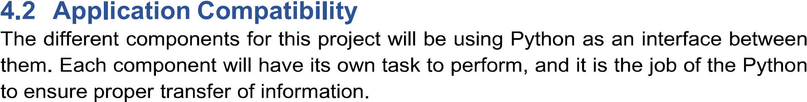\

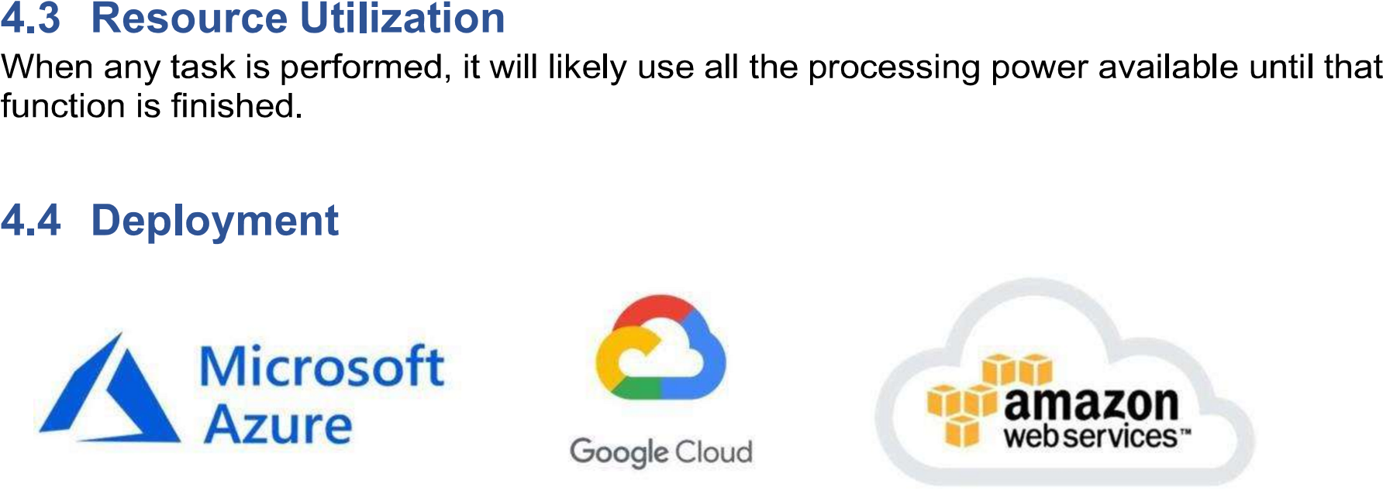

5. Dashboards

Deshboards will be implemente to display and indicate certain KPIs and relavant indicators for the uneiled problem that if not addressed in time could cause catastrophes of unimanginable impact.

6. Conclusion:

The Model will predect the bigmarl sale using the previoues data.And it will help the Bigmart chain to properly increase their sale.