Low Level Design (LLD)

**Bigmart sale prediction**

Last date of revision:

Showmick guha paul

**Contents**

[**Abstract**](https://docs.google.com/document/d/1RXbk3vCLueOtVfSIfenHxT5gXqnZMmzW/edit#heading=h.30j0zll)

1. Introduction

[1.1 Why this Low-Level Design Document?](https://docs.google.com/document/d/1RXbk3vCLueOtVfSIfenHxT5gXqnZMmzW/edit#heading=h.3znysh7)

[1.2 Scope](https://docs.google.com/document/d/1RXbk3vCLueOtVfSIfenHxT5gXqnZMmzW/edit#heading=h.2et92p0)

[1.3 Constraints](https://docs.google.com/document/d/1RXbk3vCLueOtVfSIfenHxT5gXqnZMmzW/edit#heading=h.tyjcwt)

[1.4 1.3 Risks](https://docs.google.com/document/d/1RXbk3vCLueOtVfSIfenHxT5gXqnZMmzW/edit#heading=h.3dy6vkm)

[1.5 1.4 Out of Scope](https://docs.google.com/document/d/1RXbk3vCLueOtVfSIfenHxT5gXqnZMmzW/edit#heading=h.1t3h5sf)

[2 Technical specifications](https://docs.google.com/document/d/1RXbk3vCLueOtVfSIfenHxT5gXqnZMmzW/edit#heading=h.4d34og8)

[2.1 Predicting Disease](https://docs.google.com/document/d/1RXbk3vCLueOtVfSIfenHxT5gXqnZMmzW/edit#heading=h.2s8eyo1)

[2.2 Logging](https://docs.google.com/document/d/1RXbk3vCLueOtVfSIfenHxT5gXqnZMmzW/edit#heading=h.17dp8vu)

[2.3 Database](https://docs.google.com/document/d/1RXbk3vCLueOtVfSIfenHxT5gXqnZMmzW/edit#heading=h.3rdcrjn)

[3 Technology stack](https://docs.google.com/document/d/1RXbk3vCLueOtVfSIfenHxT5gXqnZMmzW/edit#heading=h.26in1rg)

[4 Model training/validation workflow](https://docs.google.com/document/d/1RXbk3vCLueOtVfSIfenHxT5gXqnZMmzW/edit#heading=h.35nkun2)

[5 User I/O workflow](https://docs.google.com/document/d/1RXbk3vCLueOtVfSIfenHxT5gXqnZMmzW/edit#heading=h.1ksv4uv)

**Abstract:**

With the increased of urban people the number of shop are increasing at a rapid speed. Although As the population increase the possibility of sale of Big mart is increasing but the competition is also increasing. Therefore learning from the sale of Big mart is so important. By using ML model we can understand different sale pattern among the big mart shop and we can make prediction how much an big mart sale can be.

1. **Introduction**
   1. **Why this Low-Level Design Document?**

The purpose of this document is to present a detailed description of the Deep BMS System. It will explain the purpose and features of the system, the interfaces of the system, what the system will do, the constraints under which it must operate and how the system will react to external stimuli. This document is intended for both the stakeholders and the developers of the system and will be proposed to the higher management for its approval.

The main objective of the project is to identify what influence for a store more sale and predict the sale of a store. BMS stand for Big mart store sale record. BMS is nothing but a dataset of big mart sale.

BMS is a important for shop sale and can:

. Contain shop identifier, location, type, size , Establishment year.

. Contain item type, weight, type, fat content, visibility.

. Allow access to shop sale and it’s correlative data to make decision about how sale can increase or decrease with various feature. With the help of that analysis we can make prediction of a store.

An Big mart sale(BMS) contains store information such as:

| **Item_Identifier** | **Item_Weight** | **Item_Fat_Content** | **Item_Visibility** | **Item_Type** | **Item_MRP** | **Outlet_Identifier** | **Outlet_Establishment_Year** | **Outlet_Size** | **Outlet_Location_Type** | **Outlet_Type** | **Item_Outlet_Sales** |
| --- | --- | --- | --- | --- | --- | --- | --- | --- | --- | --- | --- |

This project shall be delivered in two phases:

Phase 1: All the functionalities with ML model.

Phase2: Integration of UI to all the functionalities

## Scope

This software system will be a Web application. This system will be designed to detect the sale price prediction of bigmart.

# Technical specifications

## 1 Dataset

## Big mart sale prediction

## source: https://www.kaggle.com/devashish0507/big-mart-sales-prediction

## 2.1.1 Diabetes dataset overview

## Contain a single table. Table contain of information about item and store. There

Are a total of 8523 train data , 5681 of test data.

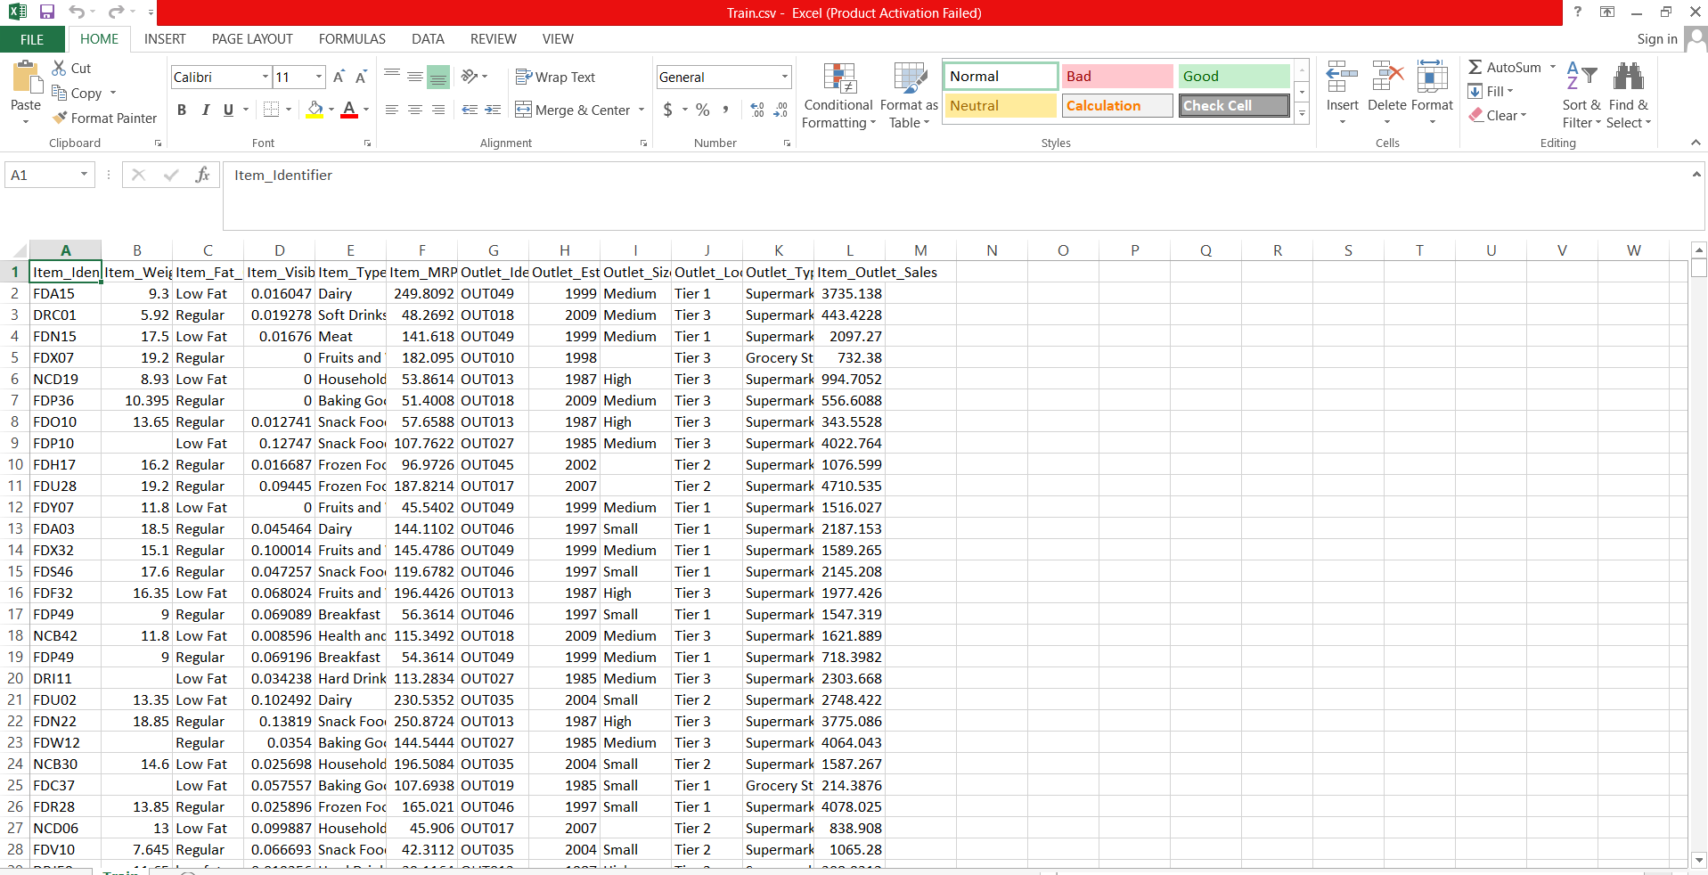

## 2.2 Predicting Disease

## * The system display item and shop information that need to enter.

## * The user inter the value of item and shop.

## * The system should be able to predict the sale of the store.

## 2.3 Logging

We should be able to log every activity done by the user.

* The System identifies at what step logging required
* The System should be able to log each and every system flow.
* Developers can choose logging methods. You can choose database logging/ File logging as well.
* System should not be hung even after using so many loggings. Logging just because we can easily debug issues so logging is mandatory to do.

## 2.4 Database

System needs to store every request into the database and we need to store it in such a way that it is easy to retrain the model as well..

 1.   The User gives required information.

1. The system stores each and every data given by the user or received on request to the database. Database you can choose your own choice whether MongoDB/ MySQL.

**2.5 Deployment**

1. Local

# Technology stack

|  |  |
| --- | --- |
| **Front End** | HTML/CSS |
| **Backend** | Python Flask |
| **Database** | - |
| **Deployment** | Local |

# Model training/validation workflow

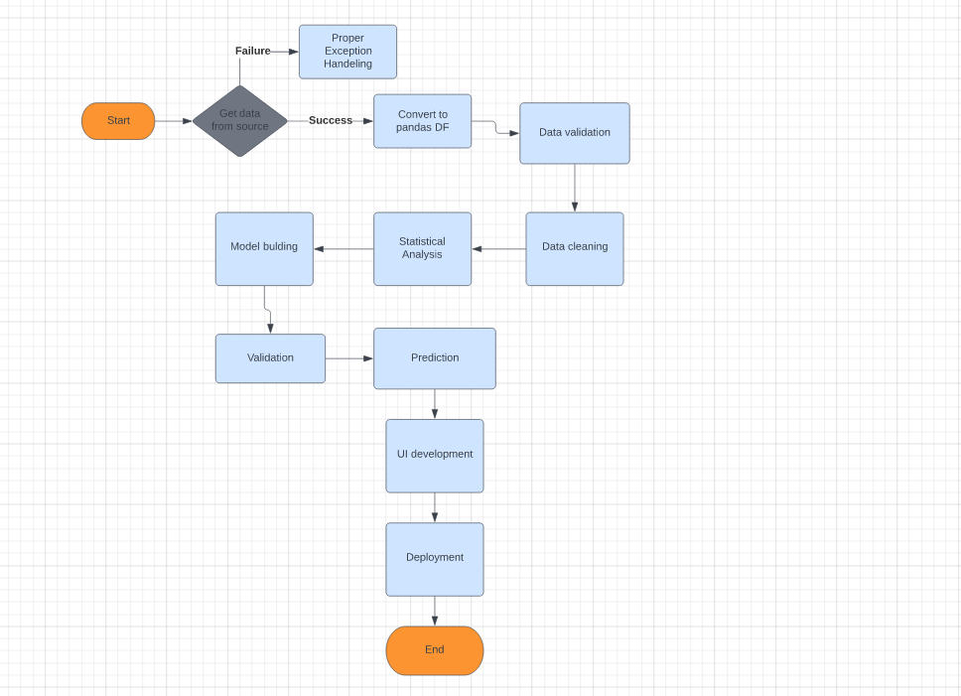

## User I/O workflow

## C:\Users\HP\PycharmProjects\Internship\Stores sale prediction\User I.O.png