Terraform

Provider and Resources

Overview of Providers:

Terraform supports multiple providers.

Depending on what type of infrastructure we want to launch, we have to use appropriate providers accordingly.

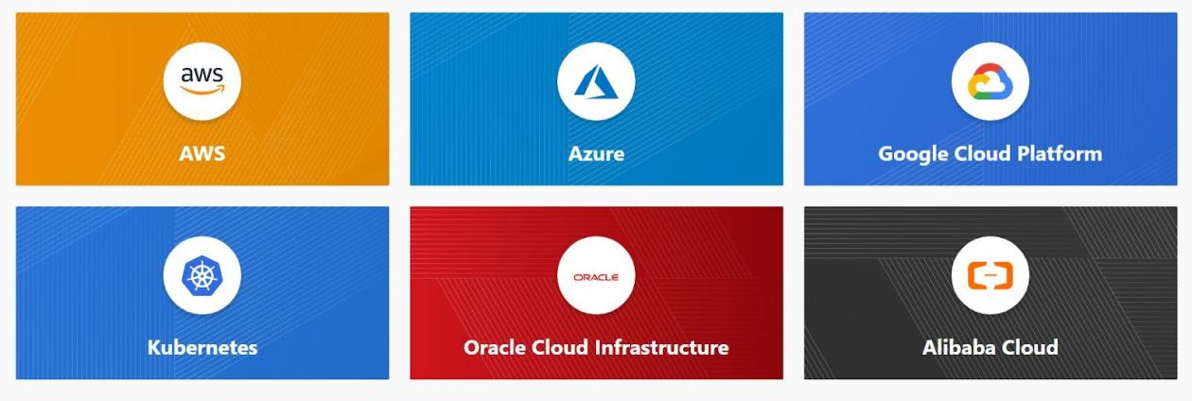

Overview of resources

Resources are the reference to the individual services which the provider has to offer

Example:
resource aws_instance
resource aws_alb
resource iam_user
resource digitalocean_droplet

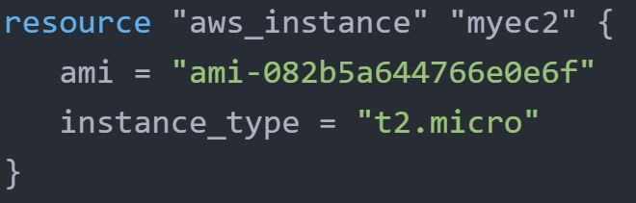

Write Phase
This is the phase where we write our terraform code into files with .tf extension.
Initialization Phase

Upon adding a provider, it is important to run terraform init which in-turn will download plugins associated with the provider.

Plan Phase

In this phase we plan to see what resources we want to create

Apply Phase

We issue the command to create resource.

Deploy EC2 Instance using Terraform

provider "aws" {
region = "us-west-2"
access_key = "PUT-YOUR-ACCESS-KEY-HERE"
secret_key = "PUT-YOUR-SECRET-KEY-HERE"
}

resource "aws_instance" "myec2" {
ami = "PUT AMI HERE"
instance_type = "t2.micro"
}

NOTE :

From 0.13 onwards, Terraform requires explicit source information for any providers that are not HashiCorp-maintained, using a new syntax in the required_providers nested block inside the Terraform configuration block

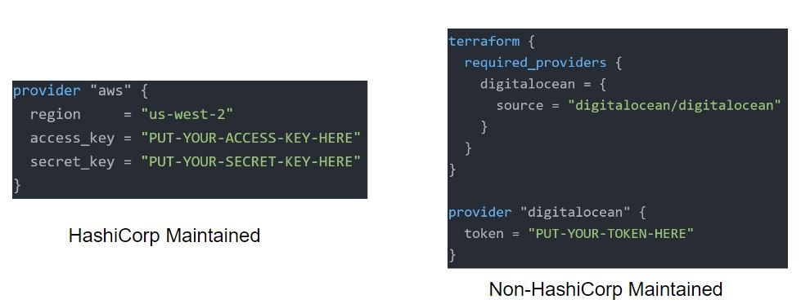

Destroying Infrastructure with Terraform (NEW)

If you keep the infrastructure running, you will get charged for it. Hence it is important for us to also know how we can delete the infrastructure resources created via terraform.

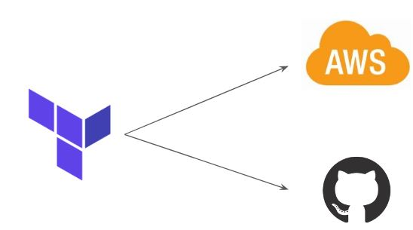

Approach 1

terraform destroy allows us to destroy all the resources that are created within the folder.

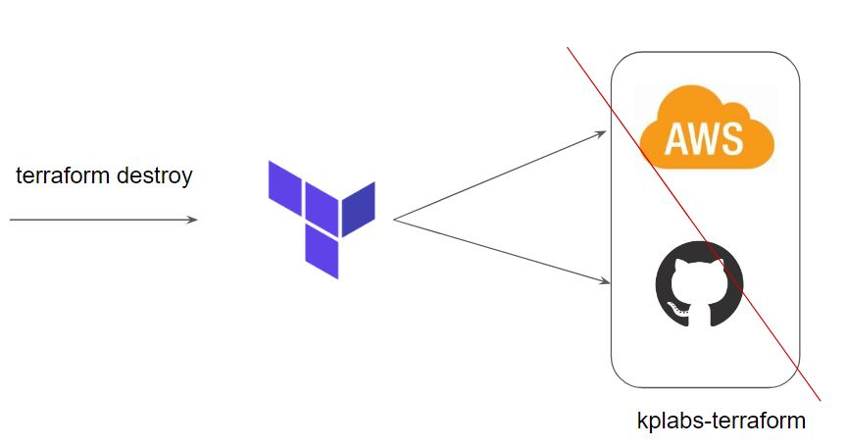

Approach 2

terraform destroy with -target flag allows us to destroy the specific resource.

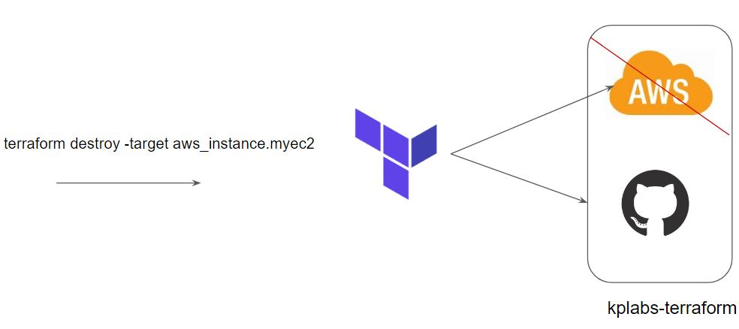

Terraform Destroy with Target

The -target option can be used to focus Terraform's attention on only a subset of resources.

Combination of: Resource Type + Local Resource Name

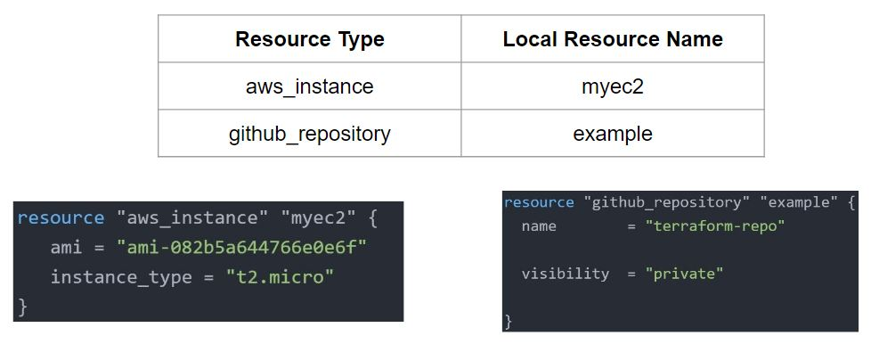

Terraform State File

Overview of State Files:

Terraform stores the state of the infrastructure that is being created from the TF files.

This state allows terraform to map real-world resources to your existing configuration.

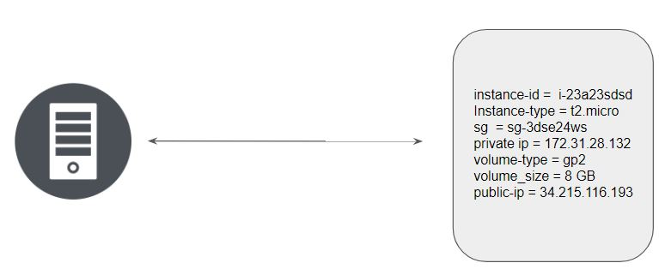

Multiple resources in Terraform will have a separate block with the state file.

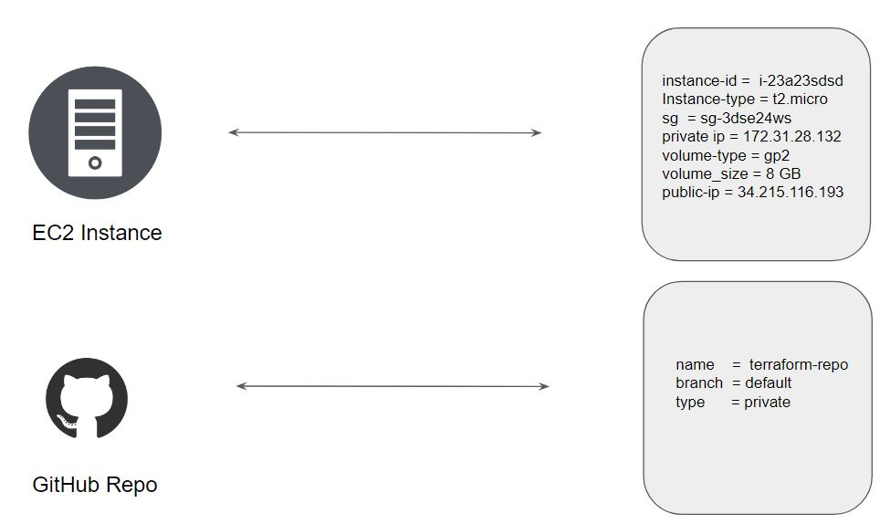

Whenever a resource is removed, its corresponding entry under the state file is also removed.

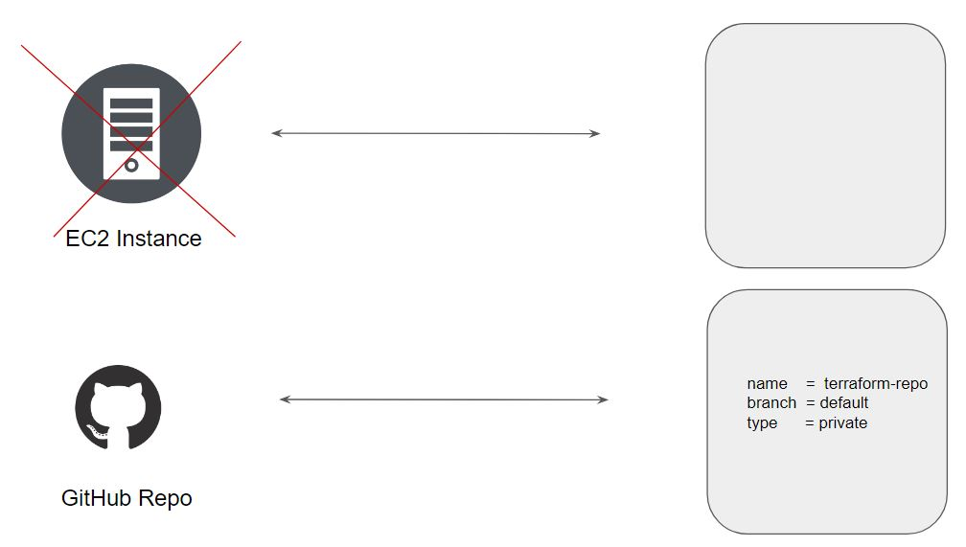

Desired & Current State

Desired State

Terraform's primary function is to create, modify, and destroy infrastructure resources to match the desired state described in a Terraform configuration

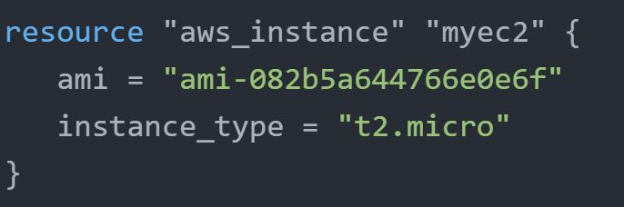

Current State

The current state is the actual state of a resource that is currently deployed.
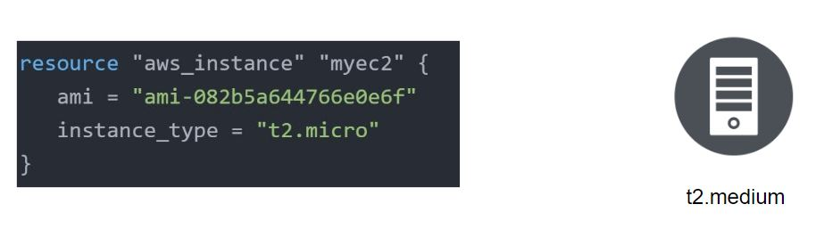
Important Pointer

Terraform tries to ensure that the deployed infrastructure is based on the desired state.

If there is a difference between the two, terraform plan presents a description of the changes necessary to achieve the desired state.

Provider Versioning

Overview of Provider Architecture

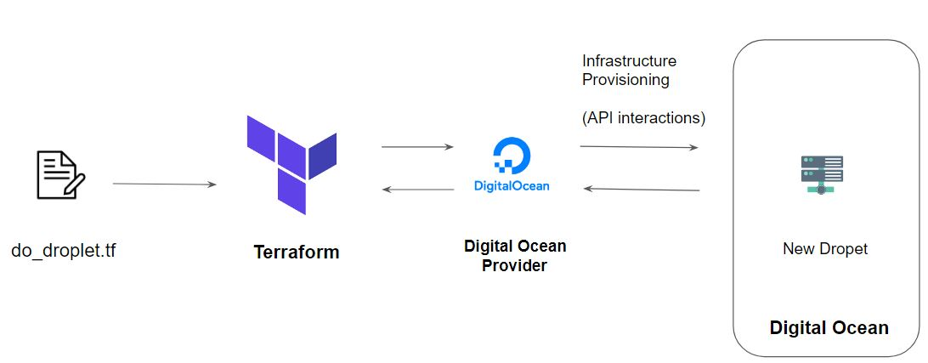

Provider Versioning

Provider plugins are released separately from Terraform itself.

They have a different set of version numbers.

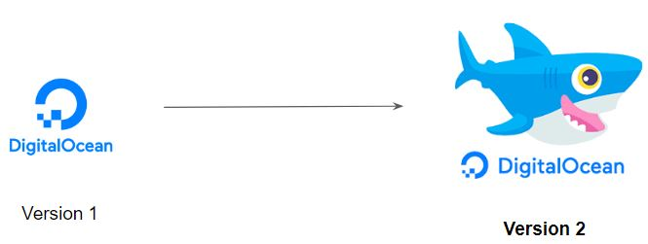
Explicitly Setting Provider Version

During terraform init, if the version argument is not specified, the most recent provider will be downloaded during initialization.

For production use, you should constrain the acceptable provider versions via configuration, to ensure that new versions with breaking changes will not be automatically installed

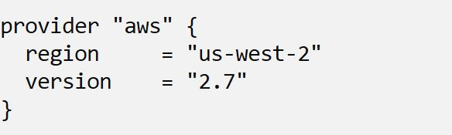

Arguments for Specifying the provider

There are multiple ways of specifying the version of a provider.

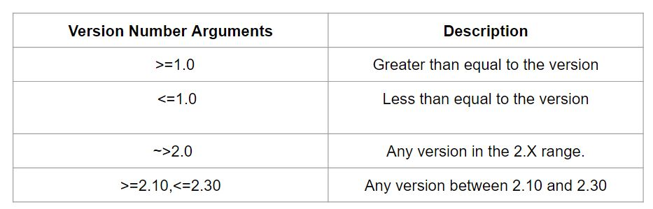

Terraform variables

Repeated static values can create more work in the future.

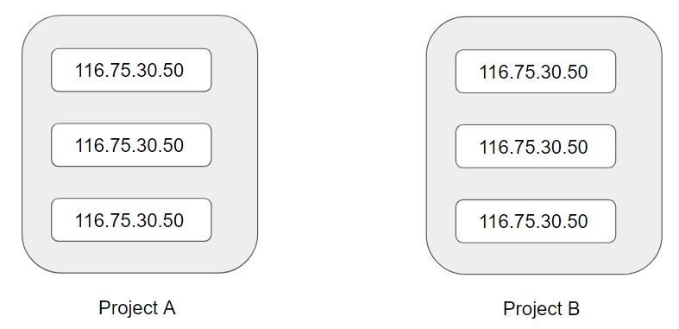

Terraform Variables allows us to centrally define the values that can be used in multiple terraform configuration blocks.

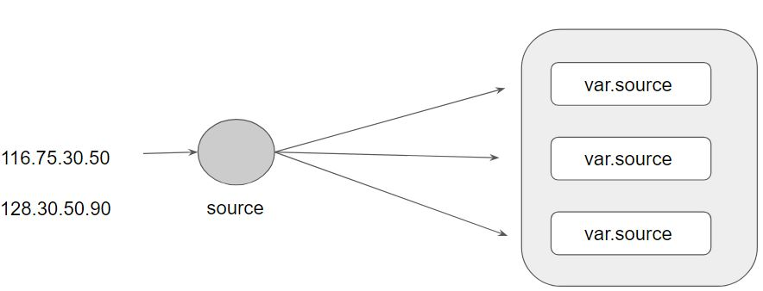

Approach for Variable Assignment

Variables in Terraform can be assigned values in multiple ways.

Some of these include:

Environment variables
Command Line Flags
From a File
Variable Defaults

Sample Commands for the following:

i) Environment Variables:

export TF_VAR_instancetype="t2.nano"
echo $TF_VAR

ii) Command Line Flags:

terraform plan -var="instancetype=t2.small"
terraform plan -var-file="custom.tfvars"

iii) From a File (terraform.tfvars):

instancetype="t2.large"

iv) Variable Defaults:

variable "instancetype" {
default = "t2.micro"
}

Data Types for Variables

Overview of Type Constraints

The type argument in a variable block allows you to restrict the type of value that will be accepted as the value for a variable

variable "image_id" {
type = string
}

If no type constraint is set then a value of any type is accepted.

Example Use-Case 1

Every employee in Medium Corp is assigned an Identification Number.

Any resource that an employee creates should be created with the name of the identification number only.

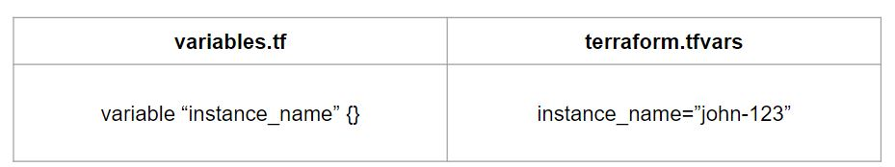

Example Use-Case 2

Every employee in Medium Corp is assigned an Identification Number.

Any EC2 instance that employee creates should be created using the identification number only.

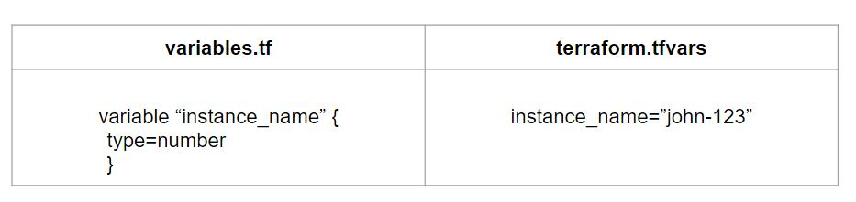
Overview of Data Types

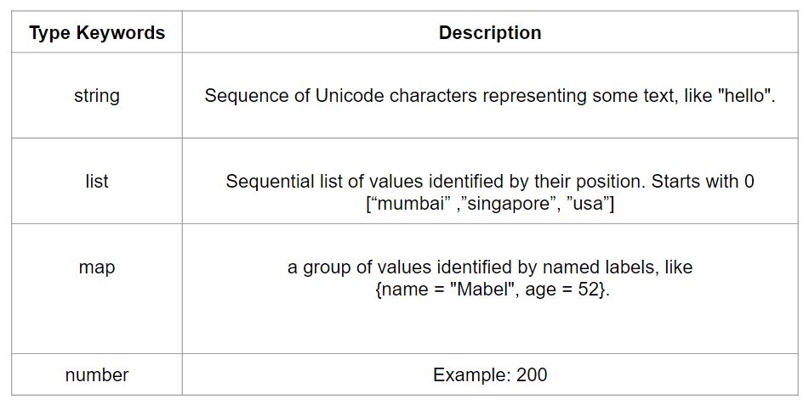

Count Parameter

Overview of Count:

The count parameter on resources can simplify configurations and let you scale resources by simply incrementing a number.

Let’s assume, you need to create two EC2 instances. One of the common approaches is to define two separate resource blocks for aws_instance.

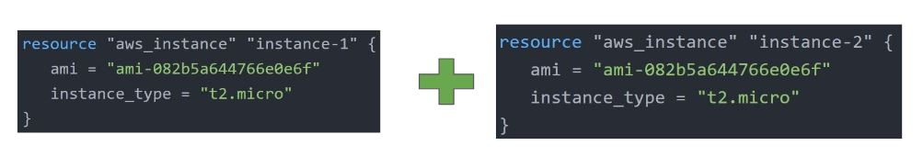

With the count parameter, we can simply specify the count value and the resource can be scaled accordingly.

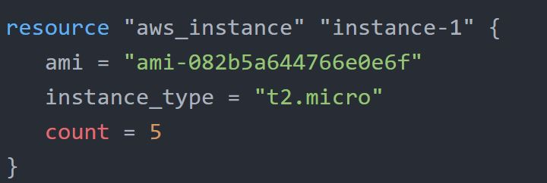

Count Index

In resource blocks where the count is set, an additional count object is available in expressions, so you can modify the configuration of each instance.

This object has one attribute:

count.index — The distinct index number (starting with 0) corresponding to this instance.

Challenges with Count Parameter

With the below code, terraform will create 5 IAM users. But the problem is that all will have the same name.

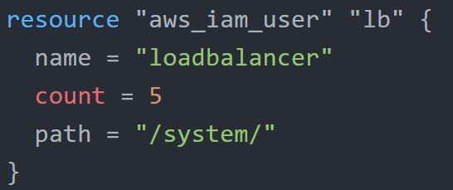

count.index allows us to fetch the index of each iteration in the loop.

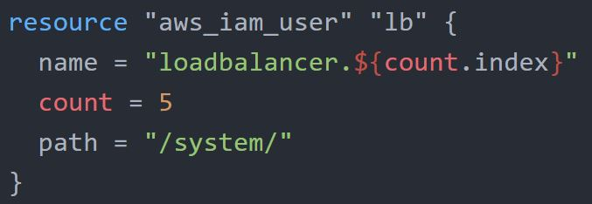

Understanding Challenge with Default Count Index

Having a username like loadbalancer0, loadbalancer1 might not always be suitable.

Better names like dev-loadbalancer, stage-loadbalancer, prod-loadbalancer is better.

count.index can help in such a scenario as well.

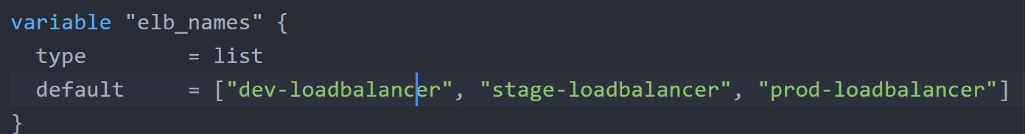

Conditional Expression

A conditional expression uses the value of a bool expression to select one of two values.

Syntax of Conditional expression:

condition ? true_val : false_val

If the condition is true then the result is true_val. If the condition is false then the result is false_val.

Let’s assume that there are two resource blocks as part of terraform configuration.

Depending on the variable value, one of the resource blocks will run.

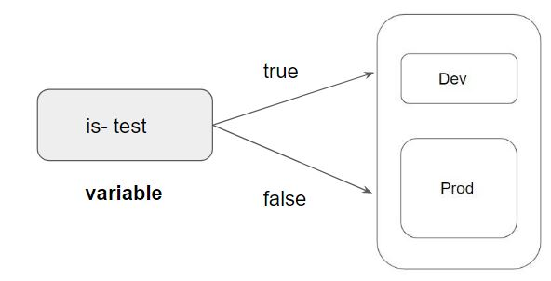

Local Values

A local value assigns a name to an expression, allowing it to be used multiple times within a module without repeating it.

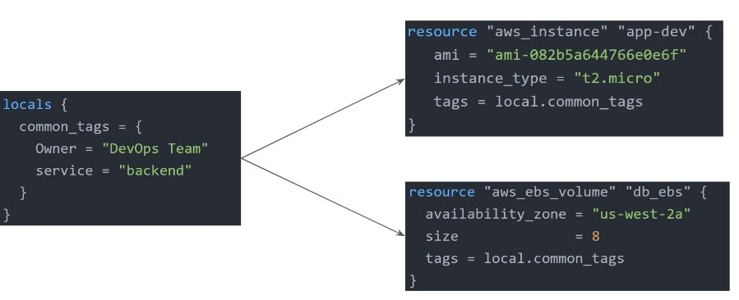

Local Values Support for Expression

Local Values can be used for multiple different use-cases like having a conditional expression.

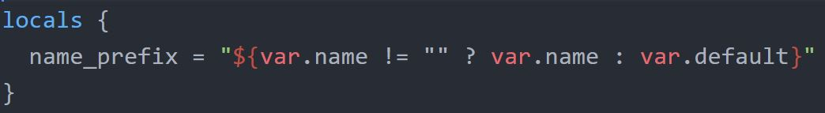

Important Pointers for Local Values:

Local values can be helpful to avoid repeating the same values or expressions multiple times in a configuration.

If overused they can also make a configuration hard to read by future maintainers by hiding the actual values used

Use local values only in moderation, in situations where a single value or result is used in many places and that value is likely to be changed in the future.

Terraform Functions

The Terraform language includes a number of built-in functions that you can use to transform and combine values.

The general syntax for function calls is a function name followed by comma-separated arguments in parentheses:

function (argument1, argument2)

Example:

> max(5, 12, 9)
12

The Terraform language does not support user-defined functions, and so only the functions built into the language are available for use

Numeric
String
Collection
Encoding
Filesystem
Date and Time
Hash and Crypto
IP Network
Type Conversion

Data Sources
Data sources allow data to be fetched or computed for use elsewhere in Terraform configuration.

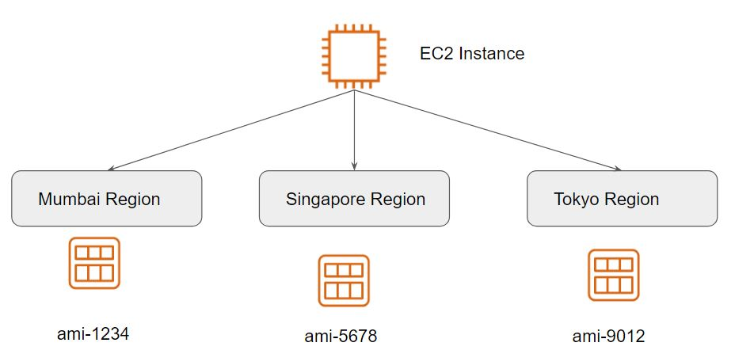

A data source is defined under the data block.

It reads from a specific data source (aws_ami) and exports results under “app_ami”

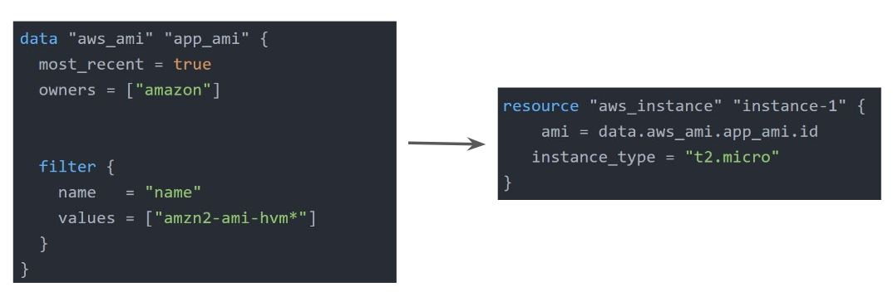

Debugging in Terraform
Terraform has detailed logs that can be enabled by setting the TF_LOG environment variable to any value.

You can set TF_LOG to one of the log levels TRACE, DEBUG, INFO, WARN or ERROR to change the verbosity of the logs

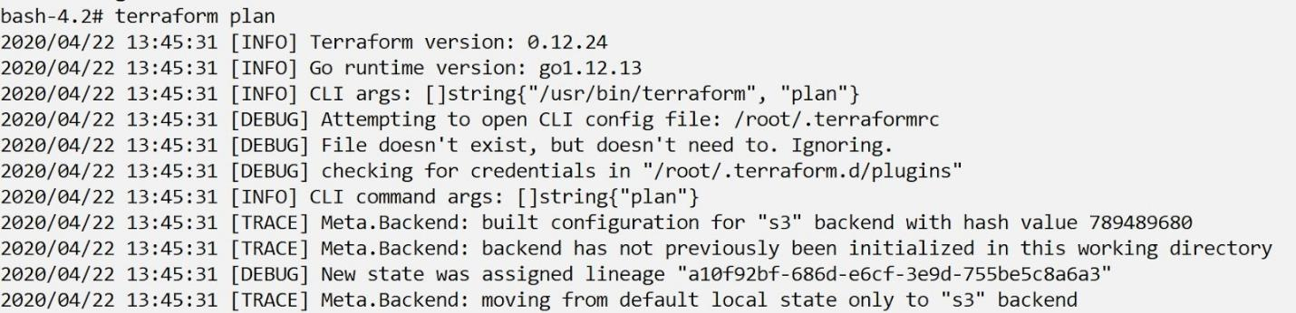

Important Pointers for Debugging:

TRACE is the most verbose and it is the default if TF_LOG is set to something other than a log level name.

To persist logged output you can set TF_LOG_PATH in order to force the log to always be appended to a specific file when logging is enabled.

Terraform Format

Anyone who is into programming knows the importance of formatting the code for readability.

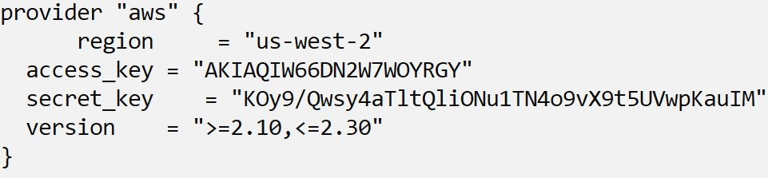

The terraform fmt command is used to rewrite Terraform configuration files to take care of the overall formatting

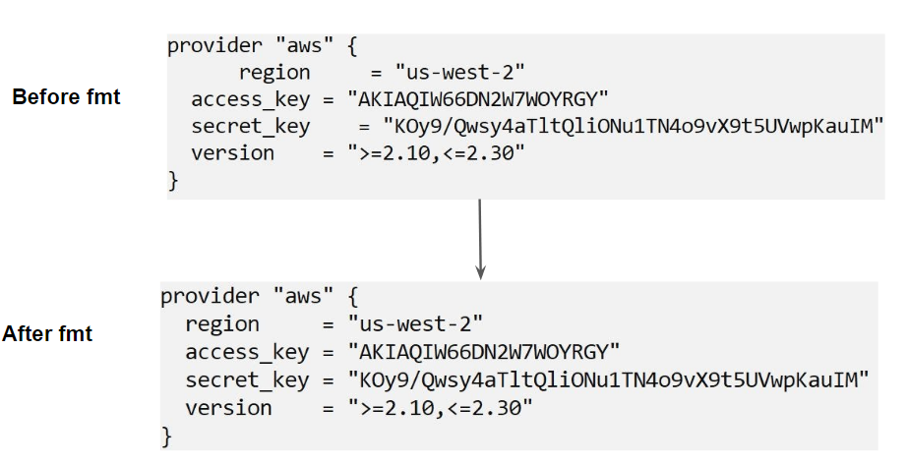

Terraform Validate

Terraform Validate primarily checks whether a configuration is syntactically valid.

It can check various aspects including unsupported arguments, undeclared variables, and others.

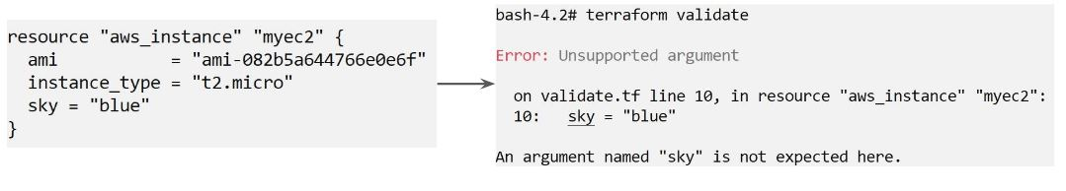

Load Order & Semantics

Terraform generally loads all the configuration files within the directory specified in alphabetical order.

The files loaded must end in either .tf or .tf.json to specify the format that is in use.

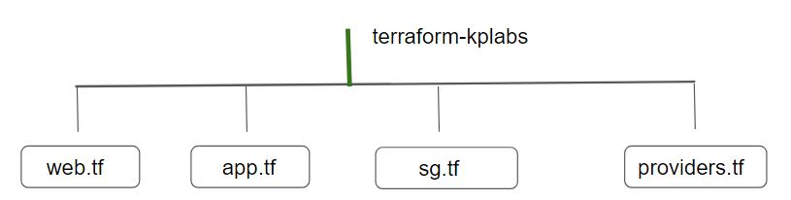

Dynamic Blocks

Understanding the Challenge:

In many of the use-cases, there are repeatable nested blocks that need to be defined.

This can lead to a long code and it can be difficult to manage in a long time.
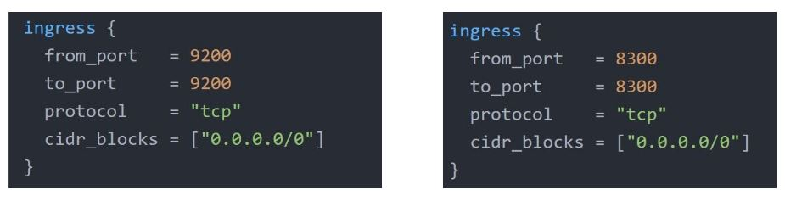
Overview of Dynamic Blocks

Dynamic Block allows us to dynamically construct repeatable nested blocks which is supported inside resource, data, provider, and provisioner blocks:

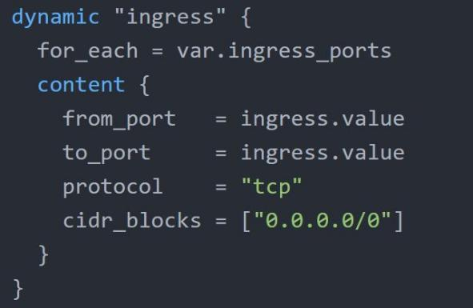

Overview of Iterators

The iterator argument (optional) sets the name of a temporary variable that represents the current element of the complex value

If omitted, the name of the variable defaults to the label of the dynamic block ("ingress" in the example above).

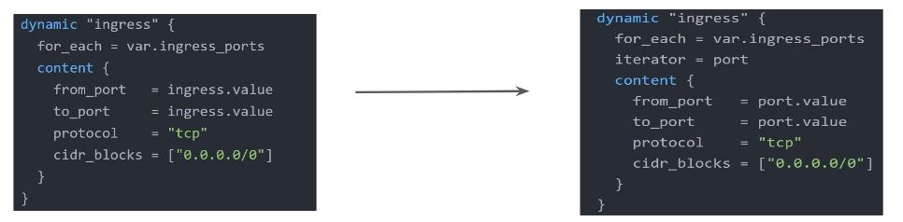

Terraform Taint

Understanding the Challenge:

You have created a new resource via Terraform.

Users have made a lot of manual changes (both infrastructure and inside the server)

Two ways to deal with this: Import The Changes to Terraform / Delete & Recreate the resource

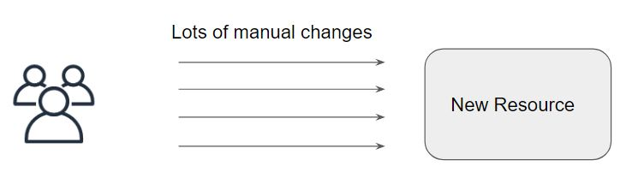

Overview of Terraform Taint

The terraform taint command manually marks a Terraform-managed resource as tainted, forcing it to be destroyed and recreated on the next apply.
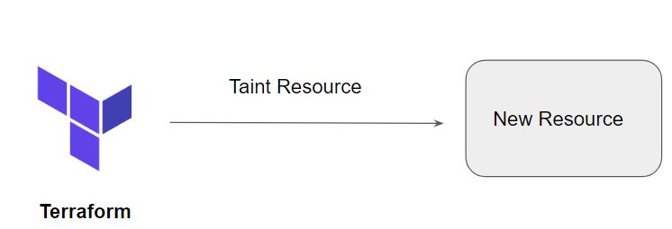

Important Pointers for Terraform Taint

This command will not modify infrastructure but does modify the state file in order to mark a resource as tainted.

Once a resource is marked as tainted, the next plan will show that the resource will be destroyed and recreated and the next apply will implement this change.

Note that tainting a resource for recreation may affect resources that depend on the newly tainted resource.

Splat Expression

Splat Expression allows us to get a list of all the attributes.

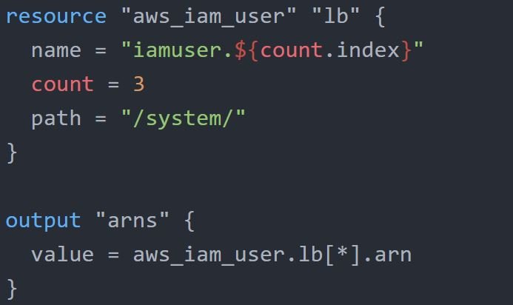

Terraform Graph

The terraform graph command is used to generate a visual representation of either a configuration or execution plan

The output of terraform graph is in the DOT format, which can easily be converted to an image.

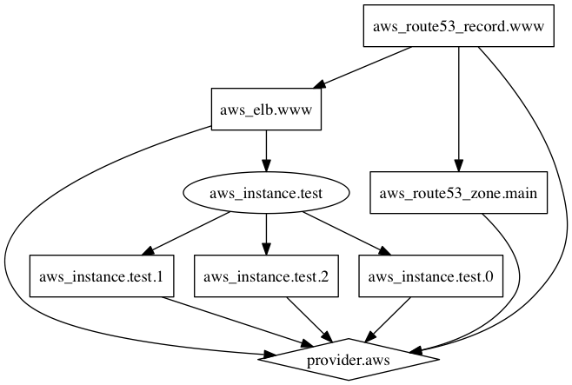
brew install graphviz
Then used the following command to convert .dot to .png
dot -Tpng DocName.dot -o DocName.png

Saving Terraform Plan to a File

The generated terraform plan can be saved to a specific path.

This plan can then be used with terraform apply to be certain that only the changes shown in this plan are applied.

Example:

terraform plan -out=path

Terraform Output

The terraform output command is used to extract the value of an output variable from the state file.

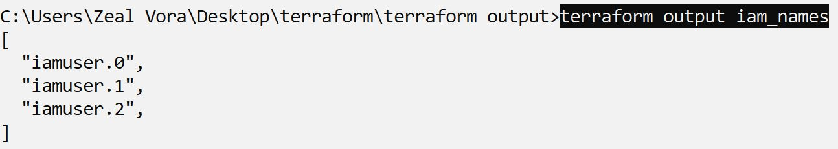

Terraform Settings

The special terraform configuration block type is used to configure some behaviors of Terraform itself, such as requiring a minimum Terraform version to apply your configuration.

Terraform settings are gathered together into terraform blocks:

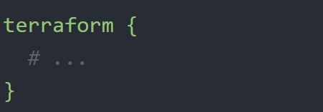

Terraform Version

The required_version setting accepts a version constraint string, which specifies which versions of Terraform can be used with your configuration.

If the running version of Terraform doesn't match the constraints specified, Terraform will produce an error and exit without taking any further actions.

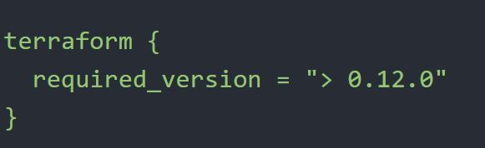

Provider Version

The required_providers block specifies all of the providers required by the current module, mapping each local provider name to a source address and a version constraint.

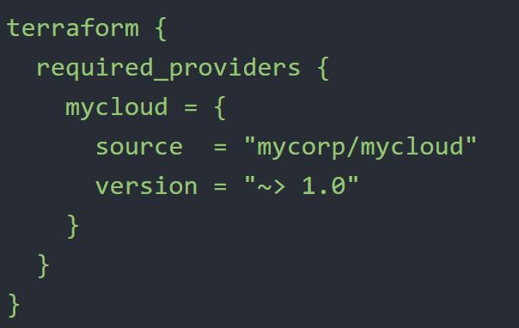

Dealing with Large Infrastructure

When you have a larger infrastructure, you will face issues related to API limits for a provider.

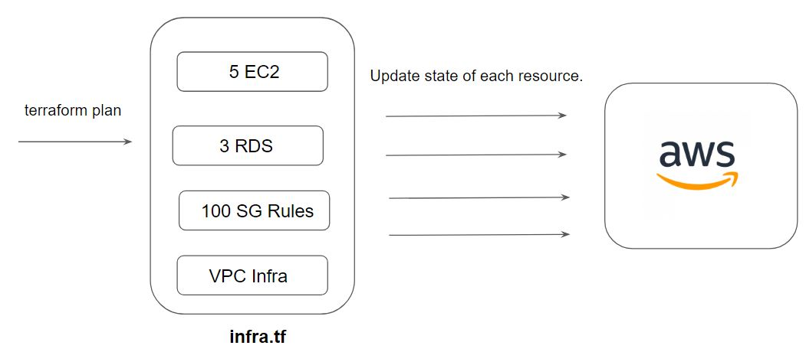

It is important to switch to a smaller configurations were each can be applied independently.

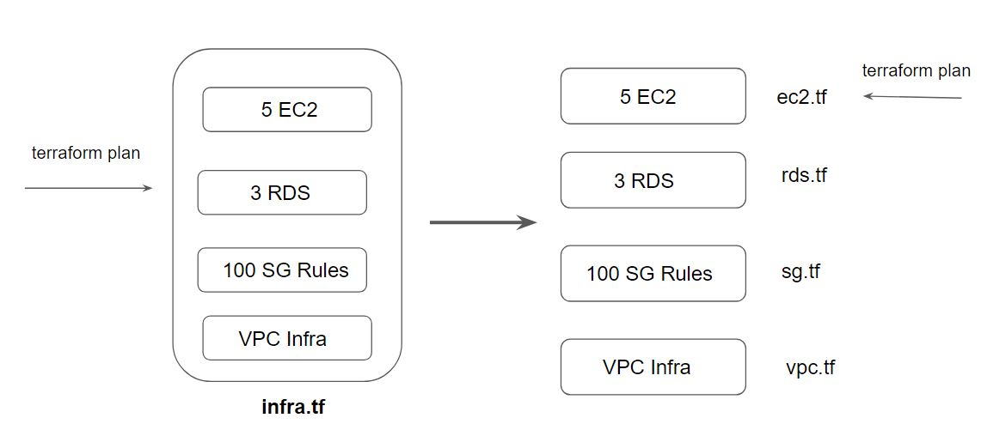

Setting Refresh to False

We can prevent terraform from querying the current state during operations like terraform plan.

This can be achieved with the -refresh=false flag

Specify the Target

The -target=resource flag can be used to target a specific resource.

Generally used as a means to operate on isolated portions of very large configurations

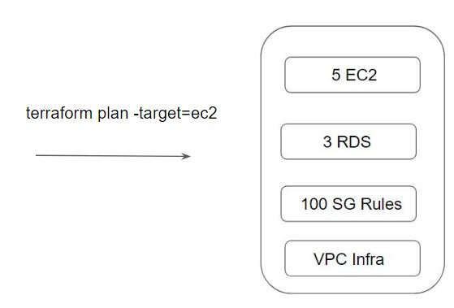

Zipmap Function

The zipmap function constructs a map from a list of keys and a corresponding list of values.

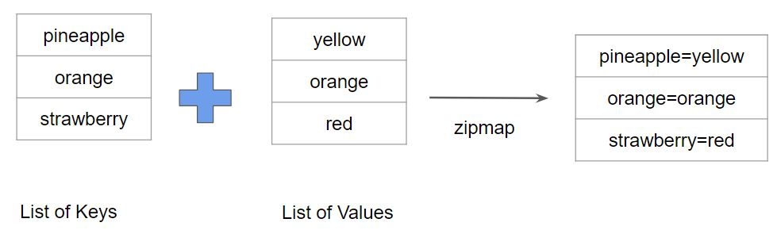

Following screenshot shows a sample output of Zipmap

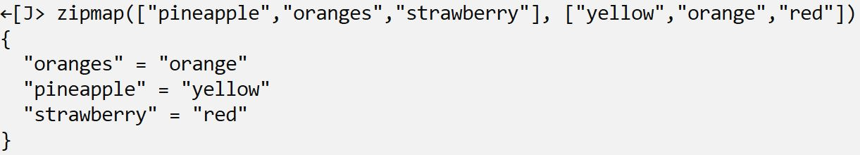

Let us understand Zipmap with a sample use-case

You are creating multiple IAM users.

You need output which contains direct mapping of IAM names and ARNs

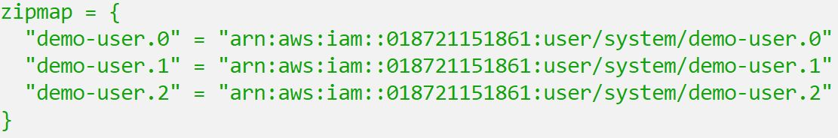

Provisioners
Module 1: Understanding Provisioners in Terraform

Till now we have been working only on the creation and destruction of infrastructure scenarios.

Let’s take an example:

We created a web-server EC2 instance with Terraform.

Problem: It is only an EC2 instance, it does not have any software installed.

What if we want a complete end to end solution?

Introducing Terraform Provisioners

Provisioners are used to execute scripts on a local or remote machine as part of resource creation or destruction.

Let’s take an example:

On creation of Web-Server, execute a script which installs Nginx web-server.

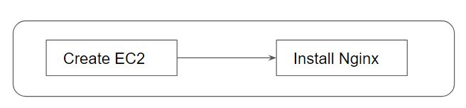

Module 2: Types of Provisioners

Terraform has the capability to turn provisioners both at the time of resource creation as well as destruction.

There are two main types of provisioners:

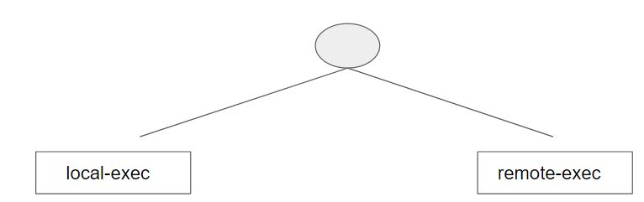

2.1 Local Exec Provisioners

local-exec provisioners allow us to invoke a local executable after the resource is created.

One of the most used approaches of local-exec is to run ansible-playbooks on the created server after the resource is created.

Let’s take an example:

provisioner "local-exec" {
command = "echo ${aws_instance.web.private_ip} >> private_ips.txt"
}

2.2 Remote Exec Provisioners

Remote-exec provisioners allow invoking scripts directly on the remote server.

Let’s take an example:

resource "aws_instance" "web" {
# …

provisioner "remote-exec" {
…………………………...
}
}

Module 3: Provisioner Types

There are two primary types of provisioners:

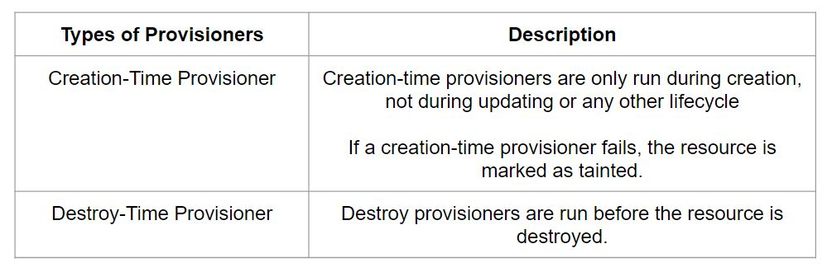

If when = destroy is specified, the provisioner will run when the resource it is defined within is destroyed.

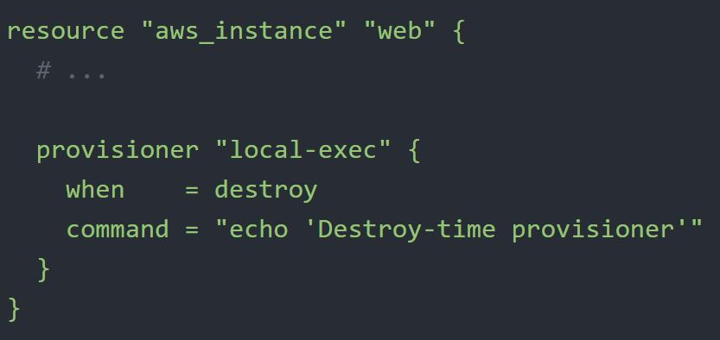

Module 4: Failure Behavior

By default, provisioners that fail will also cause the terraform apply itself to fail.

The on_failure setting can be used to change this. The allowed values are:

Terraform Modules & Workspaces

Module 1: Understanding the DRY principle

In software engineering, don't repeat yourself (DRY) is a principle of software development aimed at reducing repetition of software patterns.

In the earlier lecture, we were making static content into variables so that there can be a single source of information.

1.1 Generic Scenario:

We do repeat multiple times various terraform resources for multiple projects.

Sample EC2 Resource

resource "aws_instance" "myweb" {
ami = "ami-bf5540df"
instance_type = "t2.micro"
security_groups = ["default"]
}
Instead of repeating a resource block multiple times, we can make use of a centralized structure.

1.2 Centralized Structure:

We can centralize the terraform resources and can call out from TF files whenever required.

Module 2: Challenges with Terraform Modules

One common need for infrastructure management is to build environments like staging, production with a similar setup but keeping environment variables different.

When we use modules directly, the resources will be a replica of code in the module.

Module 3: Terraform Registry

The Terraform Registry is a repository of modules written by the Terraform community.

The registry can help you get started with Terraform more quickly

3.1 Module Location

If we intend to use a module, we need to define the path where the module files are present.

The module files can be stored in multiple locations, some of these include:
Local Path
GitHub
Terraform Registry
S3 Bucket
HTTP URLs

3.2 Verified Modules in Terraform Registry

Within Terraform Registry, you can find verified modules that are maintained by various third-party vendors.

These modules are available for various resources like AWS VPC, RDS, ELB, and others

Verified modules are reviewed by HashiCorp and actively maintained by contributors to stay up-to-date and compatible with both Terraform and their respective providers.

The blue verification badge appears next to modules that are verified.

Module verification is currently a manual process restricted to a small group of trusted HashiCorp partners.

3.3 Using Registry Modules in Terraform

To use Terraform Registry module within the code, we can make use of the source argument that contains the module path.

Below code references to the EC2 Instance module within terraform registry.

module "ec2-instance" {
source = "terraform-aws-modules/ec2-instance/aws"
version = "2.13.0"
# insert the 10 required variables here
}

Module 4: Terraform Workspace

Terraform allows us to have multiple workspaces, with each of the workspaces we can have a different set of environment variables associated

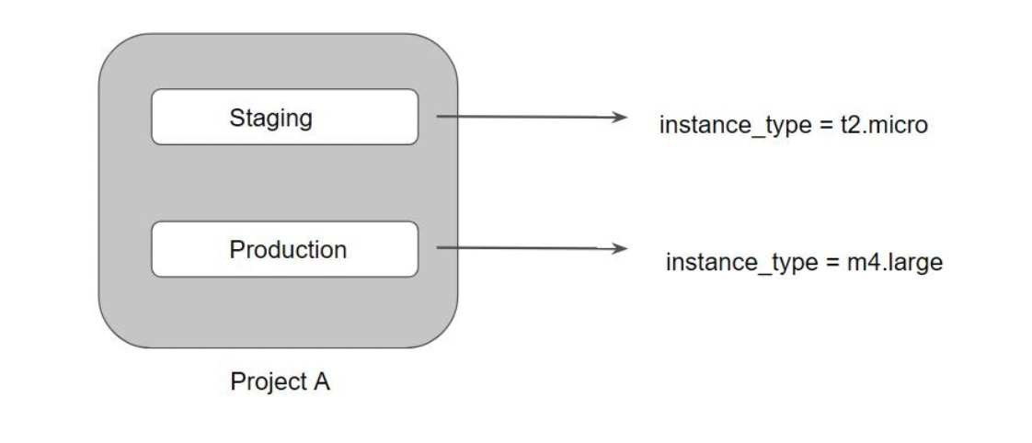

Terraform starts with a single workspace named "default".

This workspace is special both because it is the default and also because it cannot ever be deleted.

If you've never explicitly used workspaces, then you've only ever worked on the "default" workspace.

Workspaces are managed with the terraform workspace set of commands.

To create a new workspace and switch to it, you can use terraform workspace new; to switch workspaces you can use terraform workspace select; etc.

Terraform Cloud & Enterprise Capabilities

Module 1: Overview of Terraform Cloud

Terraform Cloud manages Terraform runs in a consistent and reliable environment with various features like access controls, private registry for sharing modules, policy controls, and others.

Terraform Cloud is available as a hosted service at https://app.terraform.io.

Module 2: Overview of Sentinel
Sentinel is an embedded policy-as-code framework integrated with the HashiCorp Enterprise products.

It enables fine-grained, logic-based policy decisions, and can be extended to use information from external sources.

Note: Sentinel policies are paid feature

Module 3: Remote Backends

Terraform supports various types of remote backends which can be used to store state data.

As of now, we were storing state data in local and GIT repository.

Depending on remote backends that are being used, there can be various features.
Standard BackEnd Type: State Storage and Locking
Enhanced BackEnd Type: All features of Standard + Remote Management

When using full remote operations, operations like terraform plan or terraform apply can be executed in Terraform Cloud's run environment, with log output streaming to the local terminal.

Remote plans and applies use variable values from the associated Terraform Cloud workspace.

Terraform Cloud can also be used with local operations, in which case only state is stored in the Terraform Cloud backend.

