**Title: Familiarization with microcontroller, study of blink test using and implementation of a traffic control system using microcontrollers (1)**

**1. Cover page:**

**2. Objective:**

A microcontroller is a compact integrated circuit designed to govern a specific operation in an embedded system. A typical microcontroller includes a processor, memory, and input/output (I/O) peripherals on a single chip. Microcontrollers are used in automatically controlled products and devices, such as automobile engine control systems, implantable medical devices, remote controls, office machines, appliances, power tools, toys, and other embedded systems. To accomplish the task with a microcontroller, it is certainly required to use C/C++ and assembly language. Some microcontrollers may use four-bit words and operate at frequencies as low as 4 kHz, for low power consumption. The microcontroller is a compressed microcomputer manufactured to control the functions of embedded systems in office machines, robots, home appliances, motor vehicles, and several other gadgets. A microcontroller has components like - memory, peripherals, and most importantly a processor.

**3. The apparatus and software name:**

* Arduino IDE (any version)
* Arduino Uno (R3) board or Arduino mega 2560 board
* LED lights (RED, GREEN, and YELLOW) and three 200 ohms resistors and jumper wires
* Breadboard

**4. Theory and programs:**

An Arduino is an open hardware development board that can be used by tinkerers, hobbyists, and makers to design and build devices that interact with the real world. While Arduino refers to a specific type of board design, it can also be used to refer to a company that manufactures a specific implementation of these boards and is typically also used to describe the community around compatible boards made by other people or companies which function in a similar way. Arduino consists of both a programmable microcontroller and a piece of software, or IDE (Integrated Development Environment) that runs on your computer, used to write and upload computer code to the microcontroller board. Arduino Uno also does not need a hardware circuit (programmer/ burner) to load a new code into the board. We can easily load a code into the board just using a USB cable and the Arduino IDE (which uses an easier version of C++ to write a code).

**5. A brief procedure:**

* First we familiarized with the different type Arduino family components. Arduino UNO Microcontroller is one of them.
* After that, we know the basic working principle of linkercad software.
* At first we need to open linkercad online software to implement the given circuit. Then we select different type of components to implement it.
* Next we write the code to run traffic light system.
* After that we implements the circuit in the bread board and connect this experiment in the hardware.

6. **Label each program while adding the pictures/screenshots of programs from arduinoIDE/STMcubeIDE the experiments. Label the pictures of hardware results after every lab task within experiments.**

**Code:**

void setup() {

// pin connections for the LED lights

pinMode(8,OUTPUT);

pinMode(10,OUTPUT);

pinMode(12,OUTPUT);

}

void loop() {

// turning on voltage at output 8(for red LED)

digitalWrite(8,HIGH);

delay(3000); // red LED is on

// turning on voltage at output 8(for red LED)

digitalWrite(10,HIGH);

delay(1000); // yellow LED is on

//for turning off red and yellow and turning on green

digitalWrite(8,LOW);

digitalWrite(10,LOW);

digitalWrite(12,HIGH);

delay(3000);

digitalWrite(12,LOW); //green is off for blinking next

//to make green on and off for 3 times

delay(500);

digitalWrite(12,HIGH);

delay(500);

digitalWrite(12,LOW);

delay(500);

digitalWrite(12,HIGH);

delay(500);

digitalWrite(12,LOW);

delay(500);

digitalWrite(12,HIGH);

delay(500);

digitalWrite(12,LOW);

//to turn yellow on once

digitalWrite(10,HIGH);

delay(1000);

digitalWrite(10,LOW);

}

Simulation:







Lab Simulation:

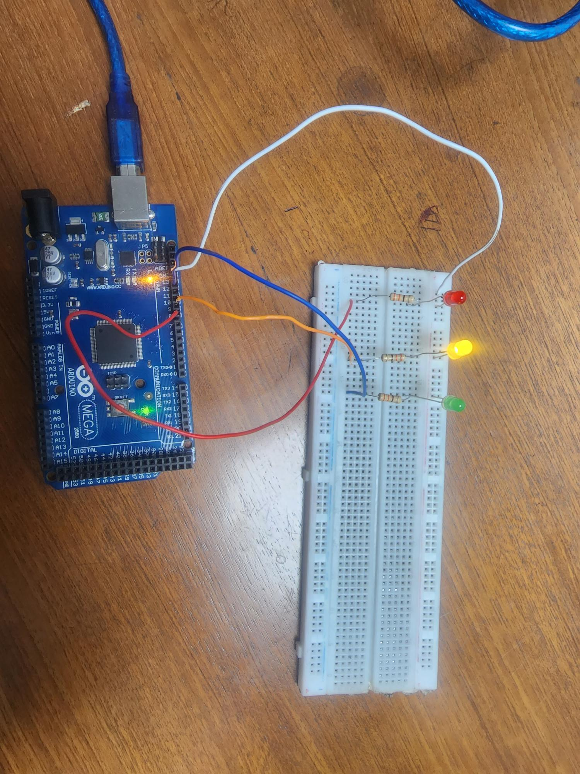

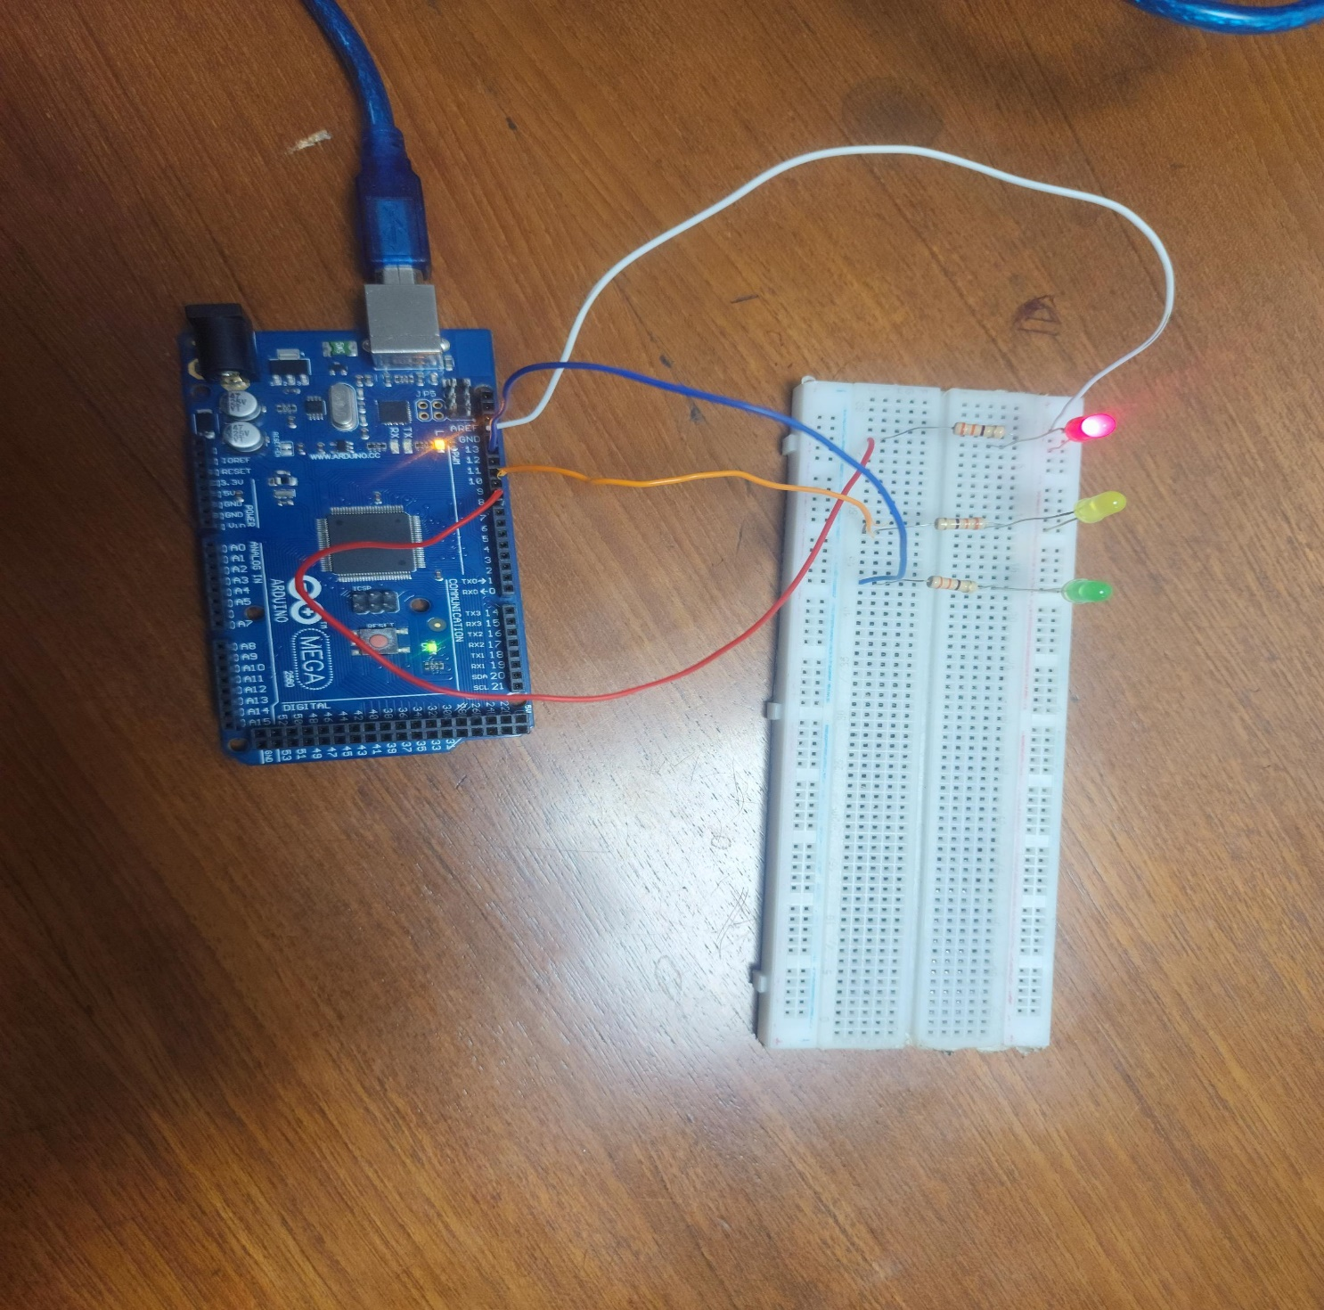

**7. Each lab report should contain the answers of the questions in report writing section assigned at the very end of every lab manual. (simulation analysis as per lab manual).**

**8. Discussions:**

We decided to start a blink test while implementing a traffic control system in this experiment. As a result, we go thinkercard.com and created an account using our Google account, and then we clicked on the new build circuit option, which brought up a new window. Then, from the basic components box, all of the components (Arduino Uno R3, Breadboard, 3 Resistor 220-ohm, RED LED, Yellow LED, and GREEN LED) were dragged and set in the right operating order. Then we made sure that all of the components were correctly connected. We moved on to the code writing step when we completed the circuit correctly. Because code authoring was critical to the system's operation, the system would not function properly without it.

**9. Conclusions:**

Microcontrollers were learned while working on this experiment, and an Arduino Uno traffic control system was developed. Our course instructor explained the entire procedure and guided us through it so that we could properly run this code. Working with Arduino for the first time was difficult at first, but it became easier with time. However, with the assistance of our tutor, the code was eventually properly executed. As a result, we were able to finish our report.