**ChatBot**

**With**

**DL and NLP**

**Contents:**

* ChatBot’s Definition
* Popular ChatBot
* Learning Issues
* Implementation Weapon/language
* NLP and DL definition
* Various Types of NLP models
* Use SEQ2SEQ model for this ChatBot
* Data Pre-processing
* Building ChatBot Architecture
* Training ChatBot
* Testing ChatBot
* Benefits of using ChatBot
* Limitation of using ChatBot

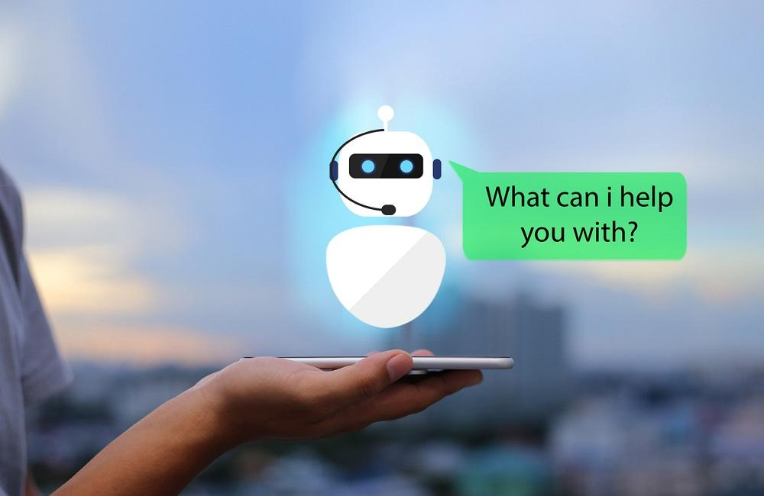

**Popular ChatBot:**

* Alexa
* Cortana
* Siri
* Google Assistant
* And many others

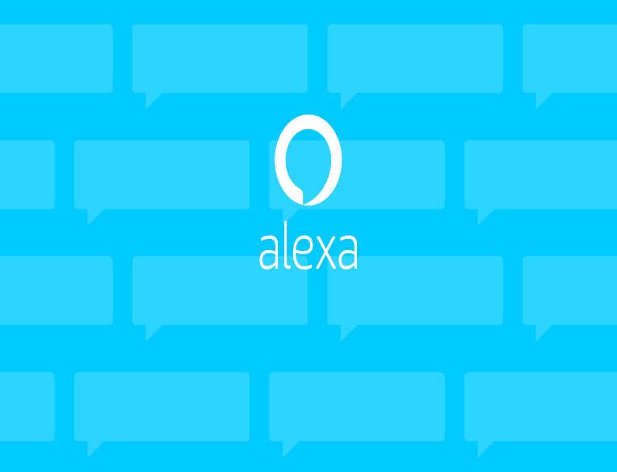

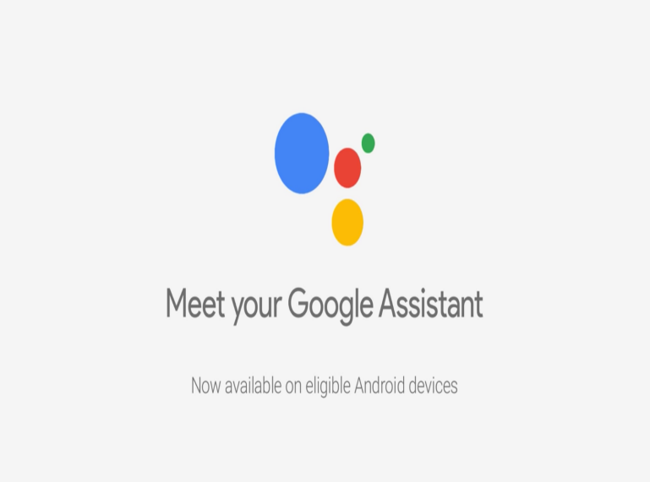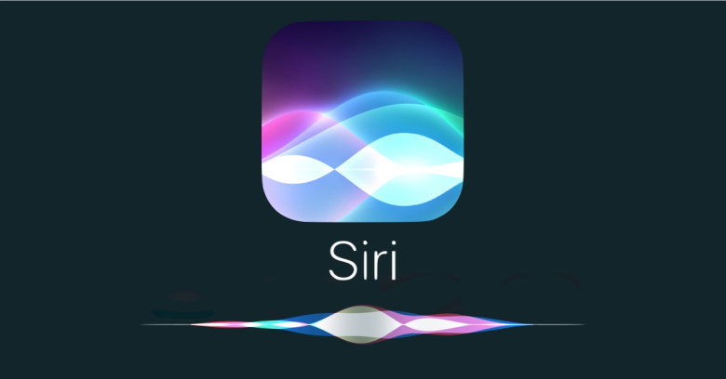

**Deep Learning and NLP Chatbot Development**

**What is ChatBot:**

A chatbot is an artificial intelligence (AI) software that can simulate a conversation (or a chat) with a user in natural language through messaging applications, websites, and mobile apps or through the telephone.

**What I’ll learn:**

All over we will make a Conversation Chatbot.

* Types of Natural Language Processing
* Classical vs. Deep Learning Models
* Bag-of-Words Model
* End to End Deep Learning Models
* Seq2Seq Architecture & Training
* Beam Search Decoding

**Weapons:**

* Conversation used from Cornell movie dialogue
* Python
  + Tensorflow
  + Numpy
  + Regular Expression
  + Pandas
* Basic Mathematics

**Natural language processing(NLP):**

Natural language processing (NLP) is a subfield of computer science, information engineering, and artificial intelligence concerned with the interactions between computers and human (natural) languages, in particular how to program computers to process and analyze large amounts of natural language data.

**Deep learning:**

Deep learning (also known as deep structured learning or hierarchical learning) is part of a broader family of machine learning methods based on artificial neural networks. Learning can be supervised, semi-supervised or unsupervised.

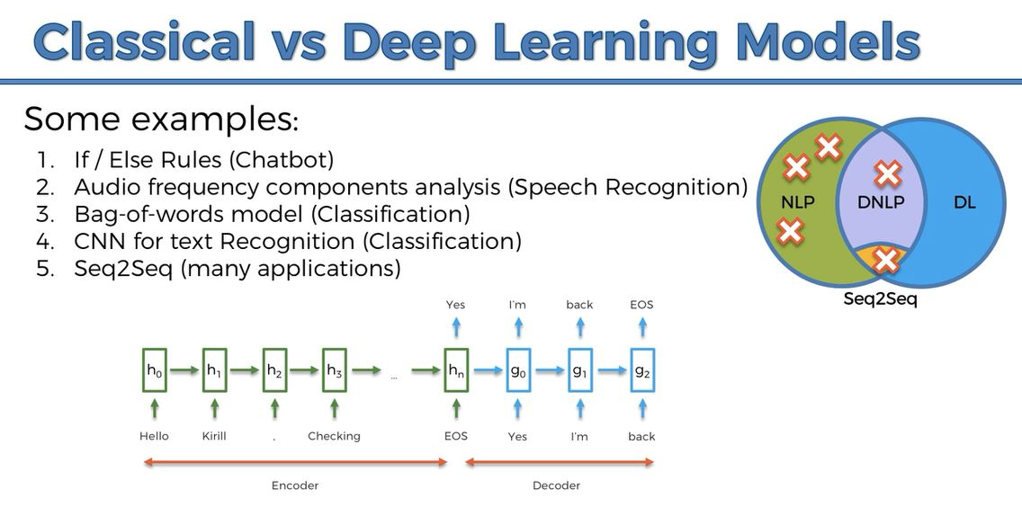

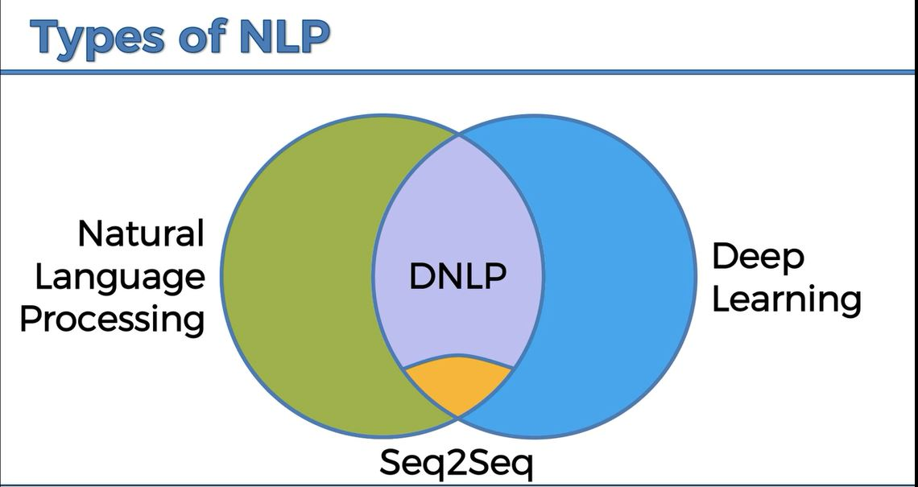

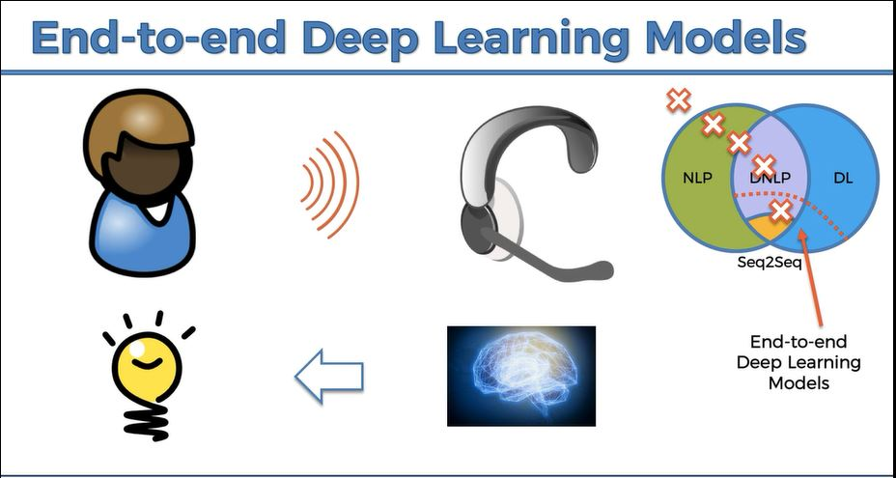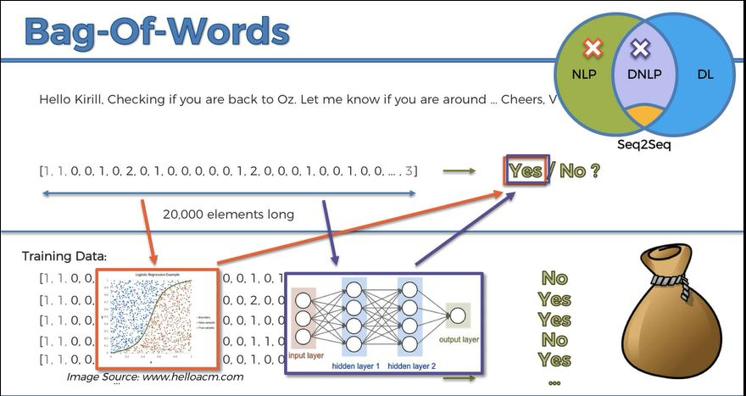

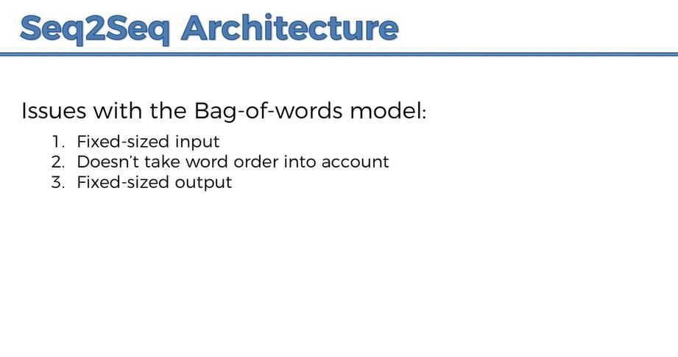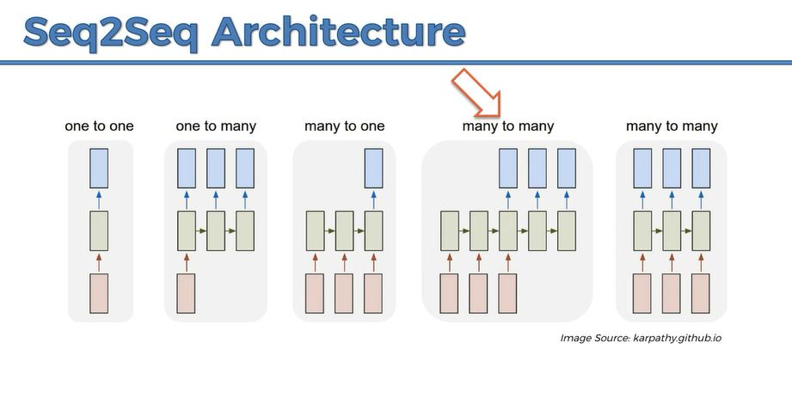

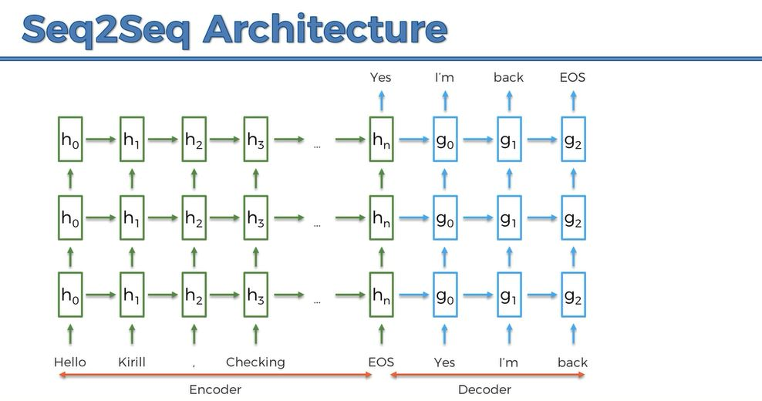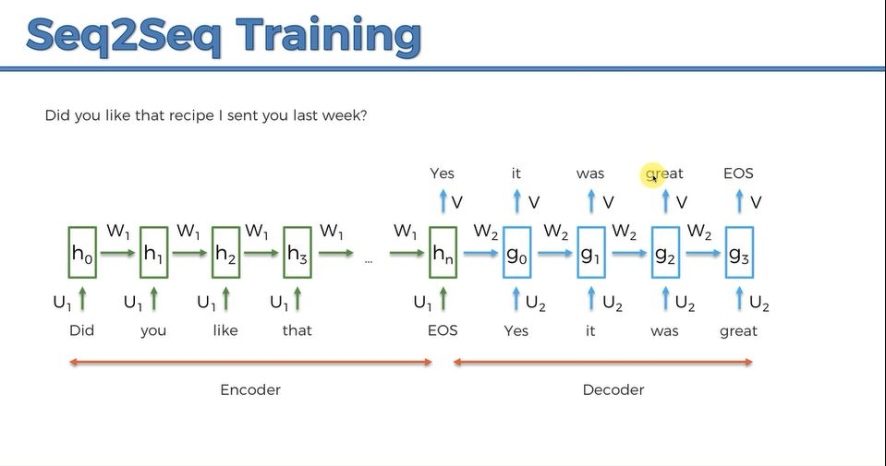

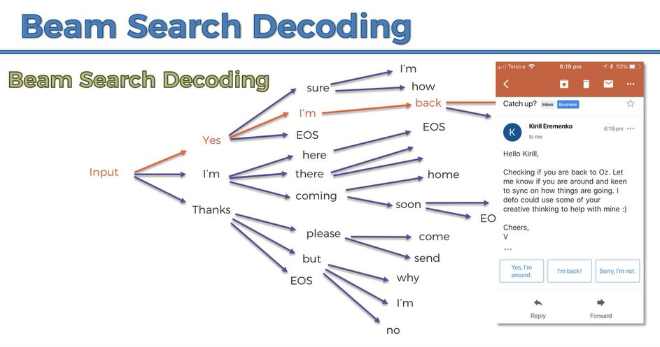

**Steps of Chatbot:**

1. Getting Dataset
2. Data pre-processing
3. Building Seq2Seq Model
4. Training Seq2Seq Model
5. Testing Seq2Seq Model
6. Improving the Chatbot intelligence

**Description:**

We've talked about, speculated and often seen different applications for Artificial Intelligence - But what about one piece of technology that will not only gather relevant information, better customer service and could even differentiate your business from the crowd?

ChatBots are here, and they came change and shape-shift how we've been conducting online business. Fortunately technology has advanced enough to make this a valuable tool something accessible that almost anybody can learn how to implement.  
  
If you want to learn one of the most attractive, customizable and cutting edge pieces of technology available, then this course is just for you!

**Benefit of using chatbots:**

There is another benefit of using chatbots in your business. They may help you reach more people which can increase your customer base. Since chatbots can be used in many applications you can take advantage of that to help your business grow. Chatbots can answer multiple questions at the same time as well.

**1. Save Time:**

One of the great benefits of using chatbots in your business is that they save time. For instance, when used on your website they can provide fast, automated answers to most questions. Their use prevents customers from waiting a day or longer to receive responses as they would have in the past.

This allows your business to serve greater numbers of people while increasing productivity and decreasing costs.

**2. Save Money:**

Chatbot use can be cheaper than hiring more workers. Costs to have a chatbot built can range from 2K to 10K or more depending on the complexity needed.

While that may sound like a lot, once created you’ll probably save in the long run. One reason for this is that you don’t have to pay it vacation time, sick days, or contribute to its 401K. It won’t become injured on the job and require medical treatment either.

**3. Provide Greater Customer Satisfaction:**

Another benefit of using chatbots in your business is that they give greater customer satisfaction. Chatbots don’t work 8 hour days and don’t need sleep which means they are always available.

Customers who pull up your website in the evening can ask questions and get answers right away. If they have product questions they may get the answers they need to complete sales. This can further increase your business profits.

Frustrated customers who don’t get quick answers, on the other hand, may leave your website and never return. Chatbots can eliminate that scenario and help you keep your customers.

**4. Increase Customer Base:**

There is another benefit of using chatbots in your business. They may help you reach more people which can increase your customer base.

Since chatbots can be used in many applications you can take advantage of that to help your business grow. Chatbots can answer multiple questions at the same time as well.

**5. Cut Down on Errors:**

Unfortunately, humans handling customer service questions and other issues can make errors. They can forget things, transpose numbers, and make other types of mistakes.

Not so with chatbots. Based on the questions asked they will always give the right answers. This makes them a huge asset when used in your business.

**6. Add Good Humor:**

An additional benefit of using chatbots in your business is that they add good humor. You never have to worry about a chatbot being in a bad mood. They will never turn away customers with an angry response, attitude, or glance.

They can be programed to have a bit of humor which can make them seem more humanlike. This puts customers at ease and makes their experience with your business more satisfying.

It’s important to make your business the best it can be to generate greater success and profits. As you can see, there are benefits of using chatbots in your business that can help that happen.

**Limitations of Chatbots:**

The creation and implementation of chatbots is still a developing area, heavily related to artificial intelligence and machine learning, so the provided solutions, while possessing obvious advantages, have some important limitations in terms of functionalities and use cases. However this is changing over time.

The most common ones are listed below:

* As the database, used for output generation, is fixed and limited, Chabot’s can fail while dealing with an unsaved query.
* Chabot’s efficiency highly depends on language processing and is limited because of irregularities, such as accents and mistakes that can create an important barrier for international and multi-cultural organization’s
* Chabot’s are unable to deal with multiple questions at the same time and so conversation opportunities are limited.
* As it happens usually with technology-led changes in existing services, some consumers, more often than not from the old generation, are uncomfortable with Chabot’s due to their limited understanding, making it obvious that their requests are being dealt machines.