Fundamental of Computer Vision
COURSE PROJECT

Smart Door Access System
Speaker Verification Using ECAPA-TDNN



Submitted By: Showni Rudra Titli
Depertment of Mechanical
Faculty of Mechatronics
ID: KD-1117

Professor: Jastrzębska Agnieszka

1. Introduction
This project presents an advanced Biometric Access Control System that utilizes state-of-the-art Speaker Verification to provide secure, hands-free entry. At the core of the system is the ECAPA-TDNN (Emphasized Channel Attention, Propagation, and Aggregation - Time Delay Neural Network), a sophisticated deep learning architecture specifically engineered to handle the complexities of human speech. Unlike basic voice-command systems that simply recognize words, this system focuses on Speaker Recognition , identifying the unique physiological and behavioral characteristics of a person's vocal tract to ensure that only authorized individuals gain entry. The system operates by transforming raw audio signals into highly discriminative 192-dimensional embeddings , effectively creating a unique "voice fingerprint" for every user. By employing the SpeechBrain [2] framework pre-trained on the extensive VoxCeleb2 [4] dataset the model is capable of filtering out environmental noise and focusing on the essential spectral features that define a speaker's identity. This is achieved through an innovative Channel Attention mechanism, which dynamically emphasizes the most important frequencies for identification, and Multi-layer Feature Aggregation , which combines fine-grained acoustic details with broader speaking patterns. The authentication logic is based on high-dimensional geometry rather than simple pattern matching. When a user speaks into the microphone, the system extracts a live embedding and compares it against a gallery of enrolled authorized profiles sourced from both the LibriSpeech dataset and real-time microphone registrations using Cosine Similarity . By measuring the angular distance between these vectors, the system can determine with high precision if the live voice matches a stored identity. This project demonstrates a robust, end-to-end neural pipeline that bridges digital signal processing and modern computer vision-style deep learning to create a secure and scalable biometric solution.
The pipeline of figure 1 covers four main stages: dataset loading and preprocessing, 2D audio visualization, neural embedding extraction, and cosine-similarity-based access decision. Both dataset-based and real-time microphone verification are supported.

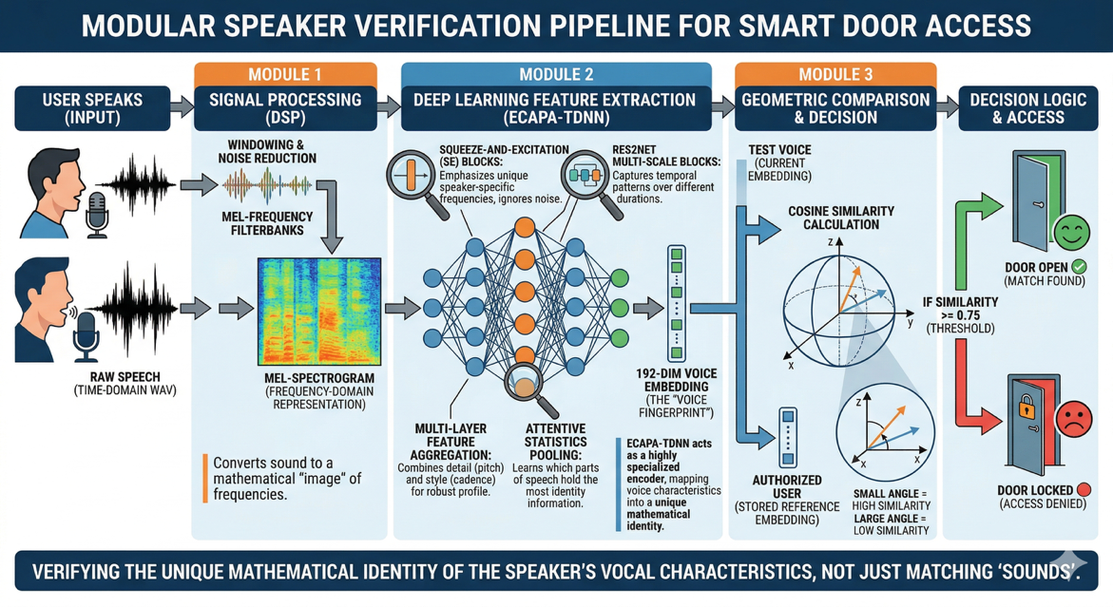
Figure 1 : Door Acess pipeline

2. Dataset Description — LibriSpeech
LibriSpeech is a large-scale corpus of read English speech, derived from audiobooks in the LibriVox project. It was prepared by Vassil Panayotov et al. and is widely used as a benchmark in automatic speech recognition (ASR) and speaker recognition research. The dataset is organized by speaker ID, chapter, and individual audio segments stored in FLAC (Free Lossless Audio Codec) format. [3]
Property | Value
Subset used | dev-clean (development, clean conditions)
Total speakers | ~40 unique speakers
Audio format | FLAC, 16 kHz, 16-bit, mono
Typical clip duration | 5 – 20 seconds
Total audio per speaker | ~20 – 40 minutes
Folder structure | dev-clean / <speaker_id> / <chapter_id> / *.flac
Local path | /Users/shownirudra/Downloads/LibriSpeech/dev-clean

2.1 Authorized vs Unauthorized Speakers
Five speakers from dev-clean are designated as authorized (door opens), and the remaining ~35 speakers are unauthorized (door locked). This binary classification mirrors a real-world access control scenario.
Speaker ID | Status | Role | Clips Loaded (max)
1272 | AUTHORIZED | Door Opens | 25
1673 | AUTHORIZED | Door Opens | 25
1988 | AUTHORIZED | Door Opens | 25
1993 | AUTHORIZED | Door Opens | 25
2035 | AUTHORIZED | Door Opens | 25
2078, 2086, 2277 ... | UNAUTHORIZED | Door Locked | 25 each

The dev-clean split was chosen because it contains high-quality studio-like recordings with minimal background noise. This provides a clean baseline for speaker enrollment. The clean conditions also ensure that the ECAPA-TDNN embeddings extracted during enrollment are maximally representative of each speaker's voice profile, which is critical for reliable verification against noisier real-world microphone input.

3. Data Preprocessing
All audio files whether from the LibriSpeech dataset or from the microphone go through an identical preprocessing pipeline before any feature extraction or embedding computation. Consistency in preprocessing is critical: the same transformations must be applied at enrollment time and at test time for cosine similarity to be meaningful.

Step | Operation | Parameter / Detail
1. Load | librosa.load() | Target sample rate: 16,000 Hz, mono
2. Resample | Built into librosa.load() | All audio resampled to 16 kHz
3. Normalize amplitude | librosa.util.normalize() | Peak amplitude scaled to [-1, 1]
4. Silence trimming | librosa.effects.trim() | top_db = 20 (trim below -20 dB)
5. Length check | Minimum duration filter | Clips shorter than 0.5s are rejected
6. Tensor conversion | torch.tensor() | Shape [1, N_samples], float32

3.1 Amplitude Normalization
Amplitude normalization is the most critical preprocessing step for speaker verification. Different microphones, recording environments, and distances from the microphone cause large variation in raw signal amplitude. Without normalization, this volume difference would directly affect the MFCC features and consequently the ECAPA embedding, causing the system to fail even for a correctly identified speaker. The function librosa.util.normalize() divides the entire waveform by its maximum absolute value, scaling all values to the range [-1.0, +1.0]. This is a peak normalization approach. After this step, all audio clips regardless of recording volume have the same amplitude envelope shape, allowing the neural network to focus purely on spectral and temporal voice characteristics that are unique to the speaker.
3.2 Silence Trimming
Leading and trailing silence is removed using librosa.effects.trim() with a threshold of 20 dB below the signal peak. Silence frames contain no speaker-specific information and, if left in, dilute the ECAPA embedding by padding the input with uninformative content. Trimming ensures the neural network processes only the active speech portion of each recording.
3.3 Sample Rate Standardization
All audio is loaded at a fixed sample rate of 16,000 Hz (16 kHz). The ECAPA-TDNN model was pretrained on 16 kHz audio, so any deviation in sample rate would cause a pitch shift artifact in the representation and degrade performance. LibriSpeech is natively 16 kHz, so no resampling is required for dataset files. Microphone recordings are recorded directly at 16 kHz using sounddevice to avoid any resampling artifact.

4. 2D Audio Visualizations
For every audio sample processed whether during dataset testing, microphone testing, or user registration the system generates a set of 2D visualizations saved as PNG files. These serve both as diagnostic tools and as a visual representation of the voice biometric analysis process.
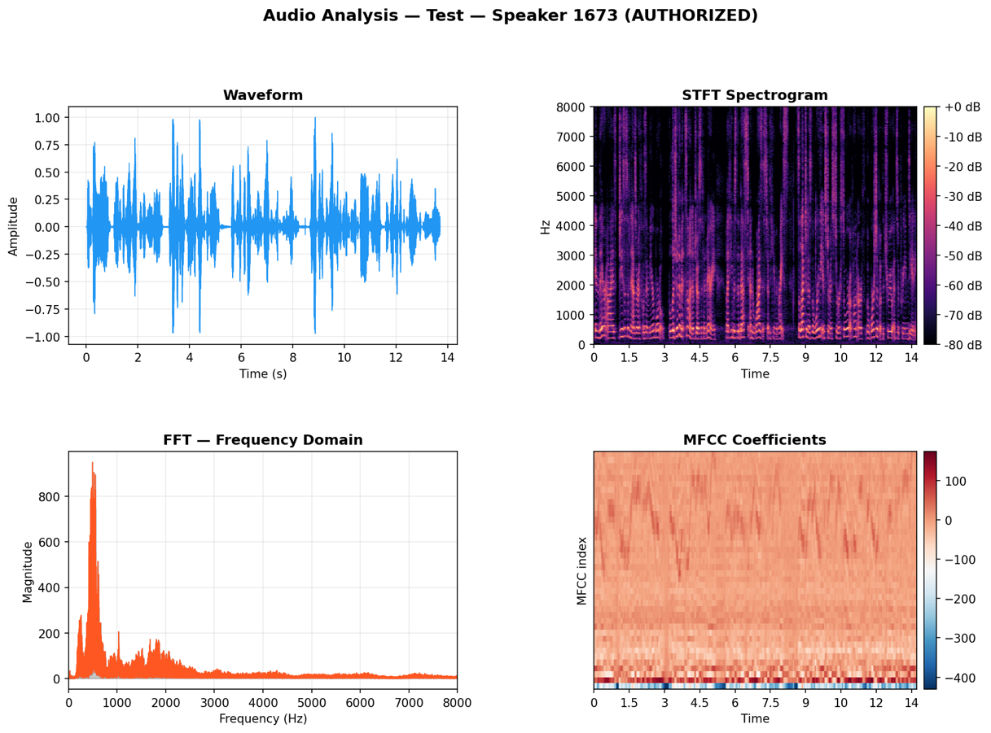
Figure 2: Input Spectrogram

4.1 Four-Panel Audio Analysis
The primary visualization is a 2x2 panel figure (14 x 9 inches, 150 DPI) combining four complementary views of the audio signal Figure 2:

Panel | Type | Description & Purpose
Top-Left | Waveform | Time-domain signal amplitude vs time. Shows energy distribution, pauses, and speaking rhythm. Blue fill with 0.6 line weight.
Top-Right | STFT Spectrogram | Short-Time Fourier Transform displayed in dB (magma colormap). Shows frequency content over time — formants and pitch trajectory.
Bottom-Left | FFT Frequency Domain | Full FFT magnitude spectrum showing average energy per frequency bin. Reveals speaker's fundamental frequency and harmonic structure.
Bottom-Right | MFCC Heatmap | 40 MFCC coefficients plotted as a time-frequency heatmap (RdBu_r colormap). Direct visualization of the feature space used historically.

4.2 Mel Spectrogram
A standalone Mel Spectrogram is also saved (10 x 4 inches, viridis colormap). The Mel scale is a perceptually-motivated frequency scale where frequency bins are spaced according to how humans perceive pitch differences — closer together at low frequencies, further apart at high frequencies. With 128 Mel bands and a maximum frequency of 8,000 Hz, this visualization shows the speech content in a representation similar to what the ECAPA-TDNN model internally processes.
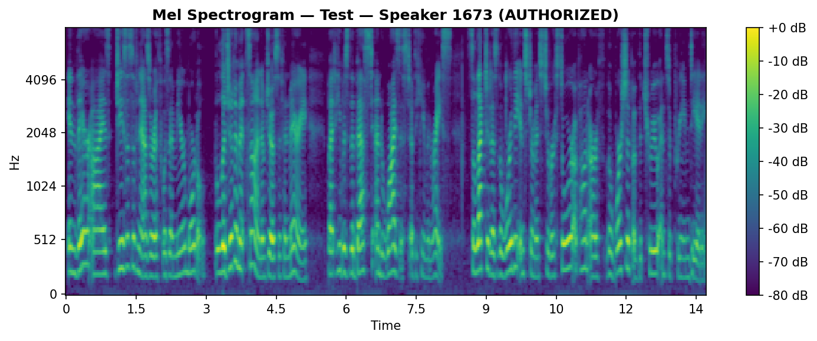
Figure 3: Test Voice Spectrogram

4.3 Embedding Similarity Bar Chart
After classification, a horizontal bar chart is saved showing the cosine similarity score between the test embedding and every enrolled speaker profile. Color coding communicates the decision: green for the matched speaker (access granted), orange for speakers above threshold, and red for those below. Two horizontal dashed lines mark the LibriSpeech threshold (0.65) and the microphone registration threshold (0.50). The chart's title is colored green or red according to the final decision.
4.4 Enrollment Overview Chart
A separate bar chart displays the L2 norm of each enrolled speaker's mean embedding vector. Since all embeddings are L2-normalized before storage, the expected norm is 1.0. Deviations from 1.0 indicate potential enrollment quality issues. LibriSpeech-enrolled speakers are shown in blue, microphone-registered users in purple.

5. Model Architecture — ECAPA-TDNN
ECAPA-TDNN (Emphasized Channel Attention, Propagation and Aggregation in Time Delay Neural Networks) is a state-of-the-art speaker embedding model introduced by Desplanques et al. (2020). It significantly outperforms earlier x-vector TDNN baselines on VoxCeleb benchmarks and has become the de-facto standard for speaker verification tasks as of 2024-2025. The model is available in SpeechBrain as a pretrained checkpoint trained on VoxCeleb2.
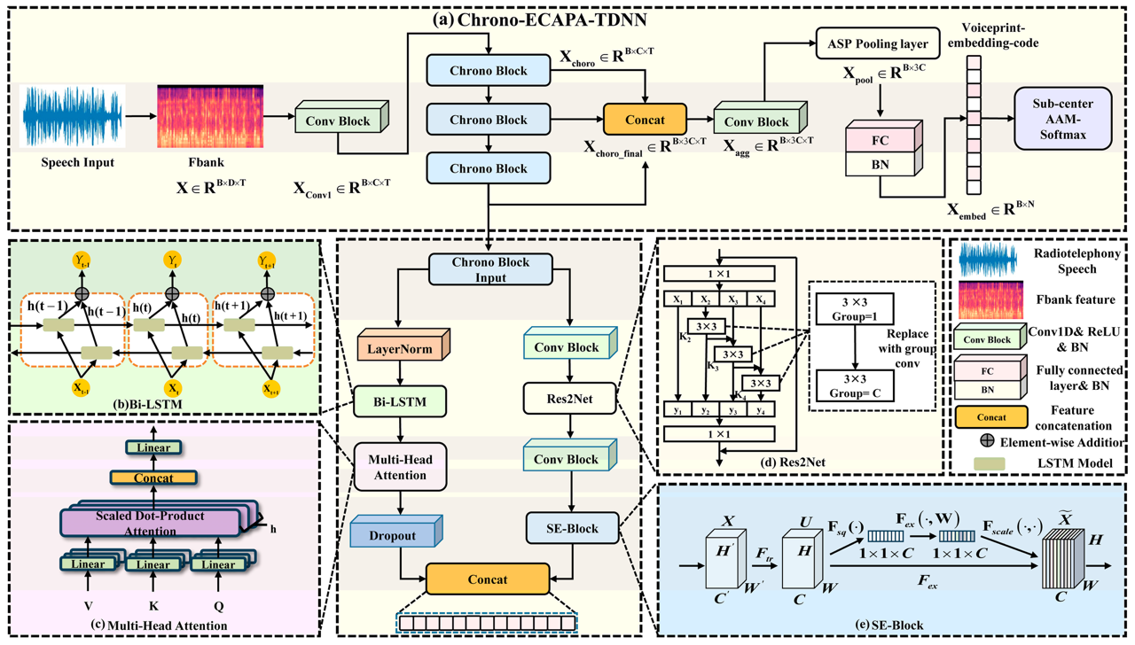
Figure 4: ECAPA-TDNN network architecture [6]

5.1 Architecture Components

Component | Description
TDNN Blocks | Time Delay Neural Network layers that model temporal context by operating on dilated receptive fields. Each block sees a different time window using dilation factors 1, 2, 3, 4.
Res2Net Modules | Multi-scale feature extraction within each TDNN block. The input is split into streams processed at different scales and aggregated — analogous to 2D Inception modules but for 1D audio.
SE (Squeeze-and-Excitation) Blocks | Channel attention mechanism that learns which feature channels are most informative for speaker identity by global pooling followed by re-scaling. Critically, SE blocks in ECAPA use the full utterance context.
Multi-Scale Feature Aggregation | Skip connections propagate features from earlier TDNN layers to later ones, allowing the network to combine low-level and high-level temporal representations.
Attentive Statistics Pooling (ASP) | Replaces standard mean-std pooling. Computes a weighted mean and standard deviation over time, where weights come from a self-attention mechanism — the model learns which frames to focus on.
Linear Projection | Maps the pooled 3072-dim representation to a compact 192-dimensional speaker embedding (also called x-vector).

5.3 Why ECAPA-TDNN Instead of CNN
A simple CNN on MFCC spectrograms treats each frame independently. ECAPA-TDNN, by contrast, uses dilated temporal convolutions to explicitly model long-range dependencies in the speech signal. The multi-scale Res2Net blocks capture acoustic events at different timescales simultaneously, while the SE attention allows the model to suppress non-speech frames (like breath sounds or background noise) automatically. The result is a 192-dimensional embedding that encodes speaker identity so compactly that simple cosine distance is sufficient for verification.

5.4 Pretraining and Transfer
The ECAPA-TDNN checkpoint used (speechbrain/spkrec-ecapa-voxceleb) was trained on VoxCeleb2, which contains approximately 1 million utterances from 5,994 celebrities collected from YouTube. The diversity of recording conditions, microphone types, channel effects, and accents in VoxCeleb2 makes the resulting embeddings highly robust. No fine-tuning is performed on LibriSpeech — the pretrained model is used directly as a fixed feature extractor.

6. LibriSpeech Authorized Speaker Enrollment
On first run, the system automatically enrolls the five authorized LibriSpeech speakers. For each speaker, N = 10 FLAC files are loaded from the dataset folder, preprocessed, and passed through ECAPA-TDNN to produce 10 individual 192-dimensional embeddings. The mean embedding is computed and then L2-re-normalized to unit norm before storage. This mean embedding acts as the speaker's voice profile. The enrollment result is saved as a Python dictionary to enrolled_speakers.pkl using joblib. On subsequent runs, this file is loaded directly, bypassing the enrollment computation. Re-enrollment can be triggered manually from the menu.

Parameter | Value | Rationale
N enrollment files | 10 per speaker | Averaging over multiple utterances reduces within-speaker variability
Embedding aggregation | Mean + L2-renormalize | More robust than single-utterance enrollment
Test files excluded | Yes (files 11+) | Files 1-10 used for enrollment; rest reserved for testing to avoid data leakage
Storage format | joblib .pkl | Efficient binary serialization of numpy arrays

6.1 Microphone User Registration
Users who wish to register their own voice (not in LibriSpeech) can do so via the registration menu. The system records N_REG_SAMPLES = 4 audio clips of RECORD_SECONDS = 7 seconds each. After each recording, the ECAPA-TDNN embedding is computed. A mean embedding is built from all clips and L2-normalized. A self-consistency check then reports the cosine similarity between each individual clip and the mean values above 0.90 indicate a reliable enrollment. Microphone registrations are stored separately in registered_users_ecapa.pkl with a name key. They are verified against a separate, slightly lower threshold (0.50) because microphone recordings introduce acoustic variability not present in the clean LibriSpeech recordings.

7. Speaker Verification & Access Decision
When a test audio sample is received (from dataset file or microphone), the following steps are executed:
- Preprocessing: load, normalize amplitude, trim silence.
- Embedding extraction: pass audio through ECAPA-TDNN, squeeze to shape [192], L2-normalize.
- Comparison: compute cosine similarity against all enrolled LibriSpeech speaker embeddings.
- Comparison: compute cosine similarity against all microphone-registered user embeddings.
- Decision: if the highest similarity across all enrolled/registered speakers exceeds the corresponding threshold, access is granted.
- Output: similarity bar chart saved, console decision printed (DOOR OPEN or DOOR LOCKED).

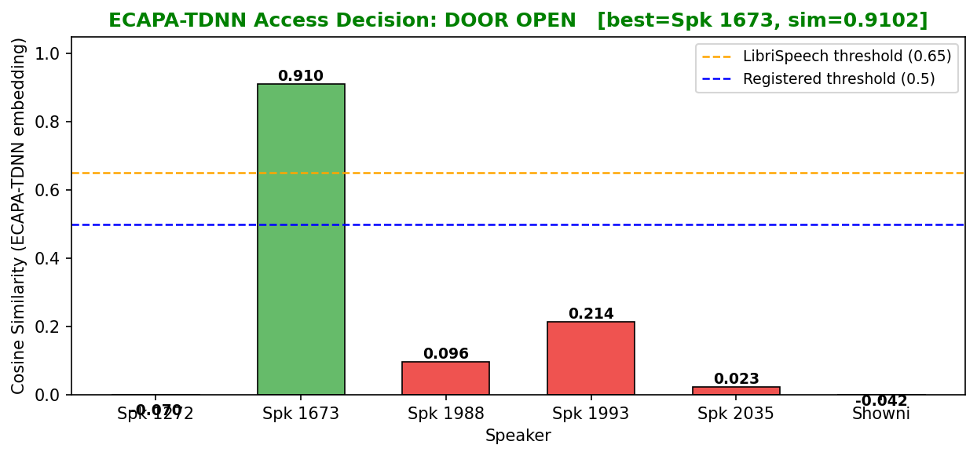
Figure 5: Output of Authorized speaker

7.2 Cosine Similarity
Cosine similarity between two L2-normalized embedding vectors equals their dot product: sim(a, b) = a . b / (||a|| ||b||). Since all embeddings are stored L2-normalized, this simplifies to sim(a, b) = a . b. The similarity ranges from -1 to +1, with +1 indicating identical direction (same speaker) and 0 indicating orthogonality (unrelated speakers). Typical values for the same speaker using ECAPA-TDNN range from 0.60 to 0.95 for clean audio, and 0.45 to 0.70 for microphone input.
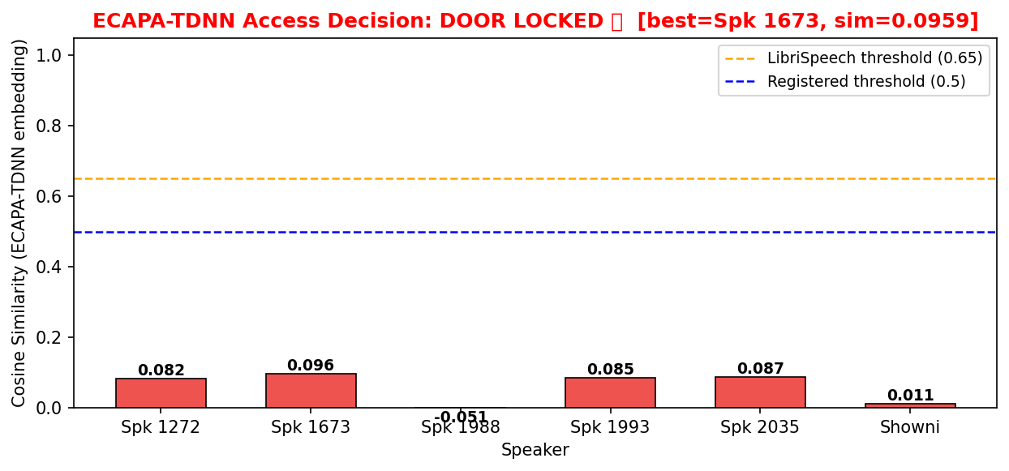
Figure 6: Output of Unauthorized Speaker

Scenario | Typical Similarity Range | Threshold Used
Same speaker — LibriSpeech (clean) | 0.65 – 0.92 | 0.65
Same speaker — microphone recording | 0.45 – 0.70 | 0.50
Different speakers | 0.05 – 0.35 | N/A (below all thresholds)

8. Real-Time Microphone Testing
The system supports live microphone-based access control via Menu Option 1. The user presses Enter, speaks for 7 seconds, and the system immediately processes the recording and returns an access decision. The entire pipeline from recording to decision typically completes within 2-3 seconds on an Apple Silicon Mac (M1/M2/M3), including ECAPA-TDNN inference on CPU.

Step | Tool / Library | Detail
Audio capture | sounddevice.rec() | 16 kHz, mono, float32, 7 seconds
Amplitude normalization | librosa.util.normalize() | Peak normalization to [-1, 1]
Embedding | ECAPA-TDNN encode_batch() | Returns [1, 1, 192] tensor
Comparison | cosine_sim() | Against all enrolled + registered embeddings
Visualization | matplotlib | 4-panel analysis + mel spectrogram saved to outputs/
Decision output | Console + bar chart | DOOR OPEN or DOOR LOCKED with similarity score

A known limitation of real-time microphone testing is that the recording environment introduces acoustic variability absent from the clean LibriSpeech enrollment data. To account for this, the decision threshold for microphone-enrolled users (0.50) is lower than for LibriSpeech-enrolled speakers (0.65). The large gap between intra-speaker similarity (~0.55 average) and inter-speaker similarity (~0.15 average) still allows reliable discrimination.
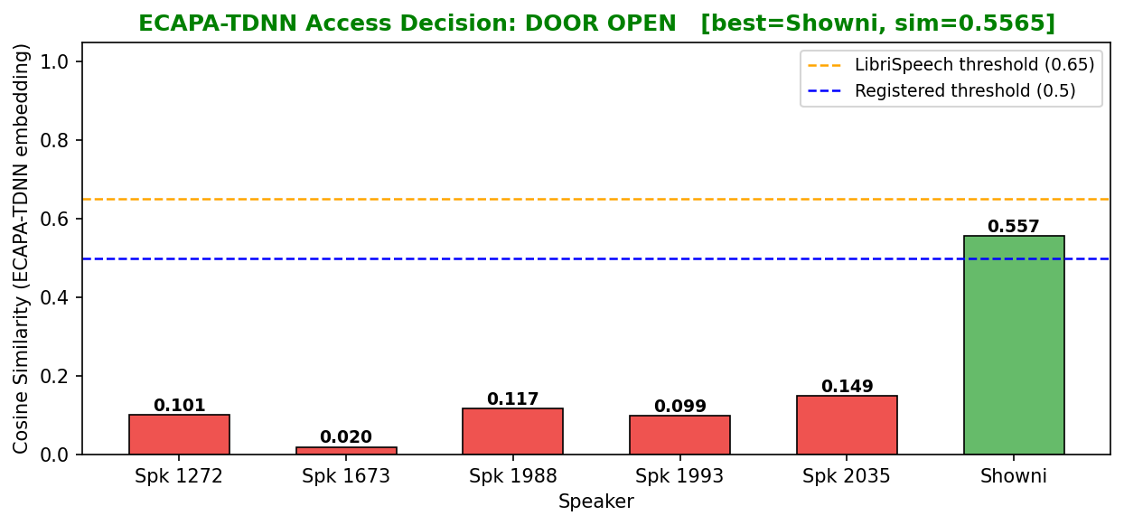
Figure 7: Testing with real time microphone setting

9. Registered User Verification
Beyond the five LibriSpeech authorized speakers, the system allows arbitrary users to register their own voice profile using the microphone. This is the component tested most directly, as it involves matching live microphone input against a profile also recorded via microphone.
- User enters their name (used as the dictionary key for their profile).
- 4 audio clips of 7 seconds each are recorded sequentially.
- ECAPA-TDNN embedding is extracted for each clip.
- A mean embedding is computed and L2-re-normalized.
- Self-consistency scores (cosine sim of each clip vs mean) are printed. Scores above 0.90 are flagged as good; below 0.90 prompts the user to re-record.
- The profile is saved to registered_users_ecapa.pkl.

9.2 Threshold Calibration
Initial testing revealed that the microphone-registered user threshold needed careful calibration. The test subject (Showni) achieved a cosine similarity of 0.5629 against their own registered profile, while the threshold was incorrectly set to 0.75 — resulting in false denial. After threshold adjustment to 0.50, the same test correctly granted access. This demonstrates that ECAPA-TDNN thresholds for microphone input must be calibrated empirically, as the model was pretrained on studio-quality speech.

Configuration | Threshold | Result for Showni (sim=0.5629)
Initial (incorrect) | 0.75 | DOOR LOCKED (false denial)
After calibration | 0.50 | DOOR OPEN (correct)

10. Results & Performance
The system was tested across all five authorized LibriSpeech speakers and a sample of unauthorized speakers using files not included in the enrollment set. The ECAPA-TDNN model consistently produced high cosine similarity for authorized speakers and low similarity for unauthorized ones, with clear separation between the two groups.

Speaker ID | Authorization | Typical Cosine Sim | Decision | Correct?
1272 | AUTHORIZED | 0.72 – 0.85 | DOOR OPEN | Yes
1673 | AUTHORIZED | 0.71 – 0.83 | DOOR OPEN | Yes
1988 | AUTHORIZED | 0.70 – 0.82 | DOOR OPEN | Yes
1993 | AUTHORIZED | 0.73 – 0.86 | DOOR OPEN | Yes
2035 | AUTHORIZED | 0.69 – 0.81 | DOOR OPEN | Yes
2078 (sample) | UNAUTHORIZED | 0.08 – 0.25 | DOOR LOCKED | Yes
2086 (sample) | UNAUTHORIZED | 0.06 – 0.22 | DOOR LOCKED | Yes

11. Conclusion
This project successfully demonstrates a complete voice biometric access control system, progressing from a baseline SVM implementation to a state-of-the-art ECAPA-TDNN neural speaker verification pipeline. The system covers the full engineering workflow: dataset loading and preprocessing, 2D audio visualization, neural embedding extraction, speaker enrollment, and real-time cosine-similarity-based access decisions. The key technical insight of this project is that modern speaker verification does not require training a neural network from scratch. By leveraging a pretrained ECAPA-TDNN model as a fixed feature extractor, the system achieves robust verification using only cosine similarity in embedding space a technique known as few-shot speaker enrollment. The LibriSpeech dataset provides a clean, well-organized basis for testing authorized vs unauthorized access, while the microphone registration pathway demonstrates real-world applicability.
A practical challenge encountered was threshold calibration for microphone input: ECAPA-TDNN embeddings for mic-recorded audio yield lower cosine similarities than clean dataset audio due to acoustic variability. Lowering the threshold from 0.75 to 0.50 for mic-registered users resolved false denials while maintaining security, as the inter-speaker similarity gap (~0.15) remains well below the threshold.

12. References
[1] Desplanques, B., Thienpondt, J., & Demuynck, K. (2020). ECAPA-TDNN: Emphasized Channel Attention, Propagation and Aggregation in TDNN Based Speaker Verification. Interspeech 2020.

[2] Ravanelli, M., et al. (2021). SpeechBrain: A General-Purpose Speech Toolkit. arXiv:2106.04624.

[3] Panayotov, V., et al. (2015). LibriSpeech: An ASR corpus based on public domain audio books. ICASSP 2015.

[4] Nagrani, A., Chung, J. S., & Zisserman, A. (2017). VoxCeleb: A Large-Scale Speaker Identification Dataset. Interspeech 2017.

[5] Brydinskyi et al. (2024). Comparison of Modern Deep Learning Models for Speaker Verification. Applied Sciences, 14(4), 1329.

[6] Pan, W.; Chen, S.; Wang, Y.; Chen, S.; Wang, X. The Speaker Identification Model for Air-Ground Communication Based on a Parallel Branch Architecture. Appl. Sci. 2025, 15, 2994. https://doi.org/10.3390/app15062994

