
AMERICAN INTERNATIONAL UNIVERSITY-BANGLADESH (AIUB)
Faculty of Engineering
Bachelor of Science in Electrical and Electronic Engineering (EEE) BAE 2101: Computer Aided Design and Drafting
Experiment # 05: Introducing with Electrical Symbols used for Electrical Circuit Design and drawing some Electrical Circuits using AutoCAD.

Objective: To familiarize students with Electrical Symbols used for Electrical Circuit Design and draw some Electrical Circuits using AutoCAD software.

List of Electrical Symbols
Direct Current Alternating Current
Resistor
Non-reactive Resistor
Impedance

Inductor Winding Capacitor

Earth
Line or cable:
existing

planned Underground Cable

ELECTRICAL CIRCUIT DESIGN
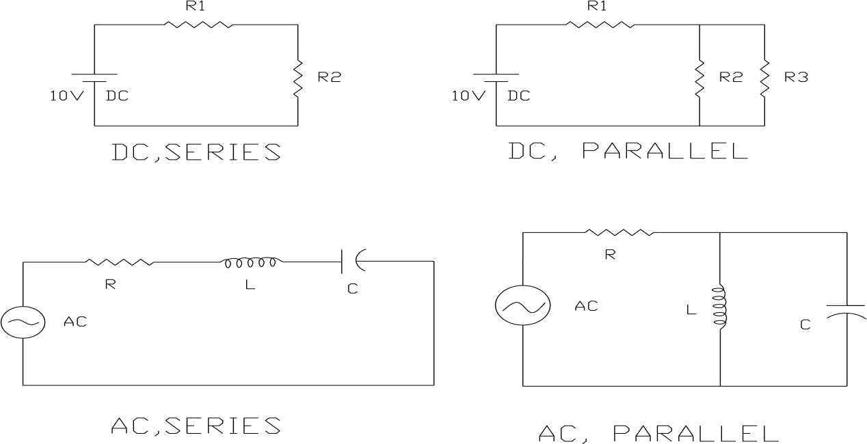

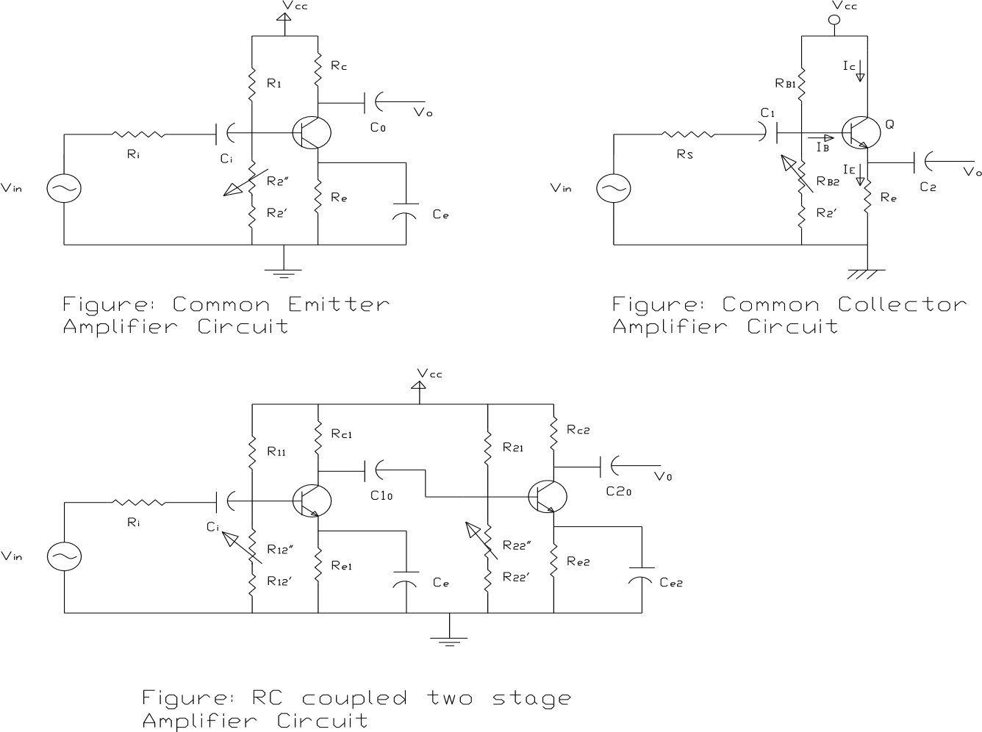

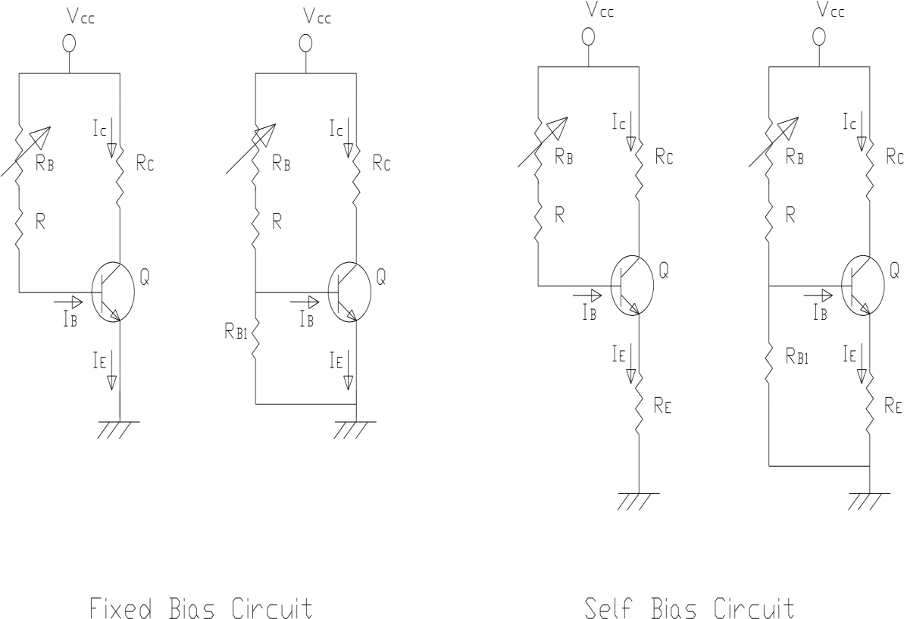

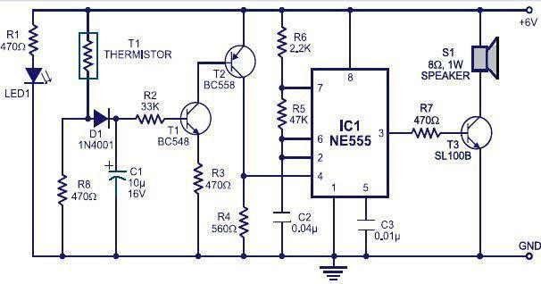

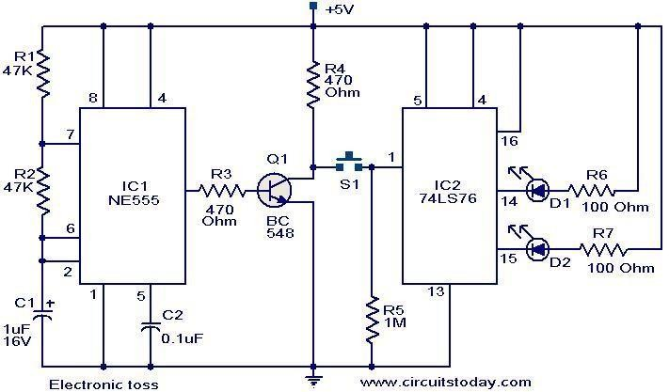

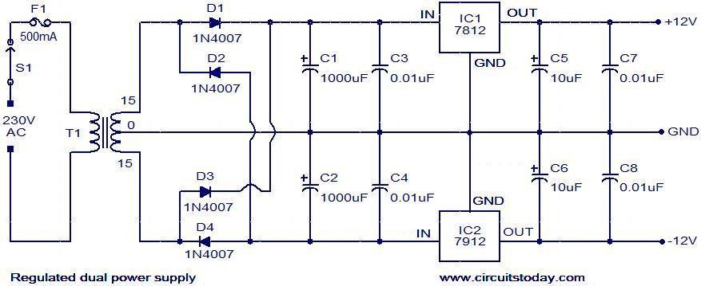
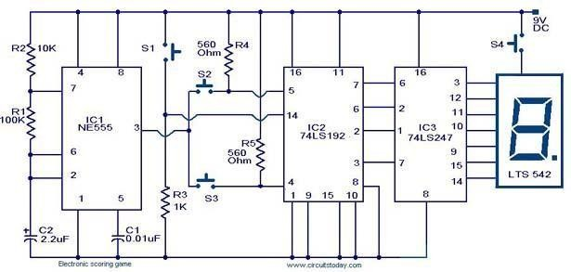

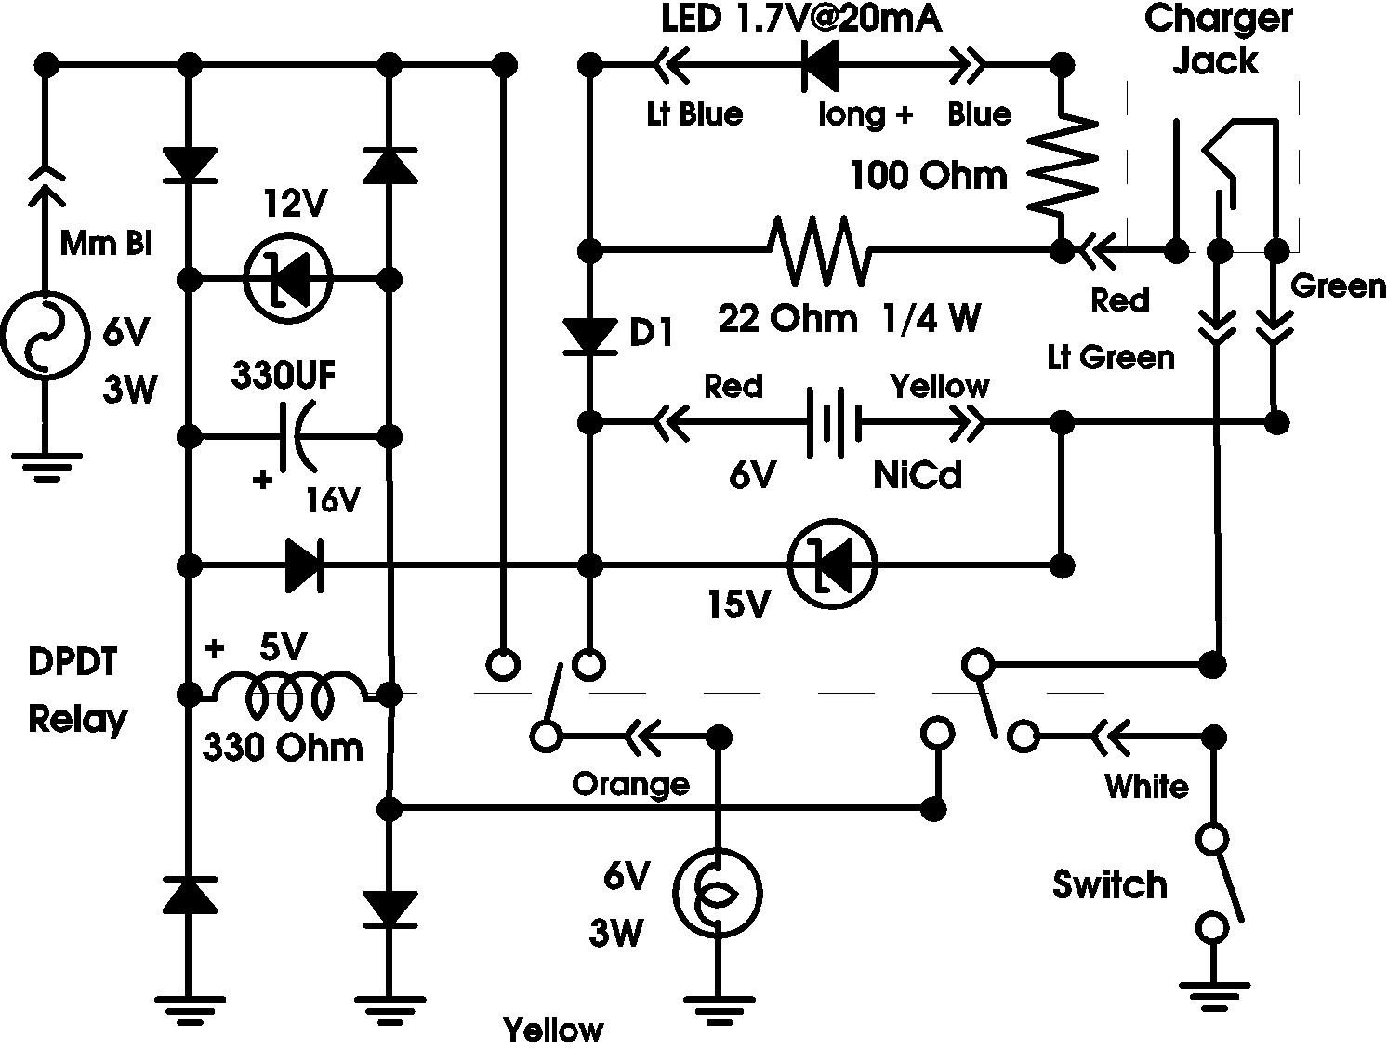

References:
- Kristen S. Kurland, “AutoCAD 2004, 2D Training Manual”.
- Bob McFarlane, “Beginning AutoCAD 2004”
- David Byrnes and Mark Middlebrook, “AutoCAD 2007 For Dummies”.

