Course: Network Security
Section: A
Name: SHOWRAV GHOSH
ID: 23-50666-1

Screenshot 1: Metasploitable2 IP Address (Target Machine - IP: 10.0.2.3)
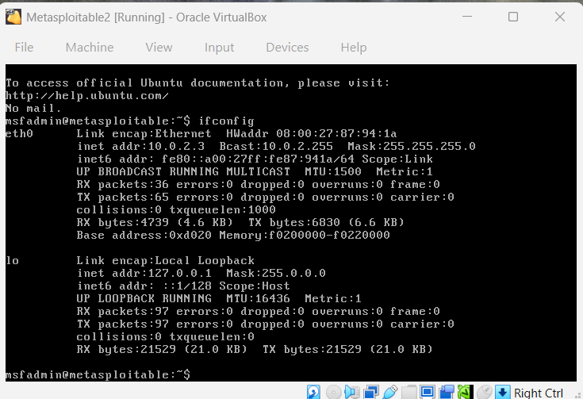
Screenshot 2: Kali Linux IP Address (Attacker Machine - IP: 10.0.2.4)
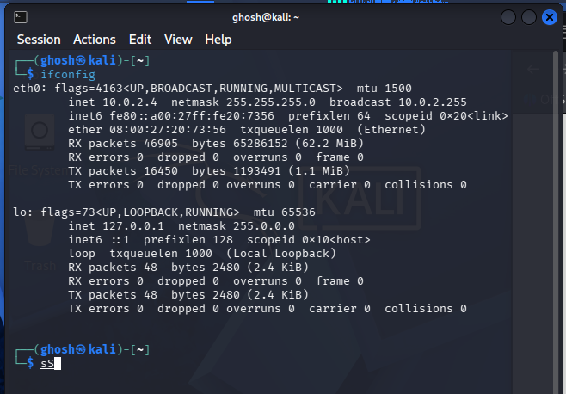
Screenshot 3: Accessing DVWA Login Page on Target (http://10.0.2.3/dvwa/login.php)
Username: admin
Password: password
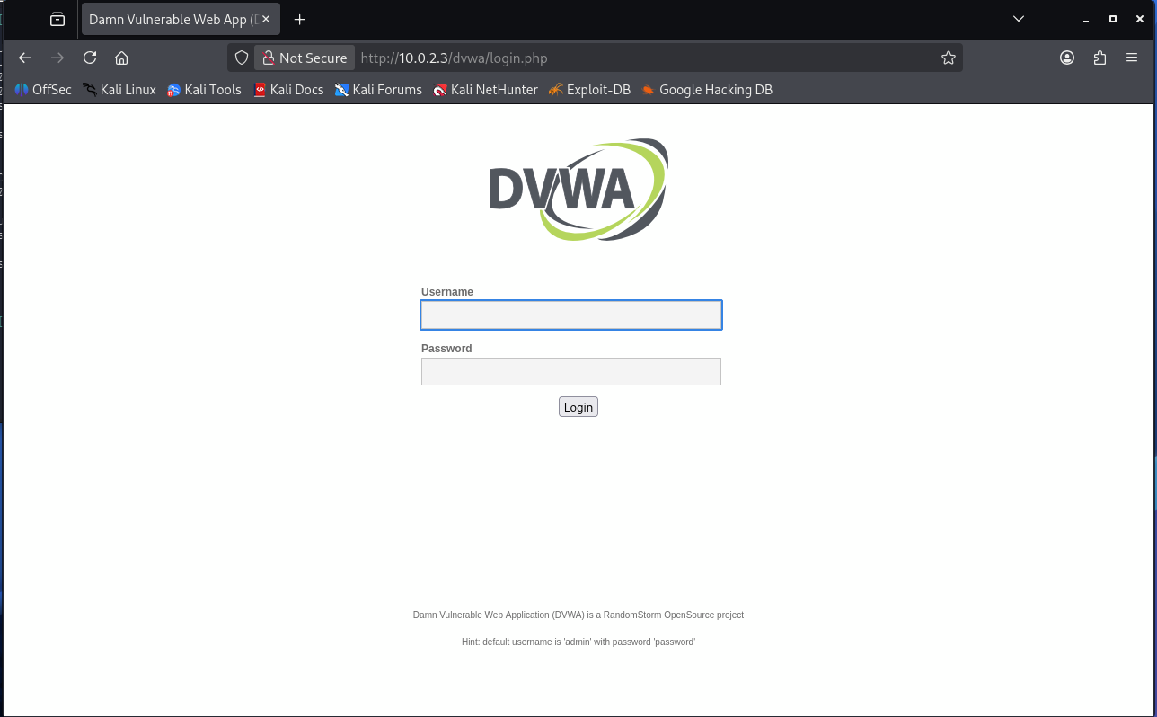

Screenshot 4: Successfully Logged into DVWA as Admin
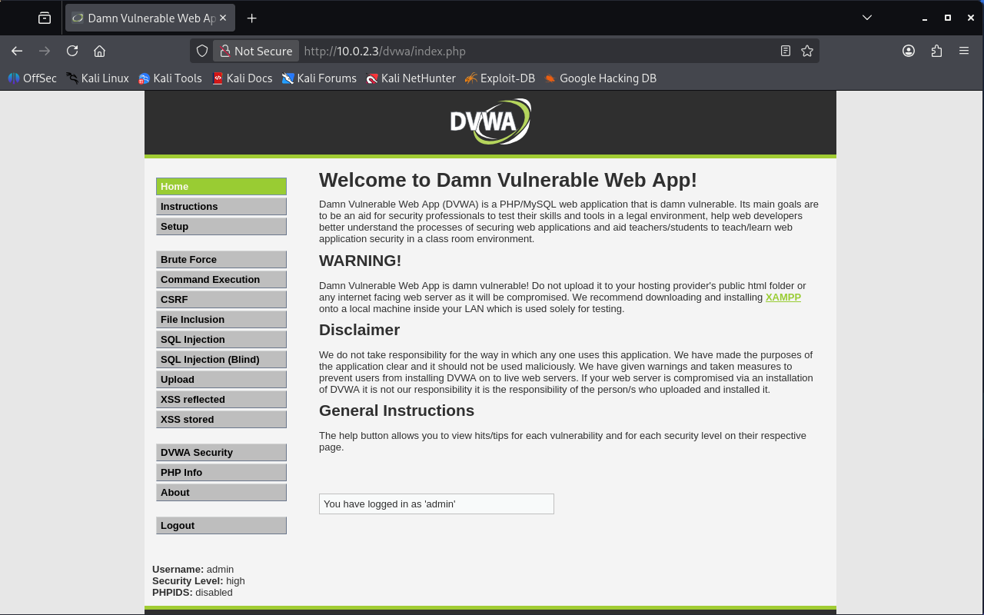
Screenshot 5: Setting DVWA Security Level to Low
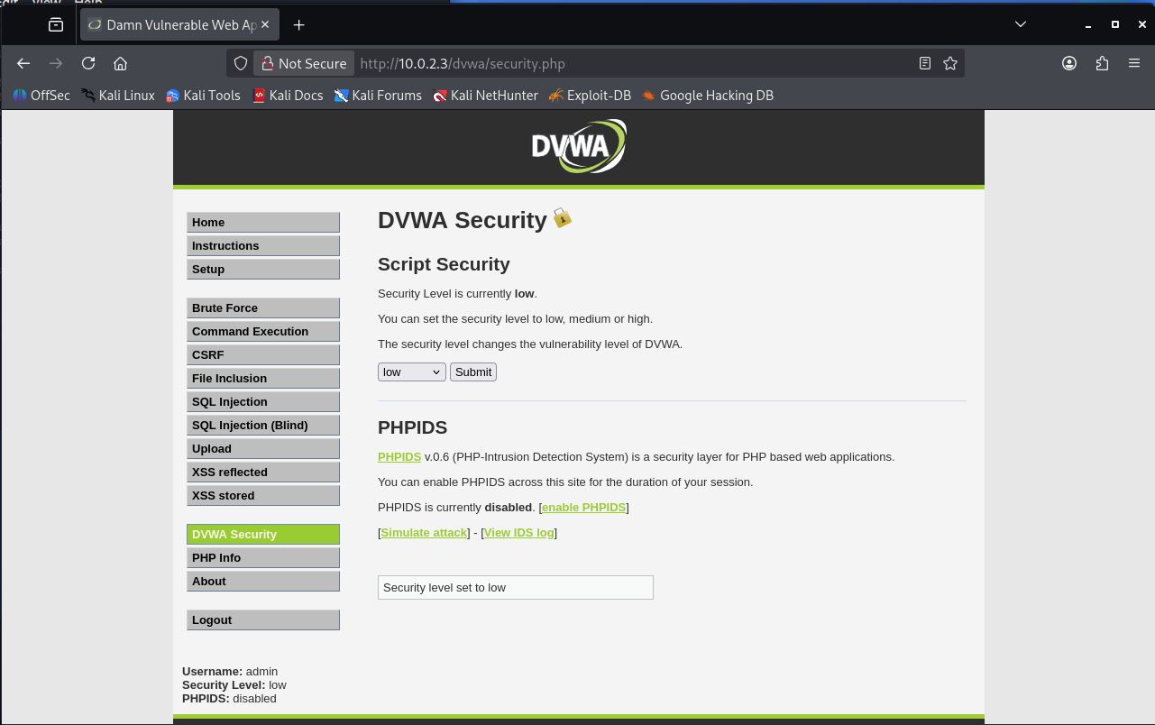

Screenshot 6: Navigating to SQL Injection Vulnerability Page
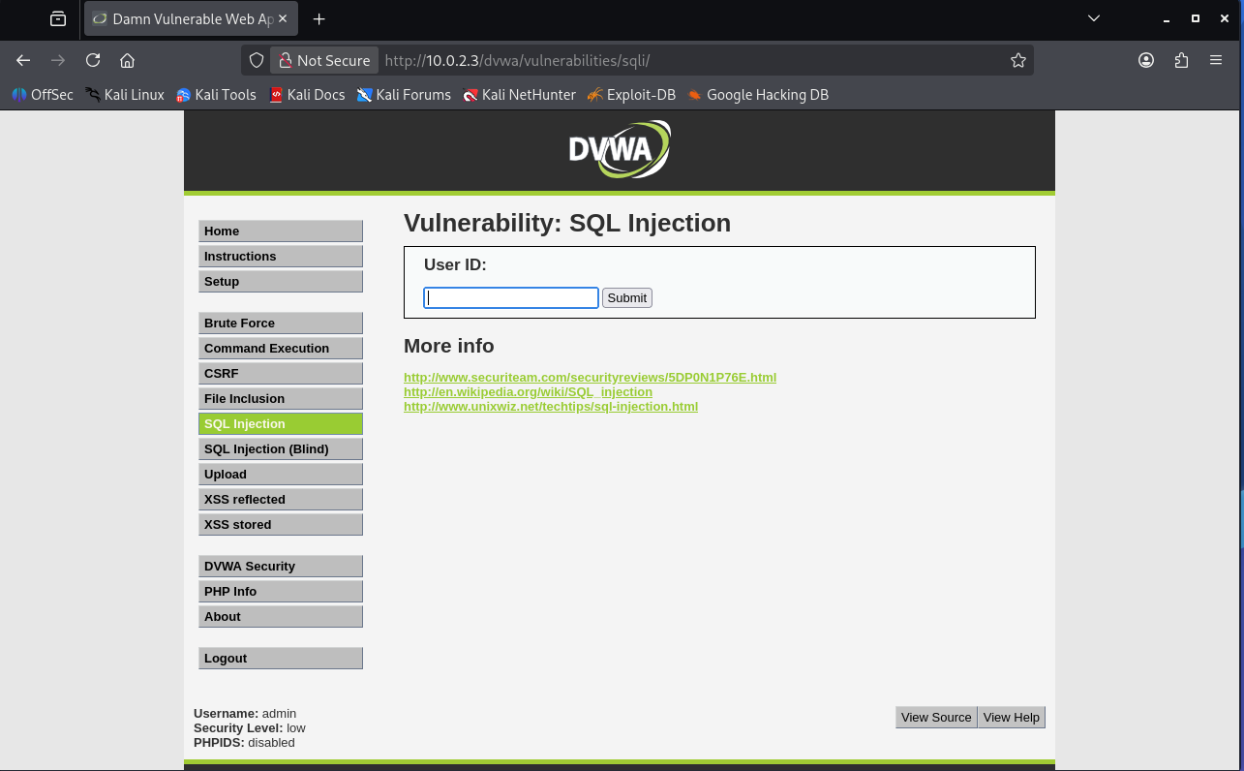
Screenshot 7: Testing Normal Input (ID=1) - Valid User Data Returned
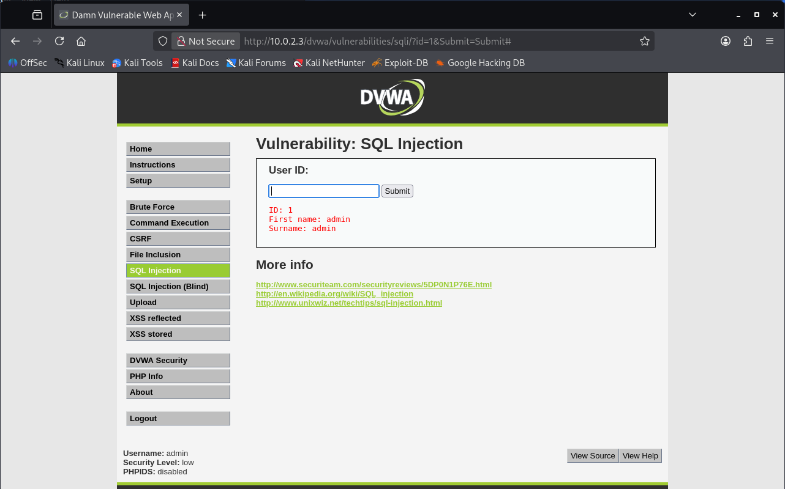

Screenshot 8: SQL Error Detected - Confirming SQL Injection Vulnerability
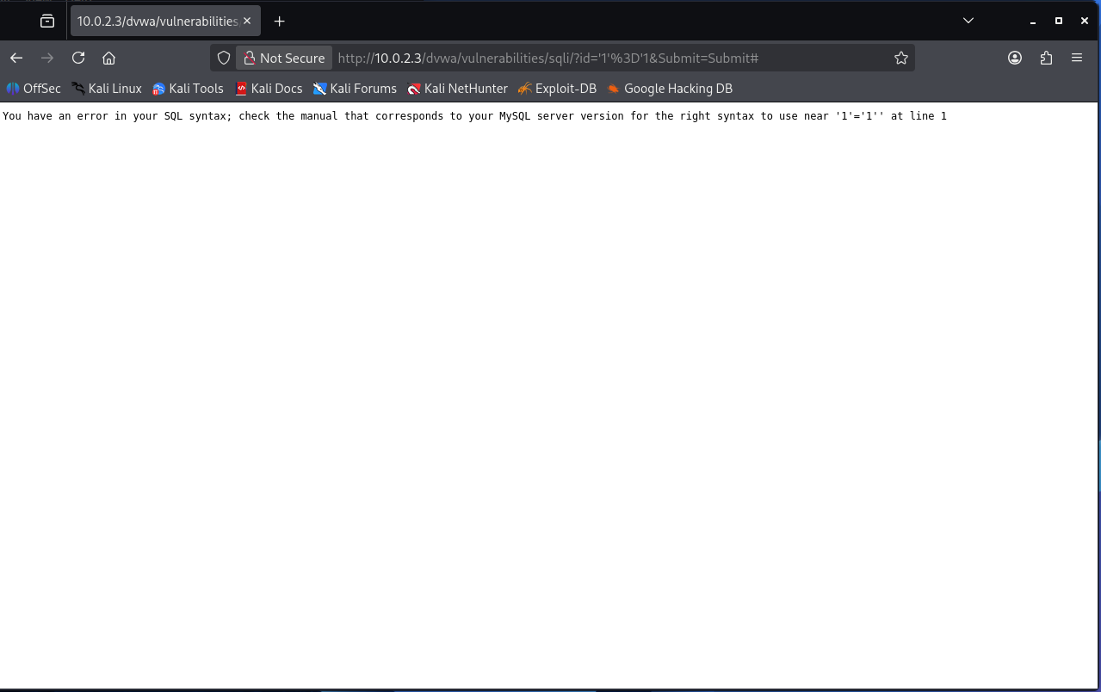
Screenshot 9: Exploiting SQLi with OR Payload - All Users Dumped ( Id: 1’ OR 1=1 # )
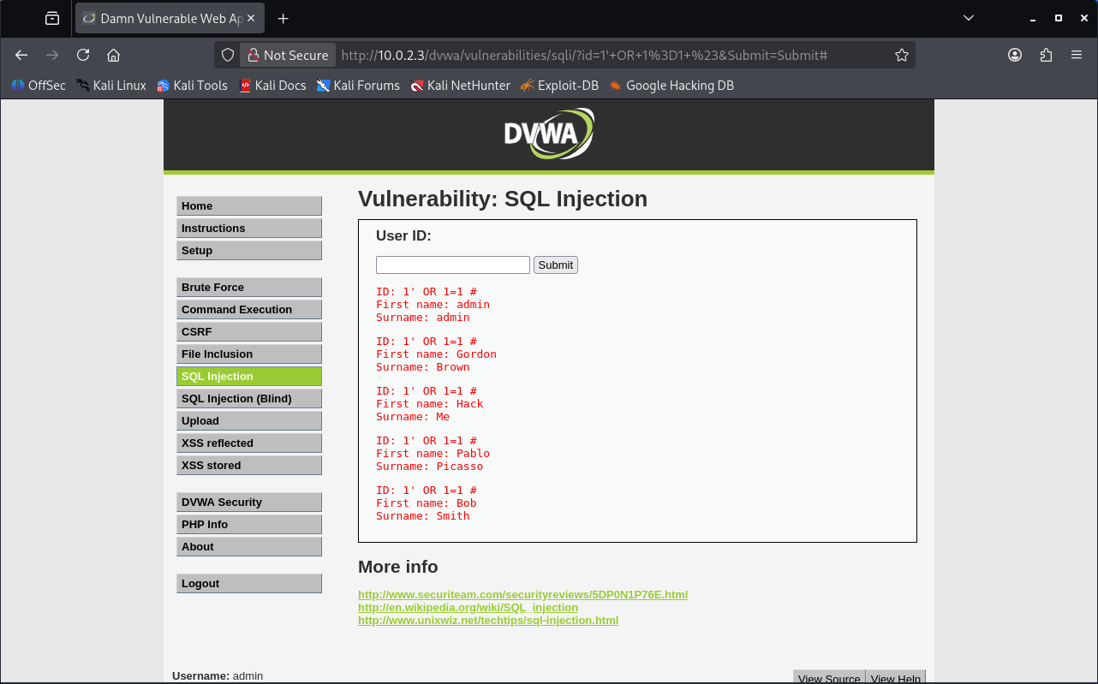

Screenshot 10: Inspecting PHPSESSID Cookie via Browser Developer Tools (Press F12)
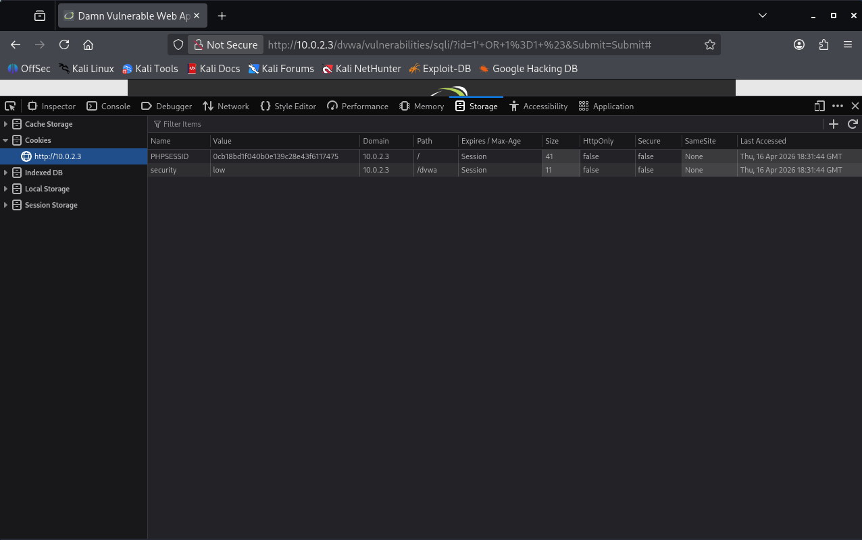
Screenshot 11: Running SQLmap with Cookie - Automated SQL Injection Attack
sqlmap -u "http://<IP>/dvwa/vulnerabilities/sqli/?id=1&Submit=Submit" --cookie="PHPSESSID=yourvalue; security=low" –dump
Purpose:
- Extract table data
- Get usernames + passwords
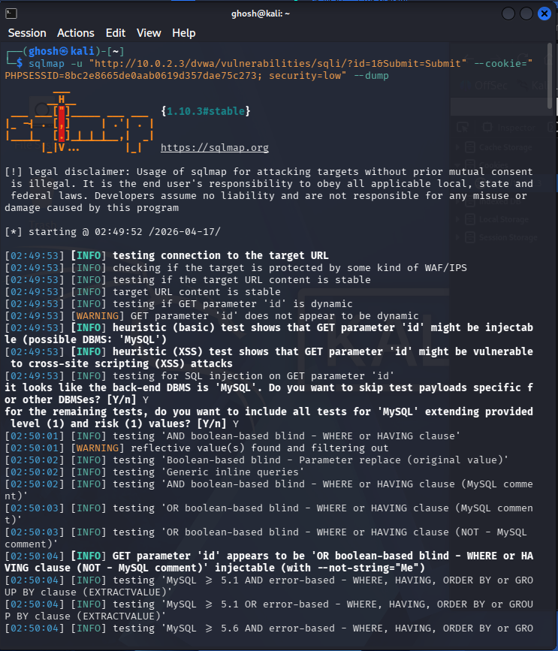
Screenshot 12: SQLmap Output - Credentials Dumped from DVWA Users Table
cat /home/ghosh/.local/share/sqlmap/output/10.0.2.3/dump/dvwa/users.csv
