DevExpress News

Dear **Alice Martin**:

|  |
| --- |
| RECENT USER FEEDBACK  "I just wanted to say a huge thank you to the DevExpress team. DevExpress offers the most unbelievable set of controls and best value for the money tools we have ever purchased. I've been working with the ASP.NET controls recently and the amount of flexbility they provide is incredible."  **Daniel Gochin** |
|  | |

# 15th YEAR ANNIVERSARY

We’ve just turned 15 years old and want to thank all of you for your loyal patronage over the years. To mark the occasion, we’re giving away gifts throughout the month of November and raising money for charitable organizations via EBay auctions. To join the celebration, follow us on our blogs, [Facebook](http://facebook.com/devexpress), [Twitter](http://twitter.com/devexpress), [Google+](https://plus.google.com/+devexpress/posts) and [YouTube](http://www.youtube.com/user/DeveloperExpress).

# UPCOMING CLASSROOM TRAINING EVENTS

Our director of training, Oliver Sturm, is conducting WinForms and ASP.NET classroom training events in New York during the month of March, 2014. You can learn more about these classes and register for seat by [visiting our website](https://www.devexpress.com/Home/Training/).

When only the best will do.

DevExpress was voted best in class by readers of Visual Studio Magazine.

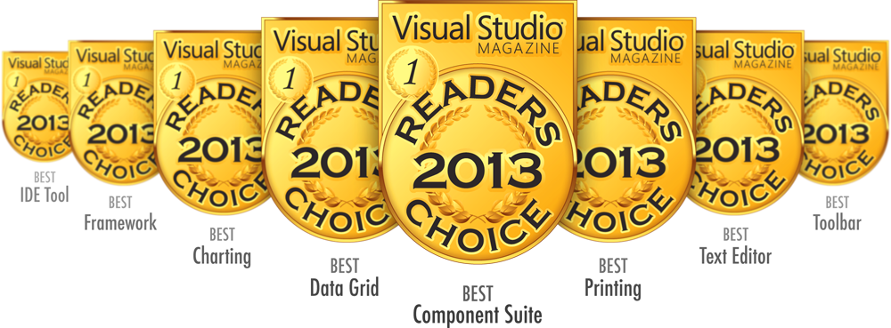

Experience the DevExpress Difference for Yourself.

Download your free 30 day trial today.

[devexpress.com/try](https://www.devexpress.com/try)

Copyright 2013 Developer Express Inc.

All trademarks or registered trademarks are property of their respective owners.