RMIT University – Assignment Cover Sheet

Course Code | BUSM4771
Course Name | People Analytics and Workforce Outcomes at CMC Global
Title of Assignment
Student name | Do Duy Thinh
Student Number | S3892620
Teachers Name | Phuong Nguyen
Group Number
Assignment due date | 26 th April 2026
Date of Submission | 26 th April 2026
Word Count | 1650 words

Declaration and statement of authorship
1. I/we have not impersonated, or allowed myself to be impersonated by, any person for the purposes of this assessment.
2. This assessment is my/our original work and no part of it has been copied from any other source except where due acknowledgement is made.
3. No part of this assessment has been written for me/us by any other person except where such collaboration has been authorized by the lecturer/teacher concerned.
4. Where this work is being submitted for individual assessment, I declare that it is my original work and that no part has been contributed by, produced by or in conjunction with another student.
5. I/we give permission for my assessment response to be reproduced, communicated compared and archived for the purposes of detecting plagiarism.
6. I/we give permission for a copy of my assessment to be retained by the university for review and comparison, including review by external examiners.
7. I/we understand that:
- Plagiarism is the presentation of the work, idea or creation of another person as though it is your own. It is a form of cheating and is a very serious academic offence that may lead to exclusion from the University. Plagiarised material can be drawn from, and presented in, written, graphic and visual form, including electronic data and oral presentations. Plagiarism occurs when the origin of the material used is not appropriately cited.
- Plagiarism includes the act of assisting or allowing another person to plagiarise or to copy my work.

I/we agree and acknowledge that:
1. I/we have read and understood the Declaration and Statement of Authorship above.
2. If I/we do not agree to the Declaration and Statement of Authorship in this context and a signature is not included below, the assessment outcome is not valid for assessment purposes and will not be included in my final result for this course.
Visit the student essentials Academic Integrity page for more information on academic integrity at RMIT, including your responsibilities, breaches and penalties for academic misconduct.

Table of Contents
Introduction 3
1. ANALYTICAL RESEARCH QUESTION 4
2. PEOPLE ANALYTICS OUTPUT 5
3.STORYTELLING 9
4. RECOMMENDATION 11
Conclusion 14
Reference List 15

Introduction
CMC Global is a leading technology and outsourcing company, offering digital solutions and software development services to clients globally (CMC Global n.d). With growth in the international market, the company acknowledges how much People Analytics is becoming paramount for the enhancement of team efficiency, talent empowerment, and strategic decision-making. For such a task, CMC Global wants to know greater details about internal workforce challenges related to career progression and employee retention. Hence, this report suggests two analytical research questions that can be derived from the provided HR dataset on the role that gender plays in managerial and compensation outcomes, and how marital status can affect employee attrition. Data visualisations and quantitative analysis will be performed using Power BI to gain insights into a solution and then provide recommendations on how it can better implement more efficient and sustainable HR practices within CMC Global.

1. ANALYTICAL RESEARCH QUESTION
RQ1: To what extent does gender influence access to managerial positions and compensation outcomes within the organisation?
Gender equality in career progression is still a paramount discussion for human resource management; especially as it applies to access to leadership and pay equity (Chang and Milkman 2020). From a theoretical standpoint, human capital theory argues that compensation and promotion decisions need to be decided based on employees’ productivity, skills, and performance (Kozioł et al. 2014). From this perspective, any differences that can be found between genders in salary or managerial representation should be accounted for by variations in measurable performance outcomes (Setyawati et al. 2022). But this ideal is often undermined by organisations which display implicit biases, institutional norms, and unequal access to opportunities which result in persistent gender disparities (Eikhof 2012). Accordingly, this research question aims to critically evaluate whether gender influences managerial advancement and compensation outcomes beyond what can be justified by performance, thereby assessing both fairness and organisational effectiveness.
RQ2: How does marital status influence employee turnover, and to what extent is this relationship mediated by engagement and satisfaction levels?
Employee turnover is a complex phenomenon impacted by both business and individual factors. Although classical economic rationalists hold that employees make reasoned cost-benefit calculations to make turnover decisions, more contemporary frameworks (like Job Demands–Resources (JD-R) model) stress the psychological causes of employee behaviour (Alla and Rajâa 2019; Roodt 2018). Within this framework, when job demands exceed available resources, workers feel stressed and have reduced well-being, which raises turnover intentions (Roodt 2018).
Marital status is a key individual element that may influence employees’ experience of job demands and resources (Koroglu and Ozmen et al. 2021). Married workers have responsibilities beyond work, such as caring for children and family obligations, which can heighten work-life conflict. If organizations do not support employees, this will result in imbalance, reduced job satisfaction and consequently increased probability of attrition (Kim and Kim 2017). So the goal of this research question is to assess whether marital status indeed influences turnover, but also whether satisfaction and engagement serve as mediating processes that account for the relationship.

2. PEOPLE ANALYTICS OUTPUT
This dataset has been gathered from 99 employee records (refer to Huebner and Patalano (2020)) and features demographic, performance, and employment-related variables. Power BI is used in generating descriptive statistics and visualizations for pattern analysis corresponding to the research questions.
RQ1: To what extent does gender influence access to managerial positions and compensation outcomes within the organisation?
In order to analyze how gender influences managerial opportunities in CMCG at greater depth, this article would firstly investigate the ratio of male to female within the CMCG.
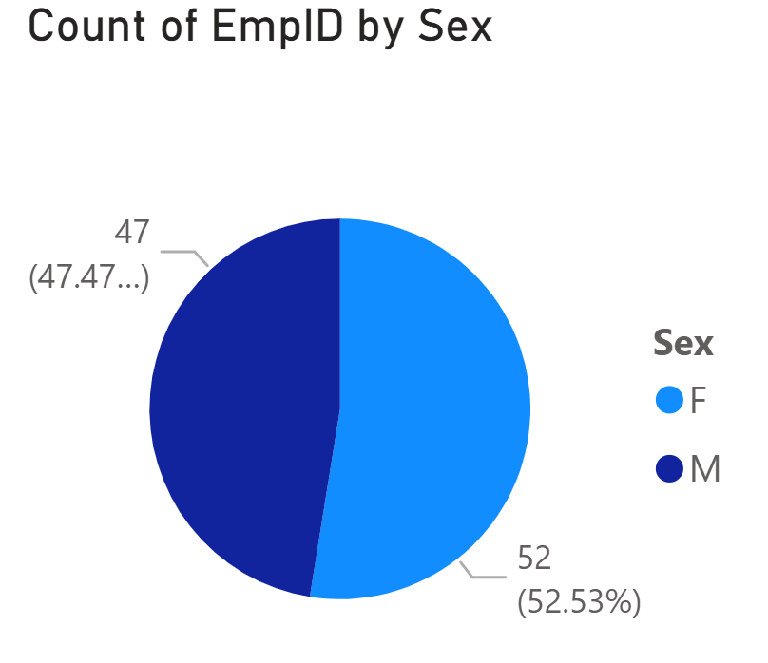
Figure 1. Gender ratio
The distribution of employees based on gender can be seen in figure 1, with 52.53% female and 47.47% male employees. It shows that entry-level gender representation is fairly equal, which means even with differences in outcomes, hiring imbalance is unlikely the root cause.
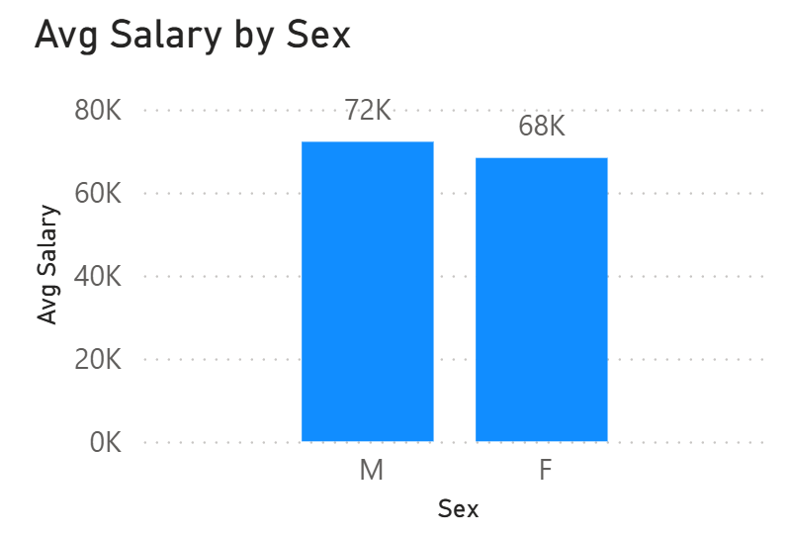
Figure 2. Average Salary by Gender
The average gender salary in figure 2 suggests that that male employees earn a higher average salary than female employees. The pattern seems suggestive that there could be a differential pay between male and female employees, but without looking at the same factors (role level, service), the actual reason for such an disparity in salary cannot yet be determined.
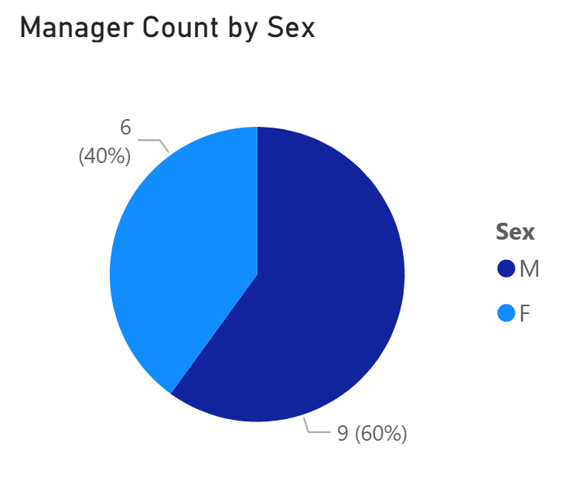
Figure 3. Manager Representation by Gender.
Figure 3 examines managerial representation by gender. Though females make up a slight majority in the workforce, about 60% of managerial positions are occupied by males. It is indicative of males being overrepresented in leadership positions, compared to the organizational picture overall.
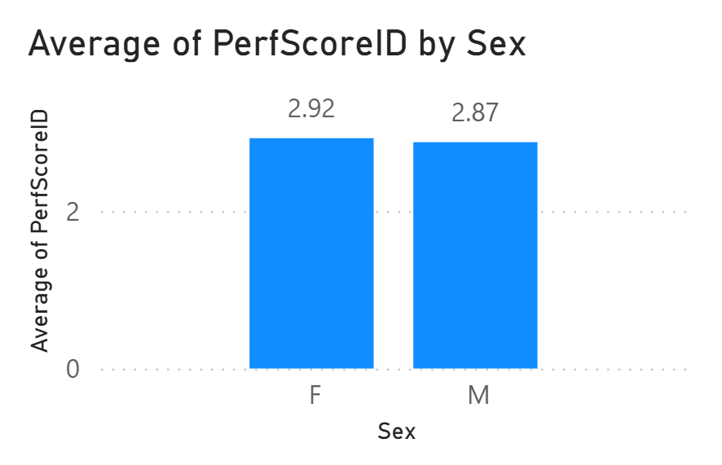
Figure 4. Average performance score by gender
Average performance scores by sex are visualized in Figure 4. On average, female employees earn a somewhat higher score (2.92) than male employees (2.87). This implies that there are performance differences that do not favor male performers.
Taken together, the patterns indicate that while gender distribution is balanced at the workforce level, disparities exist in both managerial representation and salary outcomes, with males being more represented in leadership roles and receiving higher average compensation, despite slightly lower performance scores.
RQ2: How does marital status influence employee turnover, and to what extent is this relationship mediated by engagement and satisfaction levels?
The effect of marital status on employment attrition will be examined with a perspective on the distribution of employment statuses associated with employees’ marital status. The chart below shows the proportion of employment statuses by single employee, married employee, divorced or separated group.

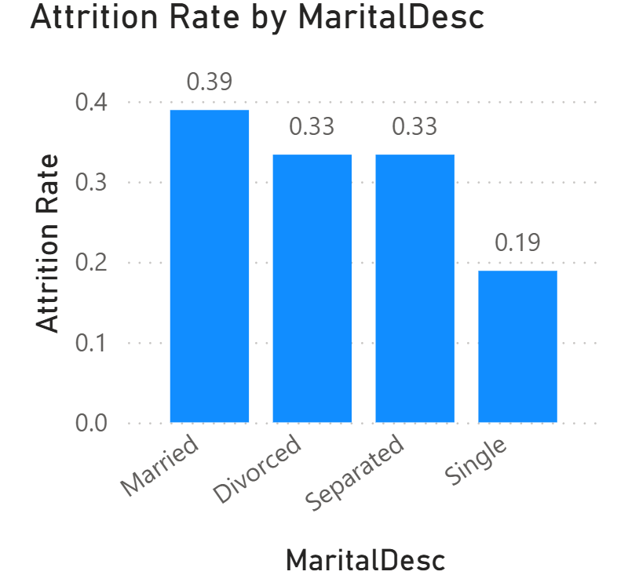
Figure 5. Attrition rate by marital status
According to figure 5, married employees exhibit a significantly higher attrition rate (approximately 39%) compared to single employees (approximately 19%). These patterns raise a concern of whether it is merely coincidence or there is actual reasonings for that.
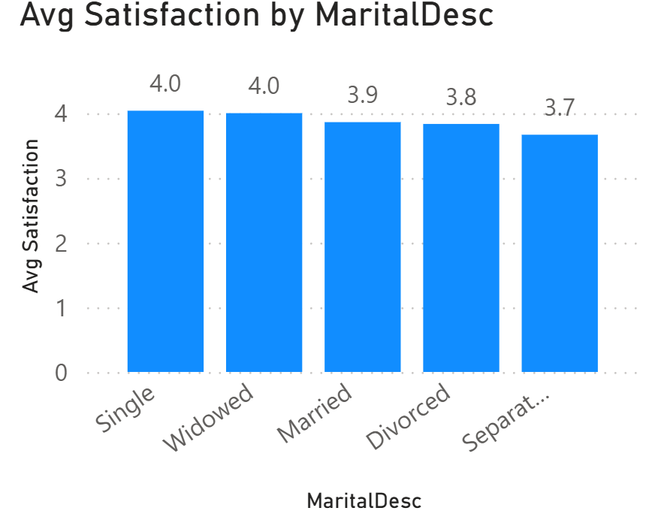
Figure 6. average satisfaction by marital status
A closer look at the average levels of satisfaction in Figure 6 shows that married employees indicate lower satisfaction (3.9) than single staff (4.0). Despite being a small gap, it indicates an employee experience distinction between the employee groups.
On the whole, the trend in the data is generally consistent, married workers tend to leave CMC more due to low work satisfaction, compared to single employees. This may mean a connection between satisfaction and turnover although interpretation is needed to identify the reasons for that relationship.

3. STORYTELLING
RQ1: To what extent does gender influence access to managerial positions and compensation outcomes within the organisation?
The findings reveal a clear disconnect between employee performance and career outcomes, suggesting that gender significantly influences both managerial opportunities and compensation within the organization. Notably, this inequity cannot be explained in terms of the performance gap which is evident in the fact that the female staff members possess a slightly better overall performance. In addition, the salary gap also raises the chances of systemic inequality. Higher pay may relate to managers, but the overrepresentation of males in those positions has to account for this pay disparity. Yet even outside of role-based salary, the continuation of a disparity implies that compensation practices also do not reflect merit-based ideals.
Limiting the advancement of high-performing female employees would also expose the organisation to the risk of underutilisation of a sizeable part of its talent pool (Semykina and Linz 2013). This can lead to a decrease in diversity of perspectives in terms of leadership, a factor that has been observed to undermine innovation, problem-solving and the quality of the overall decision-making process (Kulich and Bosak 2019). Organisational commitment and perceptions of disadvantageous promotion and compensation decrease among affected groups, and such a perception may ultimately be related to increased turnover intentions (Estrella et al. 2025). As a result, the trends shown in the data are not just an issue for equity but also a threat for efficiency and sustainability of the organisation.
RQ2: How does marital status influence employee turnover, and to what extent is this relationship mediated by engagement and satisfaction levels?
In figure5, we find a pattern that employees are much more likely to quit when married. It means the small differences of employment experience can become compounded by other contextual conditions for the effect of turnover behavior. This pattern of turnover is explained by JD-R, which states that the health and retention of employees are shaped by the ratio of job demand to job resources (Abdou et al. 2024)). Married workers have many more non-work issues — like family responsibilities — that increase their general load. When resources like flexible working arrangements, supportive management, work-life balance initiatives, etc., in the organisations are not enough, this imbalance can cause stress, less satisfaction and even leaving the organization (Ahituv and Lerman 2010).
Evidently in figure 6, married employees reported a low level of satisfaction, but we do believe this may signal early signs of the challenges of integrating work and life. Moreover, in contrast with common belief that married workers are less likely to leave as they are better prepared for family and financial problems, the data do indicate that these additional responsibilities may increase turnover rather than lessen it in the absence of adequate organisational support at the business level.
Business-wise, that is a big risk for CMC. Married employees tend to be more senior and to hold roles in their mid- to senior-level roles, so the loss of knowledge related to marriage and replacement costs can be significant (Ghayyur and Jamal 2012). Accordingly, the link between marital status, satisfaction and attrition emphasizes the need for organisational mechanisms to be in sync with employees’ changing social and professional needs.

4. RECOMMENDATION
CMCG might create a Diversity, Equity & Advancement Council (DEAC) to improve organizational diversity, especially at the executive level, in order to combat gender bias in management opportunities. By establishing a clear objective of empowering women in leadership, DEAC may modify the policies and procedures for promoting gender-diverse employees. Examples of these reforms include customized leadership development programs for high-potential female employees, adjustments to performance-evaluation standards to counteract potential biases, and the creation of mentorship programs to support female career advancement within the CMCG. Additionally, the company-wide unconscious bias awareness seminars offered by DEAC may lead to an inclusive workplace where women can be empowered both personally and professionally in a bias-free setting (Williamson and Foley 2018). However, creating a DEAC may need more time, money, and sustained effort. Consequently, CMCG might use surveys in conjunction with these campaigns to gauge their efficacy as well as the opinions of its workers on these initiatives for ongoing development and more dedication. This recommendation is related to the "Big Bet" strategy, the Complexity-Impact Matrix (Ferrar and Green 2021), since a substantial shift in workplace culture and employee attitude necessitates a substantial financial outlay (Figure 6).
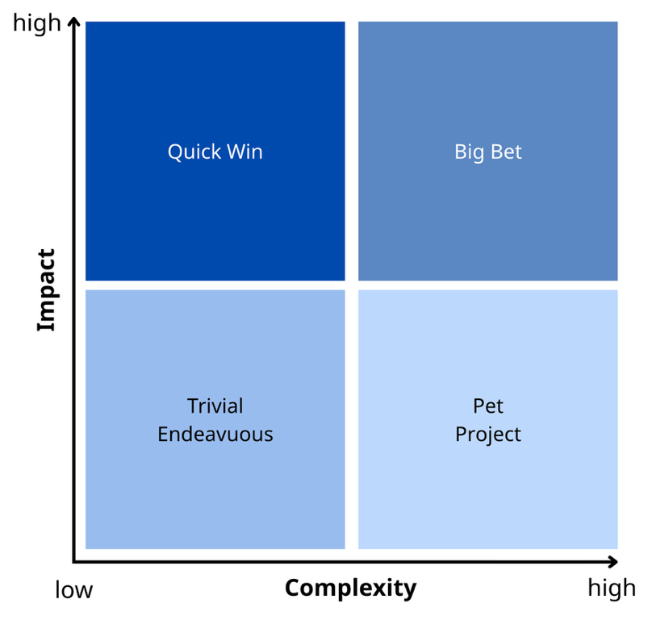
Figure 7. The complexity-impact Matrix, reproduced from Ferrar and Green (2021)
To address the turnover of married staff, CMCG might implement a number of family-friendly programs. Among them, married workers with children will be more happier with an on-site childcare facility. Additionally, flexible scheduling, like hybrid working, will improve married people's work-life balance by allowing them to better manage their time by having flexible hours to do home tasks when necessary and reducing the stress and expense associated with commuting (Rodríguez-Sánchez et al. 2020). Additionally, it has been found that open communication between managers and employees increases employee satisfaction by fostering a shared understanding of challenges (Zelnik et al. 2012). CMCG may also benefit from holding a quarterly meeting where married employees can voice their concerns and to strengthen relevant policies and benefits for married staff. Increased parental leave, all-inclusive family health insurance, and competitive compensation may be necessary to achieve this. According to Maharani and Ramli (2024) company provides working parents with improved life quality, enhanced employee loyalty, and decreased desire to quit owing to unfavorable work settings. However, adopting a family-friendly approach may result in increased expenses for an on-site daycare facility, additional incentives, and inconsistent workflows within the organization because of employees' varied work schedules. In situations when the adoption process is relatively simple, the suggested solution is a "Quick-win" (because it helps the employee quickly) (Figure 7).

Conclusion
Overall, the analysis reveals that gender disparities persist in managerial representation and compensation despite comparable performance, suggesting potential inefficiencies and bias in talent utilisation, while married employees demonstrate higher attrition rates possibly driven by unmet work-life balance needs. These findings highlight the importance of aligning organisational practices with merit-based principles and employee needs. By adopting targeted, data-driven HR strategies, organisations can enhance equity, improve retention, and ultimately strengthen long-term organisational performance.

Reference List
Abdou AH, El-Amin MA-MM, Mohammed EFA, Alboray HMM, Refai AMS, Almakhayitah MY, Albohnayh ASM, Alismail AM, Almulla MO, Alsaqer JS, Mahmoud MH, Elshazly AIA and Allam SFA (2024) ‘Work stress, work-family conflict, and psychological distress among resort employees: a JD-R model and spillover theory perspectives’, Front. Psychol, 15:1326181. doi: 10.3389/fpsyg.2024.1326181.
Ahituv A and Lerman RI (2011) ‘Job turnover, wage rates, and marital stability: How are they related?’, Rev Econ Household, 9: 221–249, doi: 10.1007/s11150-010-9101-6.
Alla AA and Rajâa O (2019) 'A Review of the Literature on Employee Turnover', American International Journal of Social Science, 8(3), doi:10.30845/aijss.v8n3p4.
Chang EH and Milkman KL (2020) 'Improving decisions that affect gender equality in the workplace', Organizational Dynamics, 49(1): 100709, doi: 10.1016/j.orgdyn.2019.03.002.
CMC Global (n.d) About us, CMC Global website, accessed 20 April 2026. https://cmcglobal.com.vn/vi/ve-chung-toi/.
Eikhof RD (2012) ‘A double‐edged sword: twenty‐first century workplace trends and gender equality’, Gender in Management: An International Journal, 27(1): 7–22, doi: 10.1108/17542411211199246.
Estrella E, Salahuddin A, Hasanudin H and Yakin I (2025) 'The Effect of Gender Equality and Job Stress on Turnover Intention with Job Satisfaction as Mediator', ECo-Buss, 7(3), doi: 10.32877/eb.v7i3.1799.
Ferrar J and Green D (2021) Excellence in people analytics : how to use workforce data to create business value, Kogan Page, Limited.
Ghayyur M (2013) 'Work-Family Conflicts: A Case of Employees’ Turnover Intention', International Journal of Social Science and Humanity, 2(3), doi: 10.7763/IJSSH.2012.V2.90.
Kim HK and Kim YH (2017) ‘Work-life conflict of married and childless single female workers’, International Journal of Manpower, 38 (8): 1157–1170, doi: 10.1108/IJM-06-2015-0089.
Koroglu Ş and Ozmen O (2022) ‘The mediating effect of work engagement on innovative work behavior and the role of psychological well-being in the job demands–resources (JD-R) model’, Asia-Pacific Journal of Business Administration, 14 (1): 124–144, doi: 10.1108/APJBA-09-2020-0326.
Kozioł L, Kozioł W, Wojtowicz A and Pyrek R (2014) 'An Outline of a Compensation System Based on Human Capital Theory', Procedia - Social and Behavioral Sciences, 148: 551-558, doi:10.1016/j.sbspro.2014.07.078.
Kulich C and Bosak J (2019) 'The persistence of gender inequality in leadership: Still a long way to go?', in Gangl K and Kirchler E (eds) A Research Agenda for Economic Psychology, doi: 10.4337/9781788116060.00015.
Maharani R and Ramli HA (2024) 'The Roles of Family-Supportive Supervisor Behaviour, Work-Life Balance, Job Satisfaction, Motivation, and Job Performance Among Married Private Employees.', Journal of HRM, 27(1): 39, doi: 10.46287/PKYK4429
Rodríguez-Sánche J, González-Torres T, Montero-Navarro A and Gallego-Losada R (2020) 'Investing Time and Resources for Work–Life Balance: The Effect on Talent Retention', International Journal of Environmental Research and Public Health, 17(6):1920, doi:10.3390/ijerph17061920.
Roodt G (2018) ‘A Job Demands—Resources Framework for Explaining Turnover Intentions’, in Coetzee M, Potgieter I and Ferreira N (eds) Psychology of Retention, Springer, doi: 10.1007/978-3-319-98920-4_1.
Semykina A and Linz SJ (2013) ‘Job Satisfaction and Perceived Promotion Equality’, Kyklos, 66: 591-619, doi: 10.1111/kykl.12038.
Setyawati NW, Woelandari DS and Rianto MR (2022) 'Career Development, Motivation and Promotion on Employee Performance', East Asian Journal of Multidisciplinary Research (EAJMR), 1(9):1957-1970, doi: 10.55927/eajmr.v1i9.1453.
Williamson S and Foley M (2018) 'Unconscious Bias Training: The ‘Silver Bullet’ for Gender Equity?', Australian Journal of Public Administration, 77(3):355-359, doi:10.1111/1467- 8500.12313.
Zelnik M, Maletič M, Maletič D and Gomišček B (2012) ‘Quality management systems as a link between management and employees’, Total Quality Management & Business Excellence, 23(1): 45–62, doi: 10.1080/14783363.2011.637781.

