FRIENDLY MOVERS PROBLEM
FRONT END
FIXED DONE – means completed
Highlighted message in yellow needs to be looked at
AFTER UPDATE – What needs doing or not working properly
MAIN WEBSITE
☒ Registration page – ONLY DRIVERS CAN REGISTER. - FIXED DONE
☒ Footer Links – All links must be linked to their respectable page. – Not all pages are linked and not all PAGES are created - FIXED DONE
Let’s Chat section
☒ Let’s chat section – Please add an option for clients to put their mobile number , but as it UK, it needs to be 11 digit numbers and not 12 digit number FIXED DONE
☒ Let’s chat section - When client click send – A (Thank you email) should be sent to customer alerting them that we have received their enquiry and we will get back to them shortly. – EMAIL TITLE WHICH IS SENT TO CUSTOMER STATED THAT THERE BOOKING HAVE BEEN CANCELLED - FIXED DONE
Booking system - Process
GET POSTCODE/ADDRES DETAILS – Getaddress.io
☒ Getting postcode – REMOVED GOOGLE API COMPLETELY AND REPLACE WITH GETADDRESS.IO API as the default. FIXED DONE
☒ Getting postcode – Now that GETADDRESS.IO API is set as default – when click on the button to switch then Postcode.io will be the Backup. - THIS BUTTON IS ONLY FOR TESTING PURPOSES AS THIS SWITCH IS DONE IN THE BACK END BY ADMIN. FIXED DONE
☒ Gather postcode using GETADDRESS.IO API – This should (AUTO FIND ADDRESS) without client having to CLICK SEE PRICES – They should just start typing postcode or area and the information is coming up automatically and customer can select the desired address they would like without having to click another button to be brought to another section to then select again. https://getaddress.io/ and select auto search on the home page and test it and you will see what im talking about. - FIXED DONE
☒ Gather postcode using GETADDRESS.IO API – Now that the site is pulling the information, its not pulling displaying all the finding, IT WOULD SEEN THAT YOU HAVE LIMITED THE RESULTS TO ONLY (6)
So if you put se136pp, there is 8 separate address at that postcode, however the suste is detecting only 6, I check this on the Getaddress.io website and its displaying all 8 address, So I can confirm that maybe you have limited how much result to display. DONE - FOR SOME REASON IM NOT GATHERING THE FULL POSTCODE LIST FOR THIS POTCODE (Se17 1ny) there is 46 address on that road, however im only shown 40 address, however on the wesite https://getaddress.io/ I got all 46 postcodes.,,, so whatever you done before to release the limitation please look ingot it again show it shows the entire list of address registered
GET POSTCODE/ADDRESS DETAILS – postcode.io
☒ Getting postcode with postcode.io – When customer enter postcode, then posdcode.io will check is the postcode is valid, if not valid the postcode which is giving the problem will be highlighted red. - FIXED DONE
☒ Getting postcode with postcode.io – When customer enter postcode and all are VALID are correct then a enpty box will appear asking customer to fill in the remaining address manually then click button to continue to booking system OR ON THE NEXT PAGE WE CAN PROVIDE THE BOX FOR THE CUSTOMER TO ENTER THE DETAILS. – A BOXED APPEARED BUT THIS BOX HAS PREDEFIND INFORMATION INSIDE, WHICH IT (SHOULD NOT) – THIS SHOULD JUST BE A BLANK BOX TO WHICH ALLOWS THE CUSTOMER TO ENTER THERE DETAILS MANUALLY. FIXED DONE
ADDRESS INFORMARTION
☒ ADDRESS INFORMATION – WHEN ENTERING THE POSTCODE AND READY TO CLICK THE (SEE PRICE BUTTON) ITS NOT CLICKABLE ONLY AT SOME AREA WHEN USING GETPOSTCODE.IO
☒ Address information basic info – at the top of the page going on the horizontal line, can we have a copy of the basic information up there: Drive time – Total mileage - FIXED DONE
☒ Address information- DRIVE TIME - This affects the hours section as well which change the price. – I CAN’T SEE THIS WHAT SO EVERY. ALMOST DONE – If the drive time is
☒ Address information- DRIVE mileage - This affects the total price. – DONE – but the mileage is not the same when checking on Google – example SE4 2FN TO EH1 1AE – IS 400+ MILES, BUT THE SYSTEM IS SAYING ITS 333 MILES – SO ITS BASICALLY ALMOST 67 MILES OFF WHICH WILL COST $67 IF WE GET IT WRONG. FIXED DONE
☒ Address information – Put a copy of the address gather in their section: Pickup address & drop-off address & any additional stop address. – So customer can see that the information they entering is related to the specific address.- It’s done in the total booking price section when viewing it via mobile the customer would need to scroll down bottom to see it. What I want this just a copy of the address to be place in the respected area. 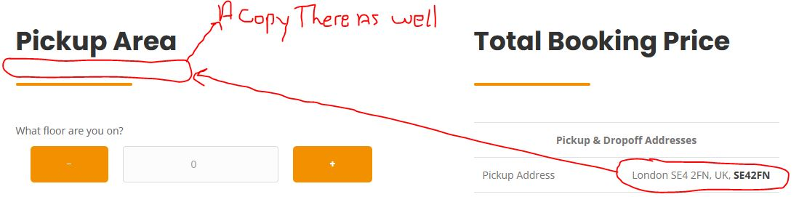 FIXED DONE
☐ Address information – AUTO DETECT IS POSCODE IS WITHIN CONGESTION ZONE OR ULTRA LOW EMMISION ZONE. – I Can’t see this whatsoever – DONE – JUST NEEDS TO ALSO DETECT ULEZ ZONE AS WELL: ULTRA LOW EMMISION ZONE (outside the Congestion zone).
☒ MOBILE USER – User unable to (SEE) how many stairs they have selected.
MILEAGE/DISTANCETIME SECTION
☒ Distance time section - This is not calculating properly, for instance SE136PP TO SE42FN is about 10, Another example se136pp to sw166pp is 30 minutes minimum drive time but our system is saying 10 minutes’ drive time?? Impossible - FIXED DONE
☒ Mileage section – this is ok, but not quite accurate, example the distant between se136pp to se42fn should be about 2.1 miles - 2.2 miles…..Another example se136pp to sw166pp is 8 miles minimum but our system is saying 6.2 miles? - FIXED DONE
DATE AND TIME & CUSTOMER INFORMATION
☒ DATE – ALLOWS CUSTOMER TO SELECT DATE ON THIS PAGE - FIXED DONE
☒ TIME – ALLOWS CUSTOMER TO SELECT TIME ON THIS PAGE - FIXED DONE
☐ TIME – all time should be within an hour’s intervals example: customer would like to book for 13:00, however we provide a 1 hour interval so another option will appear asking for which time slot from customer: between 12:00-13:00 or 13:00-14:00. – I Can only see 1 solid time online example 15:00, 16:00, 17:00, however it was meant to be between 13:00-14:00 or 14:00-15:00 time slot etc….
☒ Customer information – we will them ask customer for – FIX DONE
☒ customer information – A copy of the user (PICKUP ADDRESS) shold be added in this box as default and if they want to change it then can manually. 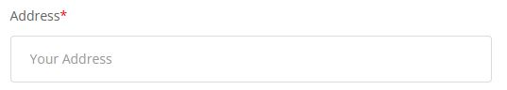TO THE
VAN SIZE & WORKERS
☒ VAN SIZE – Please if we can have the Van image as well so customer can see the size van – Need to have the van icon then customer is selecting the van FIXED DONE 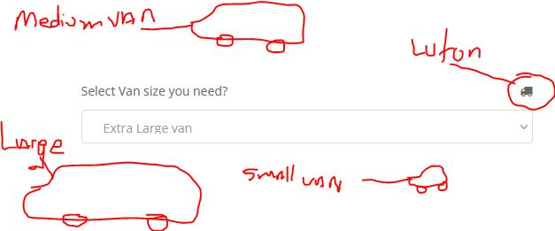
☒ VAN SIZE – once customer select the size van needed – please allow an information ICON to appear. - FIXED DONE
☒ VAN SIZE – INFO ICON – If customer clicks the icon, a pop up box will appear showing them a decent picture of the size of the van with all the van information – size, dimension-loading capacity seats..- FIXED DONE
☒ VAN SIZE minimum hours – there is a 2 hours minimum booking for small, medium and large van…. All other van are 3 hours minimum booking - which should affect the Total hours section. –DONE – but if I select a luton van which requires 3 hours then I select a small van which requires 2 hours THEN THE HOUR VALUE DON’T CHANGE, IT JUST STAYS ON 3 HOURS EVEN THOUGHT I SELECTED SMALL VAN WHICH IS 2 HOURS MINIMUM. - FIXED DONE
☒ WORKERS – Please if we can have basic worker stick man image so the customer can see a visual example of what they are ordering. –but on the driver+ helper the icon is of a man and a woman….this just needs to be 2 MAN - FIXED DONE
☒ TOTAL HOUSRS – This should starts from a minimum of 2 hours – The van selection also modify this option, - FIXED DONE
☒ TOTAL HOUSRS – Please have predefine settings in list of 2,2.5,3,3.5,4,4.5,5,5.5,6,6.5,7,7.5,8,8.5,9,9.5,10,10,5,11,11.5,12 - FIXED DONE
☒ TOTAL HOURS – When select any of the solid number (2-3-4-5-6-7) the system calculation goes crazy???? – if I should select number 4 then the calculation might be $1900 when it should be $80. - FIXED DONE
INVENTORY/SERVICE/ – what we are moving
☒ Remove this section which said (select area you want to move) - FIXED DONE
☒ Service you want - this section shouldn’t be here, it was meant to be in the postcode section, above similar to how you have that box above to switch the postcode api. FIXED DONE
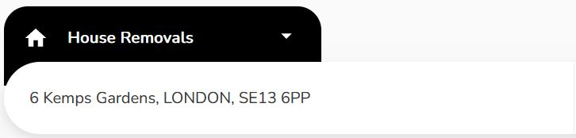
CUSTOMER INFORMATION
☒ Customer should never be able to sign up – System will Generate this information for them on their booking confirmation – THEY WONT HAVE PASSWORD TO LOGIN – but they can use their email address and booking reference to track booking - FIXED DONE
☒ Customer information – Collect customer name. FIXED DONE
☒ Customer information – Collect customer Email FIXED DONE
☒ Customer information – Collect customer number FIXED DONE
BUTTON TO GO TO THE NEXT PAGE--- Lead generated at this point. FIXED DONE
☒ Customer Information – MOBILE USER unable to type in address because the system is forcing the NUMBERS SECTION ON THE PHONE
☒ Customer Information – please put a copy of the Pickup address inside this box and allow the customer to change it them self if they want too.
Summery page
☒ layout all the client information and booking details. – CLIENT NAME AND NUMBER IS MISSING
☐ Summary page – Client can also have option to change size van – workers and hours here for quick -
price update.
☐ Summary page – Client can fill in there last name and address check details is update
PAYMENT SECTION
☐ Customer make payment via card or Pay-pal – DONE – payment needs to be added
☒ Customer to pay DEPOSIT OR FULL PAYMENT - FIXED DONE
Admin panel

Message section – Please change to (website Messages)
☒ Massage section – Needs a notification bubble which tells you that something just came in or needs to be done.  FIXED DONE
☒ Massage section - Admin/staff should be able to deleted messages. FIXED DONE
☒ Massage section – when deleting messages, there should be a pop up asking if you are sure? FIXED DONE
☒ Massage section – should be a recycling basket which hold deleted information for 7 days
Events section
☒ Event section – Needs a notification bubble which tells you that something just came in or needs to be done. FIXED DONE
☒ Event section –message keeps poping up on when you click on EVENTS saying: 3 - might be a debug code?? - FIXED DONE
☒ Event section – When displaying the job in the EVENTS CALENDAR use basic info such as: [How man guys] [size van] [pickup postcode] [dropoff postcode] Example: Booking: 2 man Luton van E36DD TO SW10 6DD – not done yet fully, just need to add it to the front before we click on a booking: Booking: 2 man Luton van E36DD TO SW10 6DD INSTEAD OF THIS: Booking: unit c first floor FIXED DONE
☒ Event section – ON click on a job, the information you have is good so far…just also need to add the amount of [workers booked] [size van] [how many hours] FIXED DONE
☐ Event section – need to have a log as to what’s been edited, change and so on….
☒ Admins/staff should be able to add a new booking to the calendar - ITS DONE BUT WHEN CLICK ON AD NEW BOOKING THERE IS A GREY SCREEN WHICH OVERS THE APPLICATION AND IM UNABLE TO CLICK OR DO ANYTHING. - FIXED DONE
☒ Event section – accurate time is not being displayed in the Job brief. – When CLICK to view job a box appear, However the job booking is still showing 12:00 when the actual time is 14:00 FIXED DONE
☒ Event section – admin/staff unable to see on the calendar the booked jobs and note when CLICK (since update 06-04-2022) FIXED DONE
☒ Event section – when you click (Add Event) and the box appear – the X button don’t work and the Cancel button don’t work. FIXED DONE
☒ Event section – when you click (Add Event and select ADD NEW BOOKING) a grey fling appears over my screen which Don’t allow me to Click or do anything. and it stays on my screen even if I click another MENU, it only disappear when I click refresh or F5. - FIXED DONE
☒ Event section – when admin click on the a job, ad option should also show, to copy partial information which include: date-time-van size-helpers-pickup postcode info-dropoff postcode info. FIXED DONE
☒ Event section – when admin click on the a job, ad option should also show, to copy (FULL) information which include: date-time-van size-helpers-FULL pickup ADDRESS info-FULL dropof ADDRESS info, Client name- client number –special instruction. FIXED DONE
☒ Event section – I can’t click on the booking/notes or any information in the even section FIXED DONE
☒ Event section – When click ADD NEW BOOKING and I’m on the booking page I cant search for postcode, when POSTCODE.IO is set as default. FIXED DONE
☒ Event section – if postcode.io is selected in the settings are as default, then this will take over throughout the system. Which includes all the section. FIXED DONE
Client section
☒ Massage section – Needs a notification bubble which tells you that a new client has been added. FIXED DONE 
☐ Client section – need to have a log as to what’s been edited, change and so on….
☒ Client section – admin/staff reset password, however NO EMAIL IS SENT TO CUSTOMER REGARDING PASSWORD CHANGE FIXED DONE
☒ Client section – admin/staff ENTER NEW PASSWORD, HOWEVER WHEN TRY TO USE NEW PASSWORD IT DOESN’T WORK. - FIXED DONE
☒ Client section/ Login section – admin/staff ENTER NEW PASSWORD, HOWEVER WHEN TRY TO USE NEW PASSWORD IT DOESN’T WORK. - FIXED DONE
☒Client section – when click ADD invoice Nothing happen, just bring you to a blank page.- Still bring me to a blank page FIXED DONE
☒Client section – when click ADD ADD BOOKING I put all the details which is required and click to add the booking, However nothing happens, please have a look as this was working before. FIXED DONE
☒ Client section – admin/staff unable to edit client information
Driver section
☒ Massage section – Needs a notification bubble which tells you that a new driver has been added. FIXED DONE 
☐ Driver section – need to have a log as to what’s been edited, change and so on….
☒ Driver section – admin/staff reset password, however FIXED DONE
☒ Driver Login section – Driver can see job, But driver is unable to accept the job – NEED TO BE ABLE TO ACCECTP AS WELL WHEN DRIVER IS INSIDE THE BOOKING DETAILS CHECKING. - FIXED DONE
☒ Driver Login section – when driver accepts jobs, He can’t see customer detail – NOT DONE, HES UNABLE TO SEE CUSTOMER NAME AND NUMBER FIXED DONE
☒ Driver section – when driver register, welcome email is not sent. – FIXED DONE
☒ Driver section – when click ADD invoice Nothing happen, just bring you to a blank page. – FIXED DONE
Service section
☐ Service section TAGS – what exactly does this do????
This is what I am after, its Google SEO meta tile and meta description
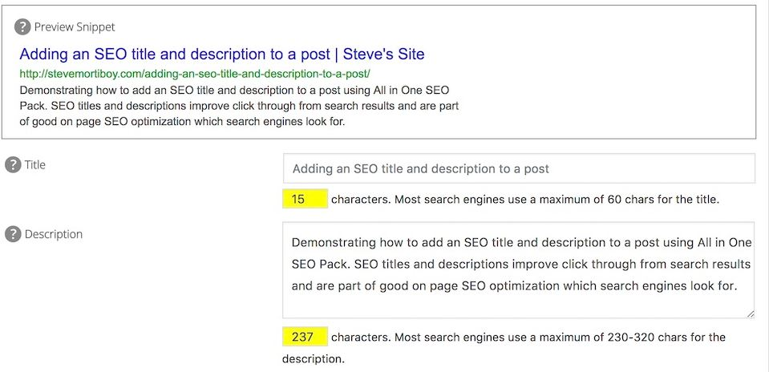
IS THE META TAGS THE SAME THING?
Blog section
☐ Blog section articles – all articles much have a keyword section for the SEARCH ENGINE/SEO… Meta title – Meta description - Meta keywords; where is this section done as I can’t see it.

IS THE META TAGS THE SAME THING?
Area section
Price section
☒ Price section – when click edit prices – there is a duplicate (Per Mile Price), however I think the second (Per Mile Price) should be change to (Per stairs) - FIXED DONE
☒ Price section – when click edit prices – unable to ad price at $12.5 or anything that has point something added at the end? - FIXED DONE
Note section
☒ Note section – Doesn’t tell you where the note was added or on which Person, client or driver. NOT DONE, AS I CANT SEE WHERE THIS NOTE WAS ADDED - FIXED DONE
☒ Note section – Option to click view note, and this will bring you diretly to the area where the note was place. FIXED DONE
☒ Note section – when you click EDIT note and try to close the box by press the X sign or the CANCEL button nothing happen. - FIXED DONE
Task section
☒ Massage section – Needs a notification bubble which tells you that a new task has been added. FIXED DONE 
☒ Task section – admin/staff should be able to ASSIGN ANOTHER STAFF MEMBER TO do task - FIXED DONE
☒ Task section - Please add a box inside the task for MORE INFORMATION --- As at the moment it only have just the TITLE to add all the information. – FIXED DONE
Booking section
☒ Massage section – Needs a notification bubble which tells you that a new booking has came - in. FIXED DONE 
☒ Booking section – Admin/staff should be able to mark job as priority – doesn’t work well, because drivers is not seeing job as priority and it’s not showing up in calendar as priority – and its now showing in driver available jobs as priority. FIXED DONE – MAYBE COULD MAKE THE COLOR OF THE PRIORITY STAR RED FIXED DONE
☒ Admin/staff should be able to add a new job to the system – working but something is wrong with the calculation. – FIXED DONE
☒ Admin/staff should be able to cancel job – this is working but we need to add (ARE YOU SURE CONFIRMATION ) – FIXED DONE
☒ BOOKING – Customer made booking but no booking email was sent of booking details. FIXED DONE
☒ BOOKING – estimated travel time is not being calculated into the price. – This is still not being done. FIXED DONE
☒ BOOKING – when inside the booking and a driver as accepted the job, it should have driver name beside the job for all to see.: Driver (driver name) Assign. – FIXED DONE
☒ BOOKING – when inside the job and you click (Booking list) it goes to a blank page. – FIXED DONE
☐ BOOKING – when admin/staff edited a confirmed booking – nothing is actually changing whatsoever, please check it out as this needs to be done for the updated email to work properly in the EMAIL SECTION
Lead section
☒ Lead section – admin/staff Unable to send email to client – FIXED DONE
☒ Lead section – When click EDIT, admin/staff unable to change/edit and delete parameters, time, address, hours, items. FIXED DONE
☒ Lead section – When click EDIT and change anything, the CALCULATION STOP WORKING AND SHOW ($NAN) - IF YOU TYPE SOMETHING INTO THE (Mid Point Address) example (SE4) then you delete it SE4 then EVERYTHING IN THE LEAD INFORMATION STOP WORKING???
☐ Lead section – When click EDIT and change anything UNABLE TO SAVE NEW SETTINGS –Done – when you click save it dosnt do it straight away, and I don’t know if the its actually working so I start clicking it multiple time -so please if possible, add a something indication that the process is acutally happening
☐ Lead section – When click SAVE THIS SHOULD ONLY SAVE THE NEW SETTINGS INTO THE SELECTED (LEAD ONLY) AND NOT DO ANYTHING ELSE. … There will be another button to simple converter lead into booking.
☐ Lead section – inside the LEAD information – Please (ADD BOTTON) to convert the lead into client/booking, call it (SUMBIT BOOKING) - Also please let system ask (ARE YOU SURE YOU WANT TO SUBMIT THIS BOOKING)
Invoice section
☒ Invoice section – admin/staff be able to search for the invoice need manually. – FIXED DONE
☒ Invoice section – Invoices are not being sent to client/drivers to alert them. – FIXED DONE
System settings section
☒ System setting section – all email templates is not creates https://rise.fairsketch.com/email_templates - this should include: FIXED DONE
☐ Email template Account - Login info - Reset password - Team member invitation - Client email verification - New client greetings - Client contact invitation - Client email verification – Not done as yet, as I can’t see anything.
☒ System setting section – admin should be able to edit and modify all email templates FIXED DONE
Payment Module section - settings
☒ Payment Module section – User unable to select half payment and complete their booking as system refuse to process this option. FIXED DONE
☐ Payment Module section – admin should be able to Modify and setup new payment module details.
☒ Payment Module section – admin should be able set the amount of deposit he would like----10%,20%,30% etc…. FIXED DONE
☒ Payment Module section – admin should be able set the amount of tax to be added to the bill for customer when checking out. FIXED DONE
Email section - SETTINGS
☒ Email section Client – When driver accept the client job the wrong email is being sent to the client. System is sending the driver accepted email, but instead the system should send to the client: Booking accepted by Driver, and them provider there contact details. – Not done as yet
☐ Email section Client & DRIVER – Admin has updated the booking information; however none of the parties was informed of the update on email?? - DONE - BUT WHAT ADMIN UPDATED IS NOT CHANGE ON THE SYSTEM AT ALL, NEED LOOKING INTO.
☒ Email section – Admin should have access to all the email templates and have the ability to edit and modify the information with also (shortcode) https://rise.fairsketch.com/email_templates FIXED DONE
☐ Email section Client – No email is sent to client when driver is assign to a job, so I believ the email section is not working properly. (THERE MIGHT BE MORE ISSUES WITH THE EMAIL BUT IM UNABLE TO CHECK AT THE MOMENT)
Address Api - SETTINGS
☒ Address API section – admin should be able to change/add/setup NEW Api Key easily for the system to work. – FIXED DONE
☒ Address API section – It’s finding the address Brilliant, however there is a lot of these symbols in the address(,,,,,,,) those need to be removed. - FIXED DONE
☒ Address API section – when the address the actually being logged into the system for it to be calculated, the POSTCODE needs to be present as well. - FIXED DONE
☒ Address API section – When user is entering postcode inside the (blank box) the auto search feature should be USED, and the system will automatically find the address the customer want to choose.- DONE - THIS IS ONLY FOR THE GETADDRESS API.
☒ Address API section – we can remove the Google API SECTION AND REPLACE IT WITH THE GETADDRESS.IO SECTION, Once that is done the the postcode.io will be the back up. - FIXED DONE
☒ Address API section – WHEN TRYING TO ADD NEW BOOKING IN THE BACK GROUND AND POSTCODE.IO IS SELECTED, THE SYSTEM IS NOT FINDING THE POSTCODE OR DOING ANYTHING. FIXED DONE
Notification section – SETTINGS
This controls the emails which is being sent and when to sent the emails.: https://rise.fairsketch.com/settings/notifications - FIXED DONE
Ticket section
☒ Massage section – Needs a notification bubble which tells you that a new ticket has been created FIXED DONE 
☒ Ticket section – Admin/staff/driver is unable to REPLY/SEND message on a open ticket - FIXED DONE
Role section
☒ Role section – Admin is unable to delete roles. - FIXED DONE
☒ Role section – When Role permission (ALLOW *** ) is selected – Staff in that category should only be able to browse the assign service linked to that category, however unable to modify or edit. HOWEVER IN IN THE EVEN SECTION AND CLCIK CLICK TO VIEW CUSTOME INFORMATION AND CLICK SEE MOREINFORMATION, STAFF THEN CAN MODIFY AND CANCEL JOB AND ASSIGN DRIVERS WHICH SHOULD BE ALLOWED IF THE PREMISION IS OFF. IF ONLY THE ALOW SECTION IS SELECTED THEN THE ABILITY TO CLICK SEE MORE INFORMATION SHOULD BE DISABLED FOR THE STAFF.ADMIN UNDER THAT GATEGORY - ALMOST DONE
☒ Role section – When Role permission (ADD) is unselected - FIXED DONE
☒ Role section – When Role permission (ADD ) is unselected – BUT (UPDATE IS SELECTED) FIXED DONE
☒ Role section – When Role permission (UPDATE) is unselected – this removes the ability to actually view the assign service: example DRIVERS section
☒ Role section- ALLOW FRONT PAGE – no permission works here – ADD-UPDATE OR DELETE none of these work.
☐ Role section - ALLOW BOOKING – when click to view the booking - permission needs to be added ASISGN BOOKING & CANCEL BOOKING
☒ Role section - ALLOW EXPENSES – THERE IS A DUPLICATE CATEGORY HERE. – FIXED DONE
Team section
☒ Team section – admin/staff unable to delete team account.- FIXED DONE
Activity log section
☐ Activity Log section – who tell you WHAT EXACTLY WAS DONE TO WITH WHOM
Email section
☐ Email section – when a driver is assign to customer – NO EMAIL WAS SENT TO CUSTOMER WITH UPDATE AND DRIVER DETAIL.
☐ Email section – booking confirmation email is not sent to the customer when they book.
☐ Email section – Email template – the short code is not working properly (Total Price: {TOTAL_PRICE})
Front page section
Expense section
☒ Expense section – When you click to EDIT an expense – admin/staff unable to click X sign to close the menu or unable to click the CANCEL button to close the menu. - FIXED DONE
Profile section
Yours message section
☒ Your message section section – Needs a notification bubble which tells you that something just came in or needs to be done. FIXED DONE
☒ Your message section – when message is created and the chat begins – on the left at the top it says (TICKETS) - FIXED DONE
☒ Your message section section – Need the option to deleted message all messages - FIXED DONE

