This document contains the raw info dump or brain dump I did while doing the project. I tried to document all errors, troubleshooting, features, and steps that I felt important and informational so this is mainly where my other documentation files are built upon.

----------------------------------------------------------------------------------------------------------------

First connection of router and switch is not connected (shown as red) when checking via hover and doing the commands enable and show interfaces status,
it shows that the router’s ethernet interface is administratively down. That's why even though there's a cable connected, there are no actual connection between the router and switch

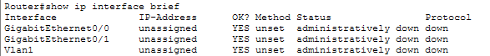

To solve it, i enabled the router’s GigabitEthernet0/0 to no shutdown:
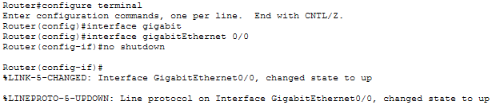
Now its up
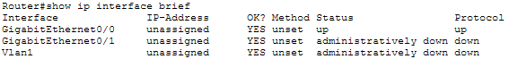

At the moment, i have this current structure

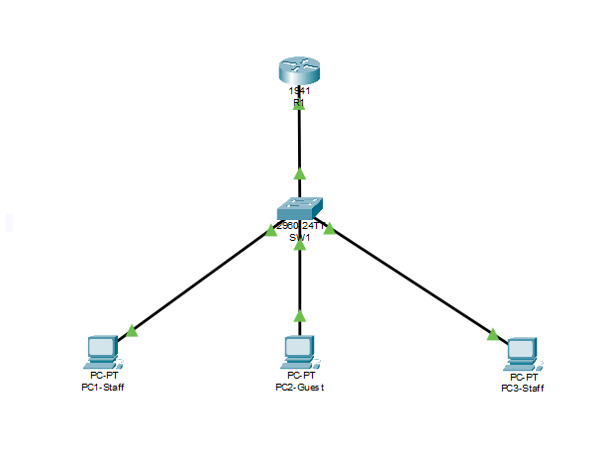
The interfaces connected are specified as follows:

R1 (GigabitEthernet0/0) ↔ S1 (GigabitEthernet0/1)
S1 (FastEthernet0/1) ↔ PC1-Staff (FastEthernet0)
S1 (FastEthernet0/2) ↔ PC2-Guest (FastEthernet0)
S1 (FastEthernet0/3) ↔ PC3-Staff (FastEthernet0)

The network is mainly separated into 3: staff, guest, and management vlan. But I will skip on the management part for the meantime to properly understand the connection between the two first. I will also configure dhcp later on to make use of dynamic ip assignment based on the separation of the vlans.
Their separation will be as follows:

VLAN | Name | Network address | Subnet mask | Default gateway
10 | Staff | 192.168.10.0/24 | 255.255.255.0 | 192.168.10.1
20 | Guest | 192.168.20.0/24 | 255.255.255.0 | 192.168.20.1

With the vlan and port separation, I now have this table which I'll use as a reference from this point onwards.

Switch Port | Connected Device | Port type and VLAN
Fa0/1 | PC1 (staff) | Access, VLAN 10
Fa0/2 | PC2 (guest) | Access, VLAN 20
Fa0/3 | PC3 (staff) | Access, VLAN 10
Gi0/1 | Gi0/1 (router) | Trunk, VLAN 10 & 20

Now, ill create and name 2 vlans (10 and 20) to serve as the vlans for staff and guest:

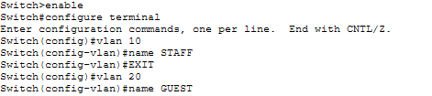

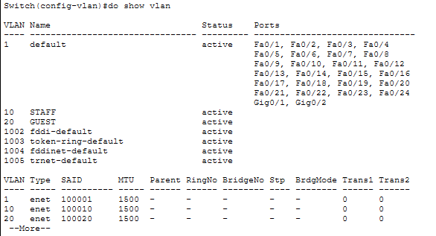

After creating vlans, ill assign the appropriate ports to their vlans to segregate them based on their functions

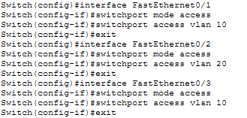

And confirm the current vlans

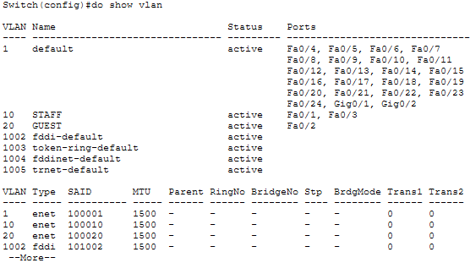

Next is to configure the connection port of the switch to the router and specify that the mode is trunk since there are 2 vlans present and must carry traffic for the 2

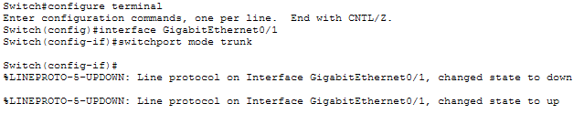

And confirm the connection

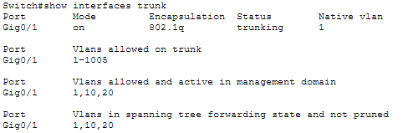

Next, I'll configure the router’s interface to enable the routing of traffic between multiple vlans using router-on-a-stick but first, will check that the router’s interface is enabled

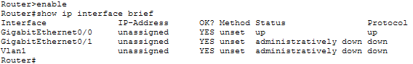

Now since GigabitEthernet0/0 is up, i will create a subinterface and associate it to vlan10 (staff) and give it a default gateway

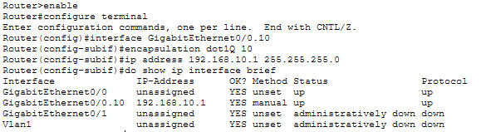

And do the same for vlan20 (guest)

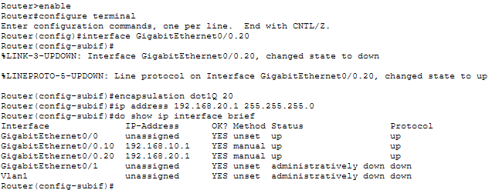

Now, i will setup the dhcp pool on the vlan10 (staff) first to specify what subnet it should serve and the default gateway it will give to the PCs that want to connect under the subnet
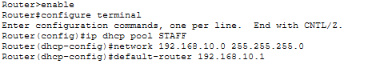

I will also specify the excluded IP addresses which are the default gateway address of the router’s subinterfaces 0.10 (vlan10) and 0.20 (vlan20)

Next, I will do the same process to the vlan20 (guest)

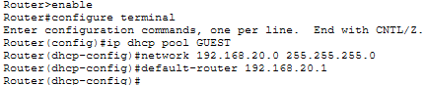

To confirm everything I did in the router so far, I used the command ‘show running-config | section dhcp’

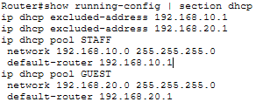

This shows the excluded addresses, and the dhcp pools of VLAN10 (staff) and VLAN20 (guest) with their default gateway as intended.

Now, I will configure the 3 PCs in the network to enable automatic IP configuration with the help of DHCP. Currently, these are the addresses that each PCs received.

PC | VLAN | IP address | Default gateway
1 | VLAN 10 - STAFF | 192.168.10.2 | 192.168.10.1
2 | VLAN 20 - GUEST | 192.168.20.2 | 192.168.20.1
3 | VLAN 10 - STAFF | 192.168.10.3 | 192.168.10.1
The current configuration allows PCs within the same VLAN to communicate directly through the switch. PCs in different VLANs can also communicate with each other through the router's subinterfaces, which provide inter-VLAN routing.
To further develop the network security configuration, I will implement an Access Control List (ACL) on the router to filter inter-VLAN traffic according to the following policies:

- STAFF to STAFF = Allowed
- STAFF to GUEST = Allowed
- GUEST to GUEST = Allowed
- GUEST to STAFF = Denied

To implement this, the following commands are executed to create and define the ACL filter:

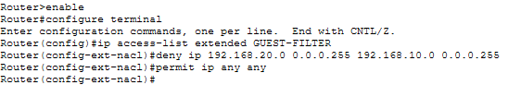

And the following commands are executed to apply and implement the defined ACL filter to the router’s subinterface 0.20 which is the VLAN 20

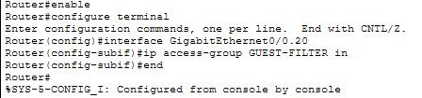

To test the ACL in play, I will ping PC1 from PC2 and vice-versa

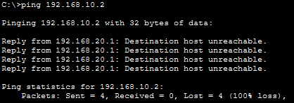

It correctly blocks the traffic from PC2 to PC1. I’ll try the same from PC1 to PC2

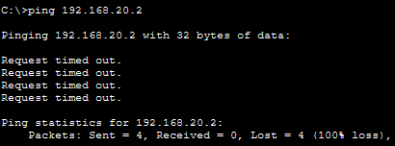

The ping displays a different result than before. To understand why, PC1 sends an ICMP Echo Request to PC2 through the router, entering via subinterface Gi0/0.10 and leaving via Gi0/0.20. The router permits this request.

When PC2 sends an ICMP Echo Reply, the packet enters the router through subinterface Gi0/0.20 and is evaluated by the inbound ACL. Its source IP address is 192.168.20.2 (PC2 in VLAN 20), and its destination IP address is 192.168.10.2 (PC1 in VLAN 10). Because the ACL denies IP traffic from the VLAN 20 subnet to the VLAN 10 subnet, the reply is blocked, causing PC1's ping to time out.

To solve this, I need to adjust the definition of the ACL filter and specify that it should allow echo replies to pass through since it was initially defined as ‘deny ip’ only which is a generic rule to block off any traffic related to IP

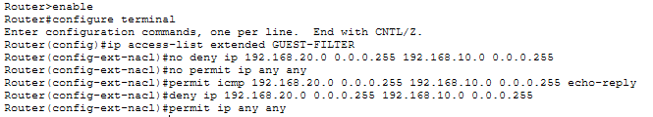

Checking again the ping from PC1 to PC2 shows the expected output

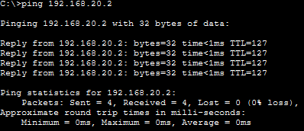

And PC2 to PC1

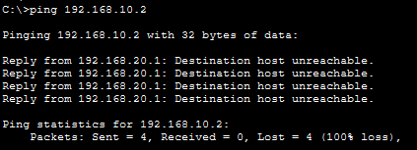

This now means that when PC1 pings PC2, PC2 is allowed to echo-reply as defined in the ACL filter. But when PC2 pings PC1, it gets blocked immediately since it passes through the subinterface 0.20 where it gets dropped immediately but this doesn’t automatically mean that all reply traffic from STAFF initiated sessions from GUEST will be permitted.

To improve the current network simulation, I will add some features to serve as practice and learning on how things work. This time, I will add a DNS server. Optimally, it could be in its own VLAN but for this project, I will connect and assign it under VLAN10 to make use of the ACL filters I defined earlier and modify it to allow certain types of traffic.

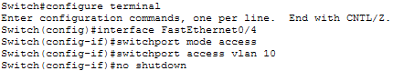

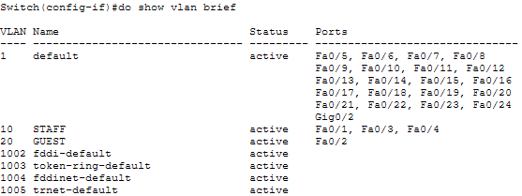

Next, I will assign it a static IP address, subnet mask, default gateway, and dns server address to make sure that we are putting addresses that are predictable.

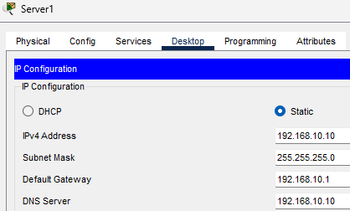

I assigned the server a static IP address to ensure that the clients that try to reach the server when it's configured into a DNS server would have the same IP as opposed to having it assigned by DHCP which might change its IP after some time. Additionally, I will also exclude that static IP to avoid it being reassigned to other clients by DHCP.

To test the setup, I pinged the gateway of VLAN 10 from the DNS server. This means that the server could reach it and work as expected.

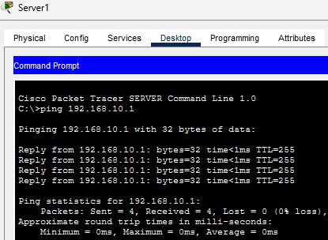

I will now turn the server into a DNS server and add a record I can use to simulate the resolving of domain names to IP addresses.

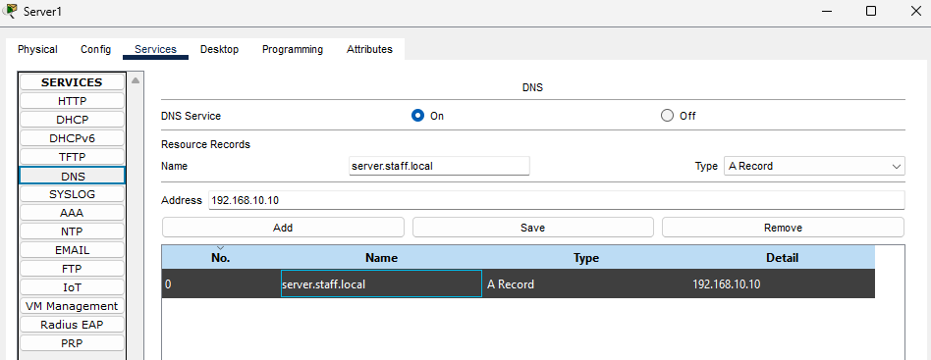

But before being able to use the DNS server, I still need to configure the PC by specifying in the router that the STAFF DHCP pool should use the IP of the DNS server when leasing IP configuration settings to clients.

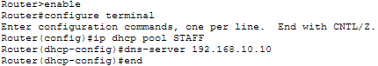

And request IP configuration settings again to get the DNS server automatically assigned.

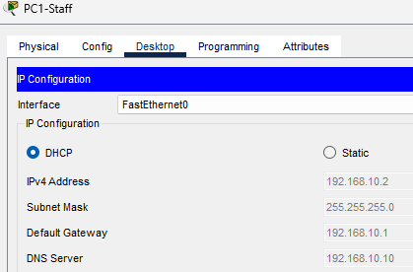

Then ping to test the domain name specified in the record if it resolves to the IP address of the DNS server, which confirms that DNS resolution works.

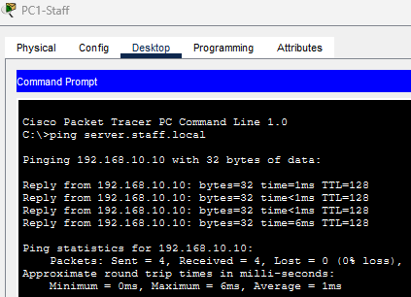

I’ll also do the same with VLAN 20 - GUEST but the current ACL filter implementation blocks off all IP traffic that is initiated by VLAN 20.

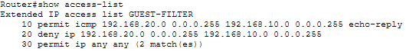

To make it happen, I have to specify that the ACL should allow DNS traffic which happens at port 53 for both TCP and UDP. This still blocks other traffic from GUEST to STAFF as specified.

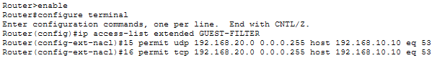

By doing these commands, it allows me to insert the last 2 lines to the whole ACL filter which is prioritized from top to bottom.

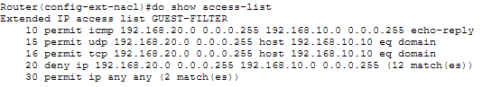

Now I can configure the router to give the DNS server’s IP address to clients in VLAN 20 (GUEST) through DHCP.

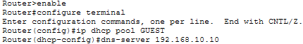

And request a new IP configuration settings with a DNS server address.

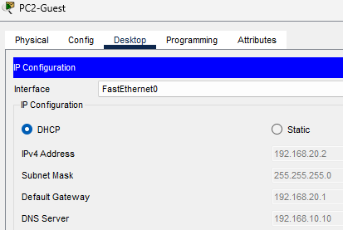

To test if the DNS server is working in VLAN 20, I tried to ping it but got mixed results.

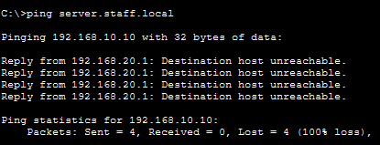

When tested with ping, it said the destination host was unreachable, so I tried to check the access-list as I retry the ping and saw that the ACL filters that were specified and implemented earlier were functioning as expected.

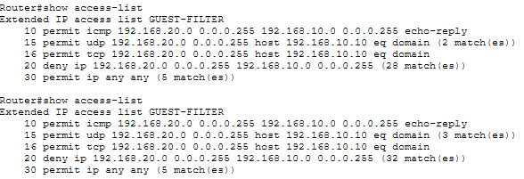

The process here was, ICMP replies from VLAN 20 that VLAN 10 initiated was permitted (as per sequence number 10) but if VLAN 20 is the one that initiates, it gets blocked (as per no. 20). So when I pinged the DNS server, it allowed the DNS query to go through (as per no. 15) and got the resolved IP address which shows on “Reply from 192.168.10.10”. To make sure the DNS server works, nslookup was done to check how was the domain name resolved to an IP address.

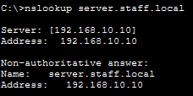

Since most of the functionalities are done, I will start securing the access to the networking devices starting with the switch. To do this, I will set a password to prevent unauthorized users from entering console and privileged configuration mode.

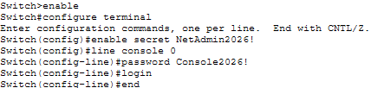

And check if the security settings are applied correctly

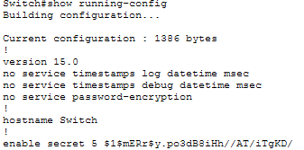
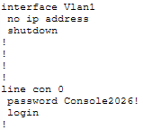

Now that it's enabled properly, I will configure SSH to have secure remote access to the switch and router over the network. It will allow me to be able to access the configurations and manage the devices in one place like on PC1 from VLAN 10.

To do that, I need to have a place where I can manage the devices. So I will use PC1 in VLAN 10 for management to keep the topology simple and centered to its main functions. I will also assign a management IP to the switch, making an SVI so that it's reachable by PC1.

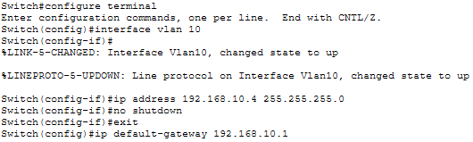

And with an ip interface brief command, it confirms that switch’s VLAN10 has the assigned IP for management.

Since I manually assigned a management IP to the switch, I need to exclude it from the DHCP pool for VLAN 10 to avoid reassigning it to another device.

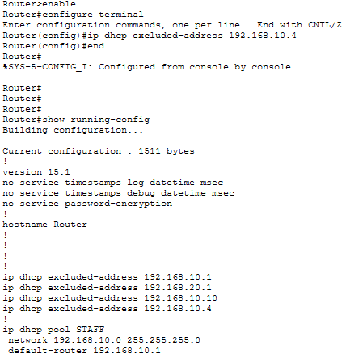

Next, I need to make sure that when a PC is accessing the switch, it provides a credential that matches the one configured earlier.

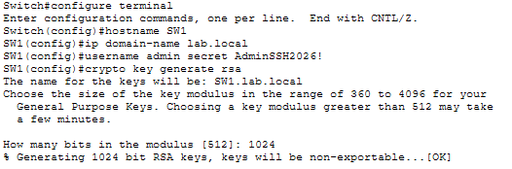

This commands will also allow the switch to authenticate using the local username database and allow the SSH connection

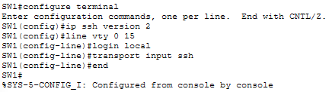

To test, I had PC1 access the switch by doing the ssh command and it authenticates the credentials which was defined earlier and is now able to access the switch (SW1) via PC1 and gives a CLI prompt.

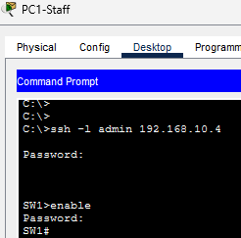

This also shows that there is a user that’s currently connected to the switch’s CLI. Which confirms that everything is working correctly as intended.

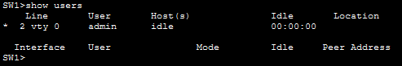

To finish off, I need to physically secure the remote connection established with the switch. To do this, I will implement port security which allows me to specify who or which devices are only permitted to physically access the port via MAC addresses.

I will configure port security on SW1’s FastEthernet0/1, which connects to PC1. Sticky MAC learning will automatically learn PC1’s MAC address and save it in the running configuration. The port will permit only that MAC address. If a different MAC address is detected, the configured port-security violation action will handle it.

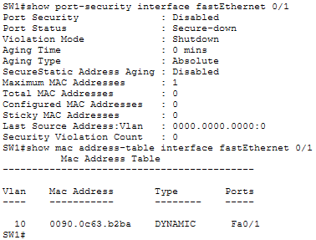

This shows that the port security is still disabled and the switch already learned the MAC address of PC1 which is connected to Fa0/1. Next, I will enable the port security to restrict other MAC addresses aside from the one learned by the switch.

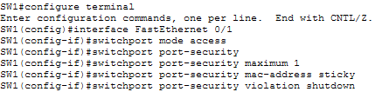

And confirm that the configurations are successful.

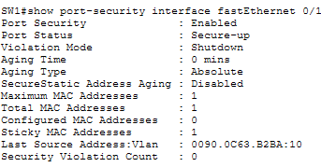

I want to test the port violation that was configured. To do that, I will first check the current status of port security.

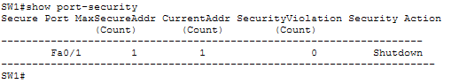

Now, I will disconnect the PC1 from SW1 Fa0/1 and connect PC2 to the same port which should trigger a violation.

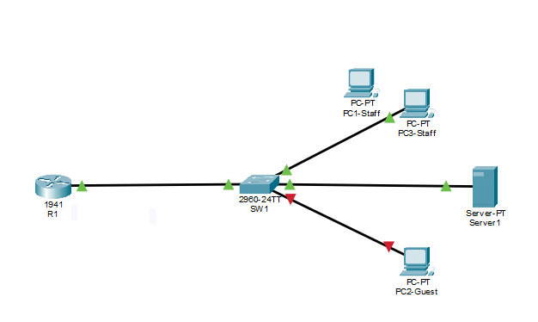

And the switch shows that there is a violation as evidenced by the violation count

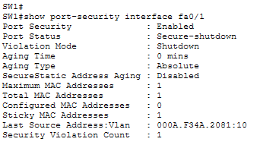

And restored it successfully by reconnecting the fa0/1 to PC1 and fa0/2 to PC2

