HIMACHAL PRADESH TECHNICAL
UNIVERSITY
(A State Government University Established Under State Legislative Act-16 of 2010)
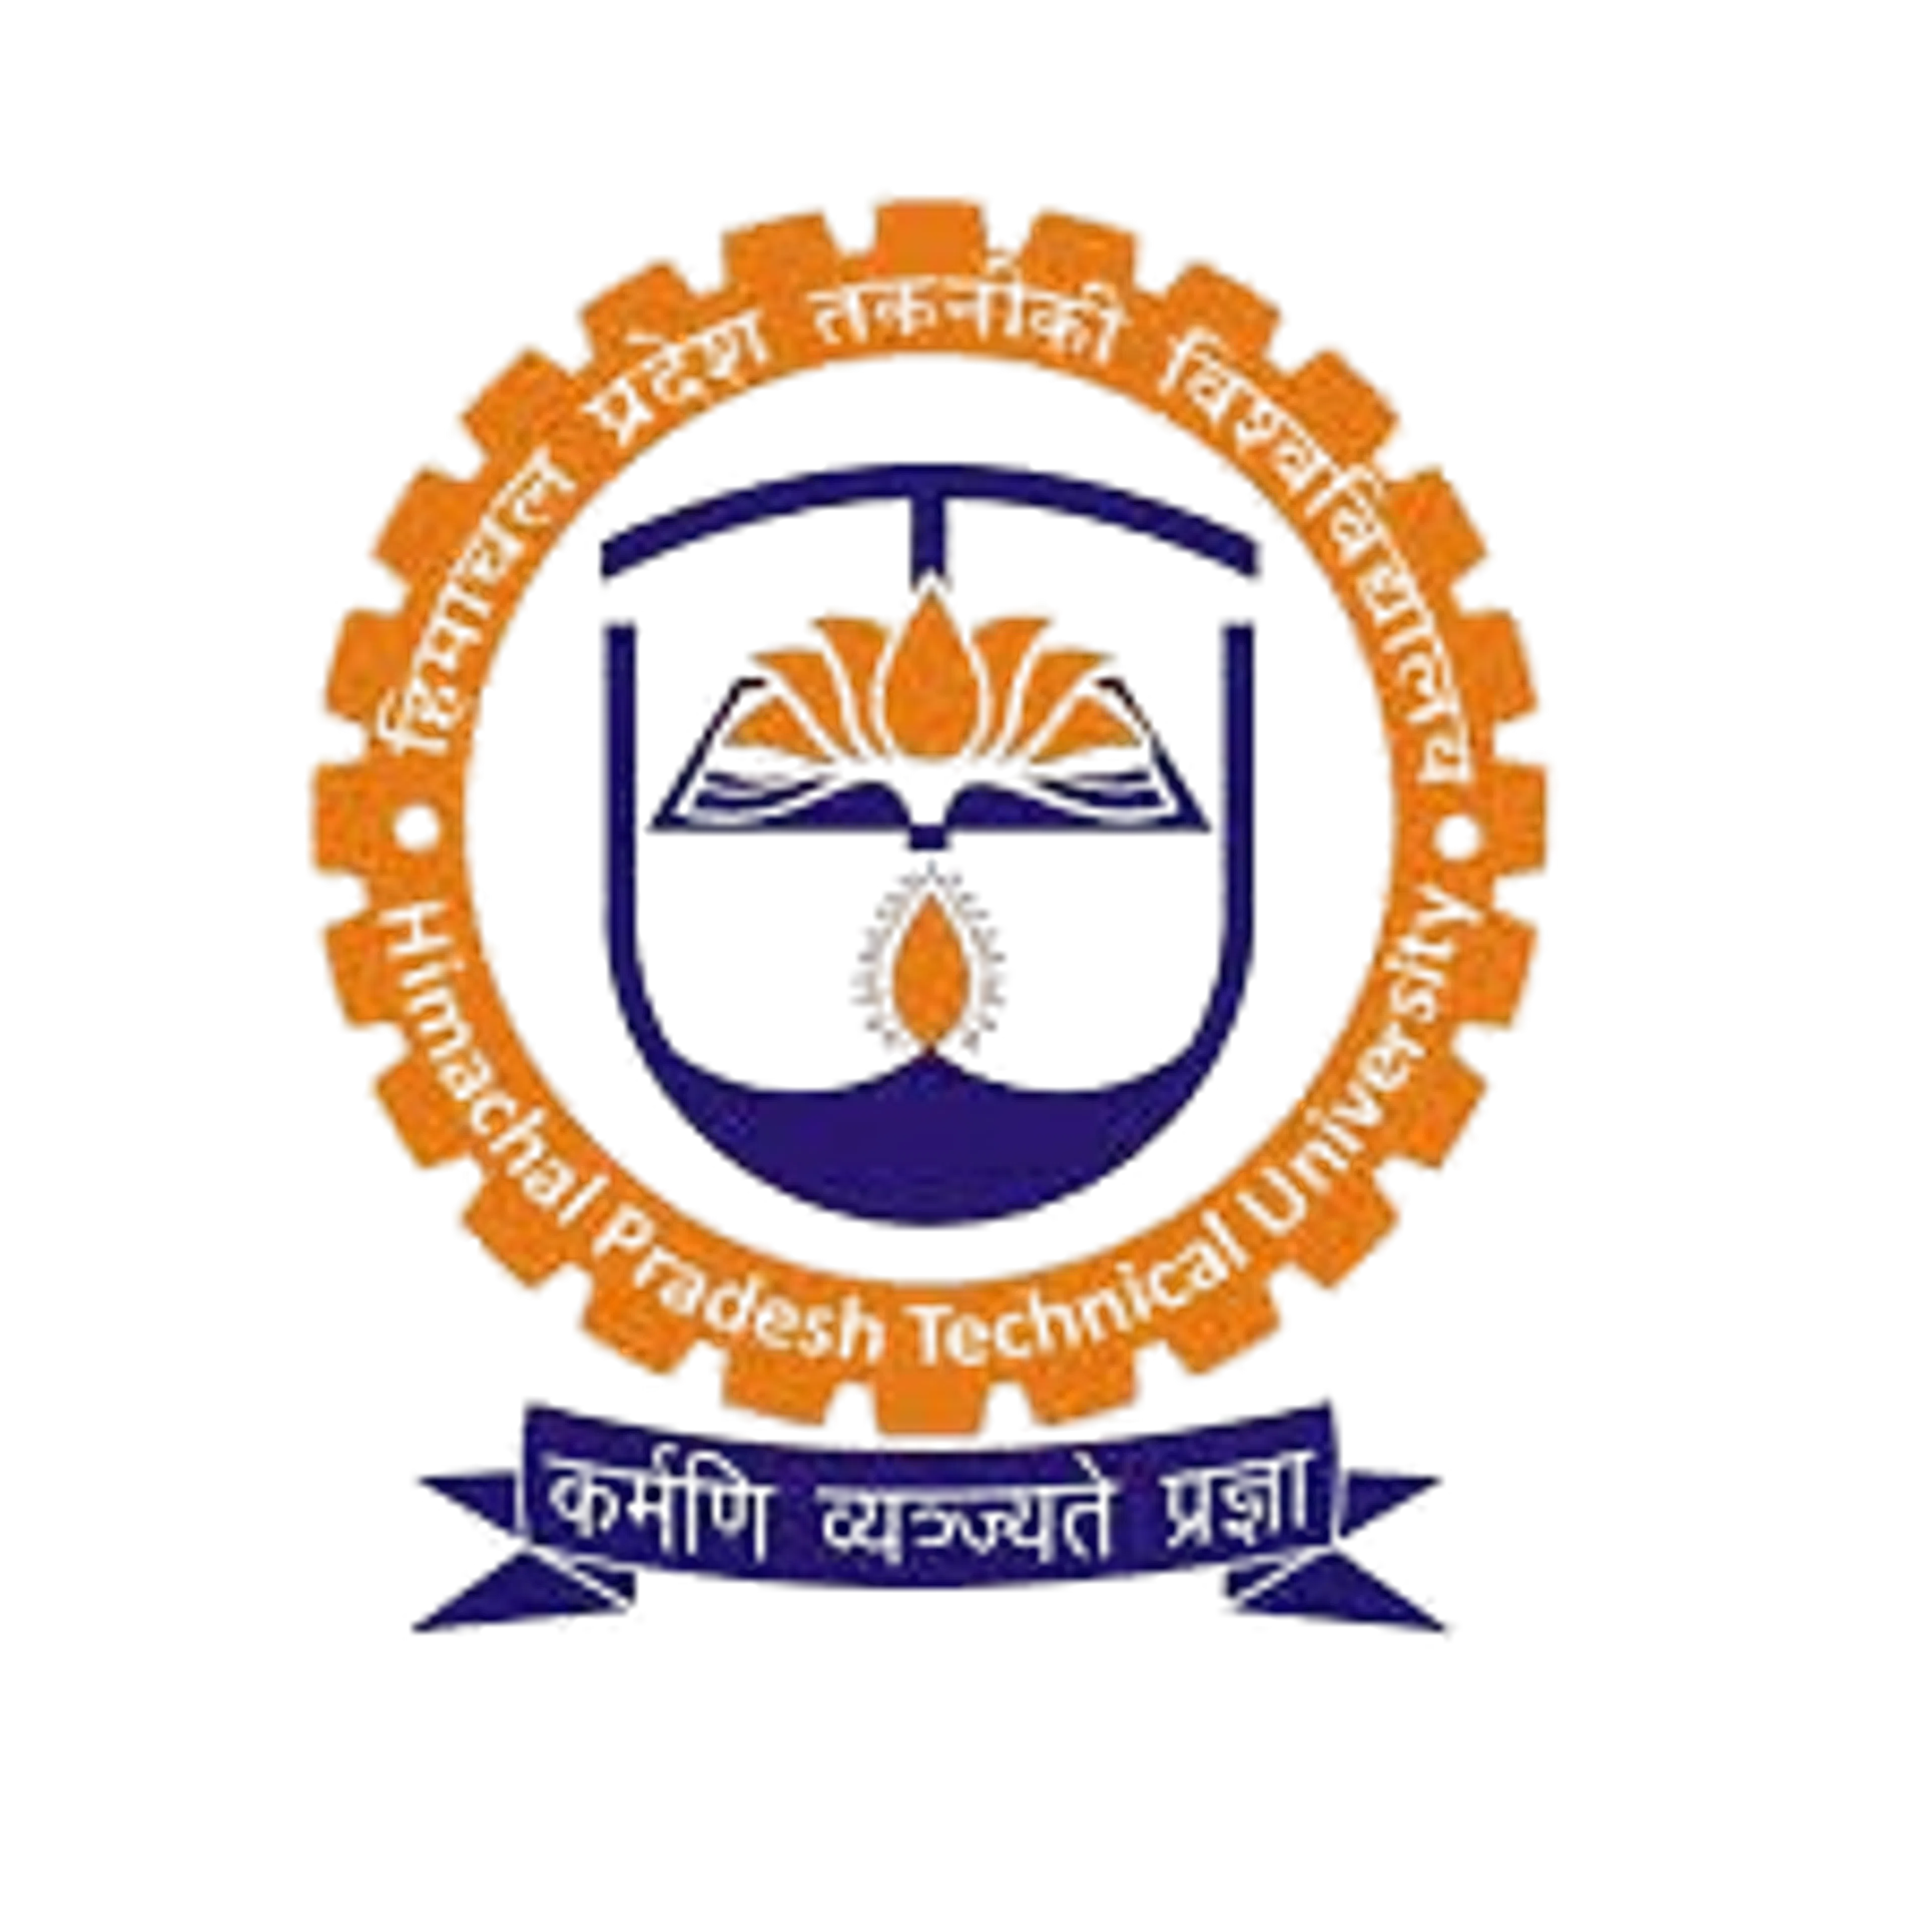
Internship report on:
Notes Sharing and Gamified Learning Platform
Submitted in partial fulfilment of the requirements for the award of B.Tech in
Computer Science and Engineering.
Submitted by: Pawan(241503020059)

Conducted At:
Sortiq Solutions Pvt. Ltd.
E-51, Second Floor, Phase - 8, Industrial Area,
S.A.S. Nagar, Mohali, Punjab 160071

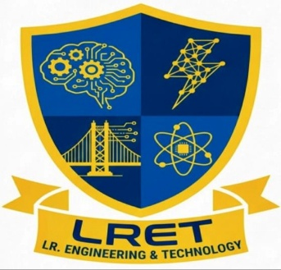
L.R Engineering & Technology
Solan, Himachal Pradesh

CERTIFICATE

Acknowledgement
I would like to express my sincere gratitude to everyone who contributed to the successful completion of my industrial internship and this internship report. This training has been a valuable learning experience that helped me bridge the gap between theoretical knowledge and practical application. It provided me with an excellent opportunity to understand the professional work environment, improve my technical skills, and gain hands-on experience in full-stack web development.
First and foremost, I express my heartfelt thanks to Sortiq Solutions Pvt. Ltd., Chandigarh, for providing me with the opportunity to undergo industrial training. The company offered a professional and supportive environment that enabled me to learn modern software development technologies and industry practices. During my internship, I gained practical exposure to web application development using the MERN Stack and learned how real-world software projects are planned, developed, tested, and maintained.
I am deeply grateful to my Industry Mentor Mr. Abhishek Kumar for their constant guidance, encouragement, and technical support throughout the internship. Their valuable suggestions, constructive feedback, and willingness to share their knowledge helped me understand various concepts of full-stack development. Their mentorship motivated me to improve my technical abilities and successfully complete my project.
I would also like to express my sincere gratitude to our Principal, Dr. D. P. P. Sharma, for providing an excellent academic environment and encouraging students to participate in industrial training programs that enhance practical learning and professional development.
I am equally thankful to our Head of the Department, Ms. Ritika Sharma, for her continuous motivation, valuable guidance, and support throughout my academic journey. Her encouragement inspired me to learn new technologies and successfully complete my internship project.
I sincerely thank all the faculty members of the Department of Computer Science and Engineering for providing me with a strong foundation in programming, database management, software engineering, and web technologies. The knowledge and skills gained during my academic studies proved extremely helpful while working on my internship project.
During the internship, I worked on the development of a Notes Sharing and Gamified Learning Platform, which was designed to simplify the sharing of academic resources among students. Developing this project helped me gain practical experience in React.js, Node.js, Express.js, MongoDB, JWT Authentication, Cloudinary, GitHub, and RESTful API development. This experience significantly enhanced my problem-solving abilities, coding practices, debugging skills, and understanding of modern web application development.
I would also like to express my heartfelt gratitude to my parents and family members for their unconditional love, encouragement, and continuous support throughout my educational journey. Their faith in me has always been my greatest source of motivation.
Finally, I thank my friends and classmates for their cooperation, encouragement, and valuable discussions that helped me overcome various challenges during the internship. Above all, I express my gratitude to Almighty God for blessing me with good health, strength, and determination to complete my internship successfully.
I sincerely acknowledge and appreciate the support, guidance, and encouragement of everyone who directly or indirectly contributed to the successful completion of my industrial training and this report. The knowledge and experience gained during this internship will remain a valuable asset in my future academic and professional career.

Abstract
Industrial training is an essential part of engineering education as it provides students with practical exposure to industry practices and helps bridge the gap between academic knowledge and real-world application. During my internship at Sortiq Solutions Pvt. Ltd., Chandigarh, I worked on the design and development of a Notes Sharing and Gamified Learning Platform using the MERN (MongoDB, Express.js, React.js, and Node.js) stack. The project was developed with the objective of creating a centralized platform where students can easily upload, organize, search, preview, and download academic notes while encouraging active participation through a reward-based credit system.
In many educational institutions, students rely on messaging applications, social media platforms, or personal storage devices to exchange study materials. These methods often result in scattered resources, duplicate files, poor organization, and difficulty in finding relevant notes when needed. The developed platform addresses these issues by providing a structured digital repository where study materials are categorized according to branch, semester, subject, and unit. This organization enables students to quickly access the required notes and improves the overall learning experience.
The application includes several important features such as secure user registration and login, PDF note uploads, note previews, advanced search and filtering options, bookmarking, downloading, and a credit-based gamification system. Users earn credits for contributing useful notes, which encourages active participation and promotes collaborative learning. A leaderboard is also included to recognize top contributors and motivate students to share high-quality academic resources.
The project was developed using React.js to create a responsive and interactive user interface. Node.js and Express.js were used to build the backend and develop RESTful APIs for handling user authentication, note management, and other server-side operations. MongoDB was used as the database to store user information, note metadata, bookmarks, and credit details. For secure authentication, JSON Web Token (JWT) and bcrypt were implemented to protect user accounts and encrypt passwords. Uploaded PDF files were stored securely using Cloudinary, ensuring reliable cloud storage and easy accessibility.
Throughout the internship, I gained practical experience in frontend and backend integration, database design, API development, cloud storage integration, debugging, version control using Git and GitHub, and software testing using Postman. I also learned the importance of following industry coding standards, maintaining clean project structures, and developing scalable applications.
Overall, this internship significantly enhanced my technical knowledge, problem-solving abilities, and understanding of modern software development practices. It provided valuable industry exposure and strengthened my confidence in building complete web applications using the MERN Stack. The knowledge and practical experience gained during this internship will serve as a strong foundation for my future academic projects and professional career in software engineering.

Company Profile
Introduction
Sortiq Solutions Pvt. Ltd. is a software development company based in Chandigarh, India, that specializes in designing and developing innovative software solutions for businesses, educational institutions, and startups. The company focuses on delivering reliable, scalable, and user-friendly applications using modern technologies and industry-standard development practices. It provides services in web application development, cloud-based solutions, database management, UI/UX design, and software maintenance.
The organization is committed to helping clients transform their ideas into efficient digital solutions. By adopting modern software engineering methodologies and agile development practices, Sortiq Solutions ensures the delivery of high-quality software products that meet customer requirements and industry standards.
Apart from software development, the company actively promotes skill development by providing industrial training and internship opportunities to engineering students. These programs allow students to gain practical knowledge, understand real-world software development processes, and work on live projects under the guidance of experienced professionals. Such exposure helps students strengthen their technical knowledge while improving communication, teamwork, and problem-solving skills.
Vision
The vision of Sortiq Solutions Pvt. Ltd. is to become a leading software development company by delivering innovative, secure, and high-quality technology solutions that help organizations improve efficiency and accelerate digital transformation. The company also aims to nurture young talent by providing practical learning opportunities and preparing students for successful careers in the IT industry.
Mission
The mission of the company is to develop reliable and scalable software solutions using modern technologies while maintaining high standards of quality and customer satisfaction. The company believes in continuous learning, innovation, and teamwork to deliver software that creates real value for its clients.
Services Offered
Sortiq Solutions offers a wide range of software development services, including:
- Web Application Development
- Full-Stack MERN Development
- Custom Software Development
- Database Design and Management
- RESTful API Development
- Cloud Integration Services
- UI/UX Design
Learning Environment
During my internship, I had the opportunity to work in a professional development environment where I learned how software projects are planned, designed, developed, tested, and maintained. I gained practical experience in requirement analysis, frontend and backend development, database management, cloud storage integration, API testing, and debugging. The guidance provided by experienced developers helped me understand coding standards, project organization, and collaborative development practices using Git and GitHub.
This internship not only improved my technical knowledge but also enhanced my confidence, analytical thinking, communication skills, and ability to work on real-world software development projects. The experience gained at Sortiq Solutions Pvt. Ltd. has provided a strong foundation for my future career as a software engineer.
Objectives of Internship
Industrial training is an integral part of engineering education as it enables students to understand how theoretical concepts are applied in real-world situations. The primary objective of this internship was to gain practical experience in software development, improve technical knowledge, and understand the professional work culture followed in the information technology industry. During my internship at Sortiq Solutions Pvt. Ltd., I worked on the development of a Notes Sharing and Gamified Learning Platform, which allowed me to apply my academic knowledge to solve a real-life problem faced by students.
One of the major objectives of this internship was to understand the complete Software Development Life Cycle (SDLC). Throughout the project, I learned the importance of each phase, including requirement analysis, planning, system design, implementation, testing, deployment, and maintenance. This helped me understand how software projects are managed systematically to ensure quality, reliability, and timely delivery.
Another important objective was to develop practical skills in Full-Stack Web Development using the MERN Stack. I gained hands-on experience in building responsive user interfaces with React.js, creating RESTful APIs using Node.js and Express.js, and managing application data using MongoDB. This practical exposure enhanced my understanding of frontend and backend integration, enabling me to develop dynamic and scalable web applications.
The internship also aimed to improve my knowledge of database design and management. I learned how to create MongoDB schemas, establish relationships between collections, perform CRUD (Create, Read, Update, Delete) operations, and optimize database queries. Understanding efficient database design was essential for ensuring that the application remained organized, secure, and capable of handling user data effectively.
Another key objective was to implement secure authentication and authorization techniques. During the project, I worked with JSON Web Tokens (JWT) and bcrypt password hashing to ensure that user information remained secure. This helped me understand the importance of data security and user authentication in modern web applications.
The internship also focused on learning cloud-based file storage by integrating Cloudinary into the application. Instead of storing uploaded PDF files on the local server, Cloudinary was used to securely manage and access files through cloud storage. This provided valuable knowledge about cloud services and media management in modern software development.
In addition to technical skills, the internship aimed to improve my problem-solving, debugging, communication, and teamwork abilities. While developing the project, I encountered various challenges related to API integration, file uploads, authentication, and database operations. Solving these issues strengthened my analytical thinking and debugging skills. Working under the guidance of experienced mentors also helped me understand professional coding standards, project documentation, and collaborative software development practices.
Overall, this internship successfully achieved its objectives by providing practical exposure to modern technologies, enhancing my technical and professional skills, and preparing me for future opportunities in the software industry. The knowledge and experience gained during this training have significantly improved my confidence in developing real-world web applications and have laid a strong foundation for my future career as a software engineer.

Nature of Work Assigned
During my industrial internship at Sortiq Solutions Pvt. Ltd., Chandigarh, I was assigned the responsibility of designing and developing a Notes Sharing and Gamified Learning Platform using the MERN Stack. The primary objective of the project was to create a centralized web application where students could upload, organize, search, preview, and download academic notes in a secure and user-friendly environment. Throughout the internship, I actively participated in different phases of software development, which allowed me to understand the complete software development process followed in the IT industry.
The first task assigned to me was requirement analysis. Before beginning the development process, I studied the problems faced by students in sharing study materials through traditional methods such as WhatsApp, Telegram, and email. These methods often resulted in duplicate files, poor organization, and difficulty in finding relevant notes. Based on these observations, the project requirements were analyzed, and the major features of the platform were identified.
The next responsibility was designing the user interface. Using React.js and Tailwind CSS, I developed responsive and interactive web pages for user registration, login, dashboard, note upload, note browsing, bookmarks, and profile management. Special attention was given to creating a clean and user-friendly interface that could be easily used by students on different devices.
I was also involved in backend development using Node.js and Express.js. My responsibilities included developing RESTful APIs to handle user authentication, note management, bookmark functionality, search operations, and profile management. These APIs ensured smooth communication between the frontend and backend while maintaining data consistency and security.
Another important task was database design and management using MongoDB. I created database schemas for users and notes using Mongoose. The database was designed to store user details, uploaded note information, bookmarks, credit points, and other application data efficiently. I also performed CRUD (Create, Read, Update, Delete) operations and learned how to retrieve and manage data effectively.
To ensure application security, I implemented JWT (JSON Web Token) authentication and bcrypt password hashing. These technologies helped protect user accounts by encrypting passwords and allowing only authenticated users to access secure features of the application.
One of the major responsibilities assigned during the project was integrating Cloudinary for cloud-based file storage. Instead of storing uploaded PDF files on the local server, the files were securely uploaded to Cloudinary, and their URLs were stored in the MongoDB database. This approach improved scalability, reduced server storage requirements, and ensured reliable access to uploaded study materials.
In addition to development tasks, I was responsible for testing and debugging the application. I used Postman to test REST APIs and verified that all application features worked correctly. Various bugs related to authentication, database queries, API responses, and file uploads were identified and resolved during the development process.
Overall, the work assigned during my internship provided comprehensive exposure to frontend development, backend programming, database management, cloud integration, authentication, testing, and debugging. This hands-on experience significantly improved my technical knowledge, problem-solving abilities, and understanding of professional software development practices, preparing me for future opportunities in the software industry.

Technical Skills Used / Learned
The Notes Sharing and Gamified Learning Platform was developed using the MERN Stack, a modern and widely used technology stack for full-stack web application development. Along with the MERN Stack, several additional tools and technologies were integrated to ensure that the application is secure, efficient, responsive, and scalable. Each technology played an important role in the successful implementation of the project.
React.js (Frontend Development)
React.js is an open-source JavaScript library developed by Meta for building interactive and dynamic user interfaces. It follows a component-based architecture, where the application is divided into reusable components, making the code easier to maintain and extend. In this project, React.js was used to develop the user interface, including pages for user registration, login, dashboard, note upload, note browsing, bookmarks, and profile management. Its fast rendering capability and efficient state management helped improve the overall user experience.
Node.js (Runtime Environment)
Node.js is a JavaScript runtime environment that allows developers to execute JavaScript code outside the browser. It is built on Chrome's V8 JavaScript engine and is known for its speed and efficiency. In this project, Node.js was used to develop the backend server and manage communication between the frontend and the database. Its non-blocking and event-driven architecture makes it suitable for handling multiple user requests simultaneously.
Express.js (Backend Framework)
Express.js is a lightweight and flexible framework built on top of Node.js. It simplifies backend development by providing features such as routing, middleware support, and request handling. In this project, Express.js was used to develop RESTful APIs for user authentication, note management, search functionality, bookmarking, and profile operations. It also handled data validation and communication with the MongoDB database.
MongoDB (Database Management)
MongoDB is a NoSQL database that stores data in the form of flexible JSON-like documents. It was used to store user information, uploaded note details, bookmarks, and credit records. MongoDB provides high performance, scalability, and flexibility, making it an ideal choice for modern web applications. Mongoose, an Object Data Modeling (ODM) library, was used to create database schemas and perform CRUD operations efficiently.
Cloudinary (Cloud Storage)
Cloudinary is a cloud-based media management platform used for storing and managing uploaded files. In this project, all PDF notes uploaded by students were stored securely on Cloudinary instead of the local server. The secure file URL generated by Cloudinary was stored in MongoDB, allowing users to preview and download notes efficiently while reducing server storage requirements.
JWT and bcrypt (Security)
To ensure secure user authentication, JSON Web Token (JWT) was implemented for token-based authentication, allowing only authorized users to access protected resources. bcrypt was used to encrypt user passwords before storing them in the database, ensuring that sensitive information remained secure.
Git, GitHub, and Postman
Git and GitHub were used for version control and project management, making it easier to track code changes and collaborate effectively. Postman was used to test REST APIs, verify server responses, and ensure that all application functionalities worked correctly before deployment.
The combination of these technologies enabled the development of a secure, responsive, and scalable web application while providing valuable hands-on experience with modern software development tools and industry-standard practices.
Project Description
The Notes Sharing and Gamified Learning Platform is a web-based application developed to provide a centralized and organized platform for sharing academic study materials among students. The primary objective of the project is to simplify the process of uploading, searching, and accessing educational resources while encouraging students to actively contribute through a reward-based system. The application eliminates the limitations of traditional file-sharing methods and creates a structured digital repository that improves collaboration and knowledge sharing within educational institutions.
In many colleges, students exchange notes through messaging applications such as WhatsApp, Telegram, or email. Although these methods are convenient, they often result in duplicate files, unorganized documents, limited storage, and difficulty in locating the required study material. Students frequently spend a significant amount of time searching for notes before examinations because the resources are scattered across different platforms. The proposed system addresses these issues by providing a single platform where all academic resources can be stored, categorized, and accessed efficiently.
The application allows students to create personal accounts using secure registration and login functionality. After authentication, users can upload notes in PDF format by providing details such as the title, subject, branch, semester, unit, instructor name, and relevant tags. The uploaded files are stored securely using Cloudinary, while their metadata is maintained in the MongoDB database. This separation ensures efficient file management, improved scalability, and reliable access to uploaded documents.
One of the most important features of the platform is its advanced search and filtering system. Students can quickly locate study materials by selecting filters such as branch, semester, subject, or unit. The platform also includes a PDF preview feature that allows users to view documents before downloading them. This helps students verify that the uploaded notes are relevant to their academic requirements.
To enhance user engagement, the application incorporates a gamification system. Whenever a student uploads useful notes that are downloaded or appreciated by other users, they receive credit points. These credits reflect the user's contribution to the learning community and are displayed on a leaderboard. This feature motivates students to upload high-quality study materials and promotes healthy academic competition among users.
The platform also provides bookmarking functionality, enabling students to save important notes for future reference without downloading them immediately. This improves user convenience and allows quick access to frequently used study materials. Additionally, the application follows secure authentication practices using JSON Web Token (JWT) and bcrypt encryption to protect user accounts and sensitive information.
The project was developed using the MERN Stack, which includes React.js for the frontend, Node.js and Express.js for backend development, and MongoDB for database management. The integration of modern technologies such as Cloudinary, JWT, GitHub, and Postman ensured that the application follows current industry standards for web development.
Overall, the Notes Sharing and Gamified Learning Platform provides an efficient, secure, and user-friendly solution for managing academic resources. It not only simplifies the sharing of study materials but also encourages collaborative learning and active participation among students. The project demonstrates the practical application of modern web technologies in solving real-world educational challenges while enhancing the overall learning experience.

Tools / Platforms / Languages Used
The development of the Notes Sharing and Gamified Learning Platform involved the use of various programming languages, software tools, frameworks, platforms, and cloud services. Each technology played a significant role in developing a secure, responsive, and efficient web application. The selection of these technologies was based on their performance, scalability, ease of use, and compatibility with modern web development practices.
Programming Languages
JavaScript
JavaScript was the primary programming language used throughout the project. It was utilized for both frontend and backend development, making the application development process more efficient by using a single language across the entire technology stack. JavaScript was used to implement user interactions, API communication, authentication logic, and server-side functionalities.
HTML5
HTML5 was used to create the basic structure of the web pages. It defines the layout and content of the application, including forms, buttons, navigation bars, tables, and other user interface elements. HTML5 also improves accessibility and provides semantic elements that enhance webpage organization.
CSS3
CSS3 was used for designing and styling the user interface. It helped create an attractive, responsive, and user-friendly design by controlling colors, fonts, layouts, spacing, animations, and other visual elements. CSS3 ensured that the application could adapt smoothly to different screen sizes and devices.

Development Frameworks and Libraries
React.js
React.js is a JavaScript library used for building dynamic and interactive user interfaces. It follows a component-based architecture, allowing reusable components that simplify application development and maintenance. React.js was used to build the frontend of the application, including pages for login, registration, dashboard, note upload, note browsing, bookmarks, and user profiles.
Node.js
Node.js is a JavaScript runtime environment that allows JavaScript code to run outside the browser. It was used to develop the backend server, manage user requests, process business logic, and establish communication between the frontend and the database.
Express.js
Express.js is a lightweight backend framework built on Node.js. It was used for developing RESTful APIs, handling routing, implementing middleware, managing authentication, and processing client requests efficiently.

Database Platform
MongoDB
MongoDB is a NoSQL database used to store user information, uploaded notes, bookmarks, credit points, and application data. Its flexible document-based structure allows efficient storage and retrieval of information, making it suitable for modern web applications.

Cloud Platform
Cloudinary
Cloudinary is a cloud-based media management platform used to store uploaded PDF files securely. Instead of saving files on the local server, all notes are uploaded to Cloudinary, and the generated file URLs are stored in MongoDB. This approach improves storage management, reliability, and scalability.

Development Tools
Visual Studio Code (VS Code)
Visual Studio Code served as the primary Integrated Development Environment (IDE) for writing, editing, and debugging the application code. Its extensions, integrated terminal, syntax highlighting, and debugging features significantly improved development efficiency.
Git and GitHub
Git was used for version control, while GitHub was used to store the project repository online. These tools helped manage code changes, maintain project history, and enable efficient collaboration during development.
Postman
Postman was used to test REST APIs developed for the application. It allowed verification of API requests, responses, authentication, and error handling before integrating them with the frontend.

Authentication and Security
To secure the application, JSON Web Token (JWT) was implemented for user authentication, while bcrypt was used to encrypt user passwords before storing them in the database. These technologies enhanced the security of user accounts and protected sensitive information.
By combining these programming languages, tools, frameworks, platforms, and cloud services, the Notes Sharing and Gamified Learning Platform was successfully developed as a modern, secure, scalable, and user-friendly web application that meets current industry standards.

Reflections and Challenges
The industrial internship at SortIQ Solutions Pvt. Ltd., Chandigarh was a valuable learning experience that provided me with practical exposure to modern software development technologies and industry practices. It allowed me to apply the theoretical concepts learned during my academic studies to the development of a real-world web application. Working on the Notes Sharing and Gamified Learning Platform not only enhanced my technical knowledge but also improved my analytical thinking, problem-solving abilities, and understanding of professional software development processes.
At the beginning of the internship, I was familiar with the basic concepts of web development, but I had limited experience in developing a complete full-stack application. Through continuous learning and practical implementation, I gained confidence in using the MERN Stack, designing databases, developing RESTful APIs, integrating frontend and backend components, and deploying cloud-based services. This project helped me understand the importance of writing clean, maintainable, and well-structured code while following industry standards.
One of the major challenges I faced during the project was implementing secure user authentication. Initially, understanding how JSON Web Tokens (JWT) work for authentication and authorization was difficult. I had to learn how tokens are generated, stored, verified, and used to protect restricted routes within the application. After studying the concept and implementing it practically, I was able to develop a secure authentication system that allowed only authorized users to access protected features.
Another significant challenge was integrating Cloudinary for PDF file uploads. Uploading files from the frontend, processing them using Multer, storing them on Cloudinary, and saving the generated URLs in MongoDB required careful implementation. During this process, I encountered issues related to file handling, API configuration, and cloud storage settings. Through debugging and testing, I successfully resolved these problems and ensured smooth file upload functionality.
Database management was another area where I gained valuable experience. Designing MongoDB schemas that efficiently stored user information, uploaded notes, bookmarks, and credit details required careful planning. I also faced challenges while implementing relationships between different collections and performing CRUD operations. These challenges helped me develop a better understanding of NoSQL databases and data modeling techniques.
Debugging was an important part of the development process. At different stages of the project, I encountered issues related to API responses, frontend-backend communication, authentication errors, and database queries. Using tools such as Postman, browser developer tools, and server logs helped me identify and resolve these problems effectively. This experience strengthened my debugging skills and taught me the importance of systematic testing.
Overall, this internship significantly enhanced both my technical and professional skills. It taught me the value of continuous learning, patience, teamwork, and effective time management while working on real-world software projects. The challenges I faced throughout the internship became valuable learning opportunities that increased my confidence in full-stack web development. I believe the knowledge and practical experience gained during this internship will serve as a strong foundation for my future academic projects and professional career in the software industry.

Outcomes and Learning
The industrial internship at SortIQ Solutions Pvt. Ltd., Chandigarh was a highly rewarding experience that contributed significantly to my academic and professional development. It provided me with the opportunity to apply theoretical concepts learned during my engineering studies to the development of a real-world software project. Working on the Notes Sharing and Gamified Learning Platform allowed me to understand the complete software development process, from requirement analysis to implementation, testing, and documentation. The internship enhanced my technical knowledge, strengthened my problem-solving abilities, and prepared me for future challenges in the software industry.
One of the most important outcomes of this internship was gaining practical experience in Full-Stack Web Development using the MERN Stack. I learned how to design responsive user interfaces using React.js, develop server-side applications with Node.js and Express.js, and manage application data efficiently using MongoDB. I also understood how different components of a web application communicate with each other through RESTful APIs, enabling smooth interaction between the frontend and backend.
Another significant learning outcome was understanding the importance of database design and management. I gained experience in creating database schemas, storing structured information, performing CRUD (Create, Read, Update, Delete) operations, and managing relationships between different collections. This improved my understanding of NoSQL databases and efficient data management techniques.
The internship also enhanced my knowledge of application security. By implementing JSON Web Token (JWT) authentication and bcrypt password encryption, I learned how to protect user accounts and secure sensitive information. This practical experience highlighted the importance of authentication and authorization in modern web applications and strengthened my awareness of cybersecurity practices.
A valuable learning experience was the integration of Cloudinary for cloud-based file storage. I learned how uploaded PDF files can be securely stored in the cloud while maintaining their metadata in the database. This experience introduced me to cloud technologies and demonstrated how cloud services improve application scalability, reliability, and storage management.
In addition to technical skills, the internship helped me develop several professional and interpersonal skills. I improved my communication abilities by interacting with mentors and discussing project requirements. I also learned the importance of teamwork, task management, and maintaining proper documentation throughout the software development process. Time management and meeting project deadlines became important aspects of my daily work, helping me develop a more disciplined and organized approach to completing assigned tasks.
Another key outcome was the improvement of my debugging and analytical skills. During project development, I encountered several technical challenges related to API integration, database operations, authentication, and cloud storage. By systematically analyzing problems and testing different solutions, I became more confident in identifying and resolving software issues efficiently.
Overall, this internship provided me with comprehensive knowledge of modern web development technologies, industry-standard development practices, and professional work ethics. It strengthened both my technical and personal skills, increased my confidence in developing real-world applications, and prepared me for future academic projects and career opportunities in software engineering. The experience and knowledge gained during this internship will remain valuable assets throughout my professional journey.

Conclusion and Future Work
Conclusion
The industrial internship at SortIQ Solutions Pvt. Ltd., Chandigarh provided me with an excellent opportunity to gain practical experience in modern software development and understand how real-world applications are designed, developed, tested, and maintained. During the internship, I successfully developed the Notes Sharing and Gamified Learning Platform, which addresses the common challenges students face while sharing and accessing academic study materials. The project enabled me to apply the theoretical concepts learned during my academic studies to a practical software solution, thereby strengthening my technical knowledge and professional skills.
The application provides a centralized platform where students can securely upload, organize, search, preview, bookmark, and download study notes. Unlike traditional methods of sharing educational resources through messaging applications or email, this platform offers a structured and efficient way of managing academic content. The integration of a credit-based gamification system further encourages students to contribute quality study materials and actively participate in collaborative learning. This feature makes the platform more engaging and motivates users to share valuable academic resources with others.
The project was developed using the MERN Stack, including React.js, Node.js, Express.js, and MongoDB, along with additional technologies such as Cloudinary for cloud storage, JWT for authentication, and bcrypt for password encryption. Working with these technologies enhanced my understanding of full-stack web development, RESTful API development, cloud integration, database management, and secure authentication. Throughout the project, I also learned the importance of systematic planning, clean coding practices, debugging, testing, and maintaining proper project documentation.
Overall, this internship has significantly improved my technical expertise, analytical thinking, communication skills, and confidence in handling real-world software development projects. The knowledge and practical experience gained during this training will serve as a strong foundation for my future academic projects and professional career in software engineering.

Future Work
Although the current version of the Notes Sharing and Gamified Learning Platform successfully meets its primary objectives, there are several opportunities to enhance the application further by incorporating advanced features and emerging technologies.
One of the most valuable future improvements would be the integration of Artificial Intelligence (AI) to recommend study materials based on a student's branch, semester, subjects, and previous downloads. AI could also generate automatic summaries of uploaded notes, helping students quickly understand important topics.
The platform can also be extended by developing Android and iOS mobile applications, allowing students to access study materials anytime and anywhere through their smartphones. Mobile support would significantly improve accessibility and user convenience.
Another enhancement would be the implementation of a real-time discussion forum or chat system, where students can ask academic questions, discuss topics, and collaborate more effectively. Push notifications can also be added to notify users about new uploads, comments, downloads, or credit updates.
Future versions may include advanced analytics for administrators, enabling them to monitor user activity, identify popular subjects, analyze download statistics, and generate reports. These insights would help educational institutions improve resource management and understand student learning patterns.
Additional features such as OCR (Optical Character Recognition) for searching text inside PDF files, plagiarism detection for uploaded notes, role-based access control, multilingual support, dark mode, and integration with Learning Management Systems (LMS) can further enhance the platform's usability and functionality.
In conclusion, the Notes Sharing and Gamified Learning Platform has the potential to evolve into a comprehensive digital learning ecosystem. With continuous improvements and the integration of modern technologies, it can become an even more effective solution for promoting organized knowledge sharing, collaborative learning, and academic excellence among students.

Appendix

References
The successful development of the Notes Sharing and Gamified Learning Platform was supported by various official documentation resources, technical articles, and learning platforms. These references provided detailed information about modern web development technologies, programming concepts, database management, authentication techniques, cloud storage integration, and software engineering practices. The following sources were referred to during the development of the project and the preparation of this internship report.
- React Documentation. React – A JavaScript Library for Building User Interfaces. Available at: https://react.dev/ (Accessed: July 2026).
- Node.js Documentation. Node.js Official Documentation. Available at: https://nodejs.org/docs/latest/api/ (Accessed: July 2026).
- Express.js Documentation. Express – Fast, Unopinionated, Minimalist Web Framework. Available at: https://expressjs.com/ (Accessed: July 2026).
- MongoDB Documentation. MongoDB Manual. Available at: https://www.mongodb.com/docs/ (Accessed: July 2026).
- Mongoose Documentation. Mongoose ODM Documentation. Available at: https://mongoosejs.com/docs/ (Accessed: July 2026).
- Cloudinary Documentation. Cloudinary Developer Documentation. Available at: https://cloudinary.com/documentation (Accessed: July 2026).
- JSON Web Token (JWT). JWT Introduction and Documentation. Available at: https://jwt.io/introduction (Accessed: July 2026).
- bcrypt Documentation. Password Hashing for Node.js. Available at: https://github.com/kelektiv/node.bcrypt.js (Accessed: July 2026).
- Tailwind CSS Documentation. Utility-First CSS Framework. Available at: https://tailwindcss.com/docs (Accessed: July 2026).
- Visual Studio Code Documentation. VS Code Official Documentation. Available at: https://code.visualstudio.com/docs (Accessed: July 2026).
- Git Documentation. Git Reference Manual. Available at: https://git-scm.com/doc (Accessed: July 2026).
- GitHub Documentation. GitHub Docs. Available at: https://docs.github.com/ (Accessed: July 2026).
- Postman Learning Center. API Development and Testing Documentation. Available at: https://learning.postman.com/ (Accessed: July 2026).
- Mozilla Developer Network (MDN). Web Development Documentation. Available at: https://developer.mozilla.org/ (Accessed: July 2026).
- W3Schools. Web Development Tutorials and References. Available at: https://www.w3schools.com/ (Accessed: July 2026).
- Ecma International. ECMAScript Language Specification. Available at: https://tc39.es/ecma262/ (Accessed: July 2026).

