Client documentation

1. Main idea

FIT Courses is an ultimate destination for fitness and bodybuilding courses. If the user is a kinda sportsman, he can always create his own course to share it with others who aren’t so experienced in sport. If user doesn’t want to create courses, he can just read them. Web site is created with a purpose to encourage society to do some sport.

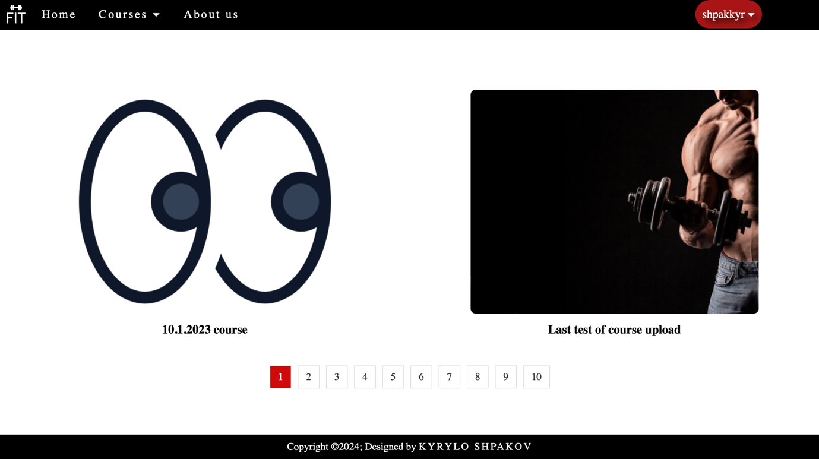

1. Navigation bar:

User can go on a home page with welcome phrase, or he can choose a course from any existed category from dropdown like: Fitness, Body-building, Cross fit or Active. There is about us page as well to introduce a user with web site.

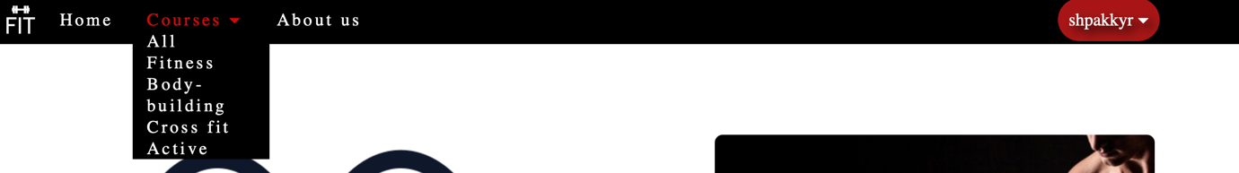

1. Pages:

* Courses page with categories contains all the courses from database (including splitting by category).

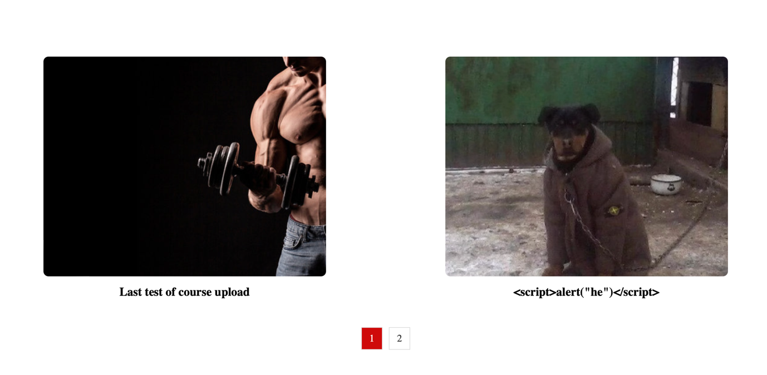

* About us page contains all the necessary info about the web site.

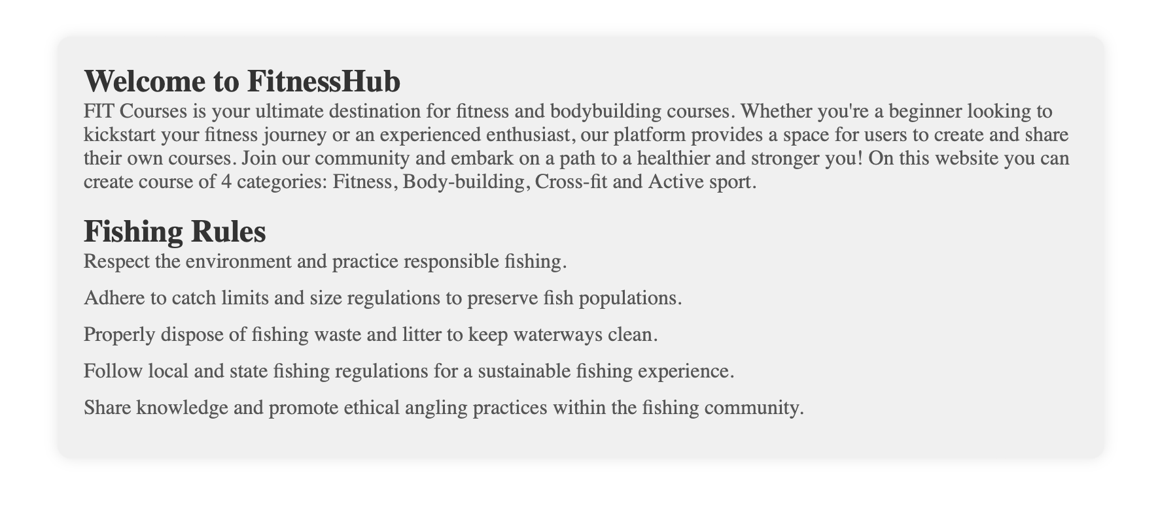

* Home page contains welcome content.

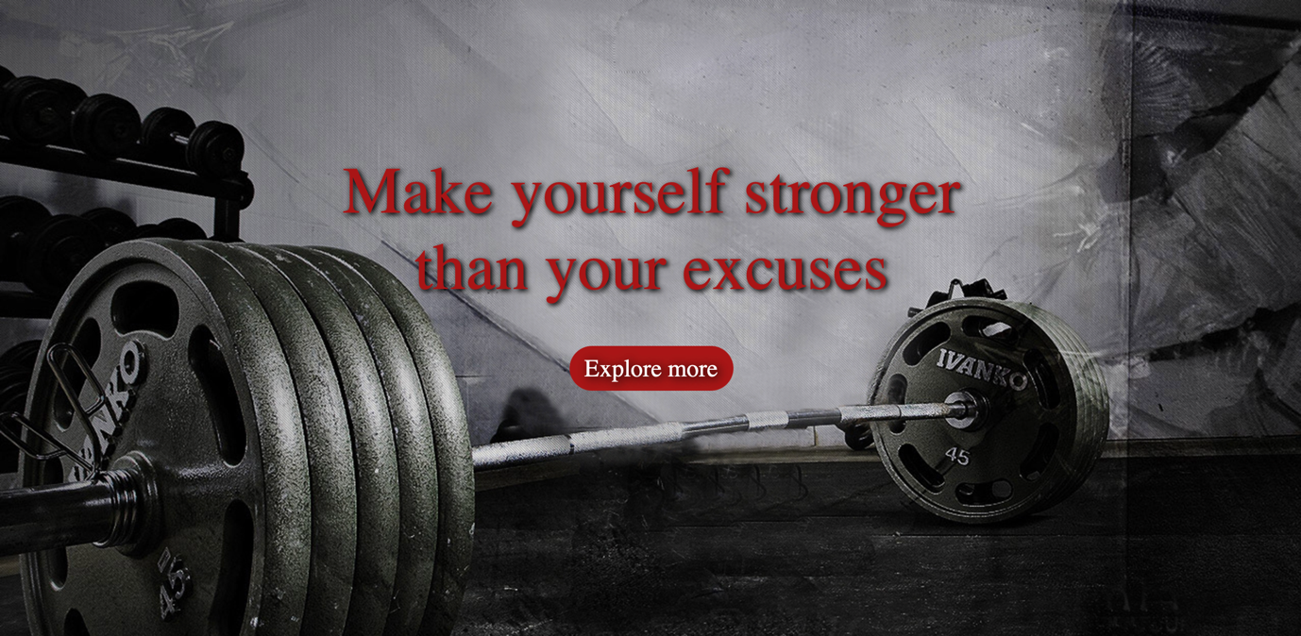

1. Functionality:

* Non-logged in: user has login/signup buttons in header. User can see courses but can’t create any courses or modify, because he will not have access to these pages.



* Logged in: user can see courses, but he can also create his own courses and modify the courses created by him. Also he has a dropdown on the right side with his name and functions of his courses, creation courses, changing password and logout.

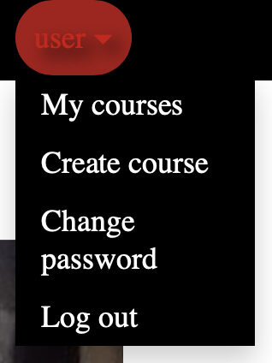

* Administrator: can do everything as was mentioned on the top, but he can also see and modify all the courses and users in admin panel and he has admin panel button in username dropdown.

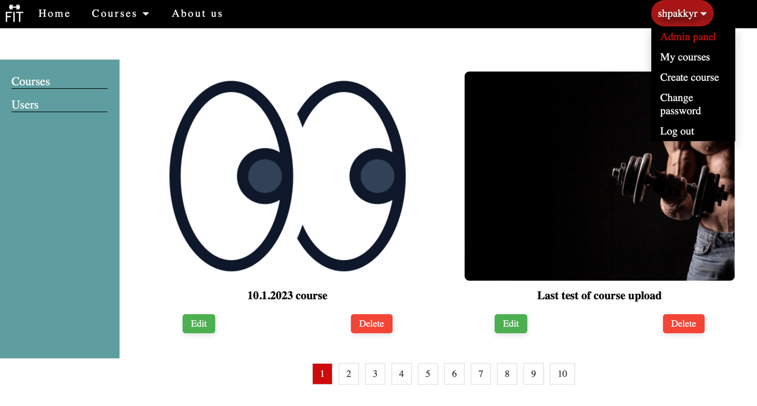

If click on edit button, then you will be redirected to the page with course editing with prefilled all the info about this course (except of image).

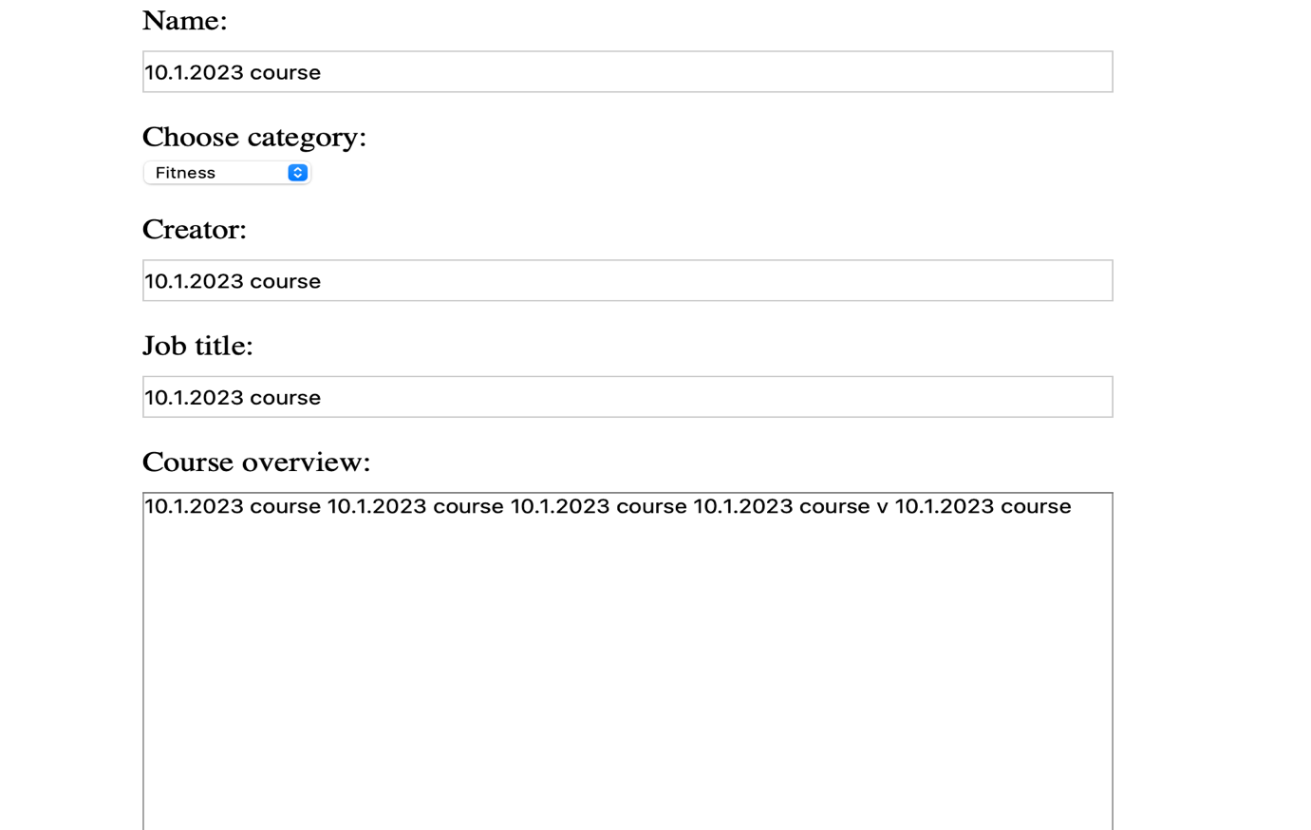

* Content creation: after user click on create course button, the window will be opened with form creation.

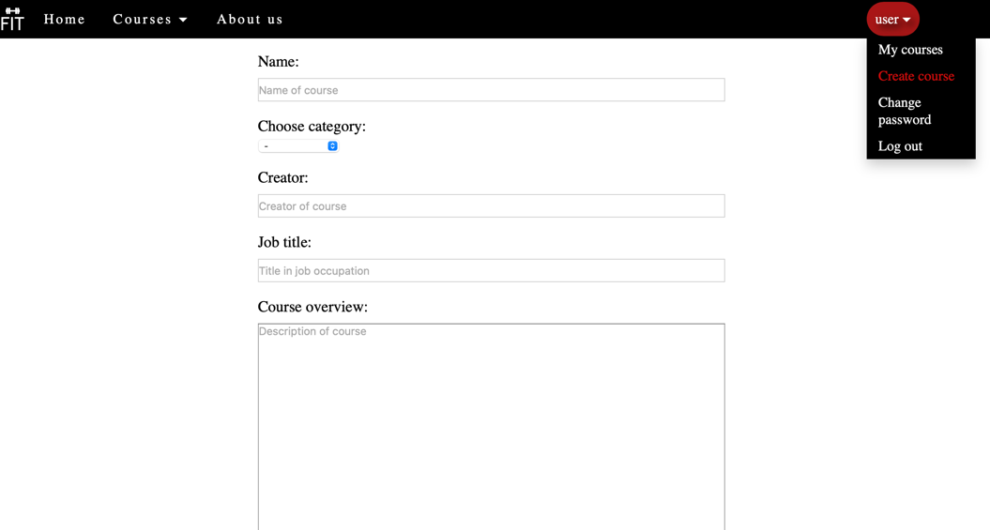

* My courses button: after clicking he gets on page with his courses

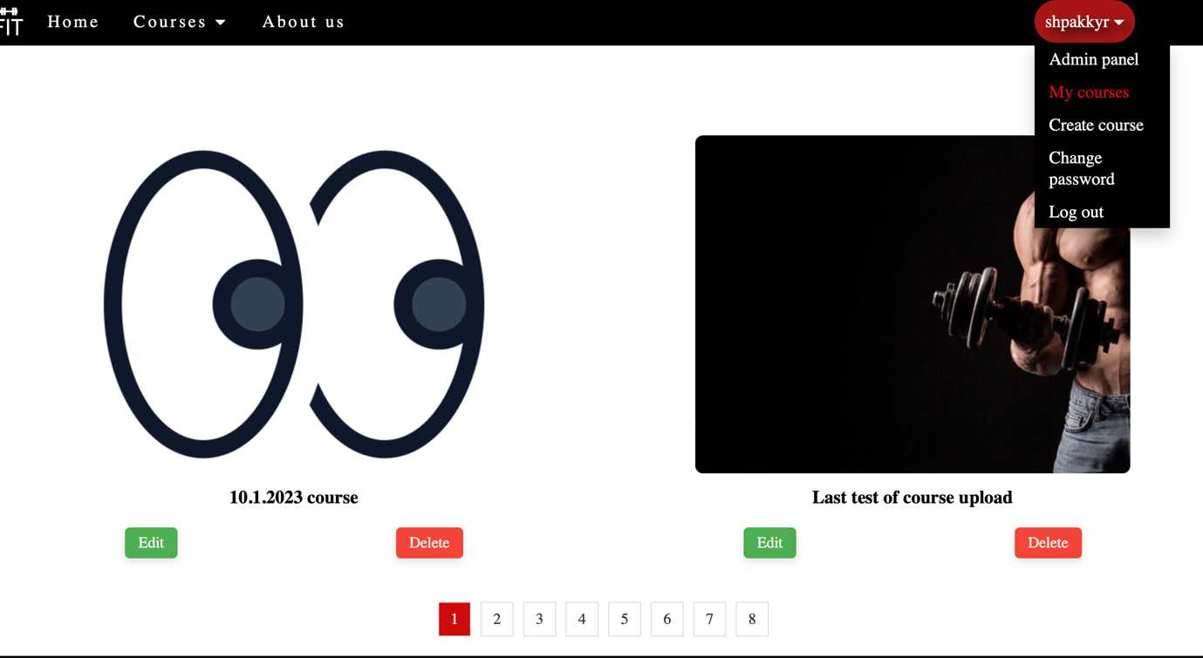

* Change password: after click any user can change his password

