Programming documentation

Description:

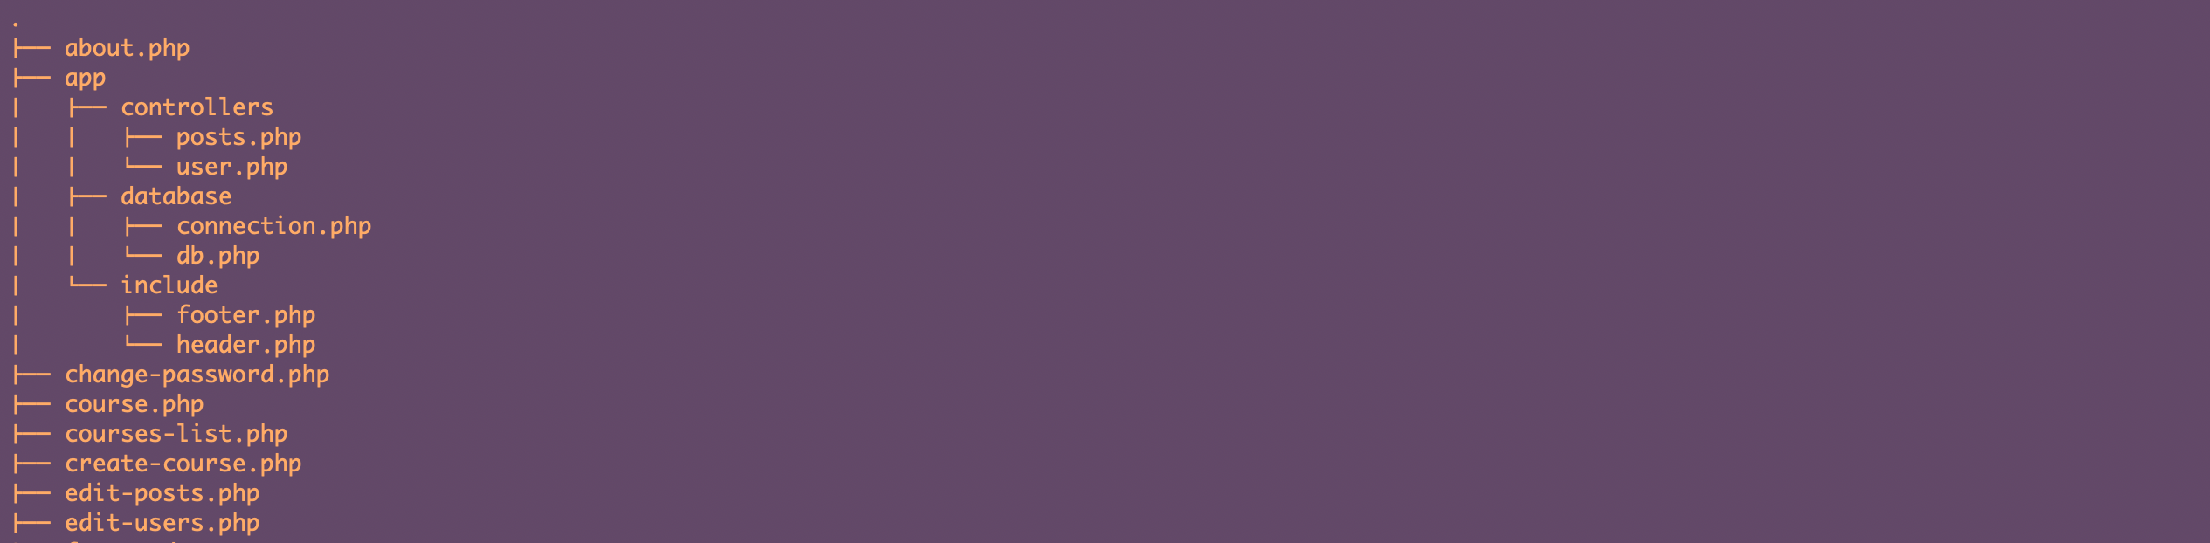

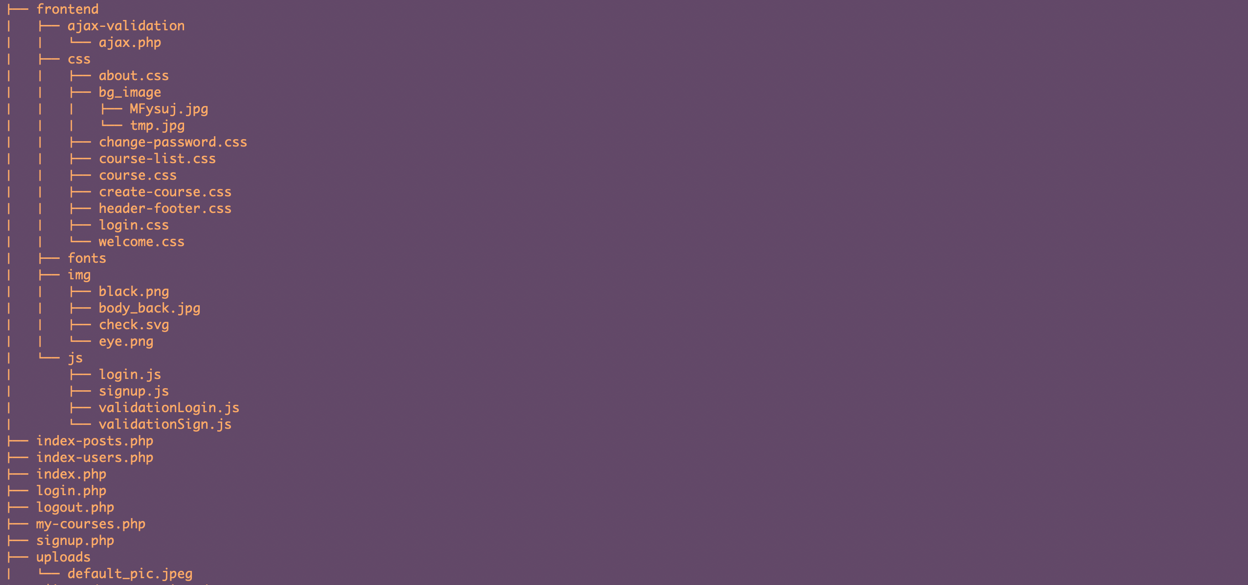

* app folder is used to:
  + handle any modification with posts or user on the web-site (controllers)
  + store db folder with connection and queries to database
  + include folder with header and footer of all pages
* frontend folder is used to:
  + handle client js validations of login-signup forms
  + store images in img folder
  + store styles in css folder
  + implementation of ajax validation
* uploads folder is used to:
  + store images uploaded by user
* The rest files are used for displaying content on the page (file-pages)

List of files with description:

* Page files
  + .php
    - Index.php – represents a welcome page
    - Courses-list.php – represents a list of courses (including all different categories).
    - My-courses.php – shows the list of courses created by user with buttons to edit and delete.
    - Index-posts.php – admin panel with posts, only user with admin set to 1 can access this page and modify all courses.
    - Index-users.php – admin panel with users, only user with admin set to 1 can access this page and modify username or email of users or delete.
    - Course.php – represents a page with all course information.
    - About.php – page about the web site and fishing ruled.
  + .css
    - Course-list.css – styles for displaying courses pages.
    - Welcome.css – styles for home page.
    - Course.css – styles for course information page.
    - About.css – styles for website overview page.
* Forms
  + .php
    - Login.php – represents a login page.
    - Signup.php – represents a registration page.
    - Change-password.php - any user can change profile password.
    - Edit-posts.php – for editing courses.
    - Edit-users.php – for editing users (only for admin).
  + .css
    - Login.css – styles for login and signup forms.
    - Create-course.css – styles for course creation pages.
    - Change-password.css – styles for change password page.
* Ajax
  + .php
    - Ajax.php – checks if email or username already exists.
* Assets
  + .php
    - Connection.php – represents connection to database.
    - Db.php – querries to database.
    - User.php – handles requests from login and signup forms, inserts, updates, deletes etc.
    - posts.php – handles requests from course creation, inserts, updates, deletes etc.
* Validations
  + .php(server-side)
    - User.php – validates if the fields from user input are correct.
    - Posts.php – validated if the fields from course creation input are correct.
  + .js(client-side)
    - Login.js, Signup.js – controls if the user clicked on eye icon, if yes – then display password.
    - ValidationLogin.js, validationSignup.js – controls, if all the input fields by user are correct.
* Other
  + Header
    - Header.php – header of all the pages.
  + Footer
    - Footer.php – footer of all the pages.
  + Style
    - Header-footer.css – styles for header and footer.