# Muvo

# Competitors

[Please write comprehensive description of what they do, how they work, how they are similar to us, and how our project is different from theirs for each of following. The way we are different is we have open helpers/users rather than fixed or hired. Our services is also cheap, around $15 an hour as compared to $80+an hour]

## Power Moves Moving and Storage LLC

## Secured Moving Company LLC

## Reliant Moving Services

## Two Men and a Truck

## UHaul

# Features

Our app will provide a sign in or sign up interface to users. All the users are put into two categories: admin and public. Public is further categorized into and based on their category, their interface will change.

The three different types of users are:

1. Admins, that are members of our team, have master privileges to view, manage, and deal with data of other category of users.
2. Public, who are general people, can post for help or can vote to help on others’ postings. It is further categorized into two groups:
3. Requesters, who are our main customers or main source of income, can post details of their movement like when are where they are moving from, where they are moving to, how many people they are looking for, what their offer is to the movers, etc. They are the ones that are paying the movers and our app/company takes certain commission off it.
4. Movers, who are general users, can sign up for a listing from a requester and after approval from the requester, can help the requester and make money off it.

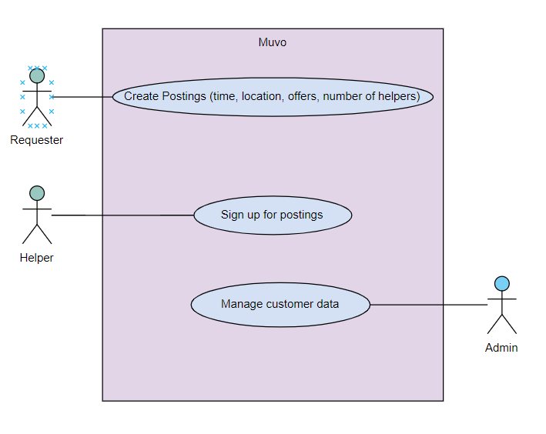

# Risks