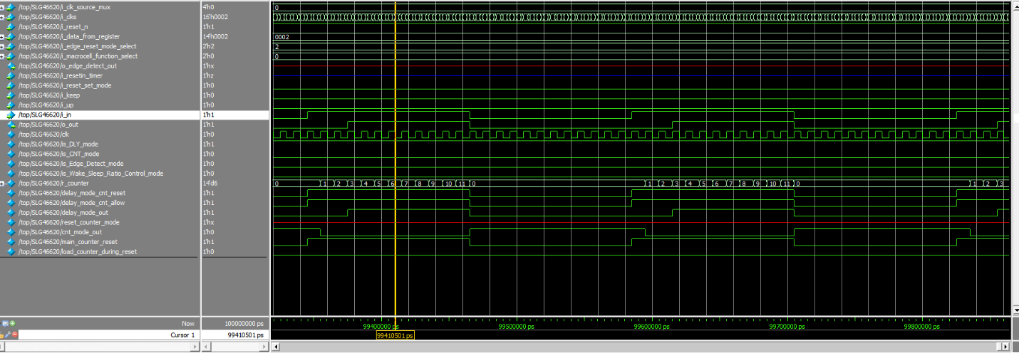

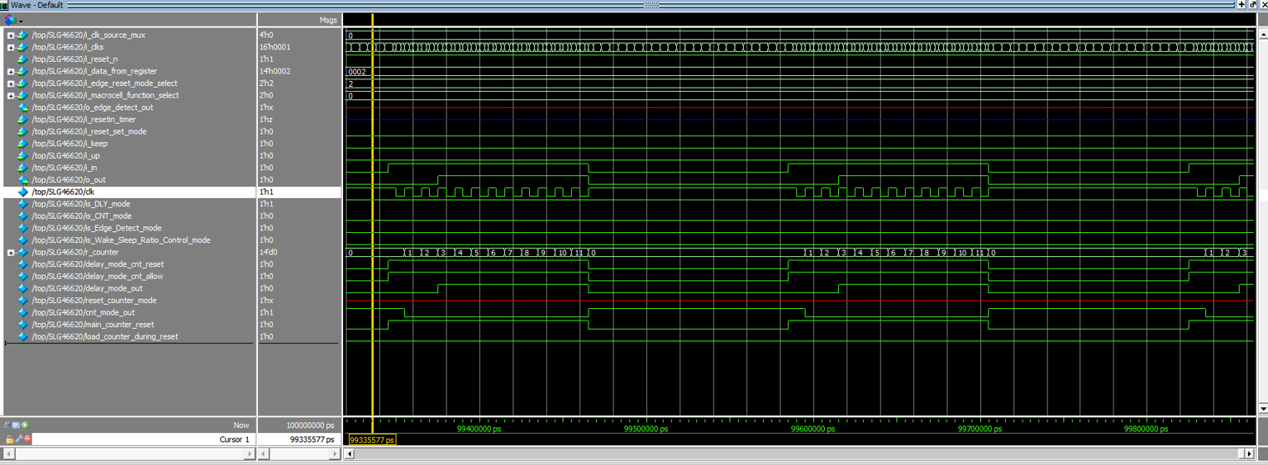

Figure 1. Timing (rising edge) for count data = 2

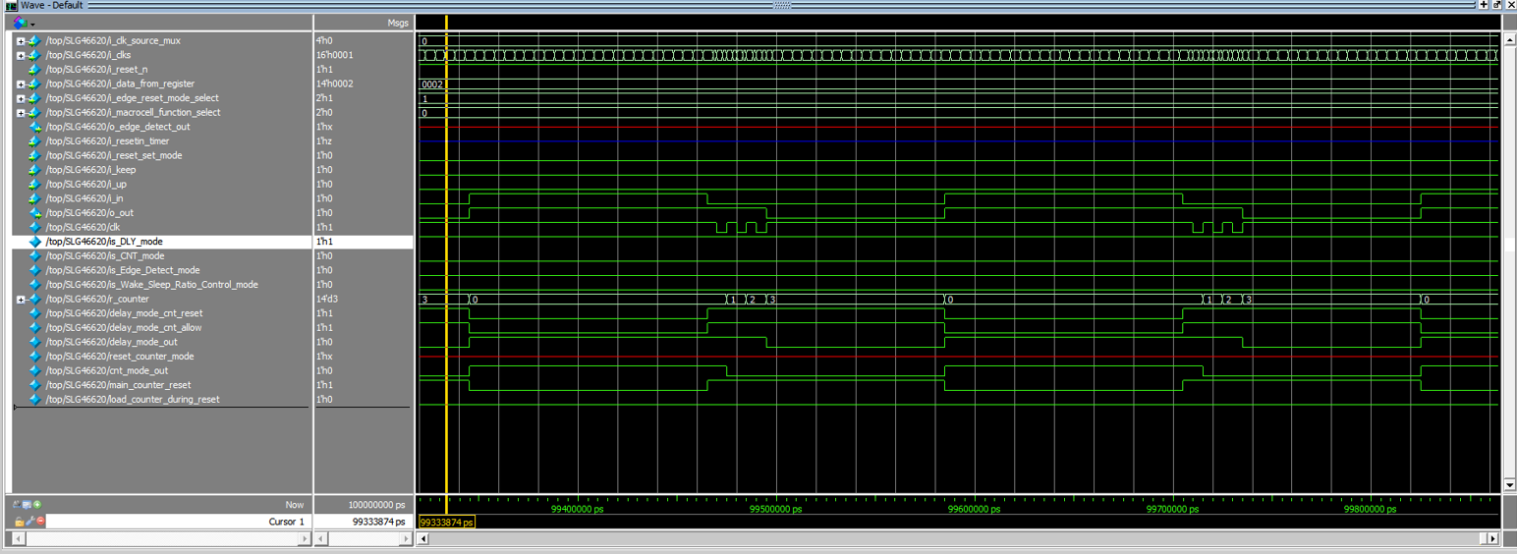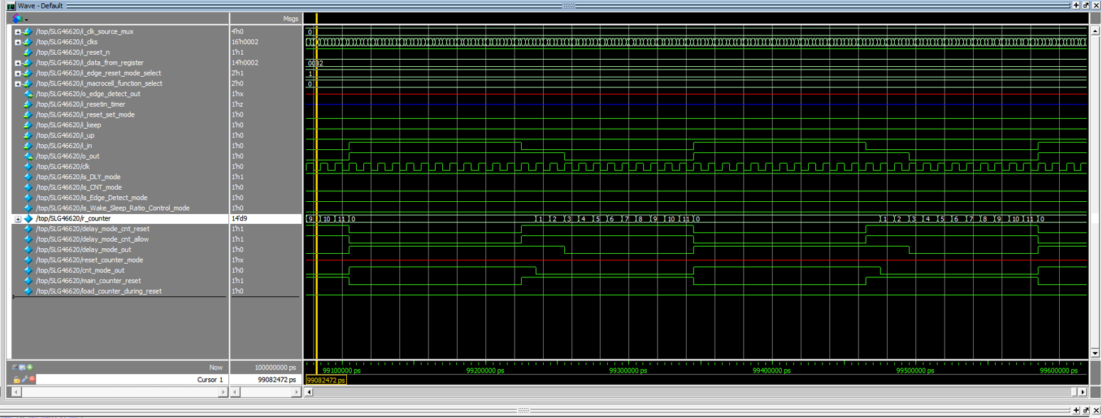

Figure 2. Timing (falling edge) for count data = 2

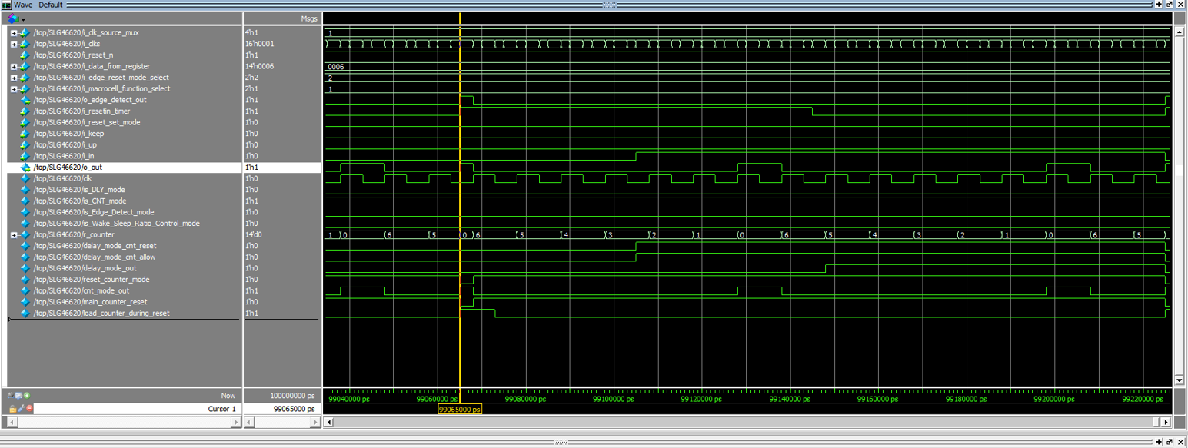

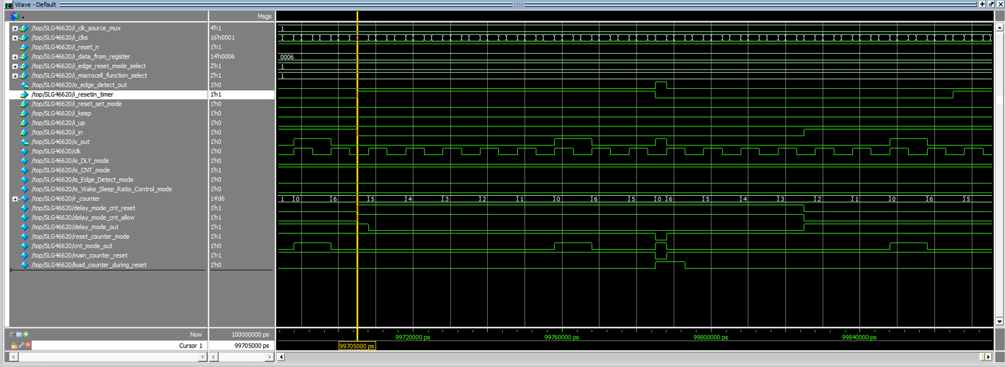Figure 3. Timing (reset rising edge mode, oscillator is forced on) for count data = 6

Figure 4. Timing (reset falling edge mode, oscillator is forced on) for count data = 6

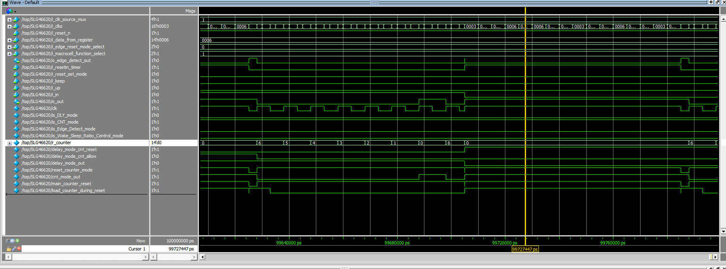

Figure 5. Timing (reset high level mode, oscillator is autopowered on (controlled by reset)) for count data = 6

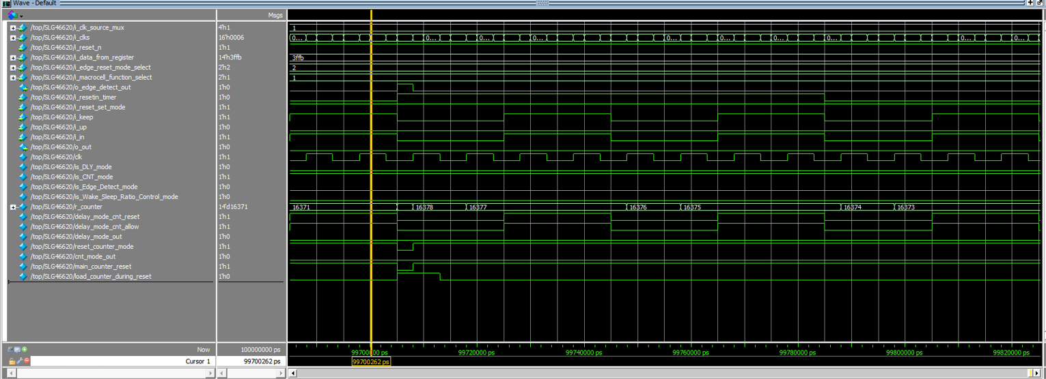

Figure 6. CNT/FSM Timing Diagram (reset rising edge mode, oscillator is forced on, UP=0) for counter data = h3ffb

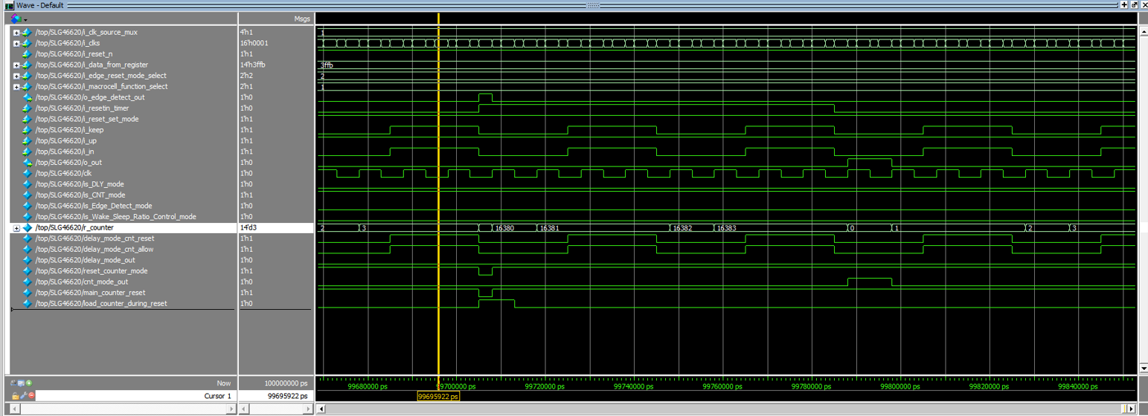

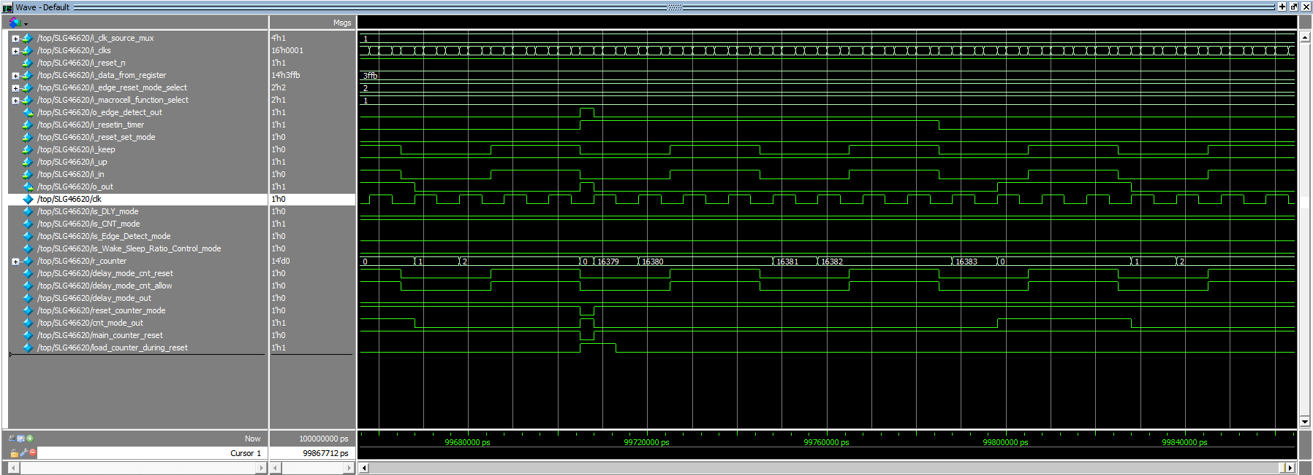Figure 7. CNT/FSM Timing Diagram (set rising edge mode, oscillator is forced on, UP=1) for counter data = h3ffb

Figure 93. CNT/FSM Timing Diagram (set rising edge mode, oscillator is forced on, UP=1) for counter data = h3ffb