**Git Commands**

**Git init**

This command is used to create a new repository.



**Git switch**

This command is used to navigate between branches.

**Git Checkout**

This command is used to create new branch and switch to the branch

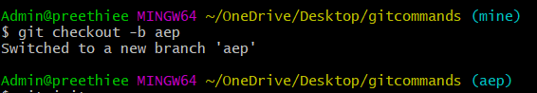

**Git add**

This command is used add files to staging area.

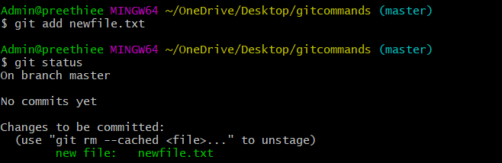

Git add . command is used to add all the files present in the folder.

**Git commit**

This command is used to record or snapshots the file permanently in version history.

It used to commit the files from staging area to local repository.

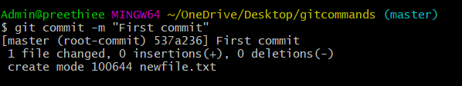

**Git remote**

This command is used to link remote server to local repository.

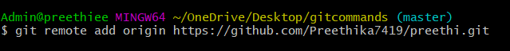

**Git push**

This command is used to push the files from local to the remote repository.

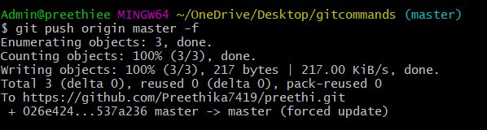

**Git pull**

This command is used to fetch and merge changes on remote server to your working directory.

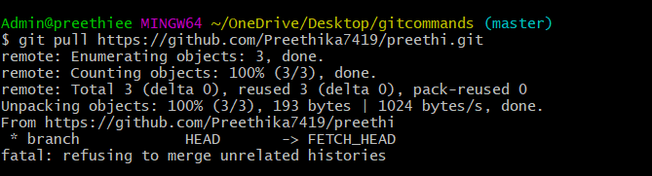

**Git clone**

This command is used for creating a duplicate copy of the file into the local system.

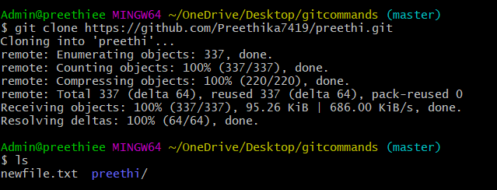

**Git status**

This command is used to check the status of the files which are in our local system.

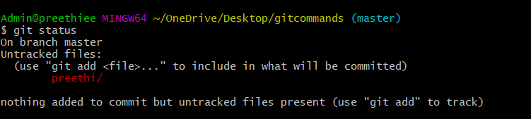

**Git log**

This command is used to list the version history for current batch.

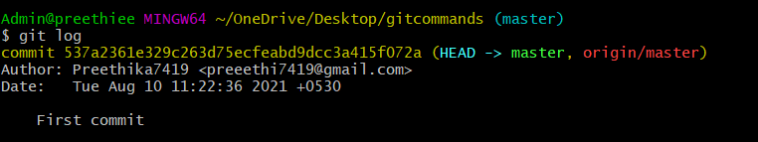

**Git merge**

This command is used to merge the specified branch’s history into current branch.

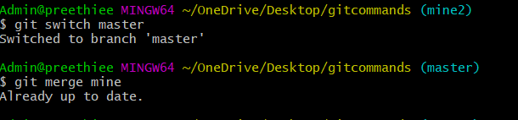

**Git branch**

This command is used to list all the local branches in the current repository.

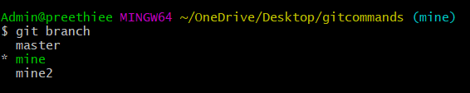

**Git switch**

Thiscommand is used to switch between branches.

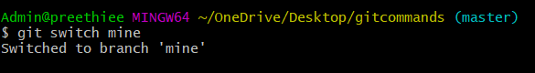

**Git revert**

This command is used to undo the commited snapshot.

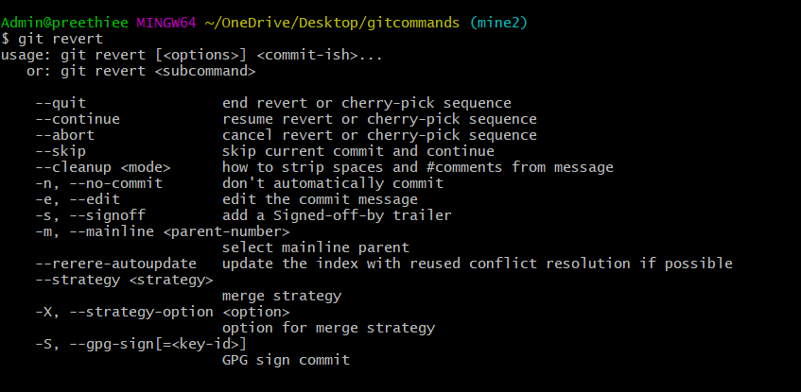

**Git diff**

This command is used to show the difference between the branches

