**Environment 2**

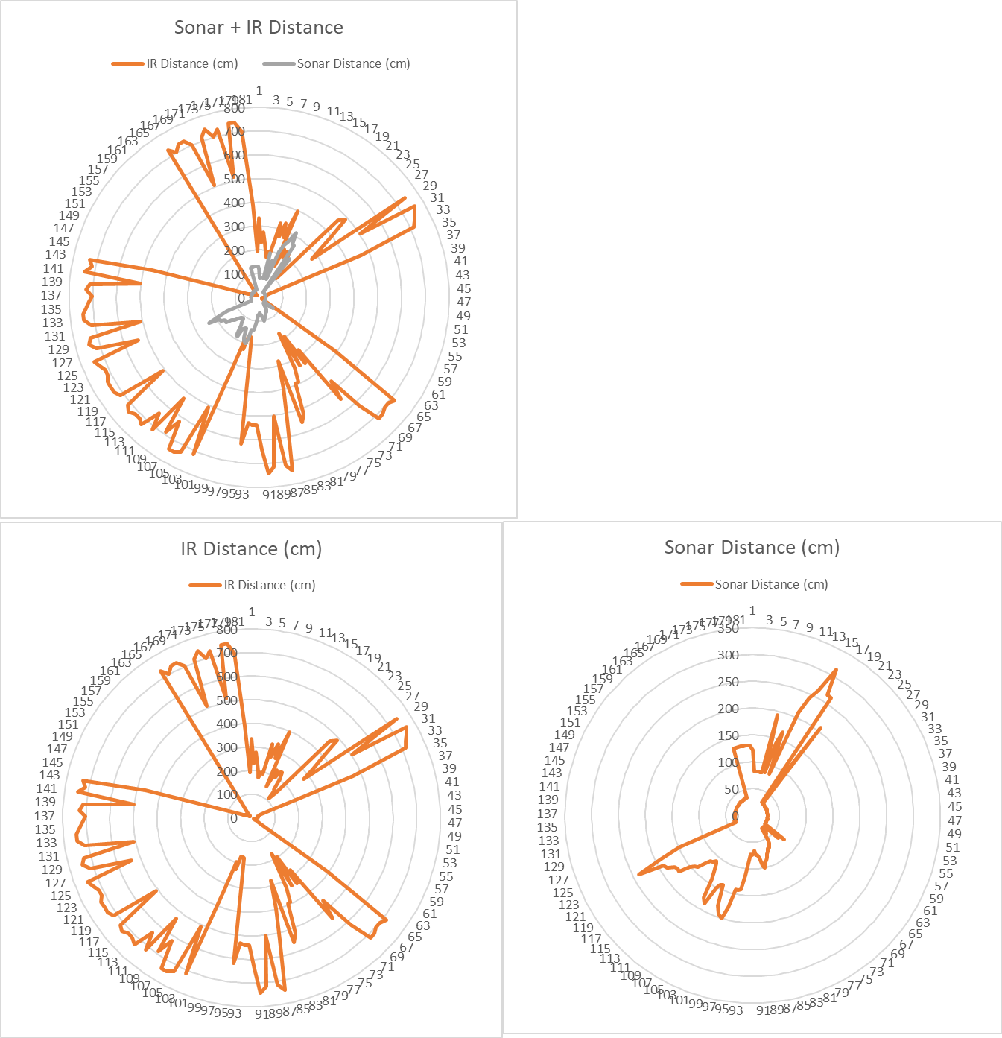

**Environment 3**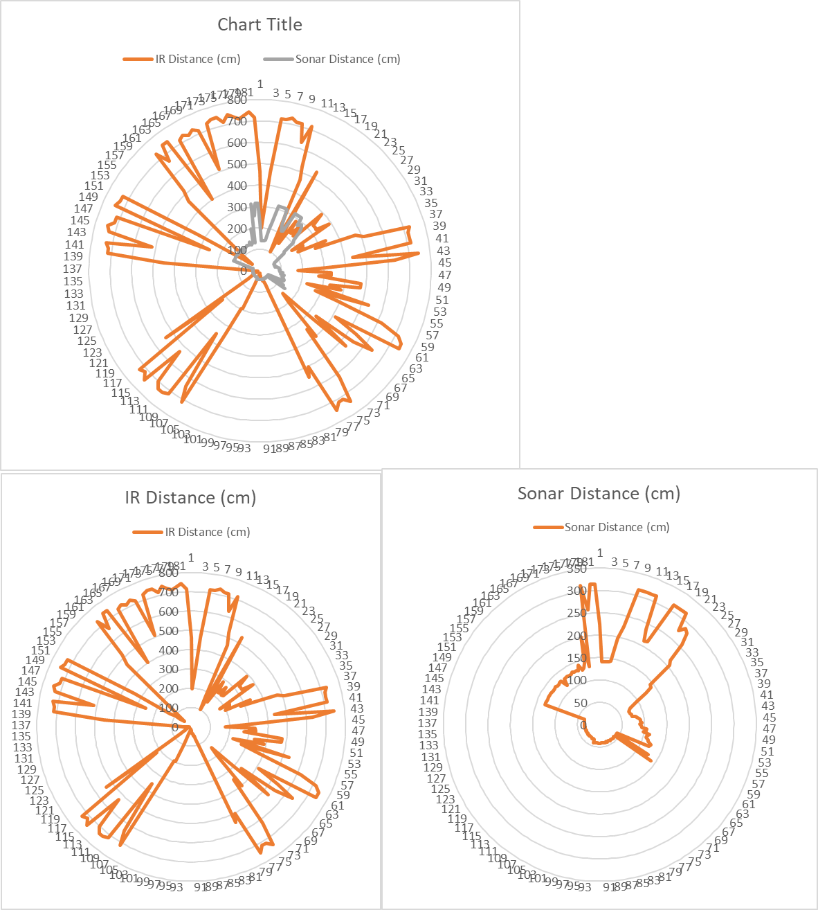

**Q1 Environment 2.** Based on this graph, we think there are a number of objects. The first object is seems to be about 32-34 cm from the robot and at about the 155 degree marker. The next position that we strongly believe to be an object is around 27-29 cm from the robot on the opposite side, approximately 51 degrees. We also believe that there could be a smaller object closer to the front of the robot, around the 0 to 3 degree markers, but cannot be sure about the distance due to the jump in sonar distance data that is visible near the 0 degree marker. Lastly, we believe, although we are quite unsure, that there could possibly be an object nearly two meters away from the robot at about the 97 degree marker. Both the IR and sonar distances seem to corroborate this, but we are unsure if this could just be due to instrument error or other "noise" in the environment.

**Q1 Environment 3.** Based on the data presented in the above graphs, we believe there are several objects in the environment. The first, strongest object is present around the 90 degree marker, approximately 40-42 cm from the robot. Next, we believe there is another object located at approximately the 130 degree marker and between 32-34 cm away from the robot. Next, there is an object located around the 158 degree mark, about 130 cm away from the robot. Next we believe there is an object directly in front of the robot, about 140 cm away. The next object is just over 210 cm away, located near the 15 degree marker. Lastly, we believe there are definitely a number of smaller objects close by to the robot at degrees ranging from about 40 to 60, and ranging from around 80 to 120 cm away, but we do not feel confident enough with the presented information to determine their precise locations.

**Q2.** We chose to use excel over matlab because we have experience with excel and no experience with matlab. We thought that if we used a tool we already knew how to use, that we’d be able to finish the lab during the lab time for once, but this proved not to be the case. After the final project group team meeting portion of the lab, and finishing our demos for lab 4, there was very little time left to actually work on this lab.

Some of the challenges in interpreting the data were that smaller objects were more difficult to recognize, and closer objects were more difficult to accurately place due to the amount of the “view” of the sensors that they obstructed.

We learned a lot about data analysis. It is important to closely look at the data when analyzing, and not to simply look at the graphs, although the graphs are an excellent resource to use to visualize the data. We also learned that it is important to work as a team, because one team member may notice something that another team member did not.