**ECEN 5803– Mastering Embedded Systems Architecture**

**Project 2 Module 3**

Contributors:

1. [Ryn Stewart](mailto:last2896@colorado.edu)
2. [Shweta Prasad](mailto:shwetapd1995@gmail.com)
3. [Micah Brouwer](mailto:mibr2407@colorado.edu)
4. [Aneesh Gurram](mailto:angu1298@colorado.edu)

* **In this module 3, three functions are implemented to perform following operations using bash:**

**- display the current running processes.**

**- display the current data and time, kernel version**

**- display the kernel dump**

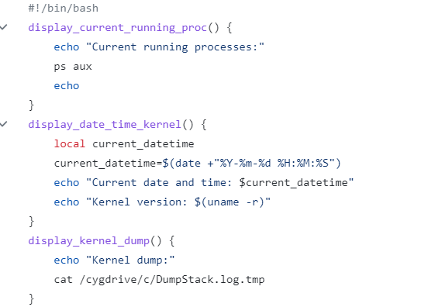

**An function has also been implemented to copy the data returned by the three functions in a log file:**

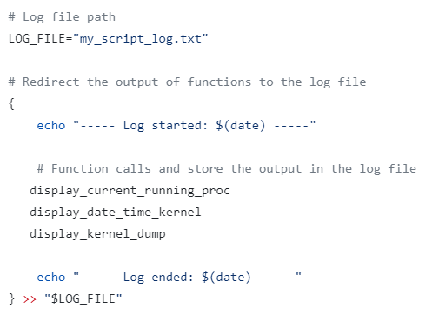

**Following data is obtained from the log file:**

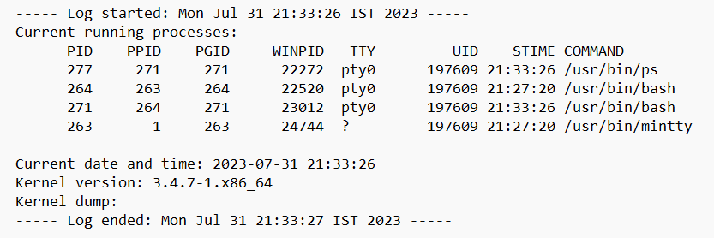

**(i) chmod +x script.sh is used to convert script into executable:**

