Title of primary manuscript: supplemental document

This template can be used to prepare a supplementary document for inclusion with submission to Optica Publishing Group’s journals. This document, which may include supplementary information such as expanded descriptions of materials and methods, will be published as a PDF linked to the primary article. The supplemental file should only present information that would be useful and worthwhile for the reader, for example, details that would be necessary to reproduce an experiment. The article, however, must be coherent without the supplemental PDF file. Please see the [Author Guidelines for Supplementary Materials](https://opg.optica.org/submit/style/multimedia.cfm) for more information. Supplementary documents are not copyedited and so should be prepared carefully with the template provided. Note that a coversheet with final article title, author block, publication date, journal branding, and other details will be added to your supplemental document by us during production. Do not include such details directly in this document. Please note that supplemental documents are not accepted for Optica Open preprints.

To use this template, you will need to apply the embedded styles to each paragraph-level item in your manuscript, or simply use this template as a visual guide.

Using the Word styles. In this template, styles such as “01 Title” for the manuscript appear in the MS Word Styles ribbon (or toolbar for older versions of Word). Apply the appropriate style before typing or apply the style to existing text. It is possible to paste manuscript text into this template or attach this template to an existing manuscript.

Numbering Items in the Supplementary Document. The supplementary materials document may contain additional figures, tables, equations, etc. Such items should be numbered, with an uppercase “S” to identify them as supplementary. For example, number the first figure in the supplementary document “Fig. S1”; the first table “Table S1”; etc.

Naming Convention for Countable Items

* Algorithm S1
* Equation (S1)
* Figure S1
* Media S1
* Table S1

 (S1)

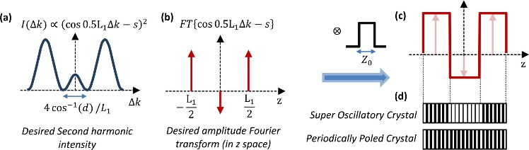

Fig. S1. Caption text with descriptions of (a), (b), and (c).

**Media.** The supplemental document may contain linked objects such as video, 2D, 3D, and machine-readable data files. Please see the Author Guidelines for Supplementary Materials for more information. All supplementary materials associated with the supplemental document that are submitted through the Prism system must be referenced in the main document as well as the supplement, using the naming convention described above.

**References.** The supplementary materials document may contain a reference list. The reference list should follow Optica Publishing Group's citation style and should be checked carefully, since no copyediting will be performed by our staff. Example references are given below. List up to three authors, and if there are more use *et al*. after the first three.

Citations that are relevant to the primary manuscript and the supplementary document may be included in both places.

References

1. M. R. E. Lamont, Y. Okawachi, and A. L. Gaeta, “Route to stabilized ultrabroadband microresonator-based frequency combs,” Opt. Lett. **38,** 3478-3481 (2013)
2. A. Cordero-Davila, J. R. Kantun-Montiel, and J. Gonzalez-Garcia, in *Imaging and Applied Optics Technical Digest 2012* (Optical Society of America, 2012), p. 13.