End-to-End Big Data Pipeline for Machine Learning Using Apache NiFi, Hadoop, Spark, and HBase: A Titanic Survival Prediction Analysis
Shaghayegh Malekshahi
Bellevue University
DSC 650 – Big Data Analytics
February 24, 2026

Introduction
The objective of this project was to design and implement a complete big data processing pipeline capable of ingesting, storing, analyzing, and persisting machine learning results using a distributed data ecosystem. The pipeline integrates several technologies commonly used in modern data engineering environments, including Apache NiFi for data ingestion, Hadoop Distributed File System (HDFS) for storage, Apache Hive for structured data access, Apache Spark for distributed machine learning, and Apache HBase for storing final model evaluation metrics. Together, these technologies demonstrate how large-scale data workflows can be orchestrated across multiple components within a big data architecture.
The dataset used in this project is based on the well-known Titanic passenger dataset, which contains demographic and travel information for individuals who were aboard the RMS Titanic. The dataset includes attributes such as passenger class, gender, age, fare, and embarkation port, along with the target variable indicating whether a passenger survived the disaster. This dataset is frequently used in machine learning research because it provides a clear binary classification problem: predicting survival outcomes based on passenger characteristics.
The project begins with the ingestion of the Titanic dataset using Apache NiFi, which automates the flow of data into the Hadoop ecosystem. Once ingested, the dataset is stored within HDFS, allowing it to be distributed across the cluster for scalable processing. Apache Hive is then used to create a structured schema that enables SQL-based access to the data, allowing it to be queried and prepared for downstream analytics.
Following the data preparation stage, Apache Spark is used to execute a machine learning pipeline designed to predict passenger survival. Spark processes the dataset in a distributed manner, performs feature preparation, and applies a classification algorithm to generate predictions and probability estimates. In addition to producing predictions, the Spark model calculates evaluation metrics such as classification accuracy and the Area Under the Curve (AUC), which measure the effectiveness of the predictive model.
The final stage of the pipeline stores these model evaluation metrics in Apache HBase, a distributed NoSQL database that enables fast retrieval and persistence of analytical results. By writing the model metrics to HBase and verifying their storage through scan operations, the pipeline demonstrates a complete end-to-end data processing workflow.
This project illustrates how modern big data technologies can be combined to create a scalable analytics pipeline capable of handling data ingestion, distributed processing, machine learning, and persistent storage of results.

Dataset Description
The dataset used in this project is based on the well-known Titanic passenger dataset, which contains demographic and travel information for individuals who were aboard the RMS Titanic. The dataset includes passenger attributes such as passenger class (Pclass), gender (Sex), age (Age), number of siblings or spouses aboard (SibSp), number of parents or children aboard (Parch), ticket fare (Fare), and embarkation port (Embarked). In addition to these features, the dataset contains the target variable Survived, which indicates whether a passenger survived the disaster.
This dataset provides a suitable foundation for machine learning analysis because it represents a binary classification problem, where the objective is to predict whether a passenger survived based on their demographic and travel characteristics. The dataset includes both numerical and categorical variables, making it appropriate for demonstrating feature engineering, categorical encoding, and model training within the Spark MLlib framework.
The dataset is hosted on GitHub and accessed directly through a raw file URL, which allows Apache NiFi to retrieve the dataset automatically through an HTTP request. Using a publicly hosted dataset ensures reproducibility and demonstrates how external data sources can be integrated into a distributed data processing pipeline. Once retrieved, the dataset is ingested into the Hadoop ecosystem and stored in HDFS, where it becomes available for downstream processing through Hive and Spark.

Pipeline Overview
The architecture implemented in this project demonstrates a complete end-to-end big data processing pipeline that integrates several core components of the Hadoop ecosystem. The pipeline is designed to automate the movement of data from ingestion through distributed storage, structured querying, machine learning analysis, and final result persistence.
The workflow begins with Apache NiFi, which is responsible for ingesting the Titanic dataset from a GitHub-hosted source. NiFi retrieves the dataset using an HTTP request and transfers the file into the Hadoop Distributed File System (HDFS). HDFS serves as the primary distributed storage layer, allowing the dataset to be stored across multiple nodes within the cluster for scalable processing.
Once the dataset is stored in HDFS, Apache Hive is used to create a structured table representation of the data. Hive enables SQL-based querying on top of distributed storage, allowing the dataset to be accessed and prepared for analytics using familiar relational database concepts.
Following data preparation, Apache Spark is used to perform distributed machine learning analysis on the dataset. Spark MLlib is used to build and train a logistic regression model that predicts passenger survival outcomes based on selected features such as passenger class, gender, age, and fare. Spark processes the data in parallel across the cluster and produces evaluation metrics that measure the performance of the model.
The final stage of the pipeline stores these evaluation metrics in Apache HBase, a distributed NoSQL database optimized for fast read and write operations. The metrics generated by the Spark model, including classification accuracy and Area Under the Curve (AUC), are written into an HBase table. This step demonstrates how analytical results can be persisted for future retrieval, monitoring, or comparison.
Together, these components form a complete distributed pipeline that demonstrates the integration of NiFi, HDFS, Hive, Spark, and HBase to support scalable data ingestion, analytics, and storage within a big data environment.

Objective 1 – NiFi Data Ingestion into HDFS
NiFi-Based Data Ingestion Design
The first stage of the pipeline automates the ingestion of the Titanic dataset into the Hadoop Distributed File System (HDFS) using Apache NiFi. This stage establishes the entry point for the architecture and ensures that external data is retrieved and transferred to distributed storage in a controlled, reproducible manner.
The NiFi flow was designed using three processors configured within a single process group: InvokeHTTP, UpdateAttribute, and PutHDFS.
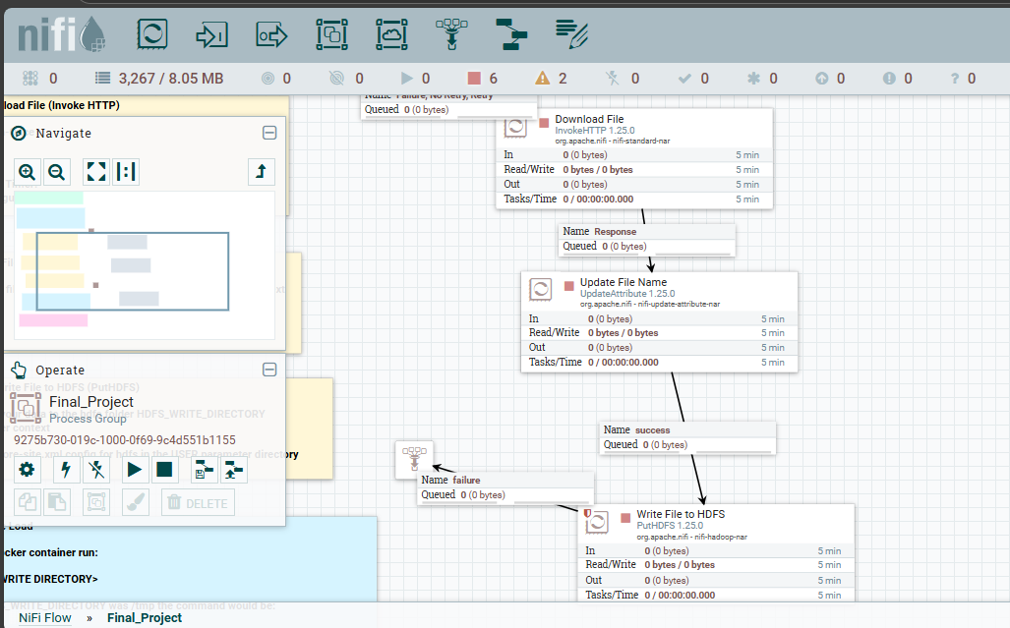
The InvokeHTTP processor retrieves the Titanic dataset from the specified HTTP source and encapsulates it within a FlowFile. This processor functions as the external ingestion interface between the data source and the Hadoop ecosystem.
The FlowFile is routed to the UpdateAttribute processor, where metadata, specifically the filename, is explicitly assigned before persistence. This step ensures consistent file naming within HDFS and supports traceability throughout the pipeline.
The PutHDFS processor writes the dataset into the configured HDFS directory. This processor represents the integration point between NiFi and distributed storage. Success and failure relationships were configured to enforce deterministic routing and error handling within the ingestion process.

NiFi Flow Running with Data Visible in Queues
After configuring the workflow, the NiFi flow was executed to validate operational behavior and confirm data movement between processors.
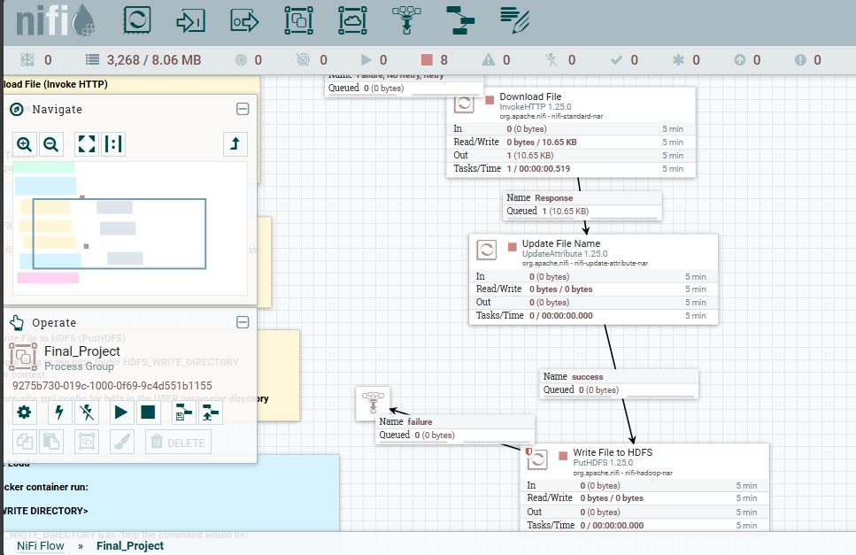
The presence of FlowFile counts (10.65 KB) in the processor queues confirms that the dataset was successfully retrieved and passed through each stage of the workflow. Processor statistics, including In/Out counts and task execution time, demonstrate that the ingestion pipeline executed as expected.
To further validate ingestion at the content level, the dataset was inspected using NiFi’s content viewer.
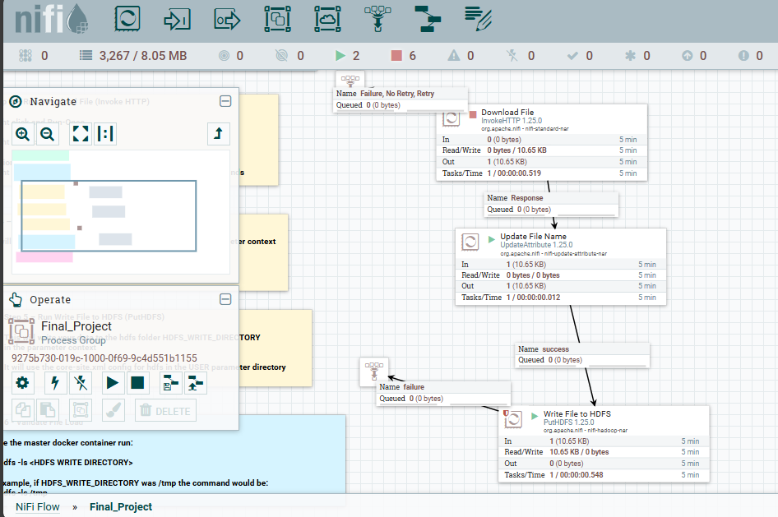
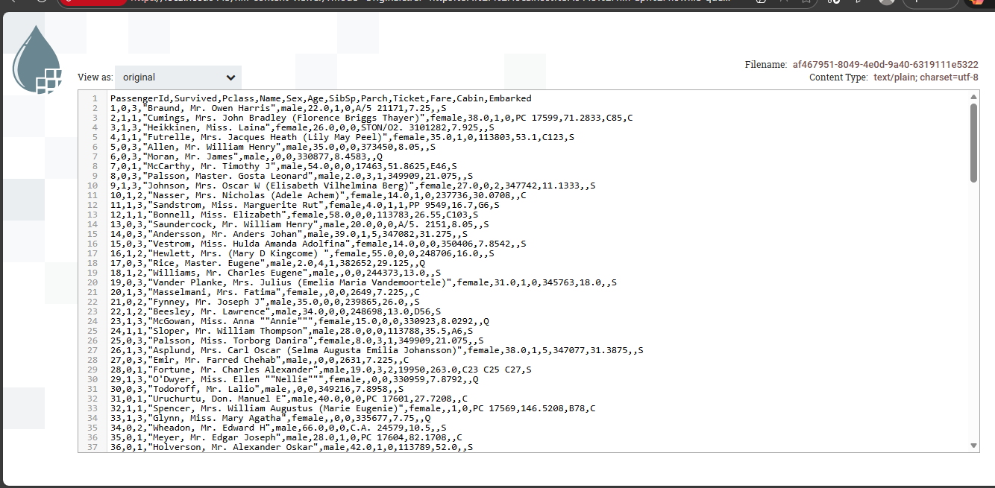

The displayed CSV structure, including headers such as PassengerId, Survived, Pclass, Name, Sex, Age, and Fare, confirms that the dataset was retrieved without corruption and preserved in its original structure. This inspection step verifies data integrity prior to storage in HDFS.

HDFS Verification of Dataset Ingestion
To confirm that the dataset was successfully persisted in distributed storage, the HDFS directory was inspected using the Hadoop command-line interface.
The following command was executed:
hdfs dfs -ls /tmp
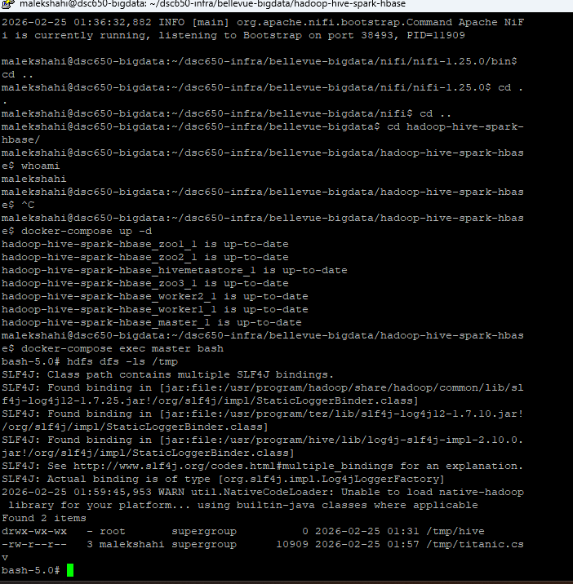
The directory listing confirms the presence of titanic.csv within HDFS, including file size, ownership, and timestamp metadata. This validates that NiFi successfully transferred the dataset into the Hadoop Distributed File System and that the data is available for subsequent Hive querying and Spark-based analytics.
Objective 2 – Hive Managed Table
After the Titanic dataset was successfully ingested into HDFS using Apache NiFi, the next step in the pipeline involved creating a Hive managed table to make the dataset queryable using SQL. Hive acts as the structured query layer within the Hadoop ecosystem, allowing distributed data stored in HDFS to be accessed in a tabular format suitable for analytics and machine learning workflows.
To organize the project environment, a dedicated database named finalproject was created and set as the active working context. Within this database, a managed Hive table called titanic_raw was created to represent the Titanic dataset stored in HDFS. The schema mirrors the structure of the CSV dataset and includes fields such as passenger identifiers, demographic attributes, ticket information, and survival status.
The Hive table was created using the following SQL statement:
CREATE DATABASE finalproject;

USE finalproject;

CREATE TABLE titanic_raw (
PassengerId STRING,
Survived STRING,
Pclass STRING,
Name STRING,
Sex STRING,
Age STRING,

SibSp STRING,
Parch STRING,
Ticket STRING,
Fare STRING,
Cabin STRING,
Embarked STRING
)
ROW FORMAT SERDE 'org.apache.hadoop.hive.serde2.OpenCSVSerde'
WITH SERDEPROPERTIES (
"separatorChar" = ",",
"quoteChar" = "\"",
"escapeChar" = " \\"
)
STORED AS TEXTFILE
TBLPROPERTIES ("skip.header.line.count"="1");

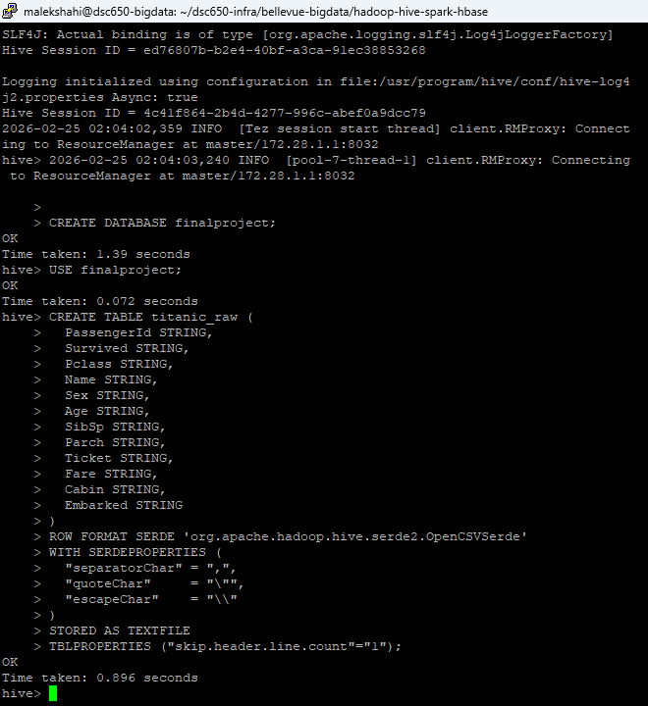
This table definition uses the OpenCSVSerde library to properly interpret comma-separated values and handle quoted text fields such as passenger names. The table property skip.header.line.count="1" ensures that the first line of the CSV file, which contains column names, is not interpreted as a data record.
Once the table schema was defined, the Titanic dataset previously stored in HDFS was loaded into the Hive table using the LOAD DATA INPATH command. This operation moves the dataset from its HDFS location into the managed Hive table storage so that it can be queried using HiveQL.
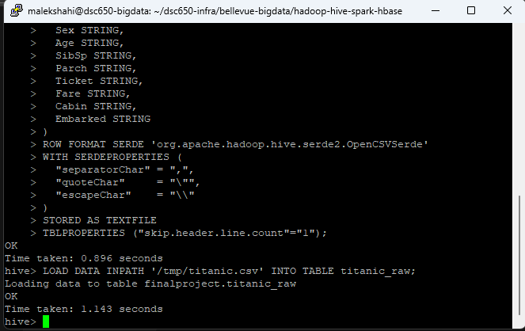

The successful execution output confirms that the dataset was transferred into the Hive table and is now accessible through Hive queries.
To verify that the table was populated correctly and that the schema aligns with the dataset structure, queries were executed to retrieve records and perform a simple aggregation. Displaying a subset of rows confirms that the dataset is readable and that fields such as passenger name, sex, and fare appear in the expected columns.
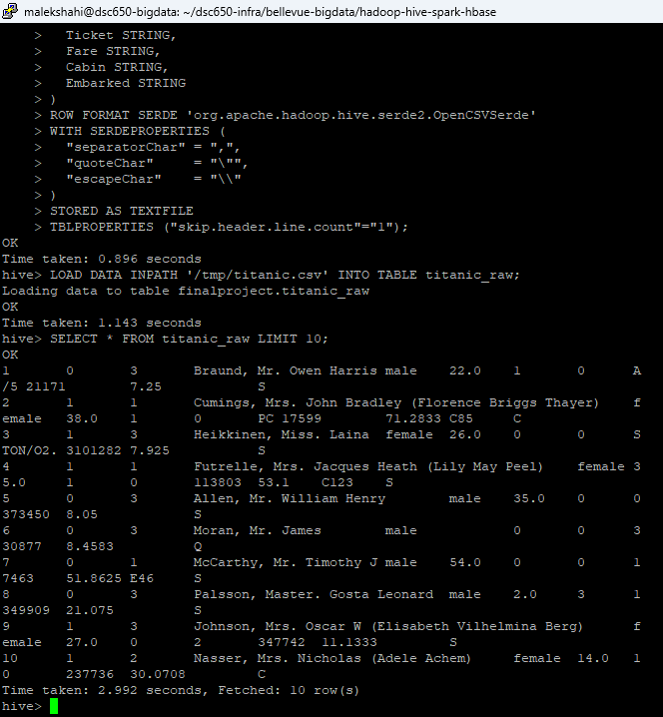

To further validate the dataset population and confirm that the target variable for the machine learning model is correctly populated, an aggregation query was executed on the Survived column.

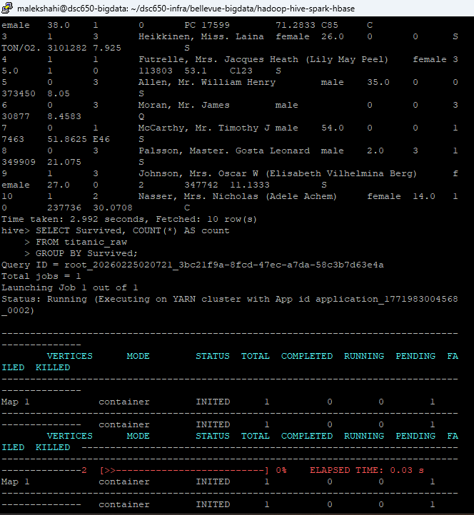
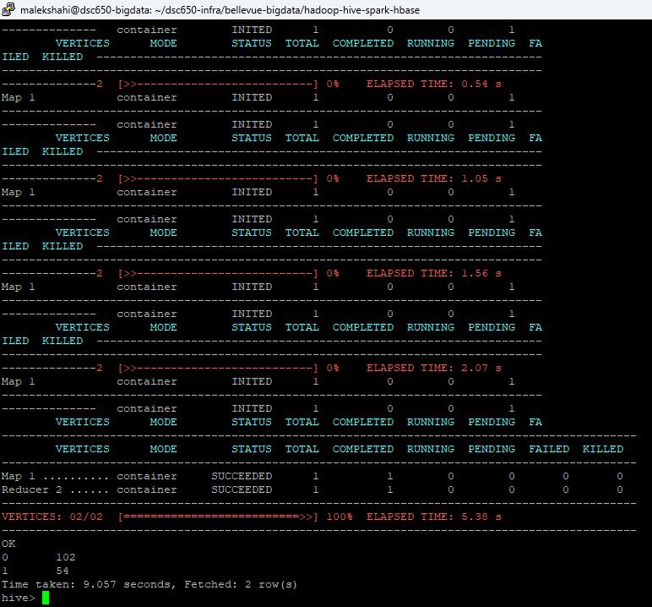

The results show counts for each survival category, confirming that the dataset has been successfully loaded and that the table structure correctly represents the Titanic dataset. This verification ensures that the Hive layer of the pipeline is functioning correctly and that the dataset is ready to be consumed by the Spark machine learning stage.

Schema Design Considerations
All columns were initially defined using the STRING data type during ingestion to minimize potential parsing errors caused by missing values or inconsistent formatting within the CSV file. This approach allows the raw dataset to be loaded reliably into Hive while preserving the original data structure. Data type conversion and feature preparation are later handled within the Spark processing stage of the pipeline, where transformations such as casting numeric variables and handling missing values are part of the machine learning workflow.

Objective 3 – Environment Setup
Before the machine learning pipeline can interact with HBase, the Python environment must be prepared with the necessary libraries. The project uses Python-based interaction with HBase, which requires installing specific packages that enable communication between Python applications and the HBase database.
To support this integration, the packages NumPy and HappyBase were installed inside the Hadoop master container using pip3. NumPy is commonly used for numerical operations within data science workflows, while HappyBase provides a Python client that allows applications to connect to HBase through the Thrift interface. During installation, pip retrieves the required dependencies and builds any necessary components before confirming successful installation.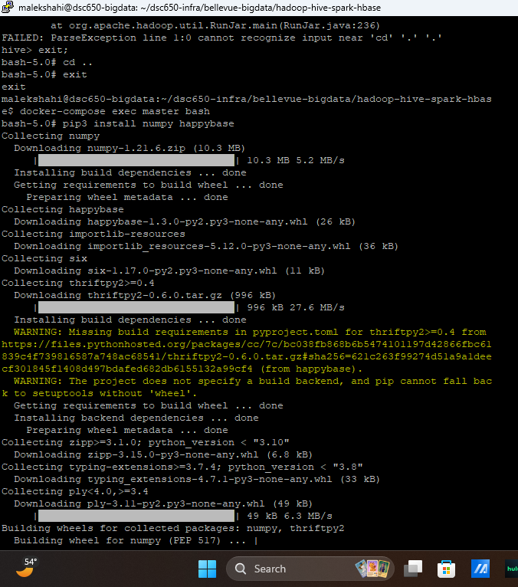
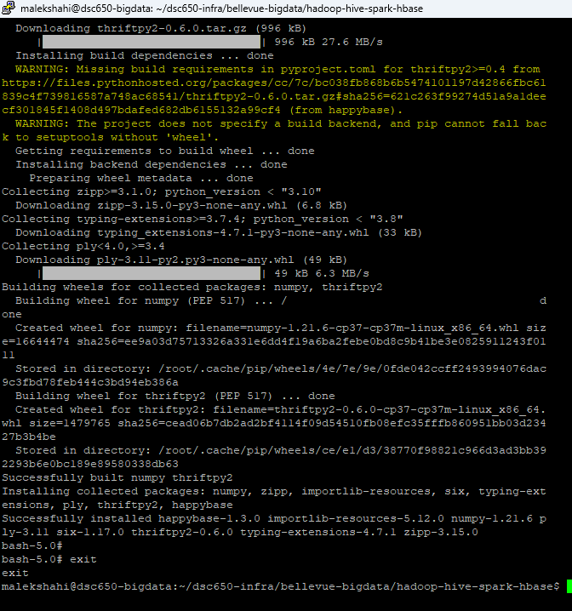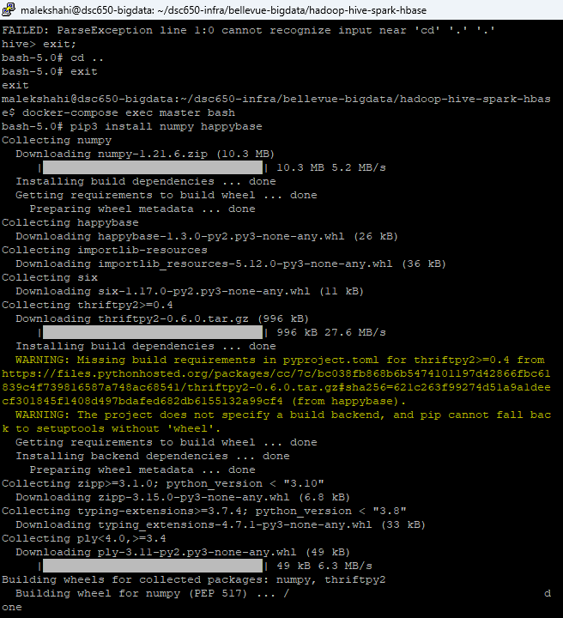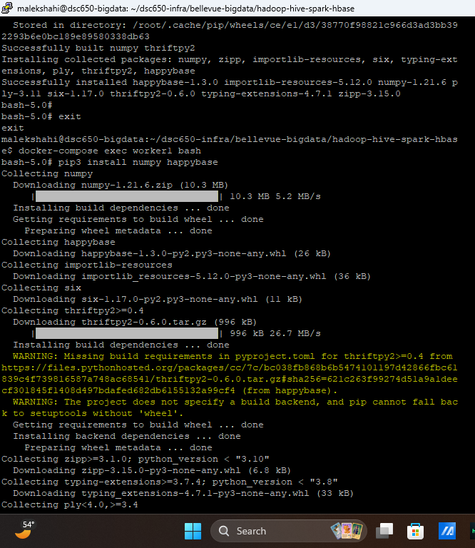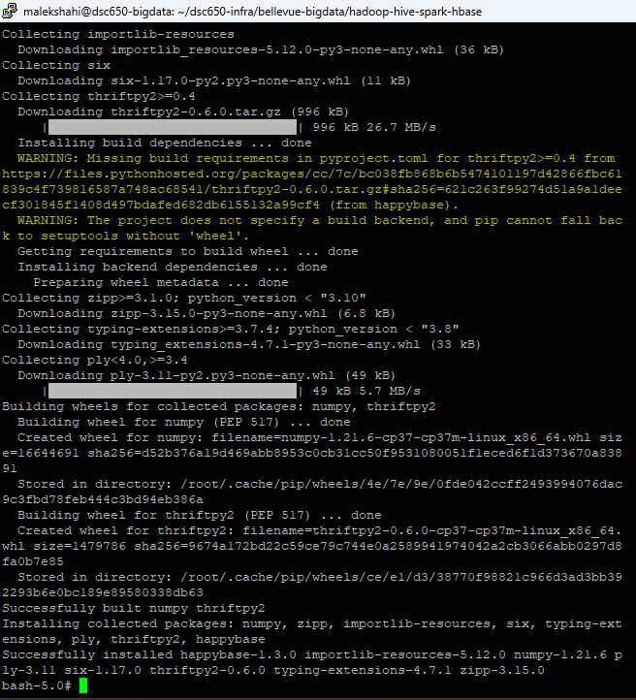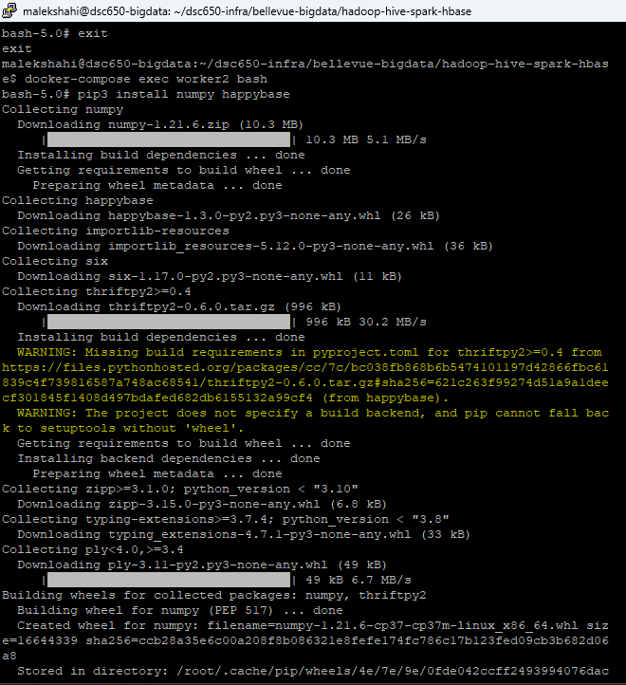
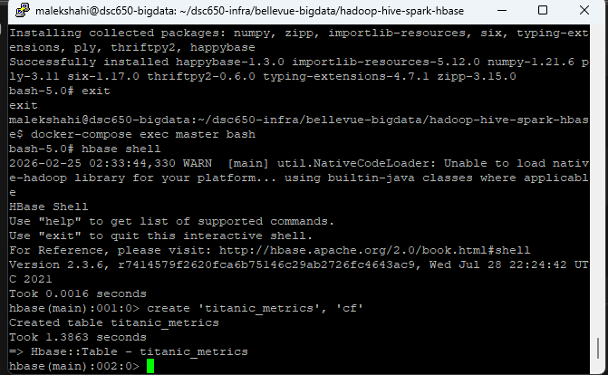

The installation output confirms that the required packages and their dependencies were downloaded and successfully installed inside the container environment. This ensures that Python scripts later in the pipeline will be able to communicate with HBase and perform operations such as inserting and retrieving data.

After installing the required Python packages, the HBase Thrift server was started. The Thrift server acts as a communication bridge that allows external applications, including Python programs using HappyBase, to interact with the HBase database. Without this service running, Python applications would not be able to establish a connection to HBase.
The server was launched using the command:
nohup hbase thrift start &

This command runs the Thrift server in the background so that it continues operating while other commands are executed. Once started, the system process list and network port checks were used to verify that the service was running and listening for incoming connections.

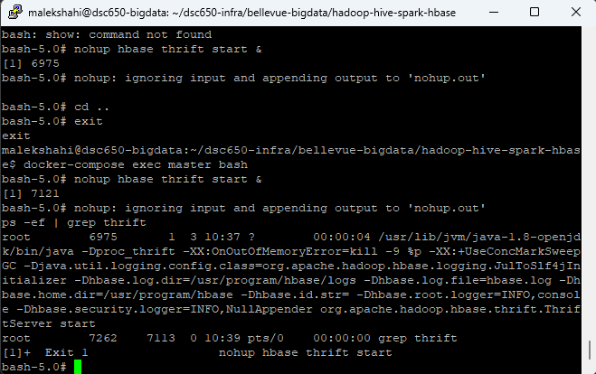
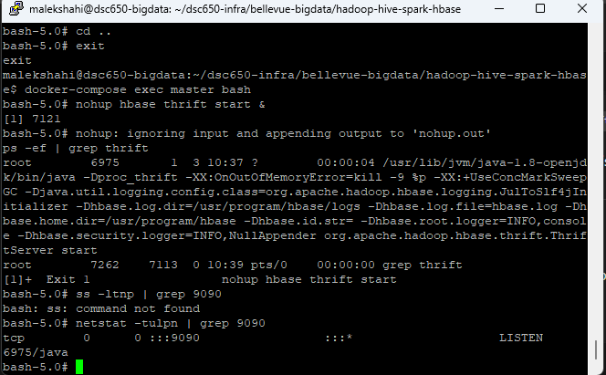

The verification output shows the Thrift service running and listening on the expected port (9090), confirming that the server is active and ready to accept client connections.

Why These Steps Are Necessary for the Pipeline
These environment setup steps are critical for enabling communication between the different components of the big data pipeline. The Python libraries provide the application layer needed for data processing and interaction with HBase, while the Thrift server acts as the network interface that allows Python clients to connect to the HBase database.
Together, these components enable the project pipeline to move processed data from the Spark analytics stage into HBase for storage and retrieval. This integration allows machine learning outputs and derived metrics to be stored in a scalable NoSQL database that can support fast read and write operations.

Objective 4 – HBase Table Creation
After configuring the environment and enabling communication between Python and HBase through the Thrift server, the next step in the pipeline was creating the HBase table that would store the processed metrics generated by the Spark analytics stage. HBase is a distributed NoSQL database built on top of HDFS that supports high-speed read and write operations across large datasets.
For this project, a table named titanic_metrics was created to store derived analytics results from the Titanic dataset. The table structure follows the HBase data model, which organizes data using row keys and column families rather than traditional relational schemas.
The HBase table was created using the following command inside the HBase shell:
create 'titanic_metrics', 'cf'

In this command, titanic_metrics represents the table name, while cf is the column family that groups related columns together. Column families must be defined at table creation time in HBase, and determine how the data is physically stored and managed.
After creating the table, an initial scan operation was executed to verify that the table existed and to confirm that no records had yet been inserted.

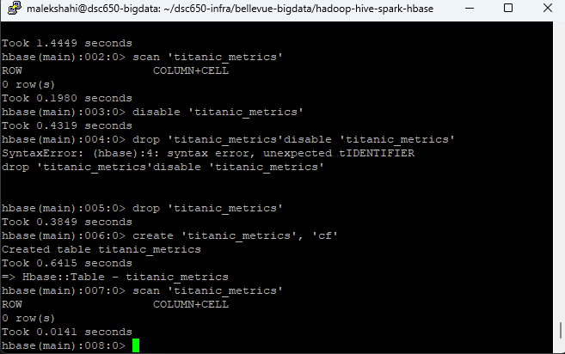
The output of the scan command shows 0 rows, confirming that the table was successfully created and is currently empty. This verification step is important because it ensures that the table structure is functioning correctly before data ingestion begins.

Row Key and Column Family Design
The table design follows common HBase best practices by using a single column family (cf) to group related attributes together. Since the dataset contains derived analytical results rather than large numbers of heterogeneous attributes, a single column family simplifies the schema and improves read efficiency.
The row key is designed to uniquely identify each metric record inserted into the table. In this project, the row key represents the identifier for each processed record or aggregated result generated from the Titanic dataset. Using a unique row key ensures that HBase can quickly locate and retrieve specific records during queries.
This schema design supports the project pipeline by allowing Spark-generated analytics results to be stored in HBase in a scalable key-value format, enabling efficient storage and retrieval for downstream applications.

Objective 5 – PySpark ML Code
In this stage of the project, Apache Spark was used to build and evaluate a machine learning model using the Titanic dataset. Spark MLlib was selected because it allows scalable machine learning processing across distributed environments and integrates well with the Hadoop ecosystem used throughout this project pipeline. The PySpark script loads the Titanic dataset, performs preprocessing and feature transformations, trains a classification model, evaluates its performance, and then prepares the resulting evaluation metrics for storage in HBase.
The machine learning algorithm selected for this project was Logistic Regression, which is well-suited for binary classification problems such as predicting passenger survival. Logistic Regression is commonly used because it is computationally efficient, interpretable, and supported directly by Spark MLlib. In this project, relevant features such as passenger class, sex, age, fare, and embarkation location were used to construct the model input vector. These features provide meaningful signals that help the algorithm estimate the probability of survival.
The complete PySpark machine learning code used for this project is provided below. The script performs data loading, feature preparation, model training, evaluation, and finally writes the resulting evaluation metrics to HBase for persistence.

Code:
from pyspark.sql import SparkSession
from pyspark.sql.functions import col, trim
from pyspark.ml.feature import VectorAssembler, StringIndexer, OneHotEncoder
from pyspark.ml.classification import LogisticRegression
from pyspark.ml import Pipeline
from pyspark.ml.evaluation import BinaryClassificationEvaluator, MulticlassClassificationEvaluator
import happybase

# ---- Write metrics to HBase with happybase
def write_to_hbase_partition(partition):
connection = happybase.Connection('master')
connection.open()
table = connection.table('titanic_metrics')
for row in partition:
row_key, column, value = row
table.put(row_key, {column: value})
connection.close()

def main():
# Step 1: Create Spark session
spark = SparkSession.builder.appName("Titanic Survival Prediction").enableHiveSupport().getOrCreate()

# Step 2: Load data from Hive table
titanic_df = spark.sql("""
SELECT
cast(Pclass as int) as Pclass,
trim(Sex) as Sex,
cast(Age as double) as Age,
cast(SibSp as int) as SibSp,
cast(Parch as int) as Parch,
cast(Fare as double) as Fare,
trim(Embarked) as Embarked,
cast(Survived as int) as Survived
FROM finalproject.titanic_raw
""")

# Step 3: Handle null values
titanic_df = titanic_df.filter(col("Survived").isNotNull())
titanic_df = titanic_df.fillna({"Age": 0.0, "Fare": 0.0, "Sex": "UNK", "Embarked": "UNK"})

# Step 4: Feature prep (categorical -> index -> onehot, then assemble)
sex_indexer = StringIndexer(inputCol="Sex", outputCol="Sex_idx", handleInvalid="keep")
emb_indexer = StringIndexer(inputCol="Embarked", outputCol="Embarked_idx", handleInvalid="keep")

encoder = OneHotEncoder(
inputCols=["Sex_idx", "Embarked_idx"],
outputCols=["Sex_ohe", "Embarked_ohe"]
)

assembler = VectorAssembler(
inputCols=["Pclass", "Age", "SibSp", "Parch", "Fare", "Sex_ohe", "Embarked_ohe"],
outputCol="features",
handleInvalid="skip"
)

# Step 5: Split train/test
train_df, test_df = titanic_df.randomSplit([0.7, 0.3], seed=42)

# Step 6: Train MLlib model (Logistic Regression is relevant for Survived 0/1)
lr = LogisticRegression(featuresCol="features", labelCol="Survived", maxIter=50)

pipeline = Pipeline(stages=[sex_indexer, emb_indexer, encoder, assembler, lr])

print("=== Training Logistic Regression model ===")
model = pipeline.fit(train_df)

# Step 7: Predict
predictions = model.transform(test_df)

print("=== Sample Predictions ===")
predictions.select("Survived", "prediction", "probability", "Pclass", "Sex", "Age", "Fare", "Embarked") \
.show(20, truncate=False)

# Step 8: Evaluation metrics (classification metrics)
auc_eval = BinaryClassificationEvaluator(
labelCol="Survived",
rawPredictionCol="rawPrediction",
metricName="areaUnderROC"
)
auc = auc_eval.evaluate(predictions)

acc_eval = MulticlassClassificationEvaluator(
labelCol="Survived",
predictionCol="prediction",
metricName="accuracy"
)
accuracy = acc_eval.evaluate(predictions)

print("=== Evaluation Metrics ===")
print(f"AUC: {auc}")
print(f"Accuracy: {accuracy}")

# Write metrics to HBase
data = [
("metrics1", "cf:auc", str(auc)),
("metrics1", "cf:accuracy", str(accuracy)),
]

rdd = spark.sparkContext.parallelize(data)
rdd.foreachPartition(write_to_hbase_partition)
# Step 9: Stop spark
spark.stop()

if __name__ == "__main__":
main()
GitHub Repository:
https://github.com/shqyqmalkshahi/bigdata

PySpark script:
https://github.com/shqyqmalkshahi/bigdata/blob/main/titanic_mllib.py

Dataset direct URL:
https://raw.githubusercontent.com/shqyqmalkshahi/bigdata/main/titanic.csv

The following output shows the machine learning pipeline executing successfully within Spark. The logs confirm that the Spark environment initialized correctly and that the logistic regression model began training on the Titanic dataset.
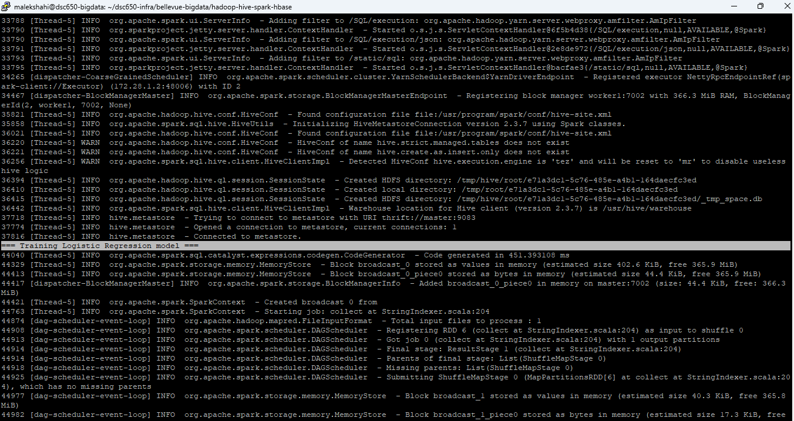
After the model finished training, Spark generated evaluation metrics that measure the performance of the model on the dataset. These metrics provide insight into how well the model predicts passenger survival based on the selected features.
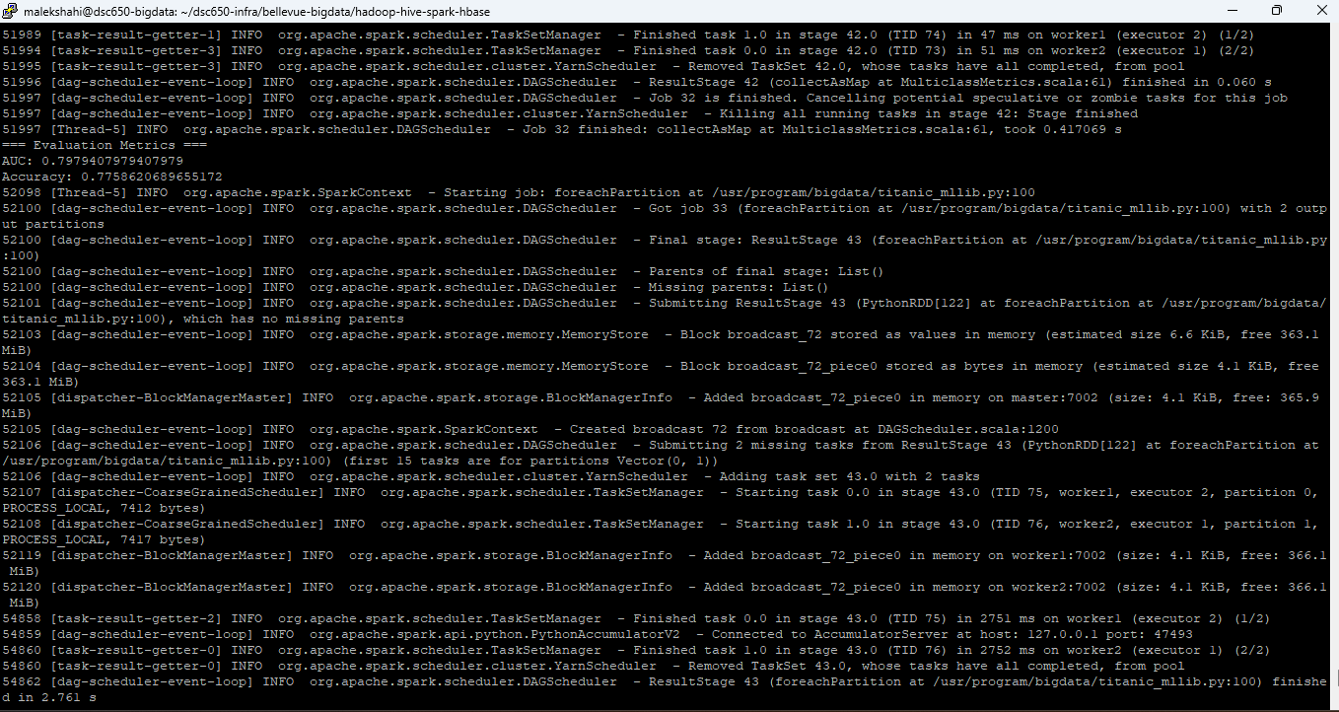

The results show that the model achieved an AUC of approximately 0.798 and an accuracy of approximately 0.776. These values indicate that the model performs reasonably well at distinguishing between passengers who survived and those who did not. The AUC value measures the model's ability to correctly rank predictions across different classification thresholds, while accuracy measures the proportion of correct predictions. Together, these metrics confirm that the model learned meaningful patterns from the dataset.

Objective 6 – Spark Submit & Output
After implementing the machine learning pipeline, the Spark application was executed using the spark-submit command. This command is used to launch Spark applications on the cluster and ensures that the program runs using the configured distributed environment rather than as a local script.
The Spark job was submitted using the following command:
spark-submit --master yarn --deploy-mode client titanic_mllib.py

Using --master yarn allows the job to be managed by the YARN resource manager, which coordinates resources across the Hadoop cluster. The --deploy-mode client option allows the driver program to run in the terminal session while still distributing the workload across Spark executors.

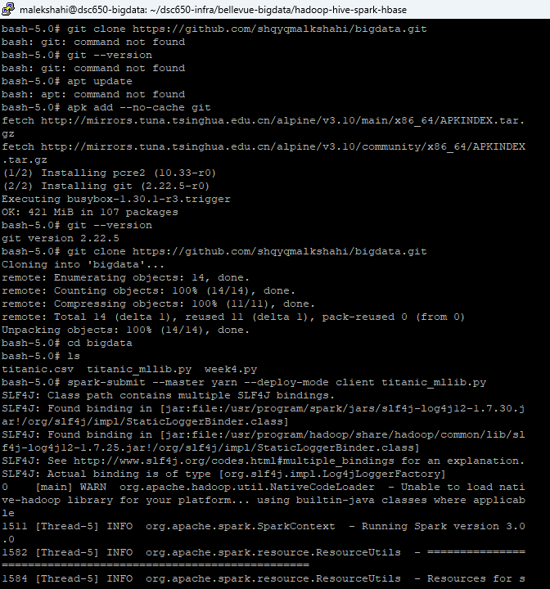

Once submitted, Spark initializes the execution environment and begins running the job. The output logs show Spark starting the context, registering executors, and processing the dataset through the machine learning pipeline.

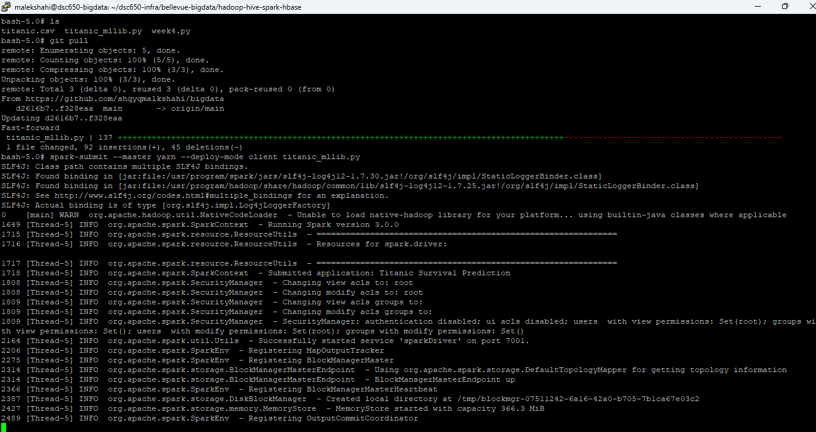
The Spark logs confirm that the job was successfully executed. Messages from components such as SparkContext, TaskSetManager, and DAGScheduler indicate that the application initialized correctly, tasks were distributed across worker nodes, and all stages of the job completed without failure. These logs verify that the Spark cluster processed the machine learning workflow as expected.
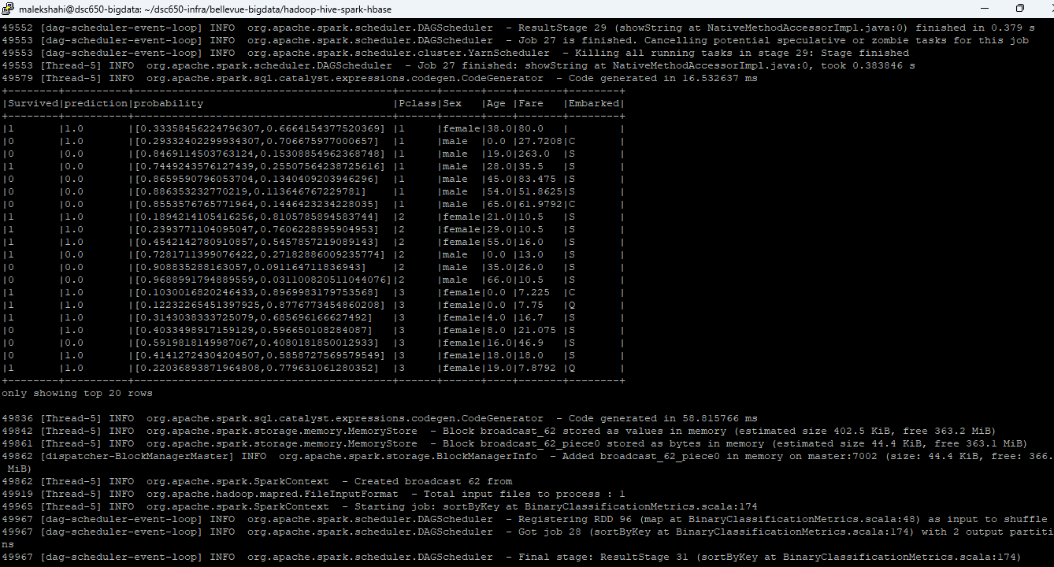

The final output shows the prediction results generated by the Spark machine learning model. Each row represents a passenger record from the Titanic dataset along with the model’s predicted survival outcome. The prediction column indicates whether the model predicts survival (1) or non-survival (0). The probability column provides the confidence level of the prediction, showing the likelihood associated with each predicted class. Additional columns such as Pclass, Sex, Age, Fare, and Embarked represent the passenger features used by the model during training and prediction.
The table output confirms that the machine learning pipeline successfully processed the dataset, applied the trained classification model, and generated prediction probabilities for each passenger record. Displaying the first twenty rows provides a sample of the model’s prediction results and verifies that the Spark job completed its analytical task correctly.
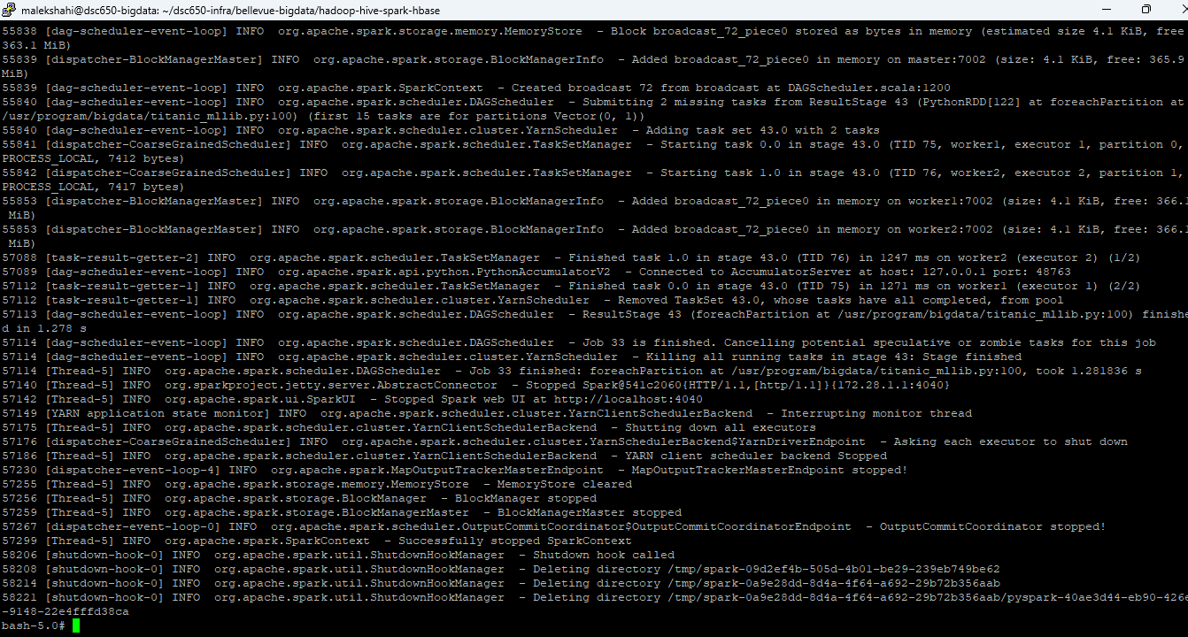

After the prediction results were generated, Spark completed the remaining execution stages and properly shut down the application. The logs show messages indicating that the job finished successfully and that the Spark context was stopped without errors. Entries such as task completion notifications, resource cleanup, and the message confirming that the Spark context stopped verify that the distributed computation completed normally. This confirms that the entire machine learning pipeline executed successfully from data loading through prediction generation and final application shutdown.

Objective 7 – HBase Scan Verification
After the Spark machine learning job completed and generated the model evaluation metrics, the results were written into the HBase table titanic_metrics. To verify that the pipeline successfully stored the model evaluation data, a scan command was executed in the HBase shell to retrieve the contents of the table.
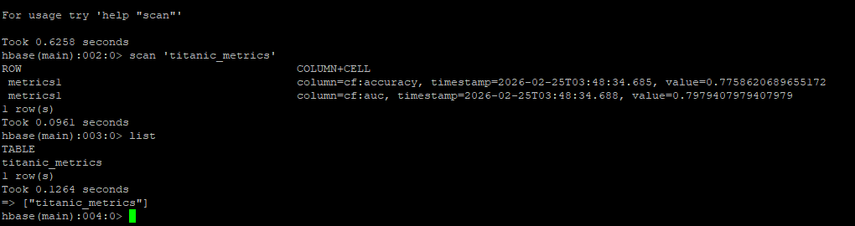
The scan output confirms that the model evaluation metrics were successfully written to HBase. The table row labeled metrics1 contains values stored under the column family cf. The stored metrics include the classification accuracy and the Area Under the Curve (AUC) value produced by the Spark machine learning model. These metrics represent the performance of the Titanic survival prediction model on the dataset.
The presence of these values in HBase verifies that the final stage of the data pipeline executed successfully. After processing the dataset with Spark and generating model predictions, the evaluation metrics persisted in the distributed HBase database. This confirms that the full big data workflow operated correctly from data ingestion to machine learning analysis and final result storage.

Issues Encountered
During the implementation of the project pipeline, several technical challenges were encountered while integrating the different components of the Hadoop ecosystem. One of the primary challenges involved managing system resources within the virtual machine environment. Because the environment operates with limited CPU and memory resources, running multiple distributed services simultaneously occasionally caused performance slowdowns or service interruptions. To address this issue, services such as NiFi were stopped after the dataset was successfully loaded into HDFS so that sufficient system resources were available for subsequent components such as Hive, Spark, and HBase.
Another challenge involved configuring the communication between Spark and HBase when storing the machine learning evaluation metrics. Proper connectivity required installing additional Python libraries, such as HappyBase, and ensuring that the HBase Thrift server was running so that Python applications could establish a connection with the HBase database. Once these dependencies were correctly installed and the Thrift server was started, the Spark application was able to successfully write evaluation metrics to the HBase table.
During the development of the Spark machine learning pipeline, additional attention was required to ensure that the dataset fields were correctly converted into appropriate data types. Because the data was initially loaded into Hive using the STRING type to prevent ingestion errors, the Spark script needed to explicitly cast numeric fields such as passenger age, fare, and passenger class into numerical types before training the machine learning model. These transformations were necessary for the logistic regression algorithm to correctly process the dataset.
Despite these challenges, each issue was systematically resolved through configuration adjustments and careful validation of each stage in the pipeline. The successful execution of the final workflow confirms that all components of the distributed system were correctly integrated and functioning together.

Conclusion
This project successfully demonstrated the implementation of an end-to-end big data pipeline integrating multiple components of the Hadoop ecosystem. The workflow began with the ingestion of the Titanic dataset using Apache NiFi, which automated the transfer of data into the distributed storage environment. The dataset was then stored in HDFS, providing scalable and fault-tolerant storage across the cluster. Apache Hive was used to structure the data and allow SQL-based interaction with the dataset, enabling efficient querying and preparation for machine learning analysis.
Apache Spark served as the analytical engine of the pipeline, executing a distributed machine learning workflow to predict passenger survival outcomes. Through Spark’s parallel processing capabilities, the dataset was transformed, analyzed, and used to train a classification model capable of generating survival predictions and probability estimates. The Spark pipeline also calculated key evaluation metrics, including classification accuracy and the Area Under the Curve (AUC), which provide quantitative measures of model performance.
To complete the pipeline, the evaluation metrics generated by the Spark model were written into an HBase table for persistent storage. The successful insertion and verification of these metrics confirmed that the analytical results were properly stored within the distributed NoSQL database. This final step demonstrates how machine learning results can be preserved for monitoring, comparison, or integration with downstream applications.
Overall, the project validates the functionality of a full big data architecture spanning data ingestion, distributed storage, structured querying, machine learning analysis, and result persistence. By integrating Apache NiFi, HDFS, Hive, Spark, and HBase into a single workflow, the pipeline demonstrates how modern data engineering tools can be combined to support scalable data processing and advanced analytics in real-world environments.

