Kia and Hyundai Vehicle Theft Trends
A Visual Story for Policy and Prevention
Shaghayegh Malekshahi
DSC 530 – Data Presentation & Visualization
Bellevue University

Introduction
Recent years have seen a sharp rise in vehicle thefts across the United States, with Kia and Hyundai models disproportionately affected due to widely publicized security vulnerabilities. While auto theft has historically followed broader crime trends, the surge in Kia and Hyundai thefts represents a distinct and targeted pattern that warrants focused analysis. Understanding where, when, and how these thefts occur is critical for public safety officials tasked with allocating limited resources effectively.
This analysis brings together four complementary datasets, including municipal records, multi-city theft reports, geographic data, and journalistic reporting from VICE News, to tell a visual story about the scope and concentration of Kia and Hyundai vehicle thefts. By combining local trends in Milwaukee with national context and geographic distribution, the analysis moves beyond raw counts to highlight actionable insights.
The goal of this report is not only to describe theft patterns, but to support informed decision-making. Through carefully designed visualizations, the findings aim to help city leadership identify high-risk areas, understand how Milwaukee compares to other cities, and determine where targeted prevention strategies may have the greatest impact.

Audience
The intended audience for this analysis is city leadership and public safety decision-makers, such as city council members, police department leadership, and municipal risk management teams. This audience is familiar with crime statistics at a high level but does not require deep technical or programming knowledge. Therefore, the visuals and narrative focus on clear trends, comparisons, and geographic context rather than complex statistical modeling. The goal is to make the findings understandable, actionable, and directly relevant to policy and resource allocation decisions.

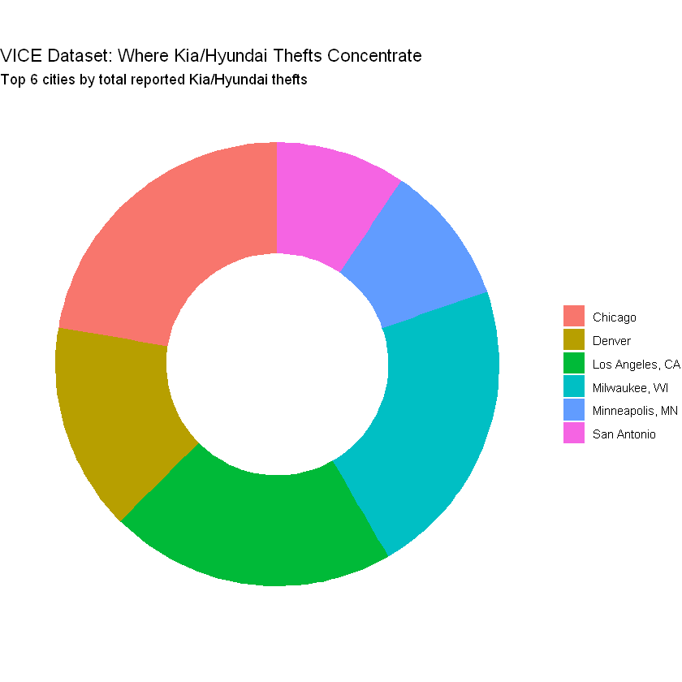

Purpose and Call to Action
The purpose of this story is to demonstrate the disproportionate rise of Kia and Hyundai vehicle thefts, particularly in Milwaukee, and to show how this local trend fits into a broader national pattern. While overall vehicle theft fluctuates over time, Kia and Hyundai thefts increased sharply beginning in 2021, suggesting a targeted and systemic issue rather than random criminal activity.
The call to action is for city leadership to prioritize targeted prevention strategies, including public awareness campaigns, partnerships with manufacturers, distribution of anti-theft devices, and focused enforcement in high-risk areas. The analysis supports allocating resources specifically toward mitigating Kia and Hyundai thefts rather than treating them as part of general auto crime trends.

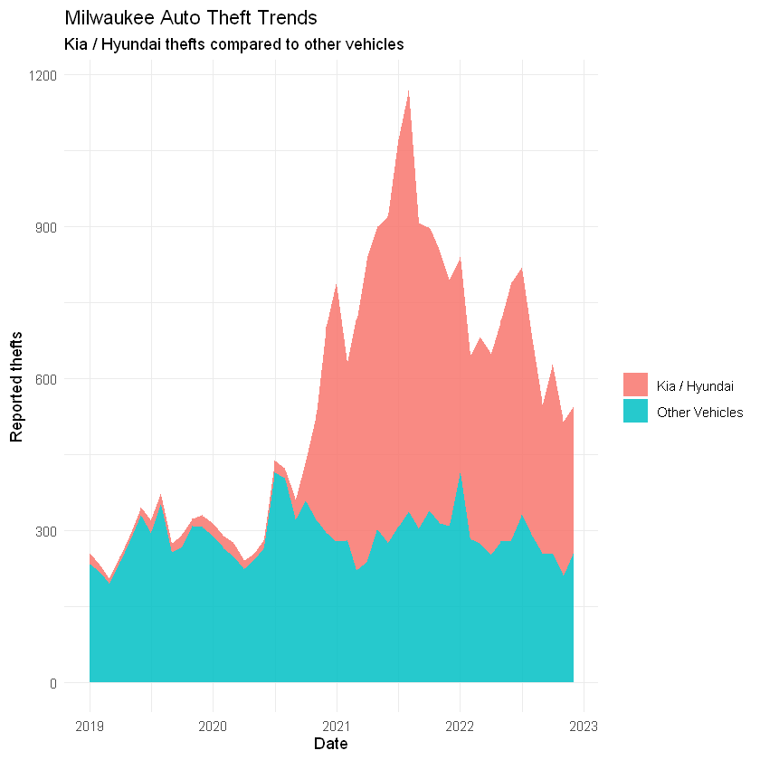
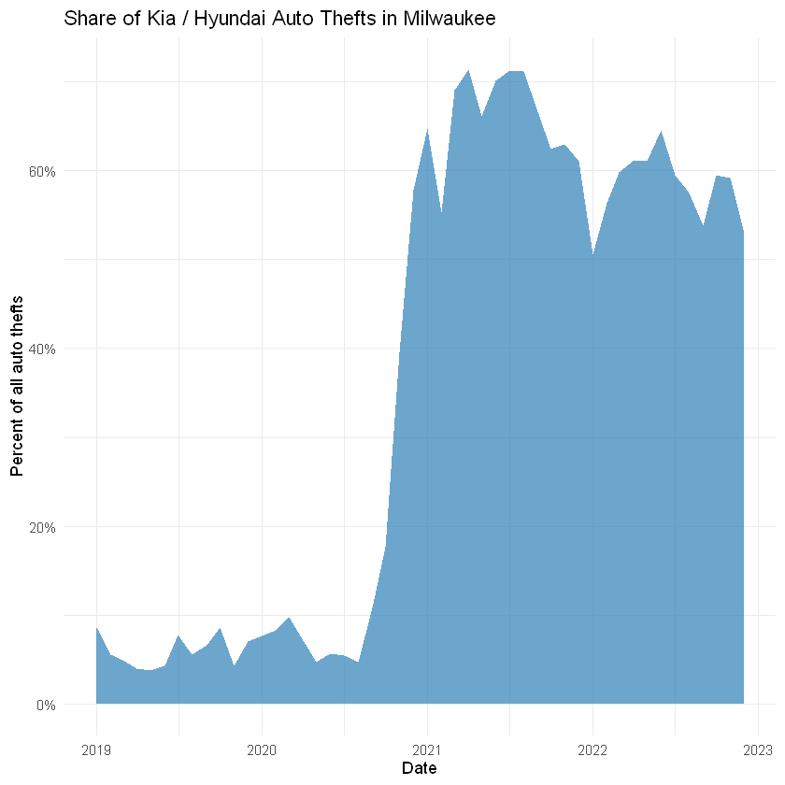
Medium
The selected medium is a data-driven report with supporting visualizations, suitable for presentation in a briefing, shared as a PDF, or embedded into a dashboard. This format allows leadership to quickly interpret trends while also providing enough detail to justify policy and funding decisions.
Design and Gestalt Principles
Gestalt principles guided the design choices throughout the visuals. Color was used consistently to distinguish Kia/Hyundai thefts from other vehicle thefts, helping viewers immediately identify the focal category. Alignment and spacing were kept minimal to reduce clutter and ensure that trends and comparisons are visually grouped. Sizing was used intentionally in treemaps and maps to emphasize magnitude, while text was limited to essential labels and titles to support clarity rather than overwhelm the audience.
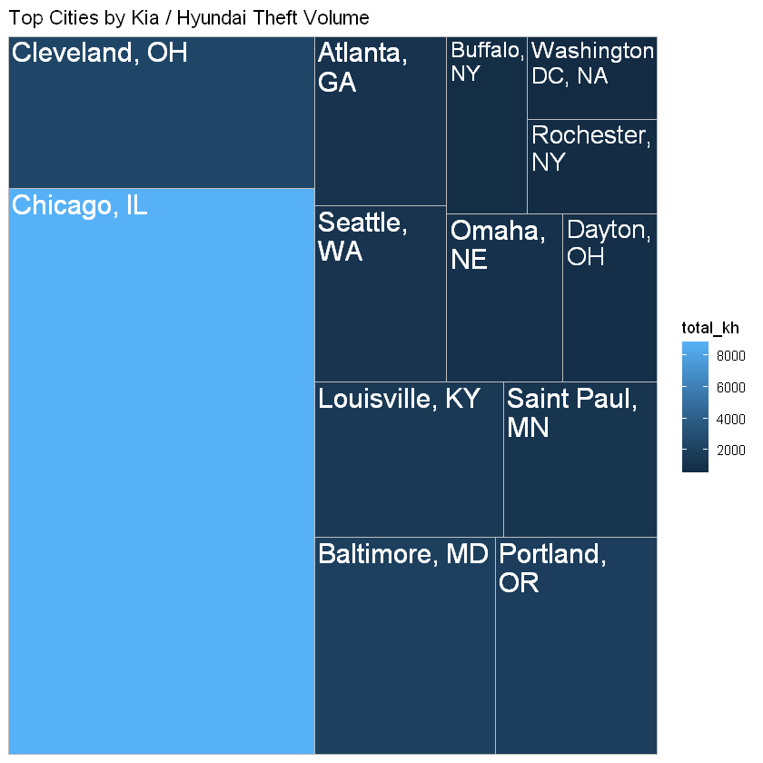
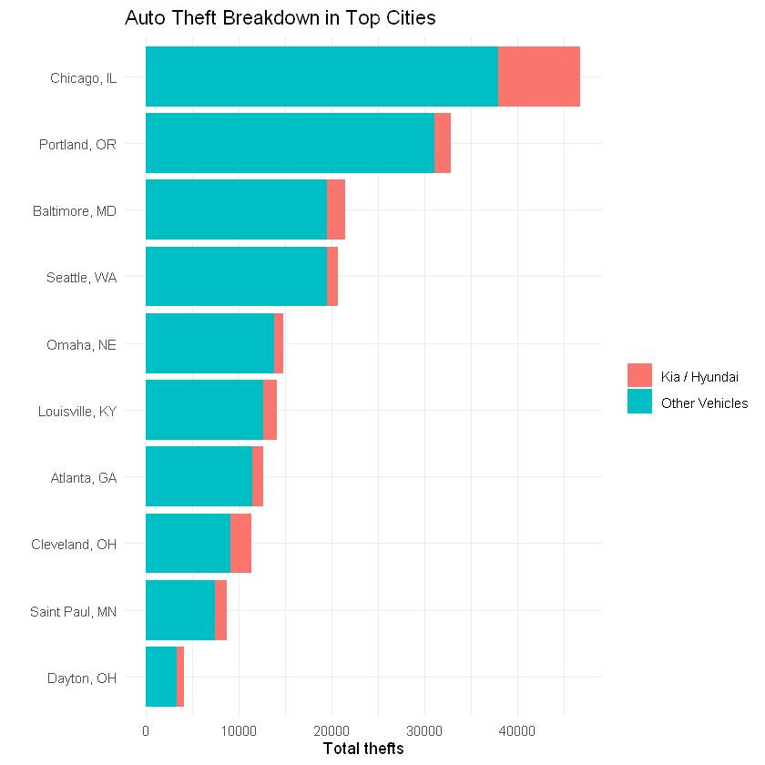

Ethical Considerations
Several ethical considerations were addressed during data preparation and visualization. The VICE dataset required substantial cleaning due to non-standard formatting, including unnamed columns, text-encoded numeric values, and embedded header rows. These columns were removed transparently, and values were converted carefully to avoid misrepresentation. Because the VICE dataset lacked explicit time labels, analysis focused on aggregate city totals rather than precise temporal interpretation.
Across all datasets, missing values were handled using documented methods (na.rm = TRUE), and no data was removed without justification. All datasets were sourced from reputable public or journalistic sources, including municipal records and VICE News reporting. To mitigate ethical risks, all assumptions and transformations were made explicit, and visuals were designed to inform decision-making without exaggerating or sensationalizing the findings.
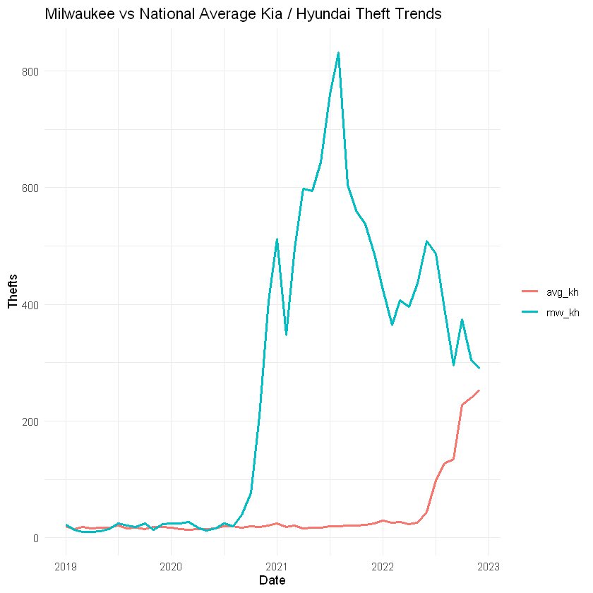
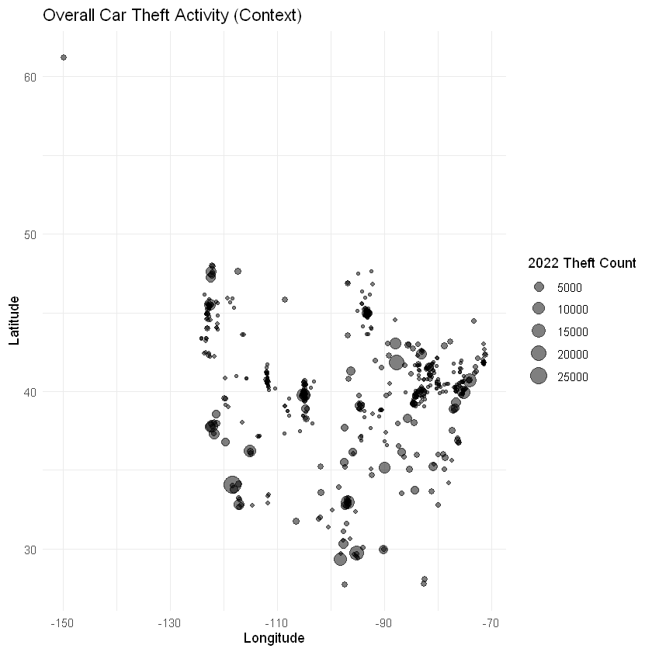
Conclusion
The visual analysis reveals that Kia and Hyundai vehicle thefts are not evenly distributed across time or geography but instead exhibit concentrated spikes in specific cities and periods. Milwaukee stands out as a notable example, where Kia and Hyundai thefts increased sharply relative to overall vehicle theft trends, reinforcing the need for targeted rather than generalized responses. When viewed alongside national data from the VICE dataset, Milwaukee’s experience aligns with a broader pattern affecting multiple urban areas.
These findings underscore the importance of data-driven intervention. Rather than applying broad auto-theft strategies, city leaders are encouraged to focus on vehicle-specific prevention measures, public awareness initiatives, and partnerships with manufacturers to reduce vulnerability. The inclusion of geographic and comparative visuals further supports prioritization of enforcement and community outreach efforts.
By integrating multiple data sources and applying thoughtful design principles, this report demonstrates how visual storytelling can translate complex datasets into clear, actionable insights. With transparent data preparation and ethical consideration, the analysis provides a reliable foundation for policy decisions aimed at reducing Kia and Hyundai vehicle thefts and improving community safety.

