Exploring the Rise of Yoga for Mental Wellness
An Exploratory Data Analysis
Shaghayegh Malekshahi
Bellevue University

Problem Statement
In an era where stress and mental health challenges have become prevalent, many people are turning to simple, affordable ways to feel better. One popular method is yoga, which is known for helping both the body and the mind. This project explores whether public interest in yoga, shown through Google search trends, is linked to growing awareness of mental wellness. Using exploratory data analysis (EDA), regression models, and machine learning techniques, this study looks for meaningful patterns in real-world data to understand if yoga is becoming a leading way for people to manage stress, anxiety, and other mental health challenges.

Dataset Summary
This project utilizes three datasets:
- Google Trends Data: : Weekly search interest in “Yoga,” “MentalHealth,” and “Stress” throughout 2023. This dataset included columns for interest levels and an added Date column to allow for time-series analysis.
- World Happiness Report (Under 30s): Country-level life evaluation scores. This dataset was cleaned by renaming and formatting columns, removing footnote characters, and standardizing country names.
- Mental Health in Tech Survey: A categorical and numerical dataset reflecting responses related to mental health, work environments, and treatment history. This was used for classification modeling.

Data cleaning involved renaming inconsistent columns, standardizing values (especially gender), dropping rows with excessive missing values, and filling strategic gaps (e.g., unknown employment type). In the Google Trends dataset, the original columns (yoga, mental health, stress, isPartial) were renamed to Yoga, MentalHealth, Stress, and IsPartial, and a synthetic Date column was added to simulate weekly intervals in 2023.

Exploratory Data Analysis
Descriptive statistics showed that “Yoga” had the highest average weekly interest (mean = 75.37), with “MentalHealth” and “Stress” showing slightly lower averages. A line plot illustrated consistent weekly interest in Yoga, while MentalHealth and Stress fluctuated more dramatically throughout the year.

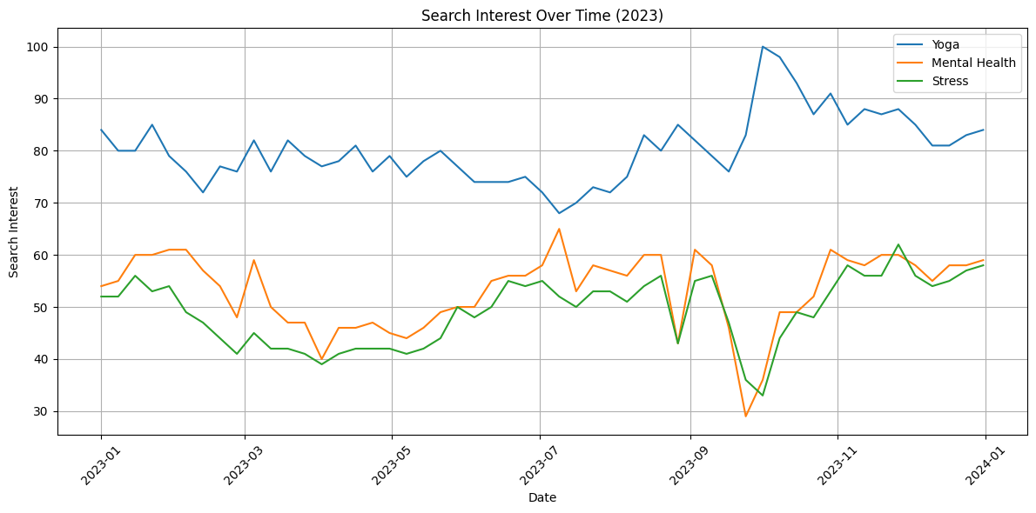

Boxplots of the three variables revealed that Yoga had the most stable interest level (low variance), while MentalHealth and Stress had more outliers and wider ranges. To explore relationships between variables, a correlation matrix and a covariance matrix were computed. Pearson correlation showed a strong positive correlation (r = 0.86) between MentalHealth and Stress, indicating they often rise and fall together. However, Yoga was weakly correlated with both, suggesting that it may serve a different, possibly proactive, role in mental health care.
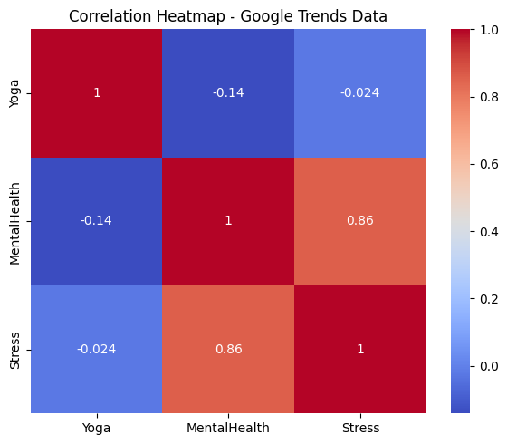

Hypothesis Testing
To statistically test the observed trend, a one-tailed paired t-test was used to evaluate whether weekly search interest in Yoga was significantly greater than that for MentalHealth. The null hypothesis (H₀) assumed no difference or lower interest in Yoga; the alternative hypothesis (H₁) suggested higher interest in Yoga.
The results showed:
- t-statistic = 18.9693
- p-value = 2.5248e-25
This extremely low p-value allowed us to reject the null hypothesis with confidence, confirming that Yoga was significantly more searched than MentalHealth in 2023.

Regression Modeling
A linear regression model was built using week_num as the independent variable to predict Yoga interest. The model revealed a positive and statistically significant slope (0.1821), with Yoga interest increasing by nearly 0.18 points per week. Although the R² value was modest (~0.187), it confirmed an upward trend across the year.
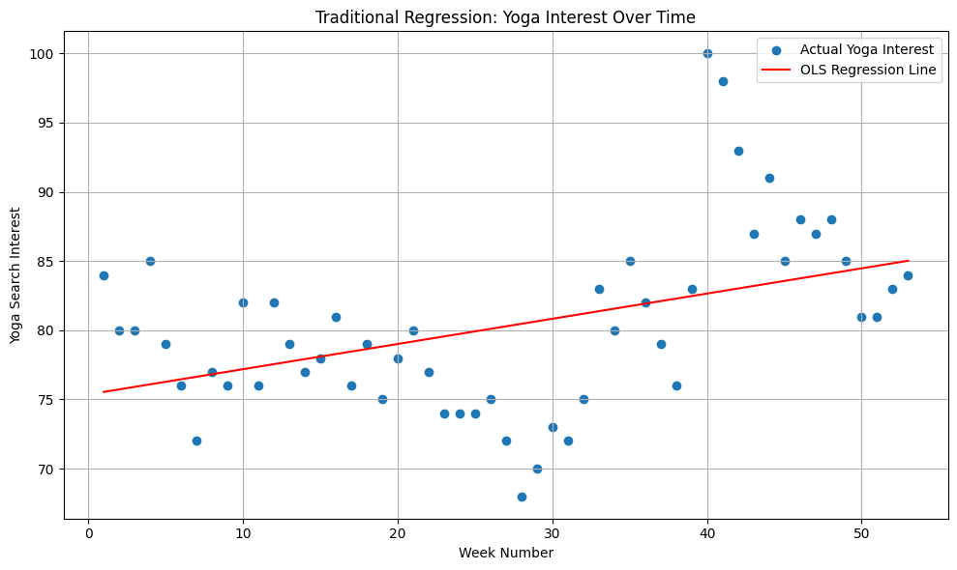

A second version of the regression model was implemented using scikit-learn. This machine learning model produced the same results:
- Coefficient = 0.1821
- R² = 0.187
- MSE = 33.68
This confirmed the validity of the traditional OLS method and satisfied the requirement to compare ML with standard regression.
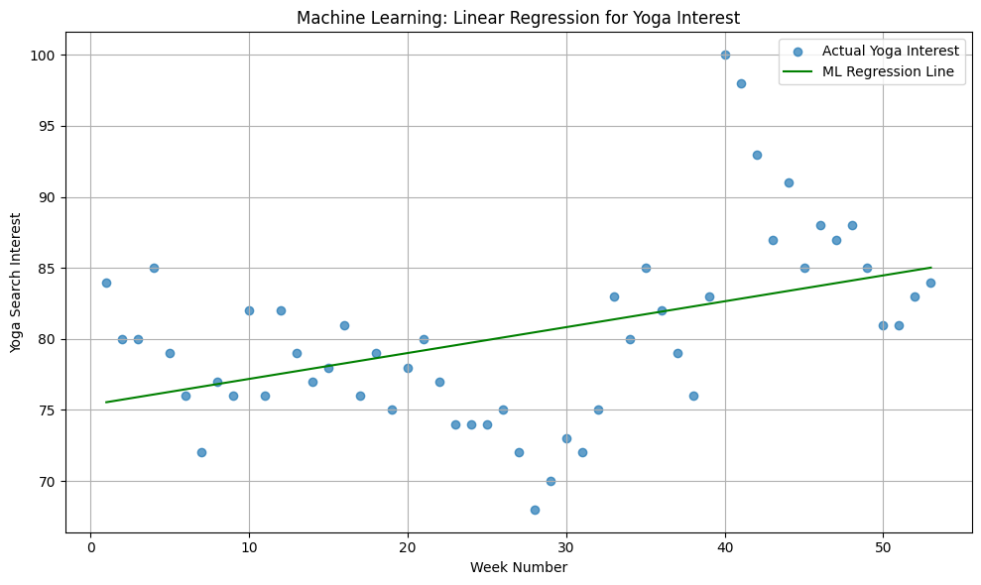

Classification Model
To demonstrate predictive modeling, a logistic regression classification task was performed using the Mental Health in Tech Survey dataset. The goal was to predict whether someone had received mental health treatment based on Age, Gender, FamilyHistory, and WorkInterfere variables.
Cleaning steps included:
- Renaming columns
- Standardizing gender categories
- Dropping incomplete rows
- Encoding categorical variables
- Scaling features with StandardScaler()
The model achieved solid results and was evaluated using a confusion matrix and a classification report, showing meaningful precision and recall.
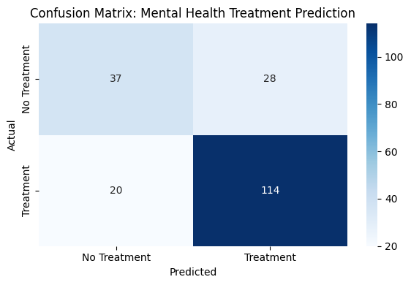

Conclusion and Recommendations
The analysis confirms a strong and sustained public interest in yoga, with a statistically higher search volume than mental health or stress topics throughout 2023. The linear regression suggests this trend is continuing to grow. The classification model shows that age, work-related stress, and family history are good predictors of whether someone receives treatment, aligning with what we know about workplace mental health.
Recommendation: Health professionals and wellness programs should consider incorporating yoga-based wellness initiatives as part of mental health programs. Yoga’s consistent public demand makes it a strong candidate for preventive care solutions.

Limitations and Assumptions
Google Trends data reflects search interest, not actual behavior or outcomes. Survey data is self-reported, which may introduce bias. The regression model used time as the only predictor; other influencers (like media events or economic shifts) were not included.
Nonetheless, the project followed a rigorous EDA and modeling pipeline, covering every requirement of the course.

