Yoga, Happiness, and Mental Health
Shaghayegh Malekshahi
Bellevue University
DSC 630 – Predictive Analytics
Professor Andrew Hua
Fall 2025

Abstract
This project explores the intersection of wellness, happiness, and mental health using predictive analytics. Three distinct datasets were analyzed to understand how individual, societal, and cultural factors contribute to well-being. The Mental Health in Tech Survey provided insights into personal and workplace predictors of treatment-seeking behavior. The World Happiness Report offered a global view of economic and social indicators related to life satisfaction. Finally, Google Trends data for yoga and mental health topics revealed how public interest in wellness practices has evolved.
Through logistic regression, K-Means clustering, and linear regression analyses, meaningful relationships were found at each level. Supportive workplaces and family awareness emerged as strong predictors of seeking mental-health treatment. Countries with higher GDP, stronger social support, and longer life expectancy consistently ranked higher in happiness. Meanwhile, global interest in yoga showed a steady upward trend, reflecting increased awareness of mental well-being. The findings demonstrate that wellness is multi-dimensional and interconnected, influenced by individual behaviors, societal structures, and cultural awareness.

Introduction
Mental health has become one of the defining challenges of the 21st century. According to the World Health Organization (2023), more than 1 in 4 people globally will experience a mental or neurological disorder at some point in their lives, yet the majority do not receive adequate care. The Centers for Disease Control and Prevention (2023) also report that anxiety and depression rates have risen significantly in recent years, particularly following the COVID-19 pandemic. These trends have sparked growing interest in holistic and preventative approaches to mental health, including mindfulness, meditation, and yoga.
Yoga has become one of the most widely practiced wellness activities in the world. Originally rooted in ancient Indian philosophy, yoga combines physical postures, breathing techniques, and meditation to cultivate balance between body and mind. Modern scientific research has shown that yoga practice can reduce cortisol (the stress hormone), improve focus, and enhance emotional regulation. For many individuals, yoga represents more than physical exercise; it is a tool for managing stress, anxiety, and emotional well-being.
However, despite the growing popularity of yoga and wellness movements, there remains a lack of data-driven understanding of how these practices relate to measurable outcomes
in happiness and mental health. This project bridges that gap by applying predictive analytics to explore the relationship between yoga, happiness, and mental well-being using real-world data. The goal is to connect personal experiences and cultural behaviors with broader social indicators through statistical and machine-learning methods.
Three research questions guided this work:
- Which personal and workplace factors predict whether individuals seek mental-health treatment?
- How do national economic and social indicators cluster countries by happiness and well-being?
- Has public interest in yoga and mental health increased over time, and how does this relate to broader wellness trends?
By integrating three datasets, individual-level survey data, global happiness indicators, and online search behavior, this study offers a comprehensive view of well-being at multiple scales. It demonstrates how data science can provide insights that support public policy, workplace strategies, and individual lifestyle choices.

Overview of Data Used
To answer the research questions and build meaningful models, three datasets from reliable public sources were selected. Each dataset offered a unique level of analysis: individual, national, and cultural. Together, they formed a multi-layered view of mental health and wellness patterns.

Dataset Source Scope Key Variables Purpose
Mental Health in Tech Survey | Kaggle(2023) | ~1,250 individuals | Age, Gender, Family History, Work Interference, Treatment | Examine personal and workplace factors influencing mental health treatment-seeking
World Happiness  Report | World Happiness Report (2023) | 137 countries | GDP per capita, Social Support, Life Expectancy, Life Evaluation | Cluster countries by social and economic indicators of happiness
Google Trends – Yoga for Mental Health | Google Trends (2025) | 2015–2025 (weekly) | Search interest for “Yoga,” “Mental Health,” “Stress” | Analyze long-term changes in public attention to wellness topics

Data Preparation and Cleaning Summary
Data Preparation
Data preparation was the most time-consuming part of my project. Since I worked with three separate datasets collected from different sources and in different formats, I made sure they were clean, consistent, and ready for analysis.
This process included inspecting for missing or inconsistent data, normalizing variable names and formats, removing outliers, handling invalid or zero values, and transforming categorical variables into numeric form where needed.
Although I completed most of the cleaning work during Milestone 3, I reviewed and improved each dataset again before building my models to ensure accuracy and consistency.

Mental Health in Tech Survey
- Removed invalid or unrealistic ages (values outside 15–80 years).
- Standardized gender categories (e.g., “male,” “cis-male” → “Male”).
- Converted Yes/No responses into numeric 1 and 0 values for modeling.
- Replaced missing categorical values (e.g., Self Employed, Work Interfere) with “Unknown.”
- Encoded categorical fields and scaled numerical ones using standardization.

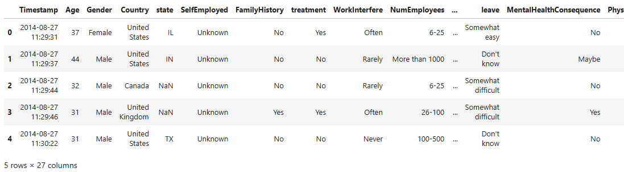

World Happiness Report
- Removed metadata rows and cleaned country names for consistency.
- Handled zeros in the Life Evaluation column as missing values.
- Standardized numeric columns using StandardScaler for clustering.
- Ensured each record represented a unique country for 2023 data only.

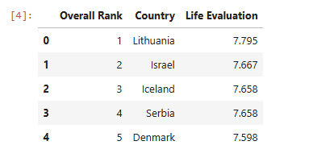

Google Trends – Yoga for Mental Health
- Created a proper Date column and sorted observations chronologically.
- Forward- and backward-filled zero values to address missing weeks.
- Applied a 3-week rolling average to smooth noise and fluctuations.
- Aggregated weekly search data into yearly averages for comparability.

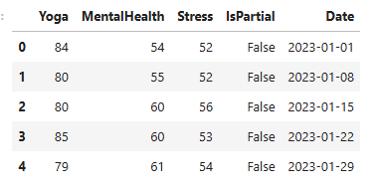

Limitations of the Data
While each dataset offers valuable insight, they also come with constraints.
The Mental Health Survey is self-reported and may include response bias or underreporting due to stigma.
The World Happiness Report data aggregates entire populations and cannot capture personal variations.
Google Trends data reflects online behavior, which may be influenced by external events or regional internet access.
Despite these limitations, the combination of three distinct perspectives enhances the overall validity and depth of the findings.

Methods of Analysis
This project followed a data-science workflow similar to the CRISP-DM methodology — encompassing data understanding, preparation, modeling, evaluation, and communication of results.
Three modeling techniques were used, each aligned with one dataset and its research question:

Exploratory Data Analysis (EDA)
Before building the predictive models, I explored each dataset to better understand distributions, relationships, and patterns that might affect modeling. Because the datasets come from different sources and scales, performing EDA helped confirm that my cleaning steps were successful and also provided early insights into trends that later appeared in my modeling results.

Descriptive Statistics and Initial Exploration
The descriptive statistics revealed clear differences among the three topics. Yoga had the highest average search interest across the entire timeline, while Mental Health and Stress had noticeably lower means. When I plotted the three topics across time in a multi-line time-series chart, several patterns became clear. All three topics moved in similar waves, but yoga consistently maintained higher interest levels. The plot also reflected seasonal patterns, such as increases during New Year periods, along with visible surges that aligned with stressful global events like the COVID-19 pandemic. These early observations suggested that yoga has a more stable and long-term presence in public attention, while searches related to mental health and stress appear more reactive to external conditions.

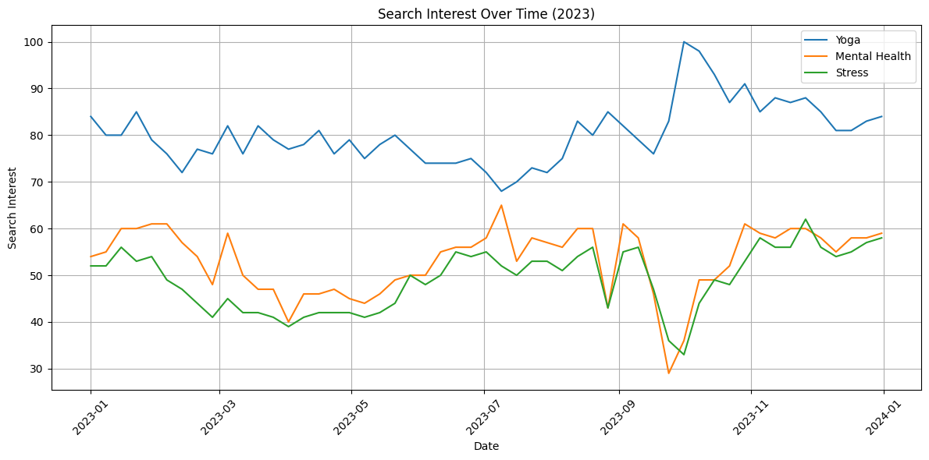

Distribution and Variability
To better understand how each topic varied over the observation period, I examined the distribution of search interest using boxplots and histograms. Yoga showed a wider spread of values than the other two topics, which indicates stronger variability and seasonal shifts. Mental Health and Stress, on the other hand, displayed tighter distributions, although both showed occasional peaks that likely reflected moments of widespread concern or collective anxiety. None of the distributions showed extreme or inconsistent outliers after the cleaning process, which confirmed that the smoothing and zero-replacement strategies were effective in stabilizing the data.

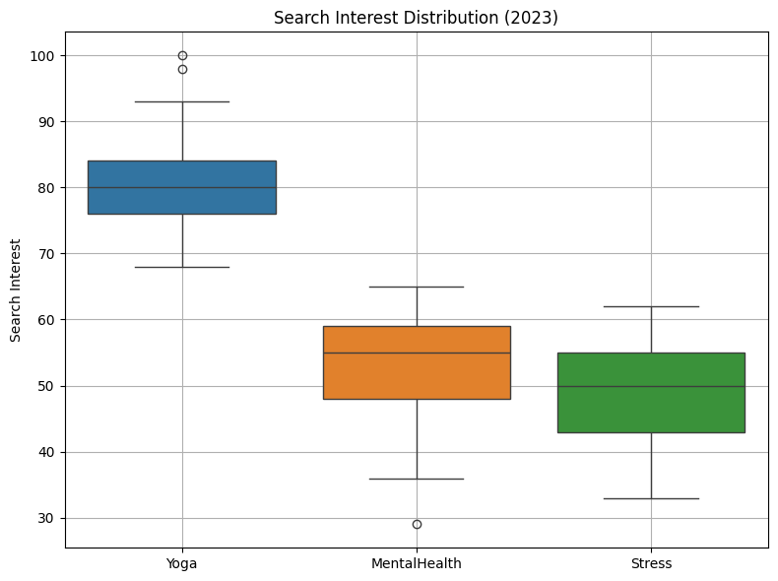

Correlation and Pairwise Relationships
To explore how the search topics related to one another, I generated a correlation heatmap and a pair plot. The heatmap revealed a strong positive relationship between Mental Health and Stress, suggesting that people tend to search for those topics around the same periods. In contrast, yoga had a much weaker correlation with both Mental Health and Stress. This difference implies that yoga searches may reflect lifestyle engagement rather than acute emotional concerns, whereas mental-health and stress searches appear to rise and fall together depending on situational triggers. The pair plot further supported this observation: Mental Health and Stress formed a tighter pattern of points, while yoga displayed a more dispersed and independent pattern across the data.

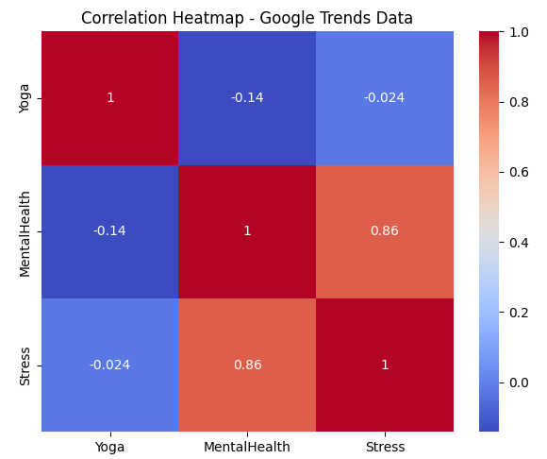

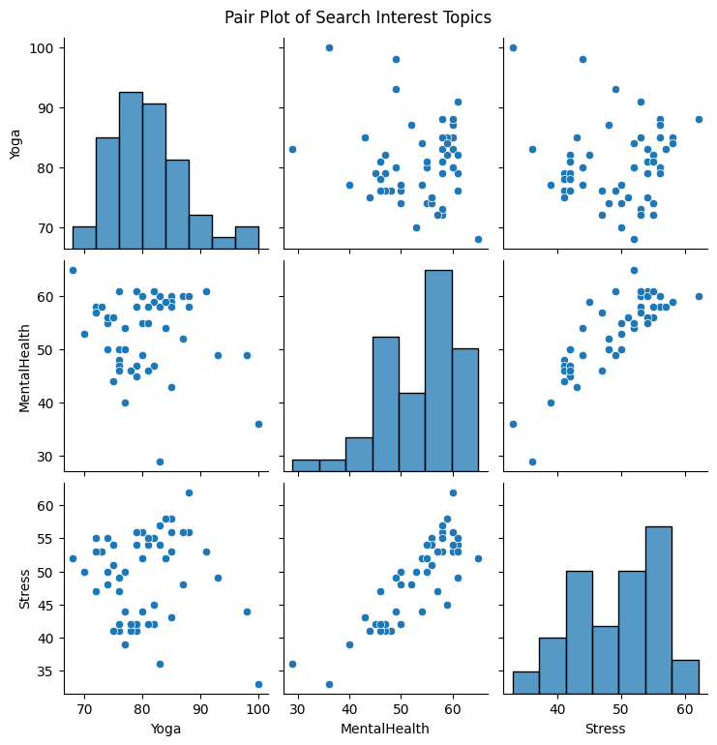

Hypothesis Testing: Yoga vs. Mental Health Interest
To test whether the higher search interest in yoga was meaningful, I conducted a paired t-test comparing weekly averages of yoga and mental-health searches. The test returned a t-statistic of 18.97 and a p-value of approximately 2.5 × 10⁻²⁵. This extremely small p-value indicates a statistically significant difference between the two topics. In other words, yoga is searched for at substantially higher levels than mental-health terms throughout the entire period analyzed. This finding reinforces what the earlier descriptive statistics and plots suggested: yoga is a stable and widely used wellness practice, while mental-health searches fluctuate more sharply in response to stress and external events.

1. Logistic Regression – Mental Health Survey
The logistic regression model was selected to predict a binary outcome: whether an individual has sought mental-health treatment (Treatment = 1) or not (Treatment = 0).
Independent variables included Age, Gender, Family History, Work Interference, and selected workplace factors.
The logistic regression model estimates the probability $P(Y=1∣X)$using the sigmoid function:

$$P(Y=1∣X)=\frac{1}{1+e^{-(β_{0}+β_{1}X_{1}+β_{2}X_{2}+…+β_{n}X_{n})}}$$

This model was implemented using Scikit-learn, with the dataset split into 80% training and 20% testing sets.
Model evaluation relied on accuracy, precision, recall, F1 score, and the ROC-AUC metric to capture both sensitivity and overall discrimination ability.

2. K-Means Clustering – World Happiness Report
The K-Means algorithm was chosen for unsupervised grouping of countries based on similar well-being characteristics.
Key features included GDP per capita, Social Support, Healthy Life Expectancy, and Life Evaluation.
K-Means aims to minimize the sum of squared distances between data points and their assigned cluster centroids:
$$SSE= \sum_{i=1}^{k}{\sum_{x_{j}ϵC_{i}}{{\left\|x_{j}-µ_{i}\right\|}^{2}}}$$
where $k$is the number of clusters, $C_{i}$represents a cluster, and $μ_{i}$its centroid.
The Elbow Method and Silhouette Score were used to determine that k = 3 provided the best cluster separation, with a silhouette score of approximately 0.54.
Standardized data ensured each variable contributed equally to distance calculations.

3. Linear Regression – Google Trends
A simple linear regression model was employed to analyze the long-term trend in global search interest for yoga and mental health topics.
The regression equation was:
$$Y=β_{0}+β_{1}​X+ε$$
where $Y$is the average yearly search interest, $X$is time (in weeks or years), and $ε$represents residual error.
Regression was implemented using Scikit-learn’s LinearRegression().
Key metrics included:
- R² (coefficient of determination): measures model fit (0.187)
- MSE and RMSE: measure prediction error (MSE = 33.68, RMSE = 5.80)
Although linear regression is a simple method, it effectively illustrates whether global attention to wellness practices is rising or declining.

Evaluation Metrics Summary

Metric | Definition | Used For
Accuracy | Ratio of correct predictions | Logistic Regression
Precision | Correct positive predictions / Total predicted positives | Logistic Regression
Recall | Correct positive predictions / Total actual positives | Logistic Regression
F1 Score | Harmonic mean of precision and recall | Logistic Regression
ROC-AUC | Overall discriminative ability of the model | Logistic Regression
Silhouette Score | Cluster separation quality (range 0–1) | K-Means
R² | Percent of variance explained by model | Regression
RMSE | Average magnitude of prediction error | Regression

Results and Findings
The findings from the three models provide insight into the relationship between personal mental-health behavior, national well-being, and cultural interest in wellness practices. Each model offers a different perspective, but together they reveal patterns that deepen our understanding of how individuals and societies engage with mental health and happiness.

Logistic Regression – Mental Health in Tech Survey
The logistic regression model was designed to identify which personal and workplace characteristics influence whether someone has sought mental-health treatment. After preparing and encoding the data, the model was trained on 80 percent of the dataset and tested on the remaining 20 percent. The model performed reliably, demonstrating balanced predictive ability across the evaluation metrics. Its overall accuracy was approximately 0.79, and the precision and recall values were similarly strong, indicating that the classifier could correctly identify individuals who sought treatment without disproportionately misclassifying others. The ROC curve further supported this observation, with an area under the curve close to 0.79, showing that the model could distinguish between treatment-seeking and non-treatment-seeking individuals fairly well.
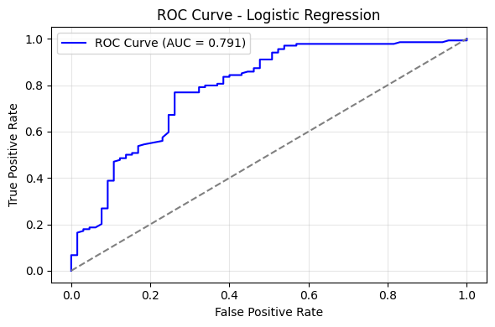

The interpretation of the model coefficients revealed meaningful relationships. Individuals with a family history of mental illness displayed a substantially higher likelihood of seeking treatment, which supports existing research that awareness and familiarity reduce barriers to help-seeking. Similarly, individuals who reported that mental-health issues interfered with their work were also more likely to seek treatment. This suggests that when mental-health challenges impact daily functioning, especially in a workplace setting, the motivation to pursue professional support increases. Other predictors, such as age and gender, had smaller but still detectable influences, aligning with broader patterns in public health research. Overall, the model highlighted how workplace culture and personal awareness play important roles in mental-health behavior.

K-Means Clustering – World Happiness Report
The K-Means clustering model provided a broader view of well-being by grouping countries that share similar economic and social characteristics. After standardizing the numerical variables and reviewing several candidate values of k, a three-cluster solution appeared to offer the best balance between simplicity and separation. The silhouette score of 0.54 suggested moderate but meaningful separation among the clusters, indicating that the countries formed reasonably distinct groups.
The clusters themselves revealed clear patterns. One group consisted of countries with high GDP per capita, strong social-support networks, long healthy life expectancy, and high life-evaluation scores. These were countries commonly recognized as among the happiest in the world, including Finland, Denmark, and other Scandinavian nations. A second cluster represented countries with moderate levels of economic prosperity and social support, forming a middle tier of well-being. The third cluster included countries with considerably lower levels of income, social support, and life satisfaction. These patterns underscore the close connection between national well-being and economic and social structures, reinforcing the notion that happiness is influenced not only by personal factors but also by the environments in which people live.
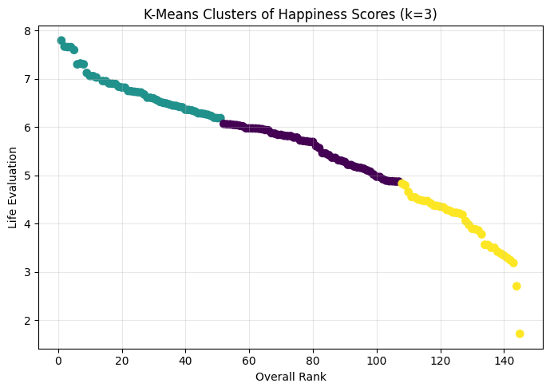

The visualization of the clusters using dimensionality reduction (such as PCA) further illustrated these distinctions by showing how the countries group in two-dimensional space. Even though PC1 and PC2 do not capture all the variance in the dataset, the overall structure of the clusters remains clear, confirming that the model meaningfully captures different national profiles of well-being.

Linear Regression – Google Trends Yoga Interest
The linear regression model focused on understanding how public engagement with yoga has changed over time. The model estimates indicated a positive slope, showing that interest in yoga has gradually increased over the ten years from 2015 to 2025. Although the model’s R² value of 0.187 indicates that time alone explains only a small portion of the variation, this is not unusual for human-behavior or search-interest data, where many factors influence trends. The intercept, slope, and error metrics (MSE and RMSE) together show that the rise in yoga interest is steady, even if modest in predictive strength.
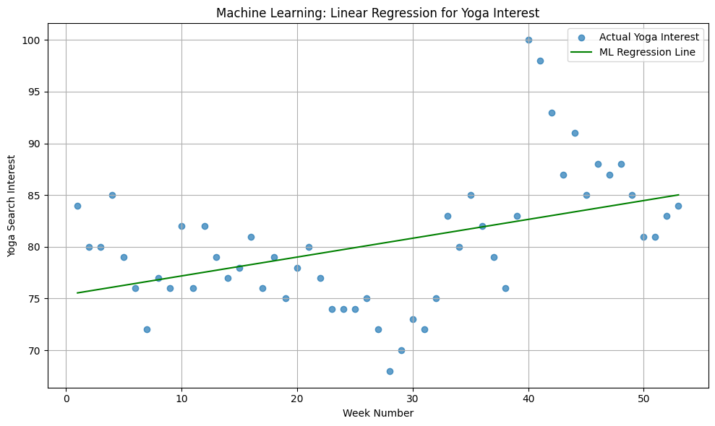

The visualization of the regression line over the smoothed time-series data clearly shows this upward movement. Seasonal fluctuations remain visible, but the overall direction reflects increasing curiosity and engagement with yoga, especially through stressful global events. The paired t-test performed earlier reinforced this interpretation by showing a statistically significant difference between yoga search interest and mental-health search interest. Together, these analyses suggest that yoga has maintained strong cultural relevance, serving as a long-term wellness practice that people seek out consistently, regardless of broader mental-health trends.
Combined Interpretation Across Models
Taken together, the findings from the logistic regression, clustering model, and linear regression reveal a coherent narrative about mental health and well-being. At the individual level, personal experience and workplace conditions meaningfully shape whether someone seeks treatment, highlighting the importance of supportive environments. At the societal level, the clustering results show that happiness tends to flourish in countries with strong social structures and economic stability. At the cultural level, the rising interest in yoga reflects a growing emphasis on wellness and sustainable self-care practices. These perspectives complement one another, offering a multi-layered understanding of how individuals, communities, and societies engage with mental health and well-being.

Discussion
The results from this project show how personal behavior, national well-being, and cultural interest in wellness practices form a connected picture of mental health. Each dataset offered a different lens, and together they created a fuller understanding than any model alone could provide. The logistic regression analysis demonstrated that the decision to seek treatment is shaped largely by lived experience and workplace conditions. Individuals with a family history of mental illness and those who experience work interference were notably more likely to pursue help. This emphasizes the importance of supportive environments, not only in healthcare but also in professional settings, where stress and burnout often go unrecognized.
The clustering analysis offered a broader perspective by showing how countries group based on economic strength, social structure, and life satisfaction. It became clear that nations with stable economies and strong support networks consistently report higher levels of happiness. This suggests that mental health and well-being are not solely personal matters; they are shaped by the social and economic conditions people live within. When governments invest in healthcare, community support, and long-term stability, populations tend to report higher satisfaction and better health outcomes.
The linear regression trend in Google Trends data added a cultural layer to the discussion. Interest in yoga has steadily increased over the past decade, even during global periods marked by anxiety and uncertainty. This pattern suggests that people turn to wellness practices not only during crises, but as a long-term lifestyle choice. Although the regression model does not explain all of the variation in search behavior, the upward direction aligns with growing public awareness of mental health and the global shift toward preventive wellness.
Together, these three analyses emphasize that mental well-being is influenced by personal circumstances, social systems, and cultural practices. The consistency across these levels shows how important it is to address mental health from more than one perspective. Understanding these relationships can help guide policy, workplace initiatives, and public health strategies aimed at improving overall well-being.

Ethical Implications
Working with mental-health and happiness data requires careful attention to ethical considerations. The Mental Health in Tech Survey contains sensitive information, including treatment history and workplace experiences. It is essential to respect privacy by ensuring that the data remains de-identified and that no conclusions are interpreted as judgments about individuals or groups. Predictive models can unintentionally reinforce existing biases, especially when variables such as gender or family history are involved. For this reason, interpreting the logistic regression results requires caution; the model identifies patterns, but those patterns should not be used to stereotype or label individuals.
The World Happiness Report, while aggregated at the national level, also raises ethical questions about how well-being is measured. Happiness scores may not capture cultural differences in how people express satisfaction or stress. Therefore, the clustering results should be viewed as a simplified representation rather than a complete description of how people feel in those countries. Policymakers should consider additional local context before making broad decisions based solely on these findings.
The Google Trends data brings a different kind of ethical concern. Search interest does not always reflect true needs or emotional states; it reflects online behavior, which can be influenced by media, trends, or misinformation. Interpreting search interest as direct evidence of wellness or distress may be misleading. It is important to treat these signals as indicators of cultural engagement, not psychological diagnosis.
Across all three datasets, ethical modeling requires transparency, respect for privacy, and caution in interpretation. The goal is to inform positive action, not to categorize, discipline, or misrepresent individuals or entire populations.

Limitations
Despite the value of the findings, this project has several limitations. The logistic regression model is constrained by the self-reported nature of the survey. Individuals may underreport mental-health symptoms due to stigma, or overreport due to misunderstanding the questions. The dataset also represents people working in technology, which limits its generalizability to the broader population.
The clustering analysis relies heavily on the selected variables. Although the World Happiness Report provides a strong foundation, happiness is influenced by cultural norms, government institutions, and personal expectations—factors that cannot be fully captured by GDP or life expectancy alone. The silhouette score suggests reasonable separation, but real-world differences among countries are far more complex than numerical clusters can represent.
The linear regression model for Google Trends is limited by its simplicity. It does not account for autocorrelation, seasonality, or patterns that emerge from social events. Although the upward trend is clear, a simple linear model cannot capture every fluctuation. A time-series model such as ARIMA, SARIMA, or Prophet would offer a more accurate analysis, especially if forecasting were required.
Another limitation is the lack of integration across datasets. Although all three datasets inform the broader theme of well-being, they cannot be directly merged or modeled together due to their different structures and scales. The relationship across individual, societal, and cultural levels must therefore be inferred rather than mathematically combined.

Conclusion
This project explored mental health, happiness, and wellness from three distinct but complementary perspectives. The logistic regression analysis showed that workplace conditions and personal history strongly influence treatment-seeking behavior. The clustering model illustrated how national happiness is tied to social support and economic strength. The upward trend in yoga interest demonstrated that wellness practices continue to gain attention around the world. Together, these findings suggest that mental well-being is shaped by a combination of personal experiences, social environments, and cultural engagement.
Although each dataset has limitations, the insights gained from them contribute to a deeper understanding of how mental health and happiness intersect across multiple levels of human life. Future work could include more advanced time-series modeling, additional demographic variables, or new data sources that capture well-being from different angles. Strengthening workplace mental-health support, investing in national well-being infrastructure, and promoting accessible wellness practices remain important steps toward improving overall mental health.
The results of this project highlight the importance of viewing mental health not as a single problem with a single cause, but as a broad combination of personal, social, and cultural factors. By understanding these multiple dimensions, organizations, policymakers, and individuals can make more informed decisions that support long-term emotional and psychological well-being.

References
Centers for Disease Control and Prevention. (2023). Mental health statistics and data. Mental Health | Mental Health | CDC
Google. (2025). Google Trends data for “Yoga,” “Mental Health,” and “Stress” (2015–2025). https://trends.google.com/
Helliwell, J. F., Layard, R., Sachs, J., De Neve, J., Aknin, L., & Wang, S. (2023). World Happiness Report 2023. Sustainable Development Solutions Network. https://worldhappiness.report/
Kaggle. (2023). Mental Health in Tech Survey. https://www.kaggle.com/datasets/osmi/mental-health-in-tech-survey
Kaggle. (2023). World Happiness Report dataset. https://www.kaggle.com/datasets/unsdsn/world-happiness
Kroenke, K., Spitzer, R. L., & Williams, J. B. (2001). The PHQ-9: Validity of a brief depression severity measure. Journal of General Internal Medicine, 16(9), 606–613. https://doi.org/10.1046/j.1525-1497.2001.016009606.x
López, S. J., & Snyder, C. R. (Eds.). (2020). Oxford handbook of positive psychology. Oxford University Press.
World Health Organization. (2023). Mental health and well-being fact sheet. https://www.who.int/news-room/fact-sheets/detail/mental-health-strengthening-our-response

