


Foundations of Programming

Lab Assignment No. : 02

PROBLEM STATEMENT:
Write a menu driven program in C to implement the basic arithmetic operations such as Addition, Subtraction, Multiplication, and Division.

OBJECTIVES:
• To understand the concept of menu driven programming in C.
• To apply conditional statements and switch–case control structures.
• To perform basic arithmetic operations using user-defined input.
• To enhance logical thinking and problem-solving skills.

THEORY:
1 if–else ladder statements syntax and sample program
#include <stdio.h>

int main()
{
int num = 5;

if(num > 0)
printf("Positive number");
else
printf("Negative number");

return 0;
}
2 switch–case or if–else ladder statement syntax and sample
#include <stdio.h>

int main()
{
int num = 2;

switch(num)
{
case 1:
printf("One");
break;

case 2:
printf("Two");
break;

default:
printf("Invalid");
}

return 0;
}
3 Basic arithmetic operations include Addition, Subtraction, Multiplication, and Division. Division by zero should be avoided.
ALGORITHM:
Step 1:START
Step 2:Read arithmetic operation as “a”
Step 3:Read numbers as “b” and “c”
Step 4:if a=1 then display addition is being done
Step 5: If a=2 then display subtraction is being done
Step 6:If a=3 then display multiplication is being done
Step 7: If a=4 then display division is being done
Step 8:Display the arithmetic operation
Step 9:Take the 2 numbers from the user and perform the operation specified
Step 10:Display the result
Step 11:STOP

Type Program
PLATFORM:
Linux
1st Method:
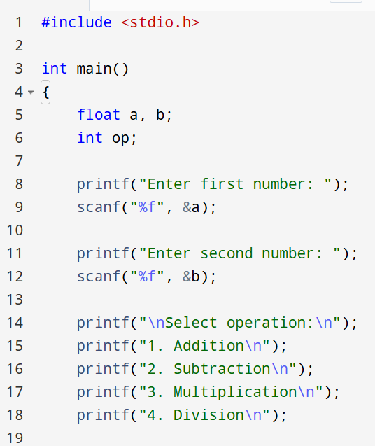
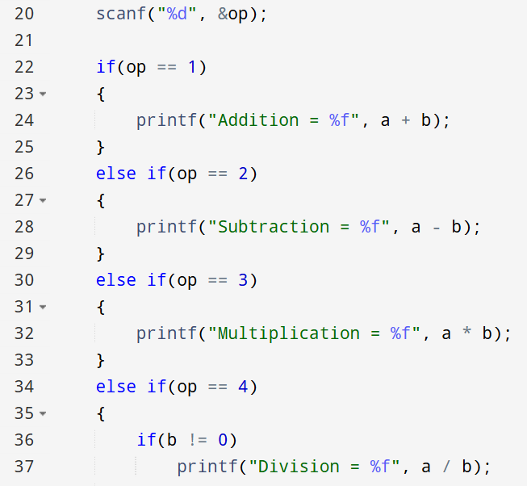
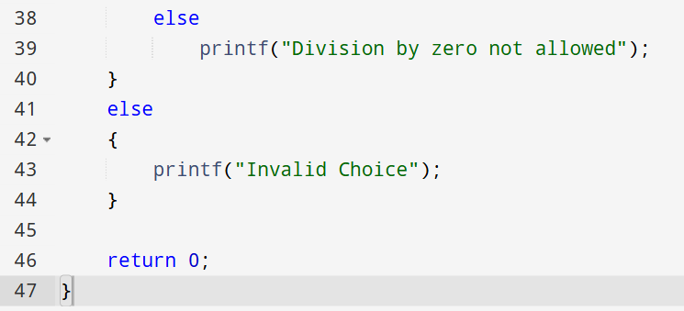
2nd Method:
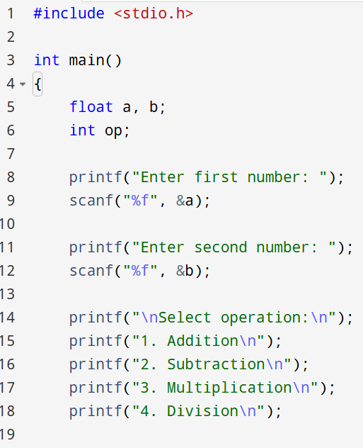
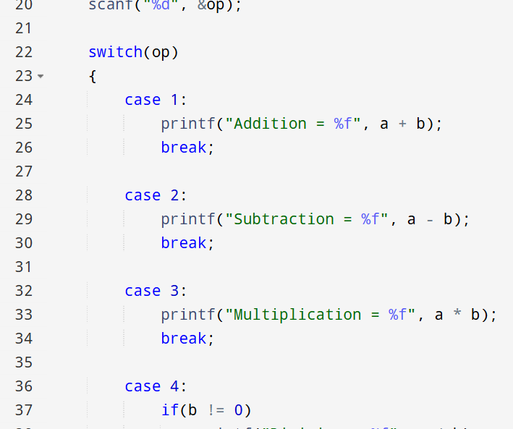
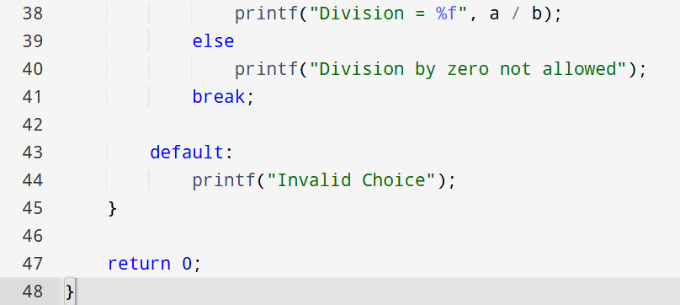

INPUT:
Choice of operation and two numbers
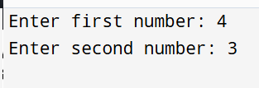
OUTPUT:
Displays the result of the selected arithmetic operation
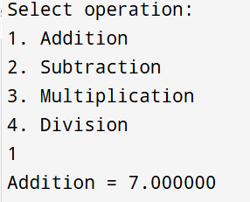

CONCLUSION:
Thus, the menu driven program in C successfully performs basic arithmetic operations using switch–case statements.

FAQs:
1. What is a menu driven program?
2. Why is switch–case preferred over if–else ladder in menu driven programs?
3. What is the purpose of the break statement in switch–case?
4. What is the purpose of the break statement in switch–case?
5. What are the limitations of switch–case compared to if–else?
Flowchart
