**Code:**

**Selenium basics:**

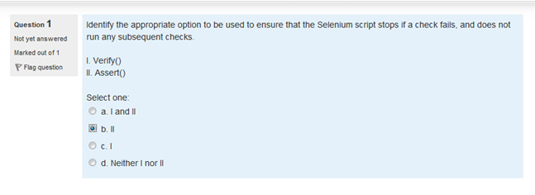**Ans: b.**

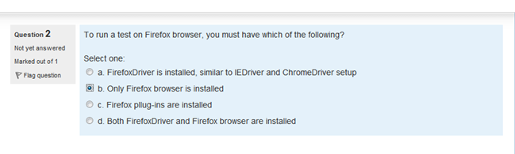**Ans: b.**

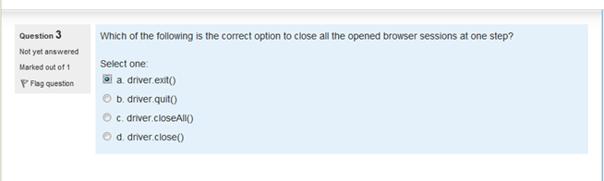**Ans: driver.quit()**

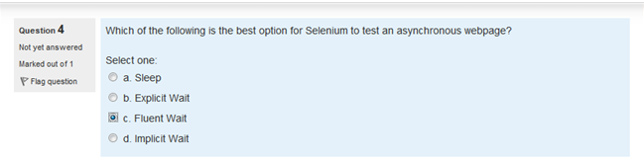**Ans: Explicit wait**

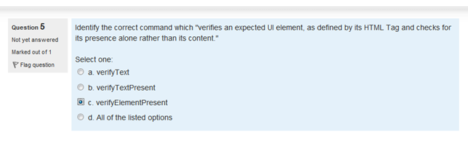**Ans: c.**

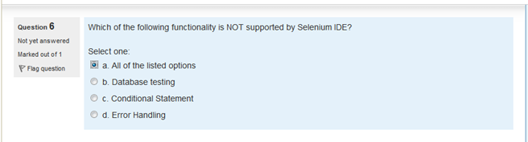**Ans: a.**

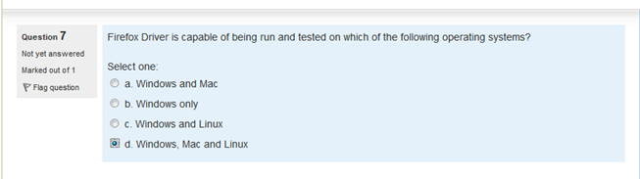**Ans: d.**

**Firefox Driver is capable of being run and is tested on Windows, Mac, Linux.**

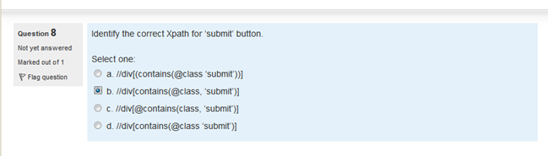**Ans: b.**

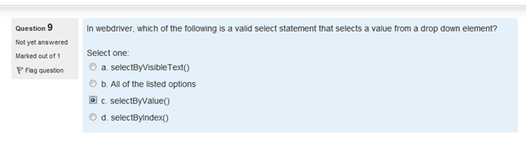**Ans: all of the listed**

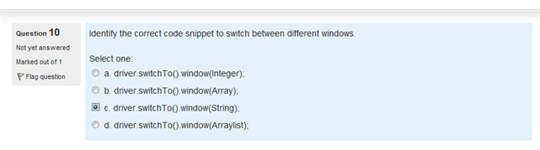**Ans: c.**

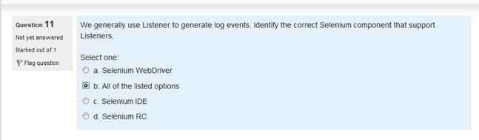**Ans: a.**

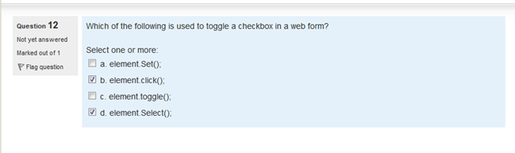**Ans: b**

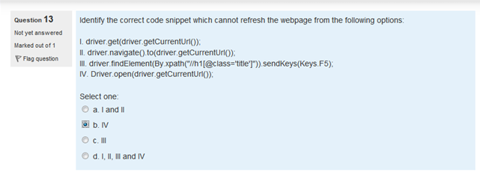**Ans: b.**

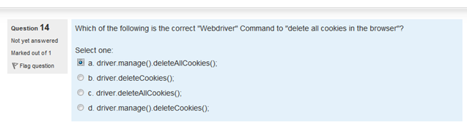**Ans: a.**

**------**

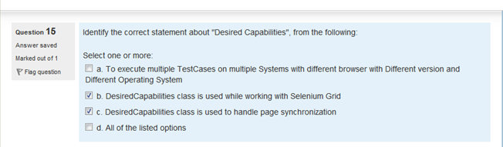**Ans: a & b.**

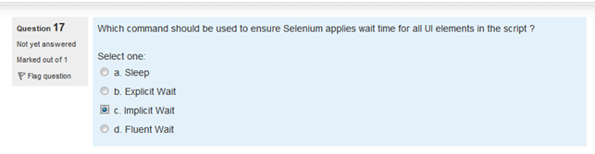**Ans: implicit**

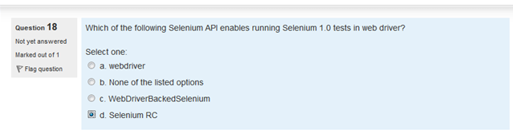**Ans: c**

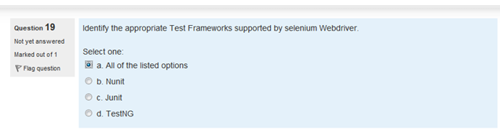**Ans: a)**

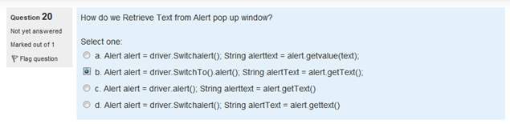**Ans: b.**

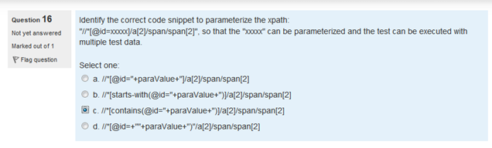**Ans: c**

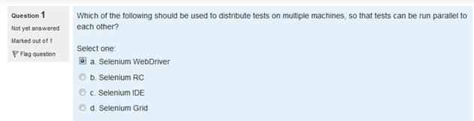**Ans: Selenium Grid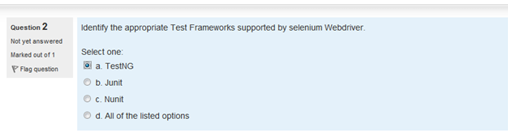 Ans: All options 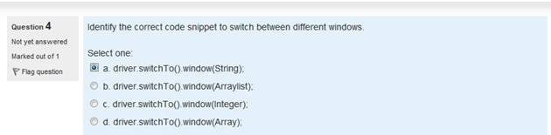Ans: a.**

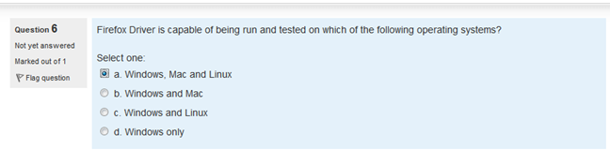**Ans: a.**

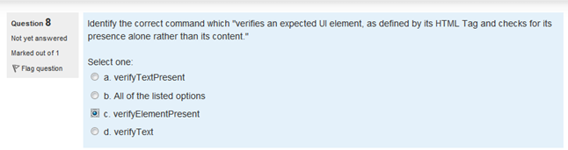**Ans: c.**

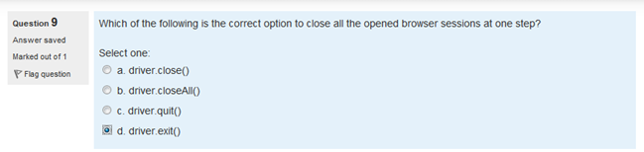**Ans: driver.quit()**

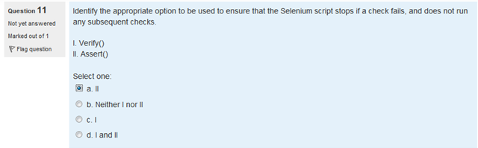**Ans: a. 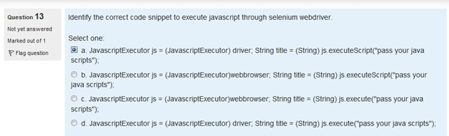Ans: a.**

**if (driver instanceof JavascriptExecutor) {**

**((JavascriptExecutor) driver)**

**.executeScript("alert('hello world');");**

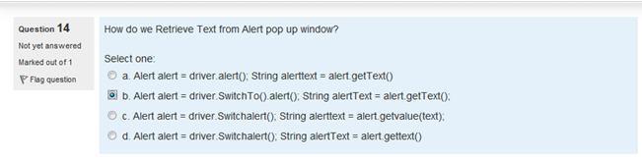**Ans: b.**

**// Get a handle to the open alert, prompt or confirmation  
Alert alert = driver.switchTo().alert();**

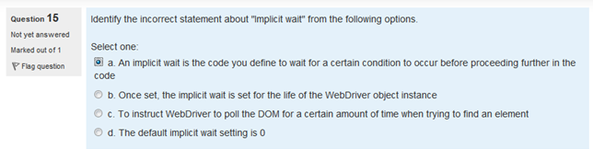**Ans: a.**

*An implicit wait is to tell WebDriver to poll the DOM for a certain amount of time when trying to find an element or elements if they are not immediately available. The default setting is 0. Once set, the implicit wait is set for the life of the WebDriver object instance.*

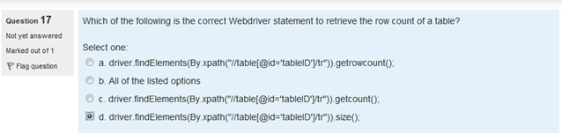**Ans: d.**

**int rowCount=driver.findElements(By.xpath("//table[@id='DataTable']/tbody/tr")).size();**

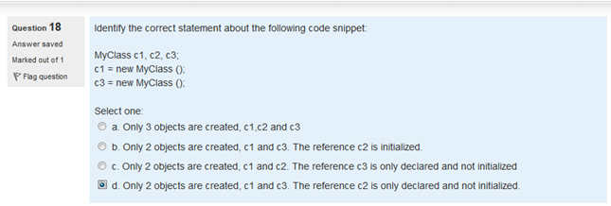**Ans: d.**

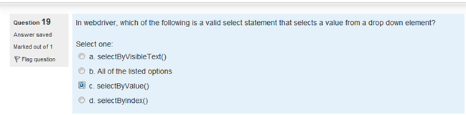**Ans: b**

**dropdown.selectByValue("prog");**

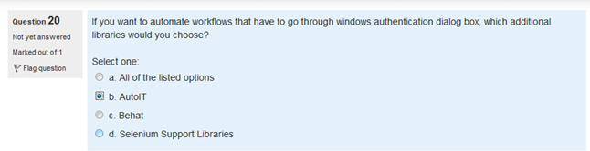**Ans: b.**

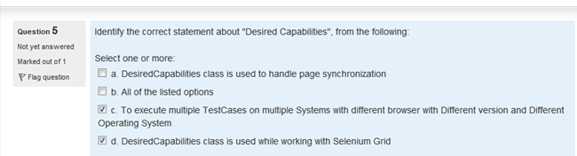**Ans: c. & d.**

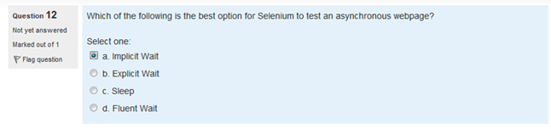**Ans: b**

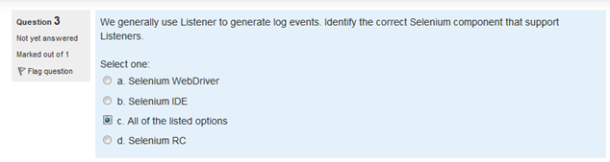**Ans: a 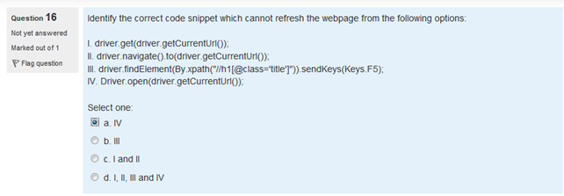Ans: a.**

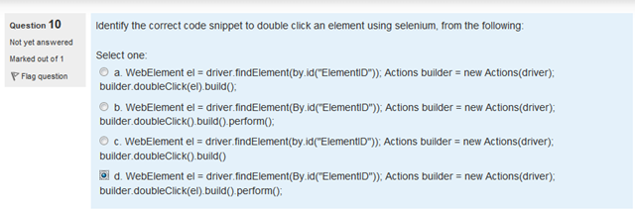**Ans: d.**

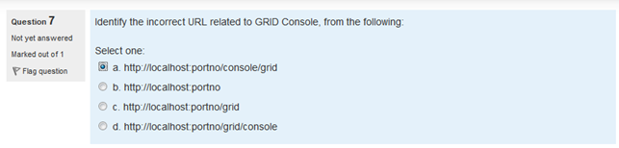**Ans: a**

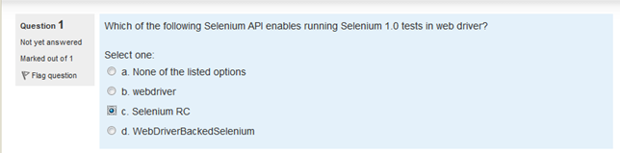**Ans: d**

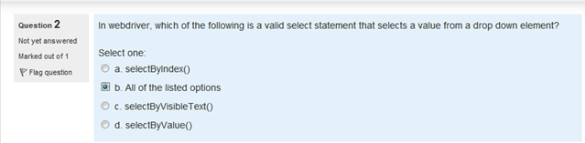**Ans: d.**

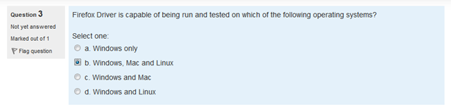**Ans:b.**

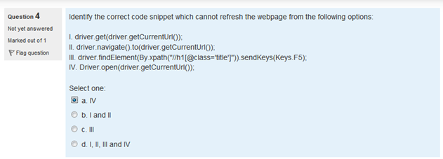**Ans: a.**

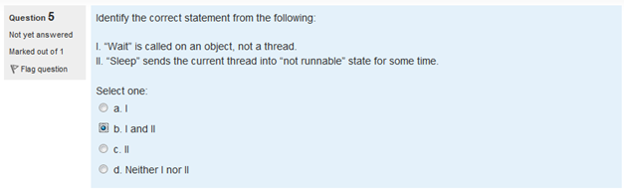**Ans: b. 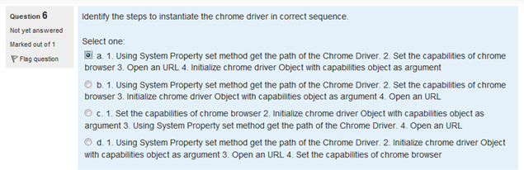Ans: b 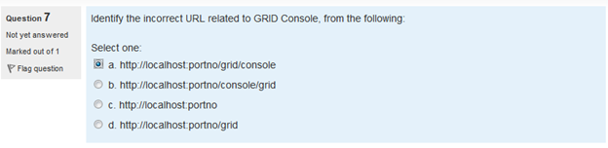Ans: b**

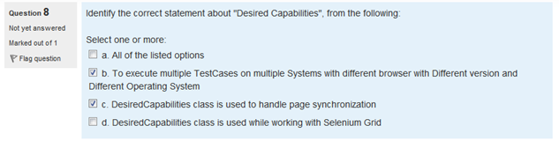**Ans: b & d**

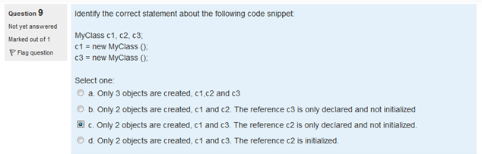**Ans: c. 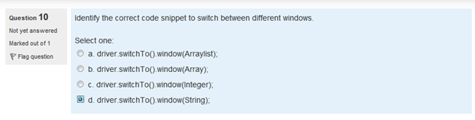Ans: d. 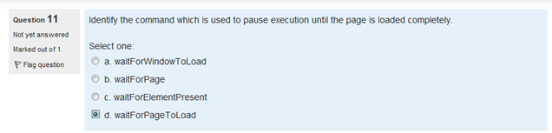Ans: d.**

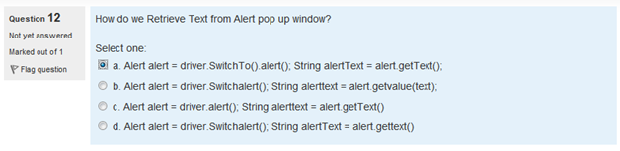**Ans: a.**

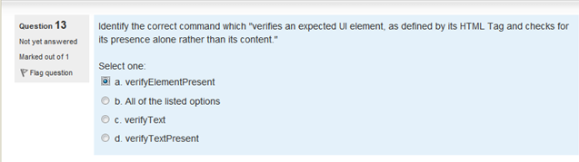**Ans: a, UI wait- implicit wait 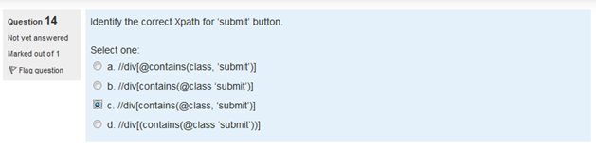Ans: c. 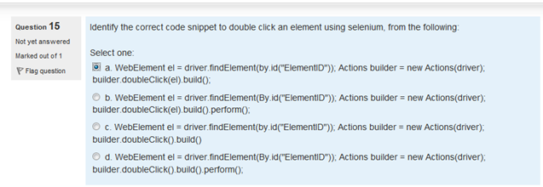Ans: d.**

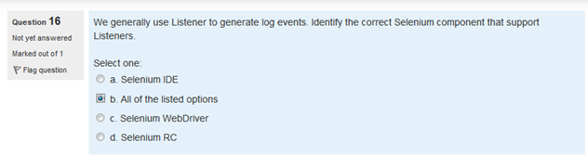**Ans: c.**

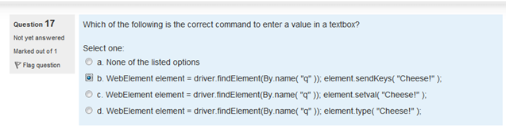**Ans: b.**

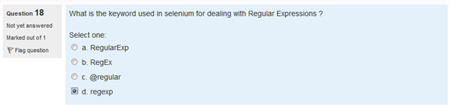**Ans: d. 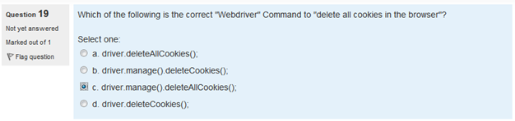Ans: c.**

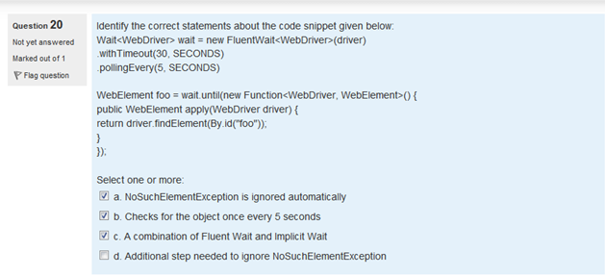**Ans: b and d**

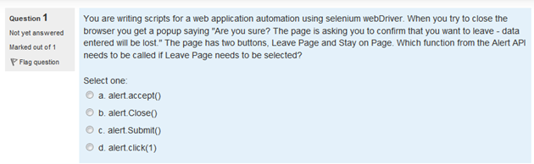

**Ans: a.**

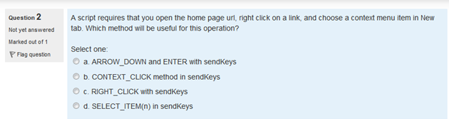

**Ans: unknown.**

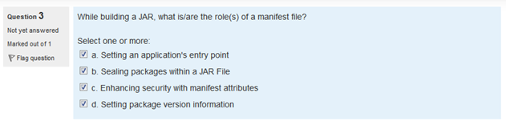**Ans: unknown**

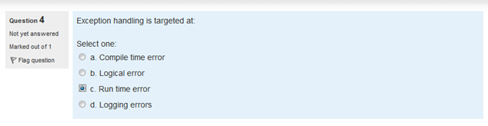**Ans: c.**

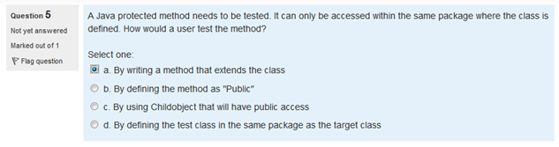**Ans: unknown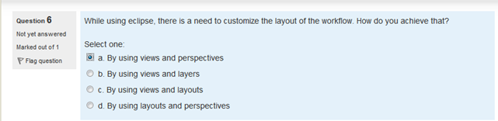Ans: a. (not sure)**

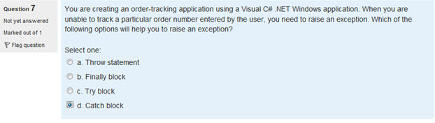**Ans: d. (not sure)**

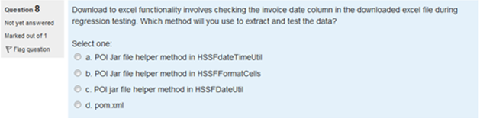**Ans: d. (not sure)**

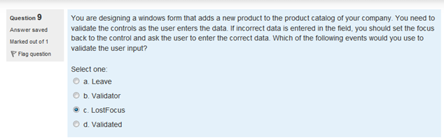

**Ans: unknown**

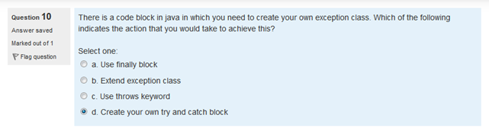**Ans: d. (not sure)**

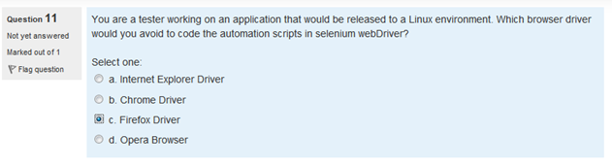**Ans: c. (not sure)**

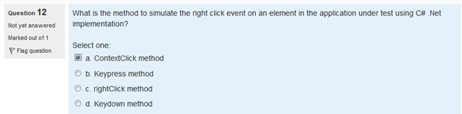**Ans: a. (not sure)**

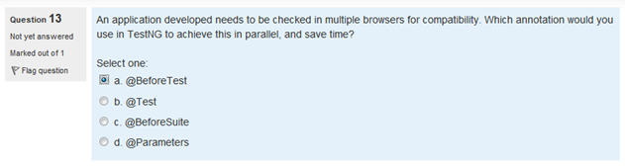**Ans: b. (not sure) 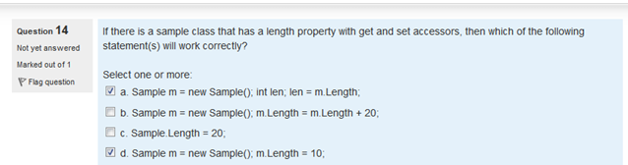Ans: a & d (not sure)**

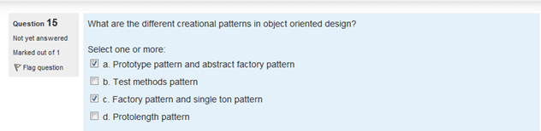

**Ans: unknown**

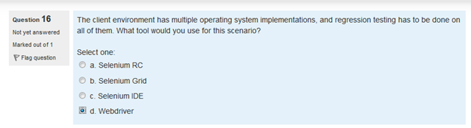

**Ans: unknown**

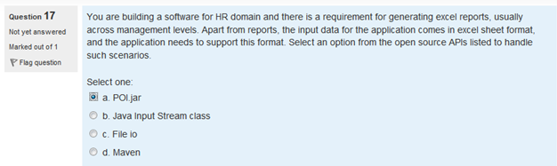 **Ans: unknown**

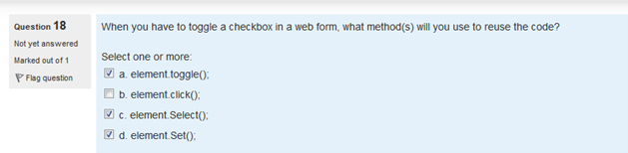 **Ans: unknown**

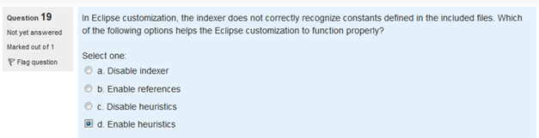 **Ans: unknown**

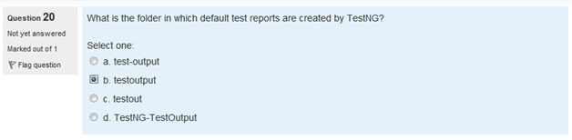 **Ans: b.**

