What is JDBC ?

It’s a J2AEE API , which is used to connect to any data base from the java code

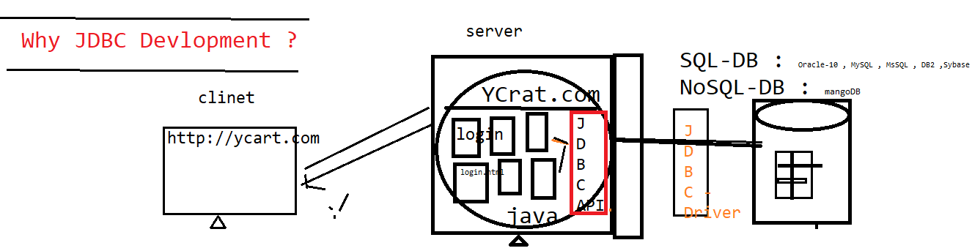



JDBC WorkFlow ?

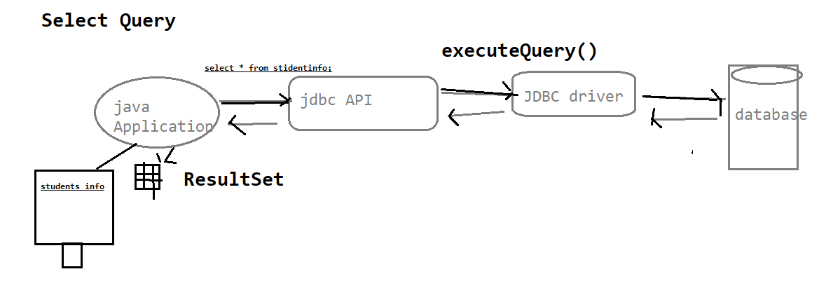

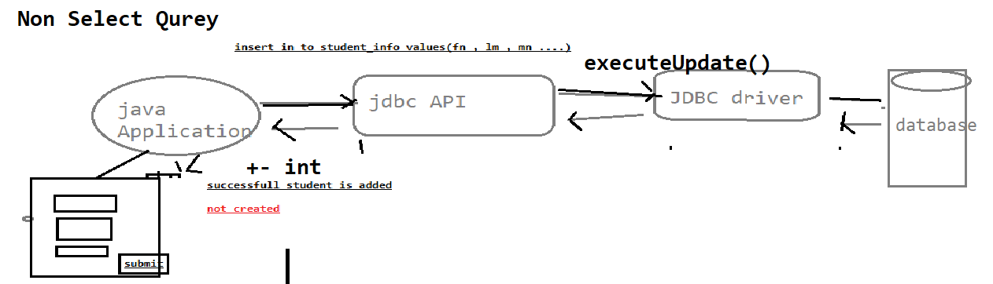

What is JDBC Drivers & JDBC API ?

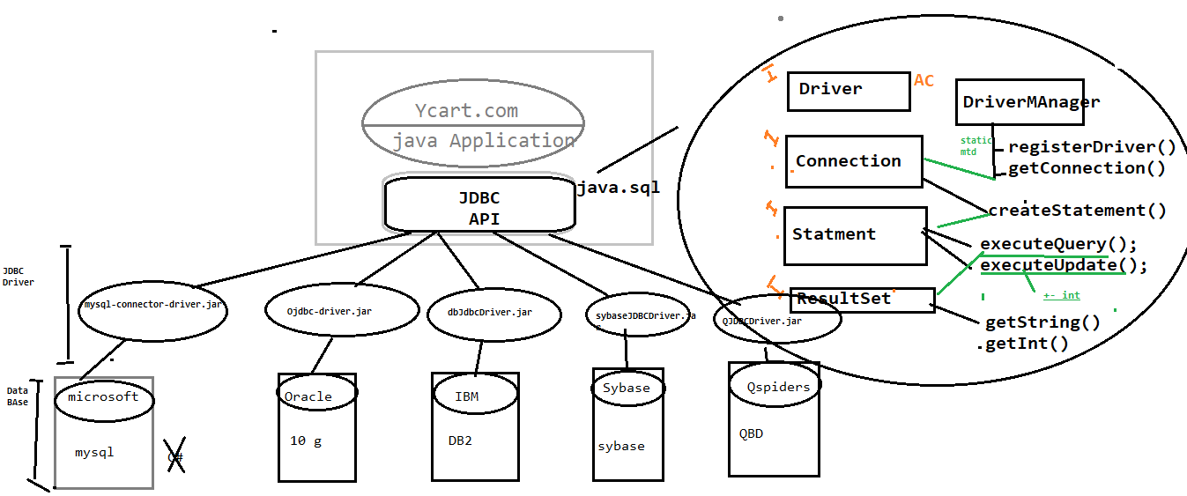

JDBC API : its an API’s available in java.sql package , which collection interfaces with abstract method & class , db independent

JDBC Driver : its implementation class of JDBC driver provided by data base vender . it’s a db dependent

Why JDBC in Automation ?

In Automation also required JDBC Connection , Most of the test case Preconditions , required few set of data in Database & validation GUI WRT Database

