1. What is Data driven testing?

Read the data from external recourse & run the test is called Data driven testing (parameterization)

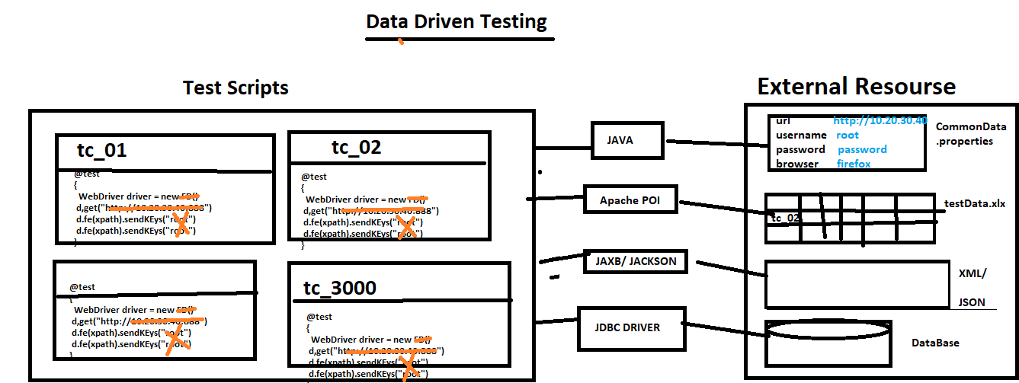

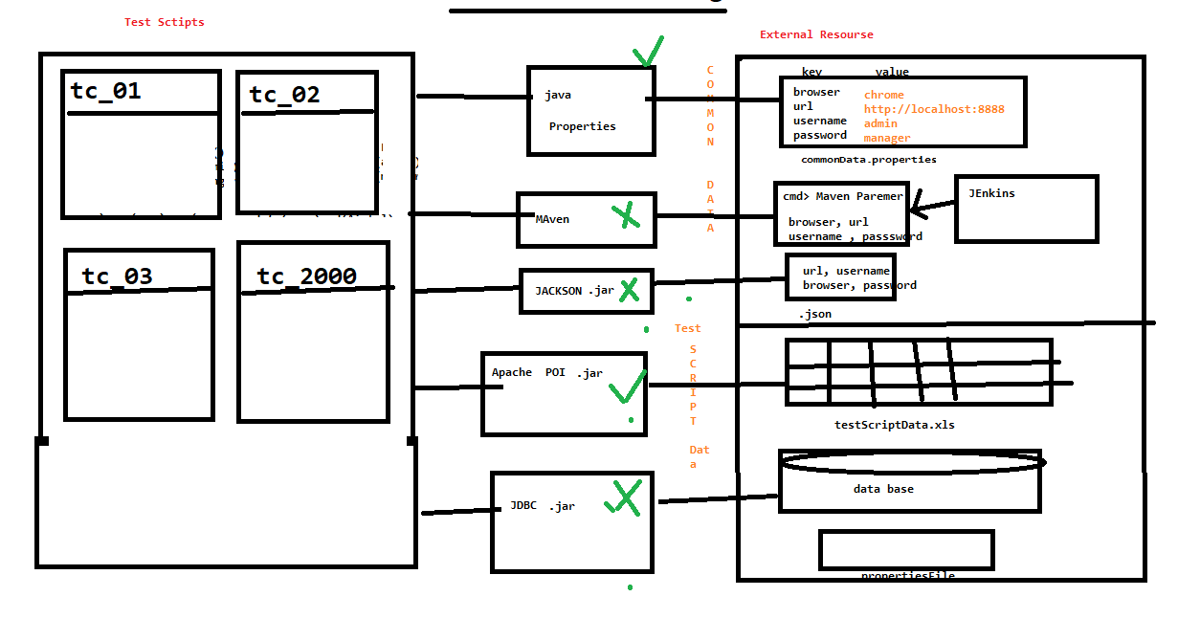

1. Why Data Driven testing ?

As per the rule of the automation data shouldn’t not hardcoded because data modification & maintenance is tedious job when you want to run the test with different data, instead we should get the data from external resource like xlsx, .properties file , db , XML, JSON, CMD Line Data

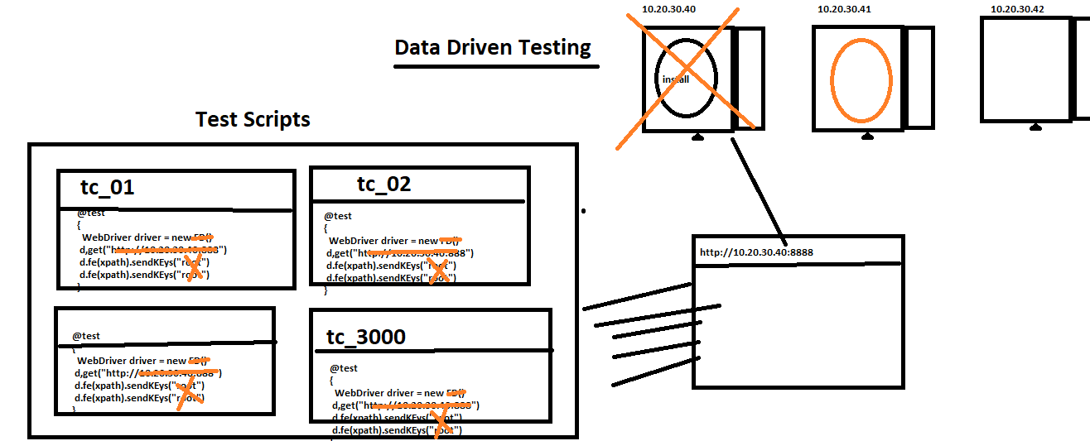

1. What is Advantages of Data driven testing
2. Maintenance of the test data is easy
3. Modification of the test data in external recourse is easy
4. Cross browser /platform testing is easy (means change the browser in property File)
5. Running test scripts in different Environment is easy
6. Running test scripts in different credentials is easy
7. We can create the test data prior the Suite execution (we can also get the data from testData team)
8. Rerunning test Script with multiple time is easy
9. How to read data from properties File?

* Get the java Object of the Physical file using “FileInputSteam
* Create a Object “Properties” class & load all the keys
* Read the data using getProperty(“Key”)

Note : properties file light weight & faster in execution compare to Excel

1. How to get Maven Parameters(data like url , username , password) from the CMD line
2. Download maven Command line plugin & set Environment varibales

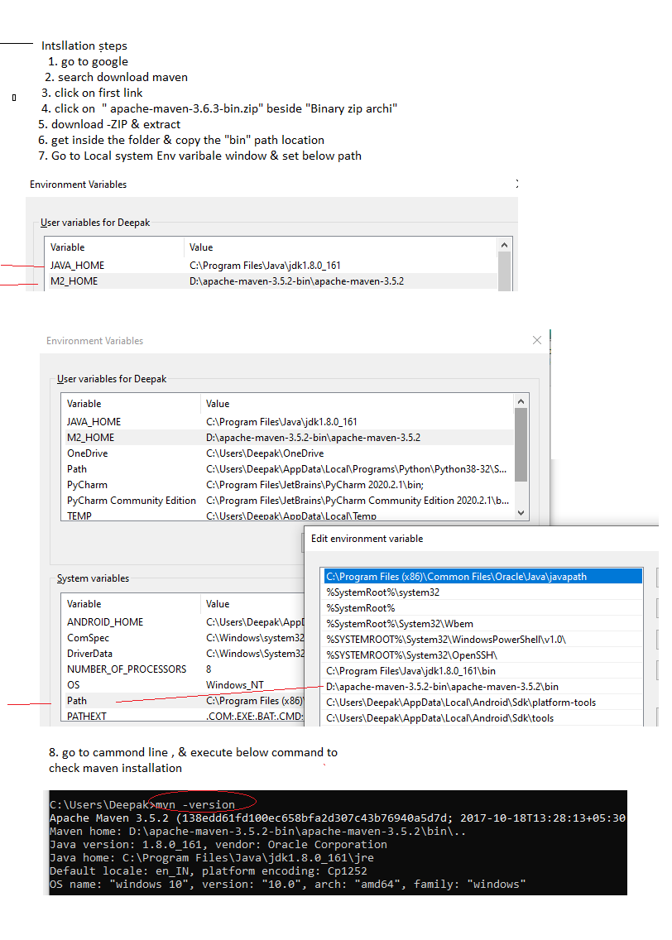

1. Create a Maven Project in Eclipse
2. Add testNG dependency in POM.xml
3. Create TestNg class

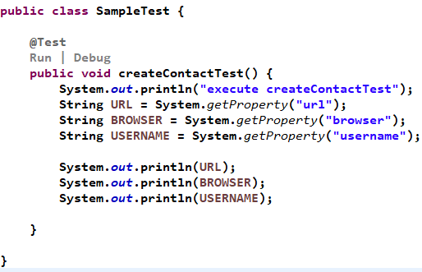

1. Copy the location of the Maven Project

Project=🡺 RightClick🡺Properties🡺 Recourse🡺 copy the 🡺 location

1. Go to Cmd line
2. Go to the location of the Project

Cmd >cd C:\Users\Deepak\eclipse-workspace\SDET_9_Project

1. Execute below Command

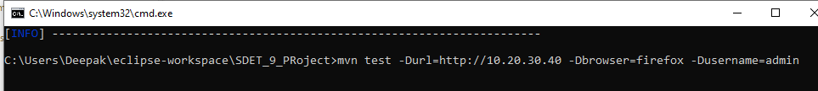

1. How to get Maven Parameters(data like url , username , password) from the Eclipse line
2. 