**What is Github**

It’s a distributed cloud decentralized repository where we can maintain our sourceCode / Automation Framwork / CRS doc /build of the application in one place

There are 2 Software in GitREpository

1. Git HUB : Cloud based repository(software) , which is used maintain the source code . then create an account[https://github.com] in order to use it [no need to install]
2. Git [Git client] : it’s a software should installed in client machine , used to communicate to GITHUB

EG : EGit , GitDeskTop , GitBash

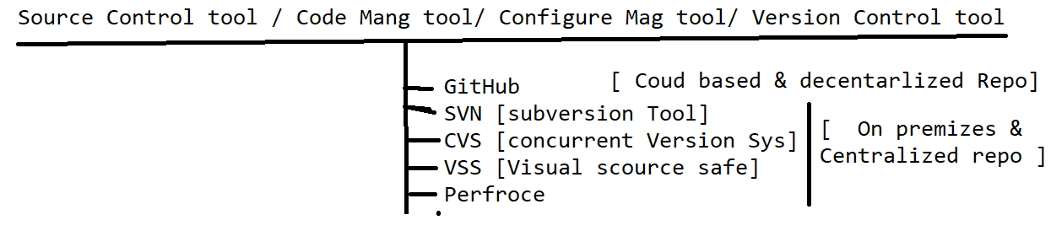

**Advantages of GitHud Cloud**

1. Since its cloud based repository , no need have maintenance team to maintain the Software / HardWare
2. Cloud means pay rent for what you use
3. Cloud software always access via internet
4. Cloud System / sever physically not present within the Organization , but present virtually
5. Initial investment is not required for Software/ Physical location
6. Scale UP / Scale Down is easy
7. File Share between the team members is easier
8. It provides remote access, it means anywhere contributors can access via internet
9. Provide History for changes made by users & backup facility
10. GitHub also provide platform to review the Code of Automaton test scripts
11. GitHub Also handle the conflict’s
12. Jenkins Always get the latest framework from the Git for Execution

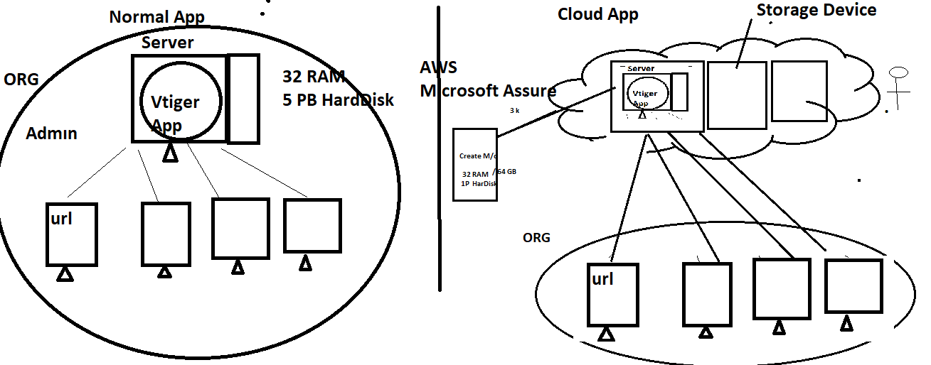

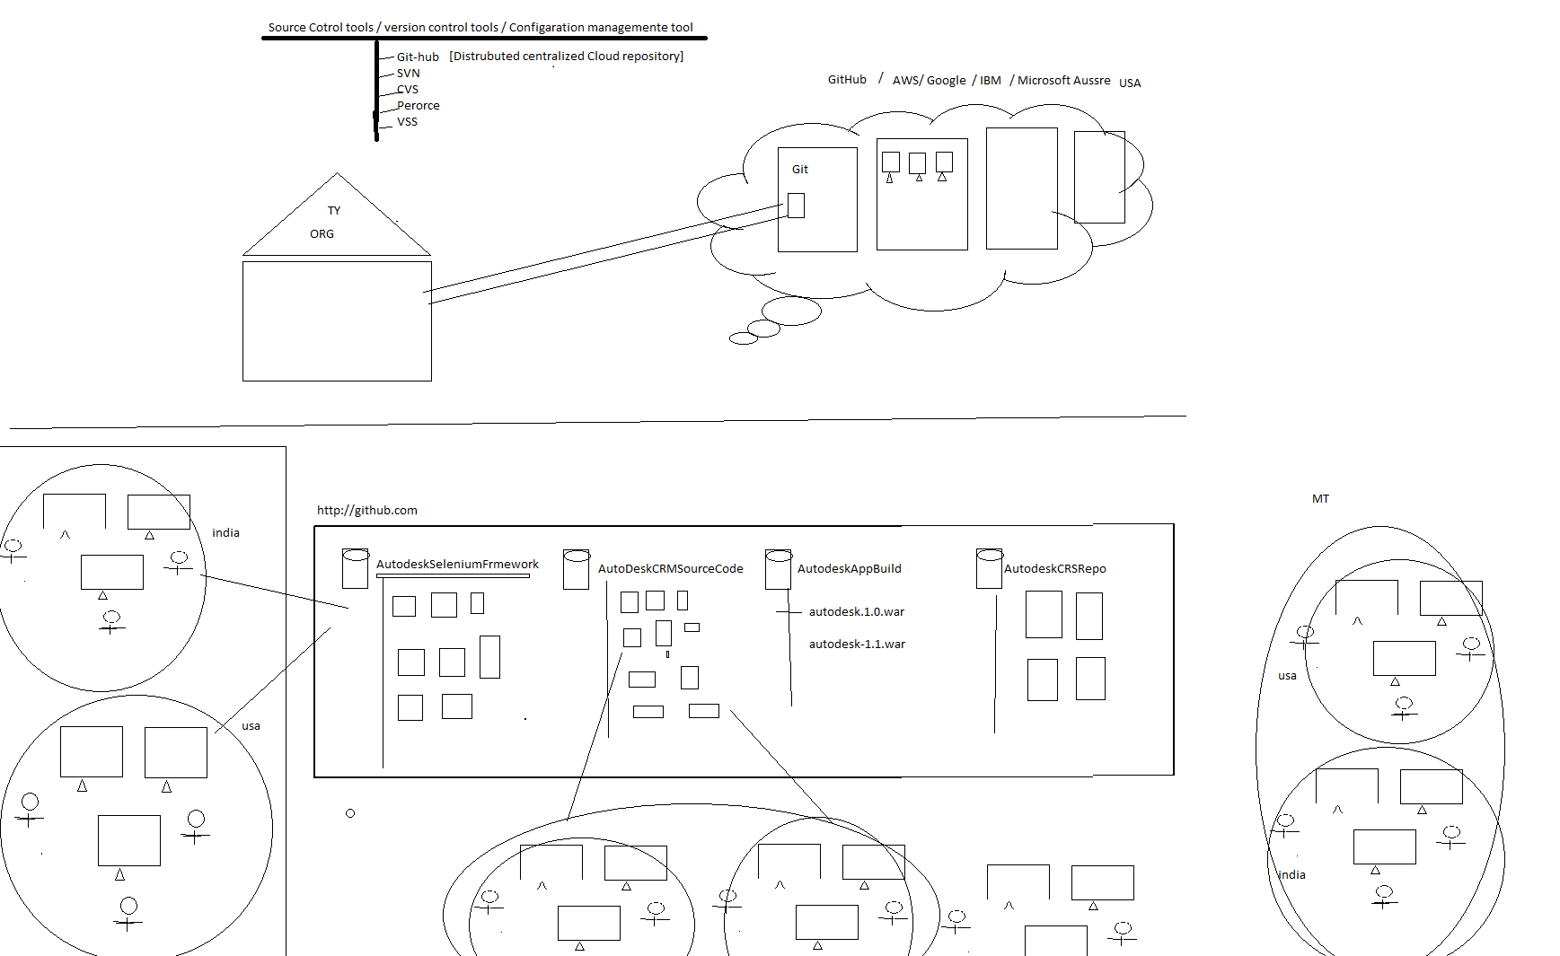

Developer Usage of Git : used to maintain the Source of the Application in one place

Automation Usage of Git : used to maintain the entire Automation framework in one place

DevOps Usage of Git : used to maintain the multiple application build version(like .exe, .war , .tar , .jar etc) in one place

Manual team Usage of Git : used to maintain the entire CRS / use case of the application

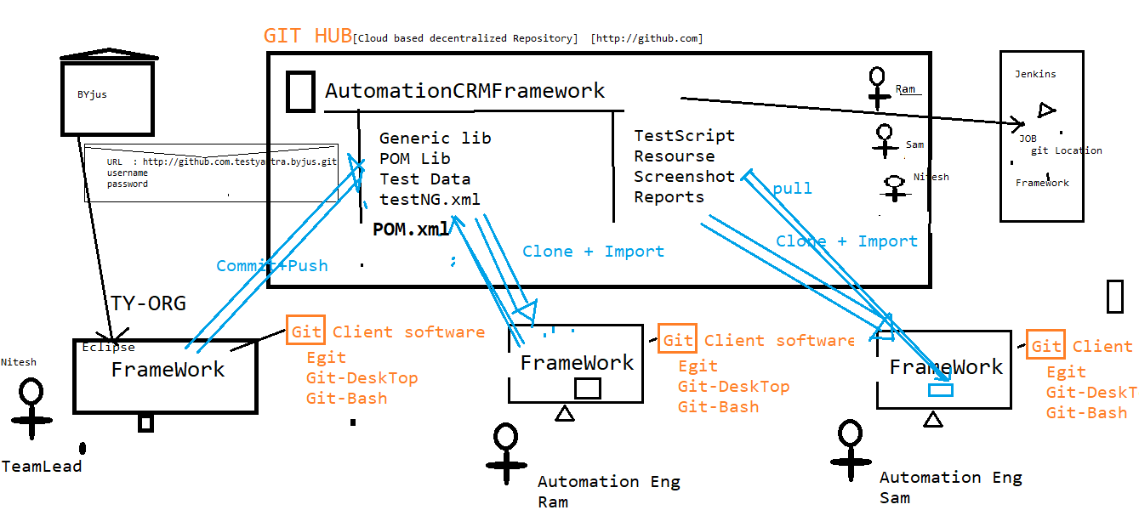

**Git Architecture**

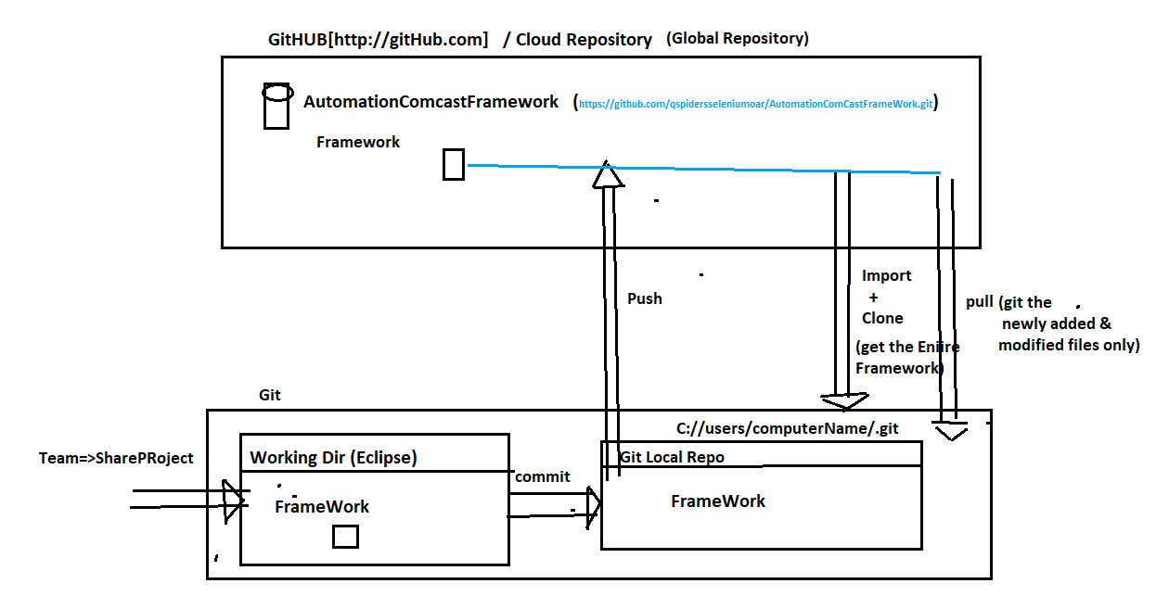

**What is Git Conflicts**

When two or more engineers modified the same file , when Eng-1 one push the file to GitHub will not get any conflicts , but Eng-2 try to push the same file to GitHub , will get git

Conflicts (because that file already modified by Eng-1)

Solution: Before push any file to GitHub, we should mandatorily Pull the Project & select merge option , then remove comments manually & analyse the code then push it

**What is Pull Request ?**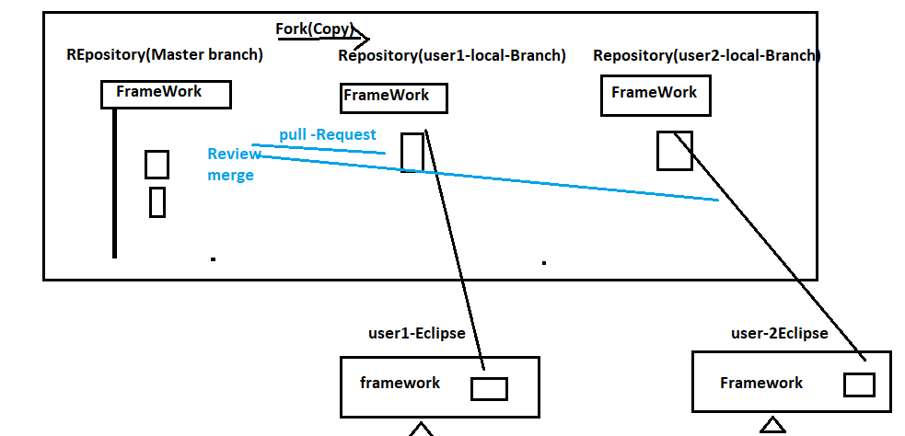

Whenever user made changes in the Programs , some Organization will not have access to push your changes to Master-Branch , in case we supposed to create a local branch using “fork” option , than push the changes to local branch & than create “Pull Request” to Team lead asking for “REVIEW & MERGE” to changes to master branch

