**Product Requirements**

|  |  |
| --- | --- |
| **Tea** | Team 3 ThePiratebay.SE |

# Brief problem statement

The Tool share application helps the people within a locality to share items of common use in order to help improve the community as a whole and also for personal uses. It enables the participants who register to borrow and lend the items through a simple and user friendly interface where the status of the items is clearly visible.

# Stakeholders

1. **Investiny Corp. Board of Directors:** Professor Daniel Krutz
2. **Investiny Corp. Product Owner:** Professor Daniel Krutz
3. **Software Engineering Team: Venkat Nitin Panaganti-(Testing coordinator), Urvi Rajendra Gandhi-(Team coordinator), Shraddha Mukeshkumar Pandya(Requirements coordinator) , Muhammad Fazalul Rahman-(Development coordinator), Akil Udayakumar-(configuration coordinator).**
4. **Beta Testing Team:** a) Lenders b) Borrowers c)Share Zone Administrators.
5. End User.

# Users profile

The system had different types of users:

1) The Shed / Zip Code Administrator:

The Shed Administrator will be the same person who has created the shed in the zip code. He will be in-charge of the shed he created and can allow any number of tools to be shared in the shed. The shed admin has full access over the operations of the shed and its contents. The shed admin can ban users or unban then, he can also make other users as admin based upon his own judgment. He is not allowed to move to a new share zone unless there is at least one another admin in the current share zone. The shed admin can also act as the tool sharer or tool borrower.

2) The User (borrower/Lender):

The user is the default role a registrant gets on entering the website. They can be a tool sharer or borrower. They will have access to almost all the normal activities but will not be able to access the higher administrative functions. A person only needs basic knowledge of computers and Internet for this role.

# System requirements

At a high-level this project will be source controlled in SVN-(subversion), developed on Django framework which uses python syntax, the database being used is SQLite and needs to be compatible with the latest browsers.

Although the application needs to be accessible through the Internet, deployments and demonstrations for this phase of the project will take place within the RIT Software Engineering environment.

The Software used to build this project are Django 1.8.3 , Python 3.4.3, SQLite version 3.7.11 2012-03-20 11:35:50 and an SVN controller(Subversion) which are compatible with all the latest browsers.

The only hardware requirement is the most basic computer available in recent times which can run a browser (assuming that the computer includes a monitor, keyboard, mouse and also a functional CPU).

This web based application can also be used on almost all the mobiles using their default browser or third party browsers but no mobile version of the site is available.

Version of software’s/languages used:-

Django : 1.8.3

Python : 3.4.3

IDLE : 3.4.3

SQLite version 3.7.11 2012-03-20 11:35:50.

**Feature requirements (user stories) :**

|  |  |  |  |
| --- | --- | --- | --- |
| **No.** | **User Story Name** | **Description** | **Release** |
| **1** | Registration | Registrant provides personal information and preferences while registering. (i.e.: Full name, address, contact details.)    System will ask the user to create a new Share Zone upon registration of User with previously unregistered zip code    *Upon registration System will associate user with an already created Share Zone based on zip code* | R1 |
| **2** | Login | Users who are previously registered can login with their user name and password. | R1 |
| **3** | Account Management - change personal info | User shall be able to change personal information after registration (for example: change address, email, username).  System will also let the user change their share zone and make the necessary changes to the items that need to be moved with the user. | R1 |
| **4** | Account Management - change user preferences | User shall be able to change preferences after registration (for example: pickup arrangements) | R1 |
| **5** | Community Shed creation | User shall be able to create a Shed for his Share Zone if he is the first person to register in that zip code location.  A Shed has a physical location where tools from several Users can be stored.  Shed creator becomes Administrator of said shed. There can be a maximum of one Shed in the zip code. | R1 |
| **6** | Tool Management – registration | User can register a tool by providing items information. (for example: Picture, Category, Name, Description, Special instructions, etc.)  User must accept default Pickup Arrangement (set during User registration) or select a different arrangement for this tool (for example: “Please knock on my door” vs. “Let's make additional arrangements via email”) | R1 |
| **7** | Sharing – from Home | User can set a previously registered tool to be shared from home.  Tool cannot be shared from two places simultaneously  *User must physically have possession of tool prior to sharing it.*  User can change a previously registered tool | R1 |
| **8** | Sharing – from Community Shed | User can set a previously registered tool to be shared from a Community Shed.  Tool cannot be shared from two places simultaneously.  *User must physically move the tool to Shed prior to being allowed to share it.* | R1 |
| **9** | Sharing – change location of tool | User can change a previously registered tool to be shared elsewhere. | R2 |
| **10** | Sharing – change availability | User can change availability of a tool. (for example: on black out dates when he/she will be using the tool, or be away/unwilling) | R2 |
| **11** | Sharing – approving a borrower | System will notify User upon a request to borrow his/her tool.  (Owner of the tools can only reject permission when the tools are not in the community shed.)  User owner of tool must approve the borrower when his/her tool is not at a Community Shed.  System will notify borrower of decision by owner and update tools status if necessary. | R2 |
| **12** | Tool Listing – availability | User can request from System a list of all tools and their availability. List shall be sorted by System.  Only tools in User's Share Zone will be visible | R2 |
| **13** | Borrowing - request | User can select to borrow a tool for specified days, provided the tool is available. Borrower can add a message to request.  User owner of tool will need to “Approve” or “Reject” the request to borrow unless the tool is in a Community Shed were it is always automatically approved.  Upon approval, System will create Reservation with requested dates and update availability of a borrowed tool.  Upon rejection, owner of tool must provide a small reason for “Reject”.  System will send notification to borrower or lender including reason or message where applicable. | R2 |
| **-14** | Borrowing – arrangements | User sharing a tool decides the arrangements required by the borrower to pick up the tools if the tools are not in the community shed, If the tool is in the community shed then the borrower must pickup the tool from the shed. | R2 |
| **15** | Borrowing - returning | Borrower will return at the tool pickup location unless otherwise agreed with tool owner.  *Borrower will notify the System that tool has been “Returned”*  System will update availability of a returned tool. | R2 |
| **16** | Tool Management – deactivation and reactivation | User can deactivate a tool they previously added to the System. Neither the tool nor its reservations are shown by default, but the system still retains the information about the tool. A tool may be re-activated at any time.  System will require confirmation in case of possible conflicts. | R2 |
| **17** | Tool Management – Status | User owner of tool can request from System a list of registered owned tools and their status. | R2 |
| **18** | Community Statistics | User can request a list of statistics for their specific Share Zone. Upon request System will verify association and display such listing.  Statistics that may be included:  - most active lenders  - most active borrowers  - most used tools  - most recently-used tools | R2 |
| 19 | Banning Users | A administrator can ban users who refuse to return the tool | R2 |
| 20 | Time Limit | The Lender can set the time limit for their tools to be shared for, the default time limit is 7 days. | R2 |
| 22 | Removal of damaged/lost tools | The tool owner will be able to completely delete a tool from the system. | R2 |
| 24 | Community Shed - Edit Details | The administrator of a community shed can change the details of the shed.  The details like shed name and shed address can be changed | R2 |
| 25 | Community Shed - Add Admin | The administrator of a shed can add another user who is registered in that same zip code as an administrator. | R2 |
| 26 |  |  | R2 |

**Use case diagram**

***User***

***Registration***

***login***

***User:Owner***

***Account Management***

***Tool Management***

***Tool Listing***

***Time Limit***

***Tool Sharing***

***Tool Deactivation***

***Tool deletion***

***Community Statistics***

***Borrower approval***

**User:Borrower**

**Account Management**

**Tool Borrowing**

**Tool returning**

**Community Statistics**

**User:Shed Coordinator**

**Tool Listing**

**Banning Users**

**Community Shed Creation.**

**User Administration**

**Use case diagram:** 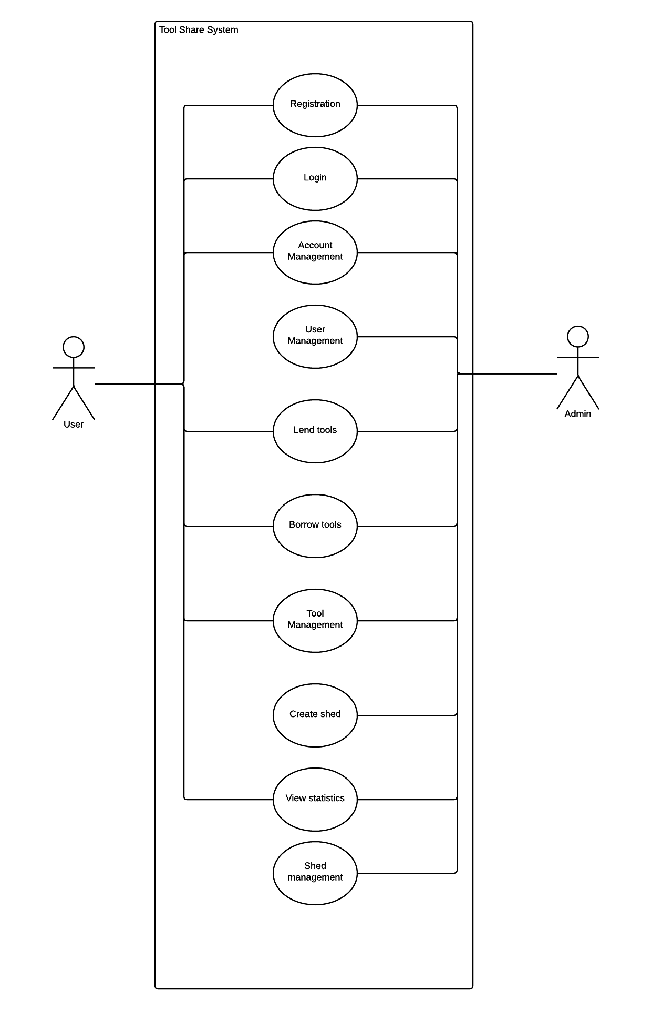

**Use case description**

|  |  |
| --- | --- |
| **Use Case Number:** | UC-01 |
| **Use Case Name:** | Registration |
| **Overview:** | The user must be registered with the system to be provided with details about the tools or to add tools, create shed or request tools. By default, the user is added as a normal user with limited access and their user status will only change when they create sheds or is elevated to admin status. |
| **Actor(s):** | User, Administrator |
| **Pre condition(s):** | - System has been setup and configured.  - System is running and open for registrations.  - User has accessed website via URL |
| **Scenario Flow:** | Main (success) Flow:  1. User selects option to register  2. System requests personal information  3. User provided personal information.  4. System verifies required information is provided.  · If information is invalid System displays message. Return to Step 2  5. System requests user's preferences  6. User provides user preferences  7. System verifies required information is provided.  · If information is invalid System displays message. Return to Step 5  8. The new user is created with the limited privileges.  9. System displays confirmation of registration |
|  | **Alternate Flows:**  After Step(2) System will display the option to Cancel the registration process. The following steps would occur:  1. The user selects option to cancel during registration  2. System requests confirmation to cancel  3. User confirms intent  4. System returns to main screen |
| **Post Condition** | User has completed the registration and the database is with the details. |

|  |  |
| --- | --- |
| **Use Case Number:** | UC-02 |
| **Use Case Name:** | Login |
| **Overview:** | User who have previously registered can login into the system again using their user name and password. |
| **Actor(s):** | User, Administrator |
| **Pre condition(s):** | - System has been setup and configured.  - System is running.  - User has accessed website via URL |
| **Scenario Flow:** | Main (success) Flow:  1. User selects option to login  2. System requests user name and password  3. User provides the required details.  4. System verifies required information is provided.  · If information is invalid System displays message. Return to Step 2  5. System logins the user into the system. |
|  | **Alternate Flows:**  After Step(2) System inform the user that the details are invalid.  1. The user is requested to re-enter their credentials |
| **Post Condition** | User is logged into the system. |

|  |  |
| --- | --- |
| **Use Case Number:** | UC-03 |
| **Use Case Name:** | Share tools |
| **Overview:** | Users can share previously registered tools from home or the community shed. Users must physically posses the tool before sharing it. The tool must have a unique attribute to distinguish it from similar tools. Tools Shared from the community shed must be physically moved to the community shed prior to sharing it. |
| **Actor(s):** | User, Administrator |
| **Pre-condition(s):** | Tool must be previously registered to be shared from home(If they are shared from home)  Tools cannot be shared from two places simultaneously.  User must physically have possession of tool prior to sharing it.  User must physically move the tool to Shed prior to being allowed to share it, if it is shared from the community shed. |
| **Scenario Flow:** | **Main (success) Flow:**  1) User registers a tool to be shared.  2) If the tool is to be shared from the community shed, it must be moved to the community shed.  3) User must enters the details about the tool to be shared into the system.  4) The tool is available to be shared. It is added to the list of available tools. |
|  | **Alternate Flows:**   1. The user gets a request from another user for a tool. 2. The user approves the request if he wishes to share the tool. 3. If the tool is in the shed, based on the availability, the share request is approved. |
| **Post Condition:** | The new user can collect the tool from the shed or specified location. |

|  |  |
| --- | --- |
| **Use Case Number:** | UC-04 |
| **Use Case Name:** | Borrowing a tool. |
| **Overview:** | Users can borrow previously registered tools from the home of the lenders or the community shed. User can select to borrow a tool for specified days, provided the tool is available.    The owner of a tool will need to “Approve” or “Reject” the request to borrow unless the tool is in a Community Shed were it is always automatically approved.  User sharing a tool decides the arrangements required by the borrower to pick up the tools if the tools are not in the community shed, if the tool is in the community shed, it must be picked up from the shed.    Tools can be returned at the tool pickup location. System will update availability of a returned tool. |
| **Actor(s):** | User,Administrator |
| **Pre-condition(s):** | The user must be a registered user.  The tool must be available to be shared in the system.  The user must pick up the tool from the location specified. |
| **Scenario Flow:** | **Main (success) Flow:**  1) User requests the tool in the system.  2) If the tool is not in the community shed, the owner is asked permission. If the tool is from the community shed then this step is skipped.  3) If the Owner grants permission, the system sets up the reservation, the borrower is informed of the time limit for which the tool can be retained  4) The location for the pickup and return of the tool is specified to the borrower.  5) The borrower collects the tool.  6) After it serves its purpose and before the time expires, the borrower returns the tool to the specified location.  7) The system updates the status of the tool. |
|  | **Alternate Flows:**  1) The tool is not from the community shed.  2) The owner refuses permission.  3) The system doesn’t allow the tool to be shared and instead sends a notification with the reason why the tool is not shared. |
| **Post Condition:** | The borrowed tool must be returned for its status to update and for it to be available to other users. If the tool is not returned or damaged, then the tool is removed from the system. |

|  |  |
| --- | --- |
| **Use Case Number:** | UC-05 |
| **Use Case Name:** | Account Management |
| **Overview:** | After registration user will be able to change his/her personal information which he/she added at time of registration and also preferences like frequency of notifications. |
| **Actor(s):** | User, Administrator |
| **Pre-condition(s):** | User must be registered in the system. |
| **Scenario Flow:** | **Main (success) Flow:**  1. After completing registration if the user want to change their personal information like contact address , they can do it by opening this page.  2. There is also function available that users can change their preferences i.e. email reminder frequency, pickup arrangements. |
|  | **Alternate Flows:**  If registrant do not want to change any of his personal information and keep preferences as default, then he will close it. |
| **Post Condition:** | If change is made page will return with new edited information or if change is not made then it returns no change . |

|  |  |
| --- | --- |
| **Use Case Number:** | UC-06 |
| **Use Case Name:** | User Management |
| **Overview:** | Administrator is the one who has access to this, The administrator can perform various actions like banning a user, making user an administrator, removing accounts which are not used for long, |
| **Actor(s):** | Administrator. |
| **Pre condition(s):** | Administrator has logged into his account. |
| **Scenario Flow:** | Main (success) Flow:   1. Administrator logs into his account. 2. Administrator clicks on the user management tab. 3. Administrator can view all the user in his user zone and has options to ban the user or make him an administrator. The administrator can also see the user rating. 4. Administrator logs out. |
| **Alternate Flows:** | After Step(2) admin will have options to ban a user or make a user admin   1. Administrator views all the users in this user zone and has options to either ban the user or to make him/her an admin for the zone. 2. Administrator tries to ban or make a user as an administrator. 3. System gives error message saying that the user not found. |
| **Post Condition:** | Main flow:  Administrator bans a user from using the facility/account.  Alternate flow:  Administrator fails in banning a user or making the user an administrator. |

|  |  |
| --- | --- |
| **Use Case Number:** | UC-07 |
| **Use Case Name:** | View Statistics |
| Overview: | The Administrator and Users can view the local statistics, information about the user’s activity. However, only the administrator can access the global statistics about all the user activities in the Zip Code. |
| Actor(s): | Administrator, User |
| Pre condition(s): | - The administrator and user has registered and is logged in. |
| Scenario Flow: | Main (success) Flow:  1. The user or administrator clicks on the local statistics tabs and the page is loaded by the system.  2. The page shows the tools that are shared and borrowed, history of tool sharing, frequency of borrowing, and so on.. |
|  | **Alternate Flows:**  1. The Administrator clicks on the global statistics tab and the page is loaded by the system.  2. The Administrator can view all the activities that are present in his ShareZone. |
| **Post Condition:** | Admin or User views all the data according to their privileges |

|  |  |
| --- | --- |
| **Use Case Number:** | UC-08 |
| **Use Case Name:** | Tool Management |
| **Overview:** | Users can view details about their tools and change properties about their tools like their description, Black out days, Special Instructions. Users can also change the location from where the tool can be shared from. |
| **Actor(s):** | Users, Administrators. |
| **Pre-condition(s):** | Tool must be previously registered.  User must be logged into their account. |
| **Scenario Flow:** | **Main (success) Flow:**  1) User goes to the tool management tab in the application.  2) User views the related information about their tools.  3) Users change details of the tools. |
|  | **Alternate Flows:**  1) User goes to the tool management tab in the application.  2) User has no tools to view, since the user has not shared nor borrowed tools. |
| **Post Condition:** | The tool’s properties in the system are updated. |

|  |  |
| --- | --- |
| **Use Case Number:** | UC-09 |
| **Use Case Name:** | Create a Community Shed. |
| **Overview:** | When a user signs up in a zip code where there are no other users, A share zone is created. The share zone is called the community shed and is created by an Administrator. |
| **Actor(s):** | Administrators. |
| **Pre-condition(s):** | There must be at least one registered user in the zip code. |
| **Scenario Flow:** | **Main (success) Flow:**  1) A user registers in a zip code. The zip code has no other user.  2) An Administrator is assigned for the zip code.  3) The administrator creates a community shed.  4) The shed details are updated in the system. |
|  | **Alternate Flows:**  Not applicable |
| **Post Condition:** | A single community shed is created in a zip code. |

|  |  |
| --- | --- |
| **Use Case Number:** | UC-10 |
| **Use Case Name:** | Shed Management |
| **Overview:** | The administrator can change the details of the community shed. The details such as address, name can be changed. |
| **Actor(s):** | Administrator |
| **Pre condition(s):** | System has been setup and configured.  System is running.  Administrator is logged in. |
| **Scenario Flow:** | Main (success) Flow:  1. Admin selects the manage shed option.  2. System displays the shed management page.  3. The admin can change details of the shed. |
|  | **Alternate Flows:**  Not applicable. |
| **Post Condition** | The shed details are altered. |