ReWear AI
Cropped website screenshots and workflow evidence
A visual demonstration of the ReWear AI prototype, created for the 1M1B AI for Sustainability Virtual Internship.

What this demo shows
A user can describe an item, choose its condition and city, receive a responsible route recommendation, and ask the assistant for item-specific guidance. The documented workflow uses IBM BOB for prompt design, testing and responsible AI review.

Submission details
Primary SDG | SDG 12 - Responsible Consumption and Production
Additional SDGs | SDG 11 - Sustainable Cities; SDG 13 - Climate Action
Repository | https://github.com/shraddha-123P/rewear-ai
Prototype | HTML, CSS and JavaScript responsive web prototype
Upload this document under Screenshots or Demo Images of the prototype/solution.

Prototype workflow
The prototype turns a vague disposal question into a practical next action.
1 Describe Item, condition, city and handover preference.
2 Classify Donation, repair, reuse, upcycling, recycling or disposal.
3 Match Compare details with suitable route categories.
4 Explain Give a reason and preparation guidance.
5 Verify Confirm live rules through the official channel.

Example result screen
The live app presents the recommended route, next action, partner website starting point, preparation guidance and verification reminder.

Website prototype evidence 1
Homepage: project purpose and Find my route entry point.
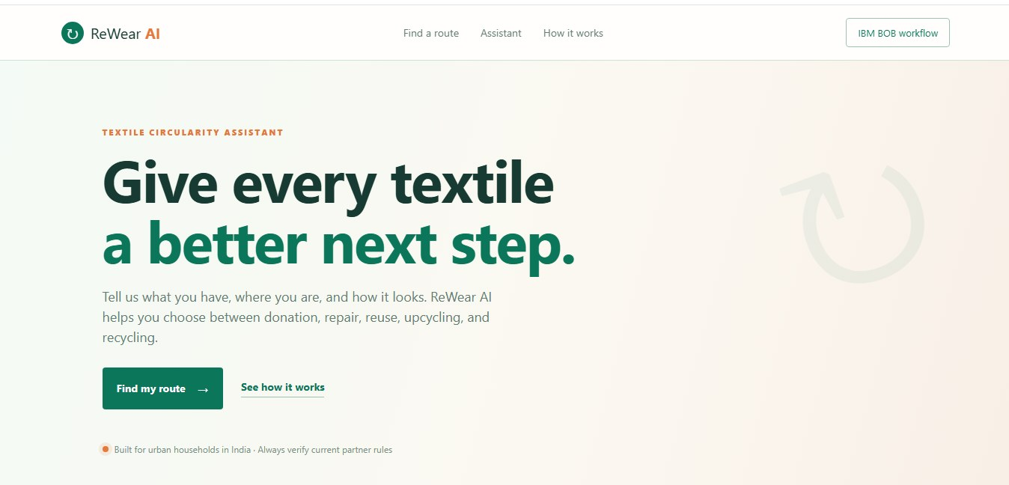
Browser and desktop borders were removed from this screenshot.
Verify live partner acceptance and pickup details through official channels.

Website prototype evidence 2
Matching form: item category, condition, city and handover preference.
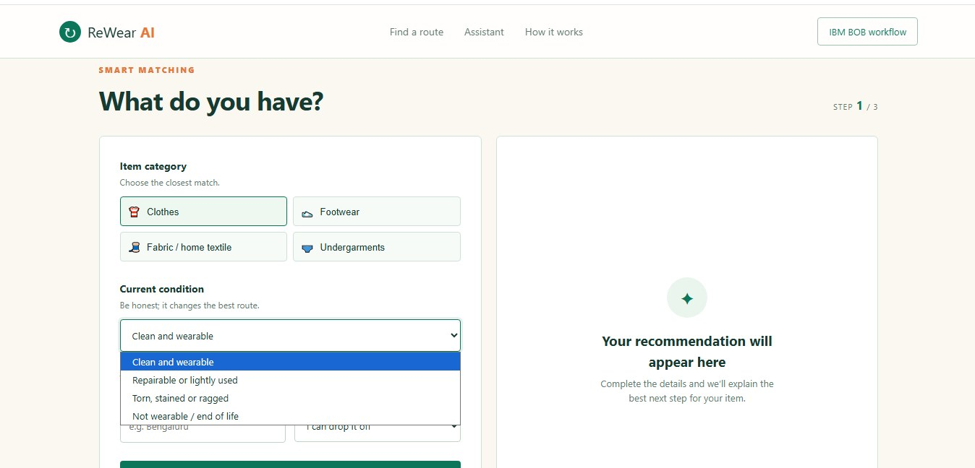
Browser and desktop borders were removed from this screenshot.
Verify live partner acceptance and pickup details through official channels.

Website prototype evidence 3
Recommendation result: route, next action, partner and verification reminder.
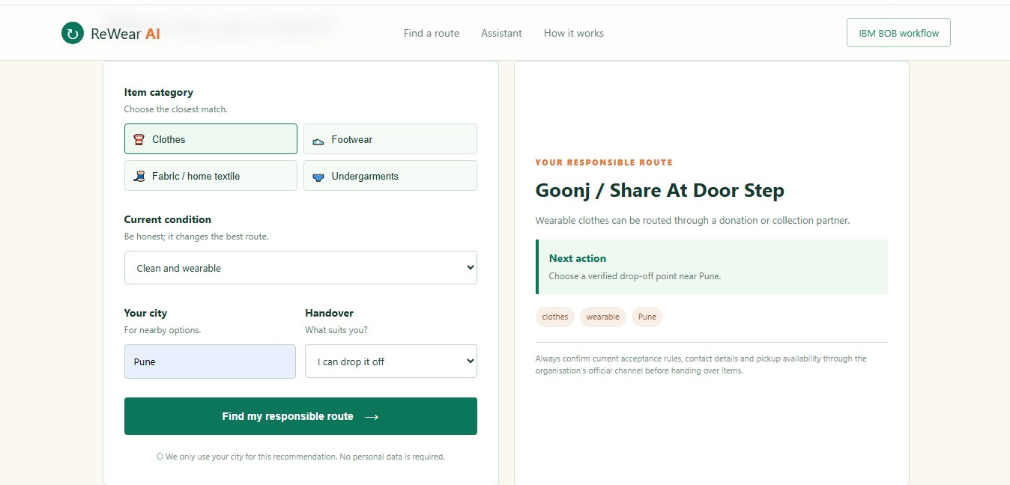
Browser and desktop borders were removed from this screenshot.
Verify live partner acceptance and pickup details through official channels.

Website prototype evidence 4
Conversational prototype: item-specific chatbot response.
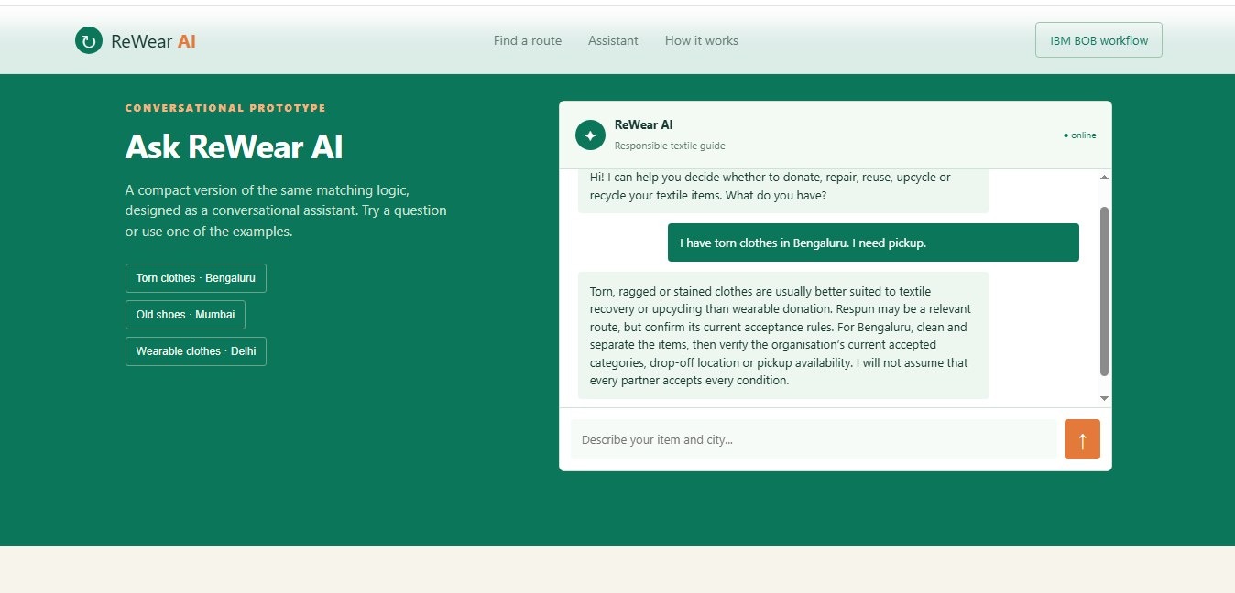
Browser and desktop borders were removed from this screenshot.
Verify live partner acceptance and pickup details through official channels.

Website prototype evidence 5
How it works: classify, match and explain workflow.
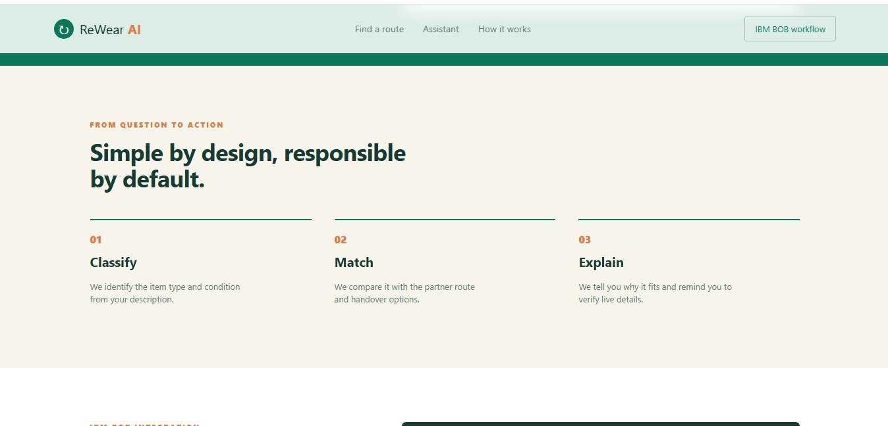
Browser and desktop borders were removed from this screenshot.
Verify live partner acceptance and pickup details through official channels.

Website prototype evidence 6
IBM BOB integration section in the ReWear AI website.
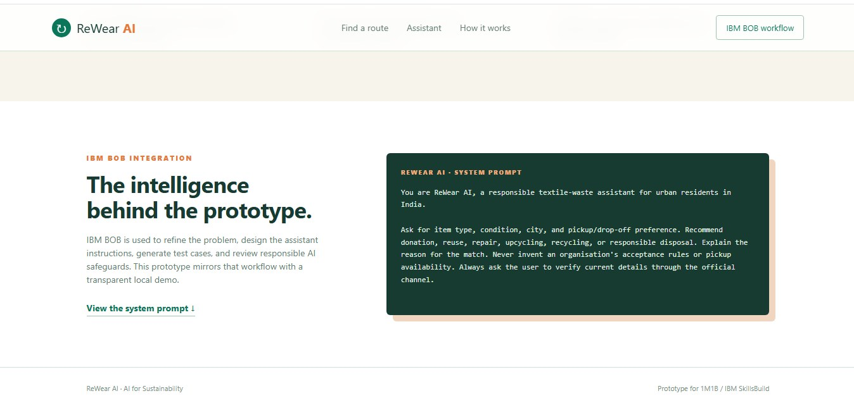
Browser and desktop borders were removed from this screenshot.
This shows the IBM BOB workflow section inside the prototype. For strongest internship evidence, also capture the actual IBM BOB conversation after running the project prompt.

IBM BOB prompt workflow
IBM BOB is incorporated through ideation, prompt engineering, test-case design and responsible AI review.

System prompt
You are ReWear AI, a responsible textile-waste assistant for urban residents in India.
Ask for item type, condition, city, and pickup or drop-off preference. Recommend donation, reuse, repair, upcycling, recycling, or responsible disposal. Explain the reason. Never invent an organisation acceptance rule or pickup availability. Always ask the user to verify current details through the official channel.

How to collect final evidence in IBM BOB
- Paste the system prompt into IBM BOB.
- Run three test questions: wearable clothes, damaged footwear, and torn textiles.
- Capture screenshots showing the prompt and the different responses.
- Add those screenshots to this document or upload them as the demo evidence.
Important: This document presents the prototype and IBM BOB workflow. The current web app uses transparent local JavaScript matching logic; it is not claiming a live IBM BOB API connection.

