ADMIN PORTAL

ADMIN PORTAL DESCRIPTION:

It deals with all the back-end data generation and product information. The role of the admin is to:

• Authorize the user

• Grant access to user

• Enable/disable the user

• Authorize the Cheque Book requests User Authorization:

After successful registration on the user portal, the user waits for the confirmation mail from the admin for his/her registration. The admin verifies the data given by the user and upon

verification, the status is sent to user’s email which is provided by the user at the time of registration. Only upon successful verification, the user’s account will get activated, the account

number gets generated and he/she can proceed with banking activities. In case of failure, user has

to re-register by providing the correct data. The admin also has a login to view the user details and

perform actions accordingly

# Admin Portal



Admin Portal











|  |  |  |  |  |  |  |
| --- | --- | --- | --- | --- | --- | --- |
| Slvanq | 8ağ | 738478]474 | aocs0eetbockno7 mum6wi | 19u1-OO/? | pancaid | xCD)348M’38#34 &Wvangabcchfii328GgmaŁcom |
| Panka | Sëni | 374B7M943 | cl/3shaníisadan.chennai | 19.03-0013 | aadhat | 63876437833424323 [penkajabcdd5256@gmaiT.com](mailto:penkajabcdd5256@gmaiT.com) |
| DeœJ | Dmuza | 9Ø383M637 | dlfÆ56. sanlacuv |  |  | GOvGHDv23 |

Name Ncme Us••N•ma



Aditya BT ogaTe adiryahhogate05

Number

39 i491820 \26

Number

39 T49 T820226

Account

 

Deposit - Withd‹aw + lransfei



Sayeli 9hogate

sayali27

39 \ 49 \B20146

394497820246 Deposit • Withdraw • Transfer v



ShJvang Bajaj

Access Granting:

The admin must set the transaction rights for the user. The three transaction rights are:

• Credit – User is allowed only to deposit.

• Credit + Debit – User is allowed to deposit and withdraw money.

• Credit + Debit + Transfer – User is granted full transaction rights (i.e) he/she can deposit, withdraw and also perform transfer of money to other account holders









39149 T@0158

39149g 8Z0? 56





Deposit • wirl›diaw acers v ;





Deposit • withdraw + Tra‹ssfer

Access



Name Name UserNome

Adigz Bhogzt+ adiyahfioga s0S

sayaIi3 I

Primary Account Number

39z491820136



394491820146

$avi Aaxount 8umber

394491820*26

39z491820246

Eaab!e

Account





n Features Granted to the Ucer

Depos if • Witindraw • Transfe r

Access

Depos ii - Wi jhdi on • Ir ansfe i





Shivang Bajaj



ihivang05

ganta2526



39149]B20l56

39149]B20t57

394491820256

39149 T820257

D rpos ii • Witfidra w Access



Deposi Access





Denzil Dsouza der\oil 12345

39149t820158

391491820258

Deposit • Withdraw + T ansfe



Enabling/Disabling the User:

The admin can disable(block) the user if he/she is found to be suspicious. If the user is

disabled, he/she cannot login and hence is restricted from performing transactions. The admin can

also enable the disabled user after verification in person.

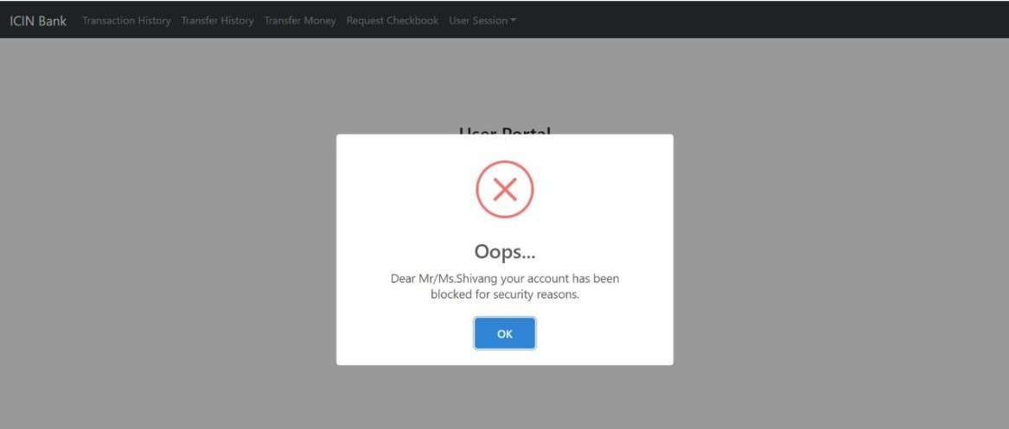





Authorizing Cheque Book Requests:

The admin has to authorize the user’s request for cheque book issue.

Only upon admin’s

confirmation, cheque books are issued to respective user and the confirmation mail is also sent to

the user’s email id

|  |  |  |  |  |
| --- | --- | --- | --- | --- |
| Raquect Humbar | Typa of Account | A¢€ouR¥ Ntambsr |  | Number of Raqas Confirm Bequest ? |
| SS  65 | 8e<ondoy  Omondag | 39149 T820246  39149\8202Z6 | 2020-08- t8 | 75  2O |
|  | Secondary | 391491820256 |  | 50 |
| 67 |  | J91491820257 |  | 20 |

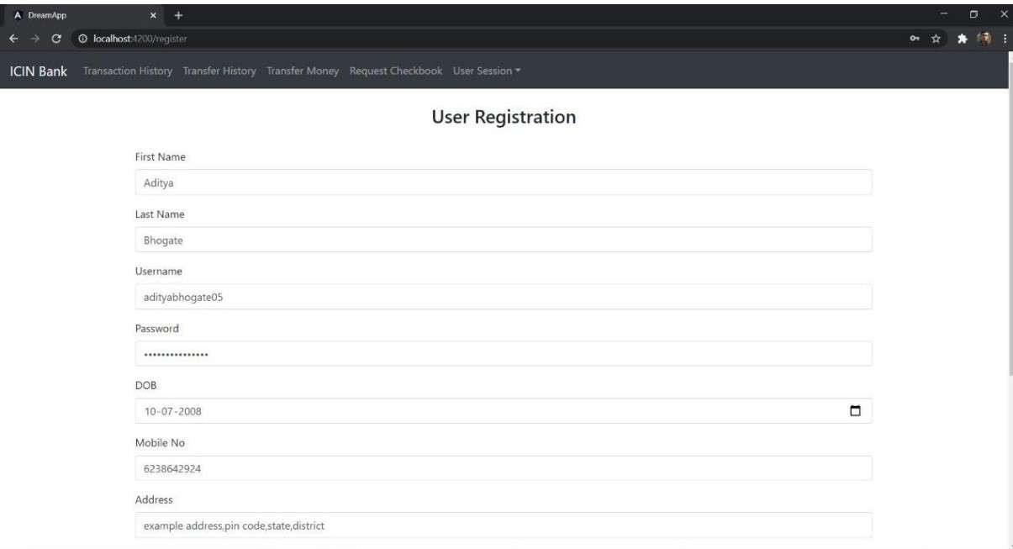

User Portal Description Features:

1) Registration:

The registration is the first step to get started with the application. The user will have to enter his first name, last name, email, phone number, address, username, password, date of birth, and an select an identity card (Aadhaar card, pan card or voters id) and enter its number and the scanned copy of the identity provided. If the username given by the user is checked for duplication in the database if a similar username exists then he or she will have to register with a new username. On registration the user information is passed on to the admin for verification. Once the admin verifies an email will be send to the user that his/her account is activated and a primary and saving account is created for the user

Pass o'rd

\0 07 - 2008 o

fvtobile No

62i8642324

Address

example address,p‹n code,staTe,di*Et ict



Upload yeur Id proof copy



En:er Id Proof eg:

0H8C63

Emir I



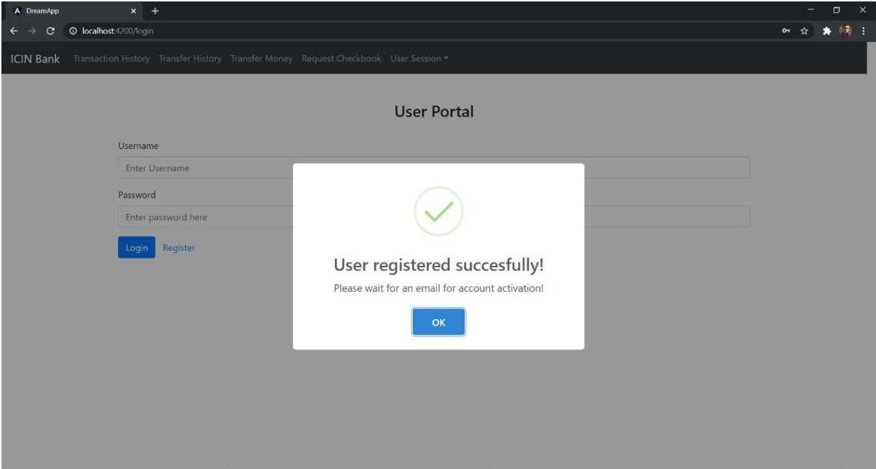

2)Login:

The user can login with the username and password that he had provided on registration after the

admin authorizes his account. The admin can also enable or disable the account. So, for successful

login the user has to enter correct username, correct password and the user has to be authorized

and enabled by the admin

User Portal



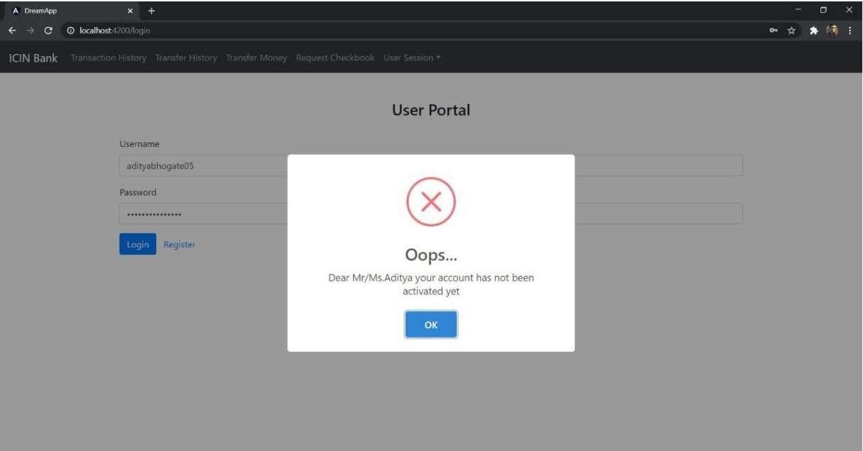



Welcome to lClN Bank

We offer ynu actions ltke Transfer of money, Cheehbook request, Deposit, Withdraw

Happy thanking !!!

Your Savings Account number: 391491820226

Your Savings Account balance : 44100

On successful login we are navigated to the home page.

3)Deposit:

The user can deposit money in his/her accounts by entering the correct account number and the

amount if the feature is enabled by the admin.

4)Withdraw:

The user can withdraw money from his/her accounts by entering the account number and the

amount if the feature is enabled by the admin. The operation won’t go through if the amount to be

withdrawn is more than the users account balance.

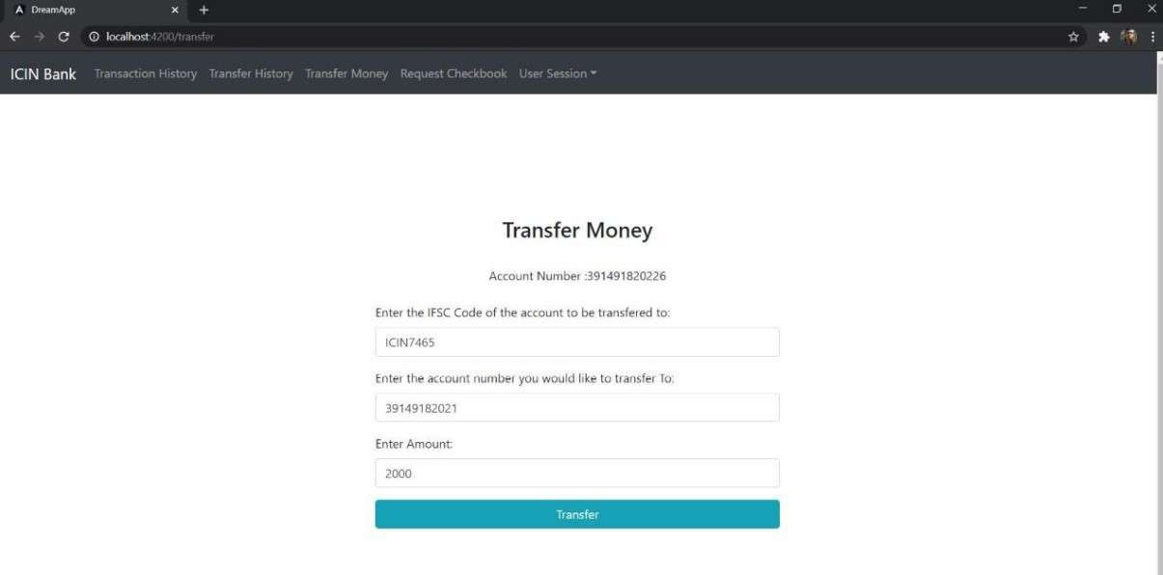

5)Transfer:

The user can transfer money from his/her accountsto other accounts by entering the his/her account

number, the receivers account number, the IFSC code of the receivers account and the amount if

the feature is enabled by the admin. The operation won’t go through if the amount to be transferred

is more than the users account balance or the IFSC code of the receiver account is incorrect.

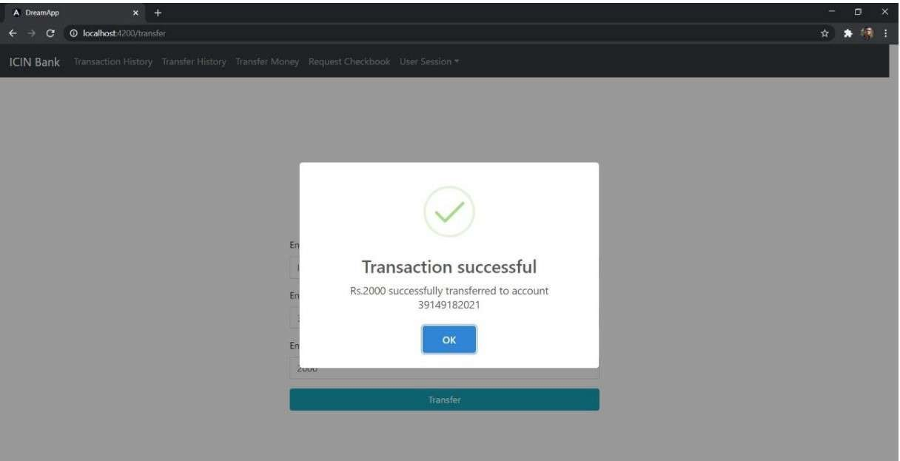

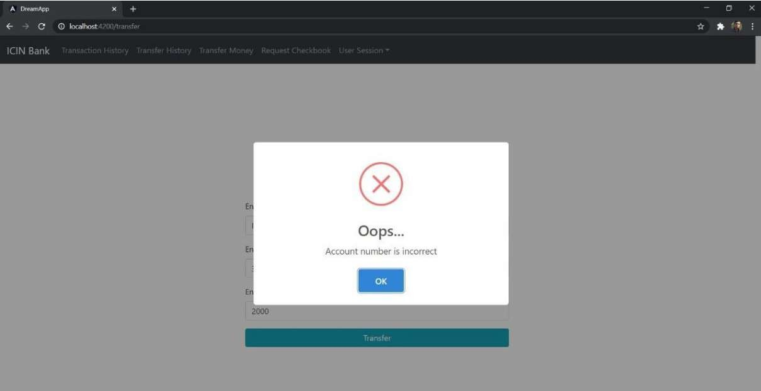

If the receivers account number is wrong.

If the IFSC code is incorrect.

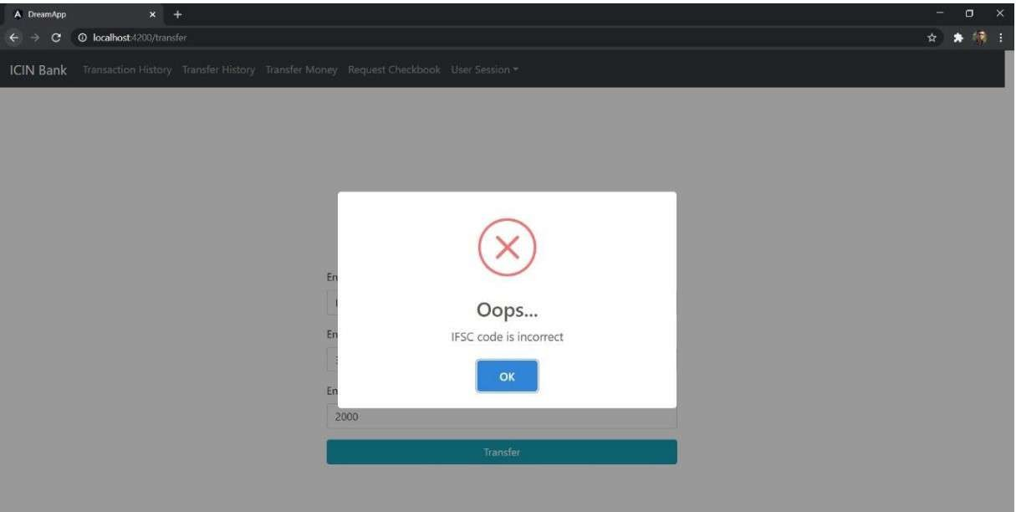

Transaction History



Type of account : Saving Saving balance : 44100 Account number : 391491820226

Date era nsac tion 1d

6)Transaction History

In the view transaction history section, you can view transactions for a particular account. Both

when money was deposited or withdrawn.

Ac t ion by pe



7)View Transfer History:

In the view transfer history section, you can view transfers for a particular account. Both when

money was transferred or received from the account will be displayed

    

|  |  |  |  |  |
| --- | --- | --- | --- | --- |
| 2020-08-18 |  | 85OD | 39J494820226 | 39149182021 |
| 202048-18 |  | 1S00 | 391491820226 | 39199182D21 |
| 2070-08-18 | 42 |  | 39J491 &20Z26 | 39149182021 |
| 2O2ÖQ8 18 |  |  |  |  |
| 2020-08-18 |  | T280 | 39J 491820Z26 | 39149182021 |
| 202O-OB.18 | 39 | 78O | 39ł 491820226 |  |
| 2020-08-18 | 38 | Rao | 39J49J B20226 | 39149J8202J |
| 2020-08- i8 | 37 |  | 391491820226 | 39149182021 |
| žO20-0818 | 36 | 20CD |  | 39149182021 |

8)Cheque Book Request:

The user can request cheque books for his/her accounts by entering the account number and

number of pages. Once admin accepts or rejects the request the user will get a mail

Request Cheque Book



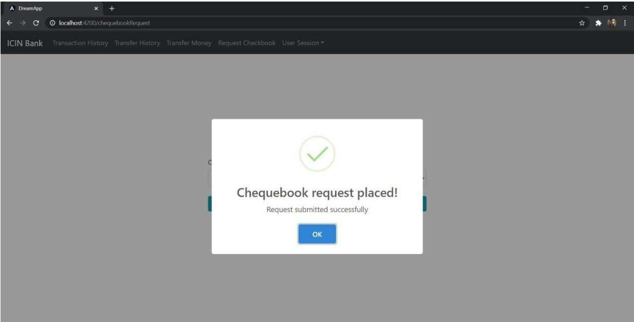

9) Update User:

The user can update some of his details with this function. The user can reset his password by

entering the new password and the correct old password. The user only has to enter the fields that

he wants to update.



Edit Profile

Entrr Phone here

Enter your Address

E«te‹emaJ he+e

evious Password Enter Password heie

Enter email here



Edit Profile





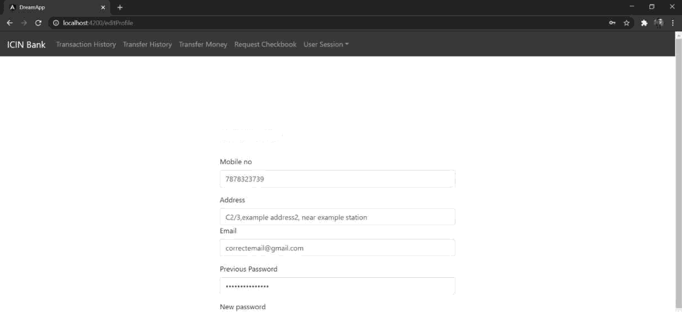

Edit Profile





