Learner’s Academy Specification Document

Project Detail
Project Name: Learner’s Academy
Project Version: 1.0
GitHub repository link:
https://github.com/shraddha-harshal/Learners_Academy

Project Details: This project is for the design and developing a backend administrative portal for the Learner’s Academy using Java EE technologies
Objective: The Objective of this project is to apply servlet, jsp and JDBC concepts.

Developer Detail
Name: Shraddha Harshal Ganbote
Simplilearn user ID: ishraddhahomkar@gmail.com
Batch: JG FSJD March 2023 COHORT 1

Technologies and tools Used:
- Servlet: to do the business logic and works a controller for the project.
- JSP: to handle the presentation view.
- SQL: to create and manage the database.
- JDBC: to make operations on the database for the project.
- CSS: to format the contents.
- Eclipse: to write and run the code.
- Tomcat: to run and deploy servlet application.

Flow Chart:
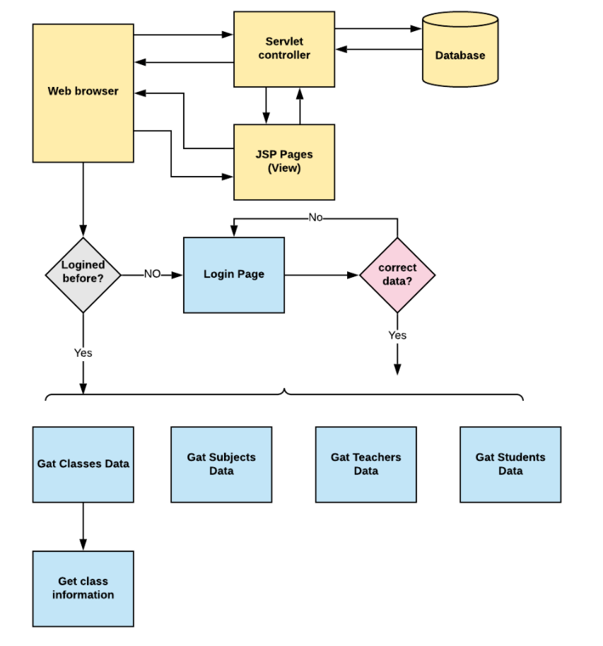

Sprint Plan:
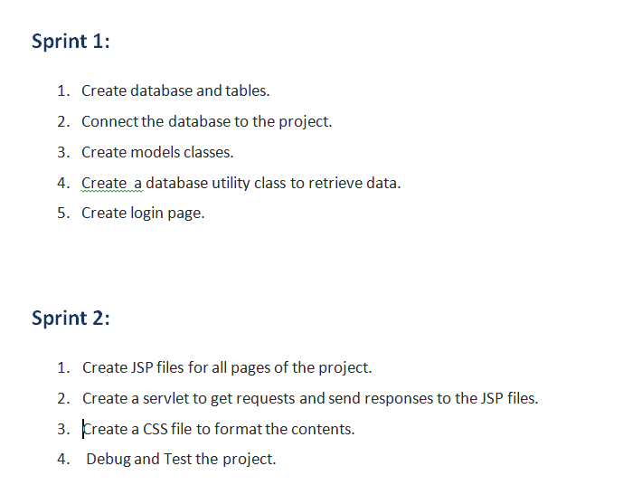
Concept used in this programme:
- Object-Oriented: used to create and model objects for users and their credentials.
- Databases: used to store and retrieve data.
- Data Sources: used to define a set of properties required to identify and access the database.
- Collections: used some collections such arraylist to store collection of data.
- Exception Handling: used to catch problems that arises in the code especially in I/O blocks.
- Cookies: to store log-in data on the client browser. Searching and Sorting

How to run the program:
- clone project
- Import the “database\database.sql” file to your database administration tool.
- Go to “\src\main\webapp\META-INF\context.xml” file and open it.
- Edit the database’ properties such as username, password and driverClassName to be suit to your database administration tool.
- Now run program on a server.
- To login you must enter admin for both username and password.

