G D @ https:,.’/us-east-1.console.aws.amazon.com,’console,‘home?r=.pion= us-east-J*

AWS Management Console

AWS services

s' Recently visited services

EC2

¥' All services

Stay connected to your AWS resources on-the-


AWS Console Mobile App now supports four additional regions. Download the AWS Console Mobile App to your iOS or Android mobile device. Learn more

Explore AWS

Build a solution
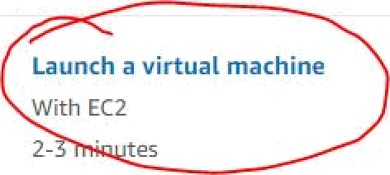Get started v+'ith s imp\e vv iza rds and autom ate d workflows.

Launch a virtual machine With EC2
tes


BuiId a web app With Elastic Beanstalk G minutes

Build using virtual servers With Lightsail

J -2 minutes

Reg ister a domain With Route 53

Z minutes

Modernize Your APls with GraphQL
AWS App5ync is a fully-managed GraphQL service that improves app performance and developer productivity. Learn moi e

AWS Backup
C entratty manage and automate backups across AWS services. Lea i n more

Connect an loT device With AWS loT
5 minutes


¥ See more

Start migrating to AWS With AWS MGN
1-2 minutes



Start a development p• i ect With CodeStar
5 minutes
a°
b

Deploy a serverless microservice
With Lambda, API Gateway
2 minutes


AWS Certification
Discover the top 7 reasons to get AWS Certified. Learn more

Announcing Incident Manager from AWS Systems Manager
Respond faster to application issues using new incident response and analysis capabilities. Learn more

Have feedback?

1. Choase ATigI 2 Choose Instance Type 3. Configure Instance 4. Add Storage S Add Tags 6. Configure Security Gfoup 7. Review

3tep 1: Choose an Amazon Machine Image (AMI)
\n AMI ls a templaæ that contains the software œnfiguration (operating system, application server, and applications) required to lannch your instanœ. You can select an AMI provîded by AWS, our user œmmunity, or the AWS Marketplaæ; or you can select one of your own AMls.

CanoeT and Exit

Q Search for an AMI by entering a search tern e.g. 'Windows"

x
Search by Systems tdaræger paranieter

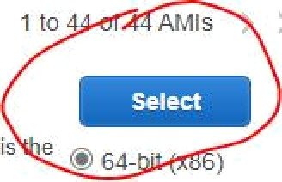{X
1 to
AMls
II
is e
.
t

Mÿ'AMîs

AWS Marketplace


Arrazon Linu
Amazon Linux 2 AMI (HVM), SSD Volume Type - ami-0d5e 40b45e9 (64-bit x86) / ami-09dt9e919d57453f8 (64bit Arm)

Amazon Linux 2 comes with five years suppoit. It provides Lin met 4.14 tuned for optimal performance on Amazon EC2, systemd 219, GCC 7.3, Glibc 2.26, Binutils 2.29.1, and the tatest software pact‹ages through extras. This AMI
ccessor of the Amazon Linux AMI that is approach” of life on December 31, 2020 and has been removed from thus WEU. o -bit (Arm)

O Free tier Œllÿ
macos Big Sur11s — ami-0459d6b36df3c5ba5

The macos Big SurAMl is an EBS-backed, AWS-supported image. This AMI indudes the AWS Command Line Interface, Command Line Tools for Xade, Amazon SSM Agent, and Homebrew, The AWS Homebrew Tap indudes the latest versions of multiple AWS packages induded in the AMI.
Root deviœ ttj css Virtuaizzton type: tvm C:NA Cnabm. Yes


64-bit (Mac)


macos Catalina 10.15.7 - ami-04c57fb416ca98499

The macos Catalina AMI is an EBS-backed, AWS-supported image. This AMI includes the AWS Command Line Interface, Command Lk-›e Tools for Xcode, Amazon SSM Agent, and Homebrew The AWS Homebrew Tap includes the latest 64-bit (Mac) versions of multiple AW5 packages induded in the AMI.

Roo4deuœ .ebs VñuaEze#ontype:üvm EMAEnaNed.Yes


Red Hat

macOS gojave 10.IJ.6 — ami-075723d78cedf20bô

The macos I\4ojave AMI is an EBS-backed, AWS-supported image This AMI indudes the AWS Command Line Interface, Command Line Toob lor Xoode, Amazon SSM Agent and Homebrew. The AWS Homebrew Tap indudes the latest versions of multiple AWS packages included in the AMI.

Red Hat Enterprise Linux 8 (HVM), SSD Volume Type - ami-0b0af3577fe5e3532 (64-blt x86) / arrii-01fc429821bf1f4b4 (64-bit Arm) Red Hat Enterprise Linux version 8 (HVM), EBS General Purpose (SSD) Volume Type


64-bit (Mac)

8e!ect
@ 64-bit [x86) O 64-bit (Arm)

1 Choose Ah1I 2 Choose Instance Type 3 Configure Instance 4 Add Storage S Add Tags 6.
Security G
7 Review
Step 6: Configure Security Group
A security group is a set of firewall rules that control the traffic for your instance On this page, you can a0d rules to allow specific traffic to reacft your instance For example. If you want to set up a web server and allow Internet traffic to reach your instance, add rules that allow unrestr!cted access to the
HTTP and HTTPS ports. You can create a new security group or select lYom an existing one below Learn more about Amazon EC2 security groups.
Assign a security group: O• Create a new security group
O Select an existing security group

Security group name: au w a 2

Description: au w a 2 reate 2021 0 0 T11 0 0 1 5 05 30

 Protocol !

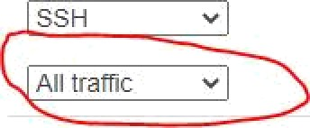TCP
SSH

All traffic •

All

Port Range i/

22
0 - 65535



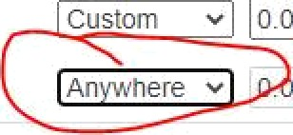0 0 0 e g S H o A i De o @
Custom 0

An here •

0 0/0, :/0 e g S H fo i De o @

Add Rule
& Warning
Rules with source of 0 0 0.0/0 allow all IP addresses to access your instance We recommend setting security group rules to allow access from Known IP addresses only.


Cancel Previous

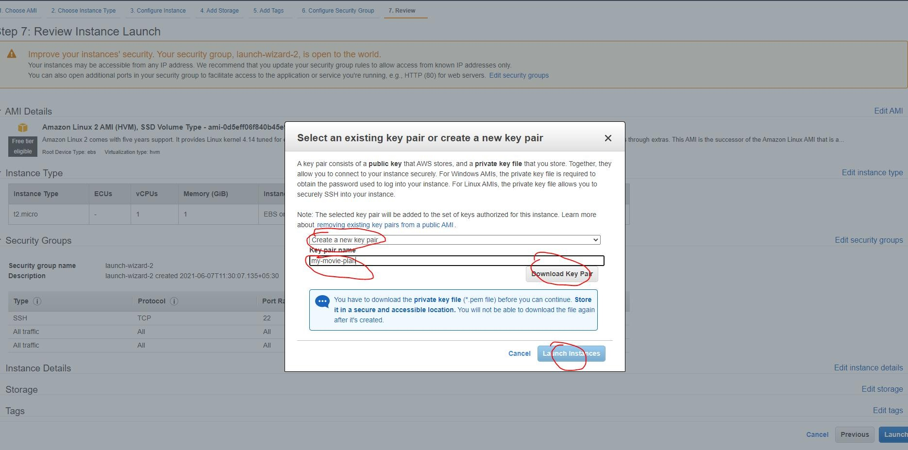

G D @ https:,’/’consoie.aws.amazon.com/’ec2.’v2,‘home*regioiz=us-eas -1é instai›ces:iiastancestate = rvi‹J‹Jina
- B O fB o C. O $ &

New EC2 Experience X
EC2 Dashboard ‹'.

Events

Instances (1/1) inio

1
Instance state '
” ec’t

Instance state: running X |  | Clear filters

Tags

@ Name

9 1 nstance 1 D

1 nstai state 9 1 nstance type 9 Stalus cbec k

Alarm status

Availability Zone 9 Public lPv4 DNS

9 Public lPv4 ... 9 Elastic IP

Limits

- 1 nsl ances Instances . .. Instance Types Launch Templates Spot Requests Savings Plans
Reserved Instances .. Dedicated Hosts Scheduled Instances Capacity Reservations

AMls

r Elastic Block Store

Volumes Snapshots
Lifec ycle Manager

8 Network & Security

i-0b18d 5979f15 8b1 I

Rune GtQ- t2.micro

No alarms -|- us-east—Id

ec2-3—87-23-8.compute... Z.87.2Z.8

G D @ https://console.aws.amazon.com/ec2,’v2/home?regioi*=us-east- JéConnectToInstance:instanceId=i-0e19201d262ba77e5

EC2 }› Instances i-0e 19201 d262ba77 e5 Connect to instance

Connect to instance Info
Connect to your instance i-De T 9201dZ 6 2ba77e 5 using any of these options

EC2 Instance Connect Session Manager SSH client EC2 5eriaL Console

Instance ID
@ i-0e 9201 d262da 77e 5
- Open an SSH client.

Locate your private key file. The key used to taunch this instance is my-movie-plan.pem
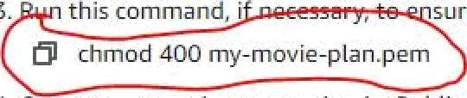
- this command, i , sure your key is not publicly viewable. @ chmod 400 my—movie—ptan.pem
- Connect to yoLtr instance using its Public ONS:
Note: In mos
uessed user name is correct. However, read your A
ge instructions to check if
the AMI owner has changed I e e.
ec2—52-7- T Z4-66.compute-1.amaz
l"jl ssh -i ”my-movie-plan.pem" ec2-Liser@ec2-52-7-1 54-66.compute-1.amazonaws.com

s s h — i •my —•ov ź e— pł an . pe• ec2— usera ec2—52— T—I 3• —66 . c o• puI e—I . as az onaw s . c o•
hłł ps i //aw s . anaz on . c or /aøaz on— ł ź nuE—2/

s s h -ź my -• ov źe-p ł an . pe• ec2-us en ec2-5 2-T - I 3• -6 6 . c o• puI e- I . aøazonaw s . c o•

iłł ps : //aws . aøazon . c oø/aøazon—ł î nus—2/

--› Pack age ec 2- ut ż As . noarch 0 : T . 2- uu . amz n2 r żI I be an upd ate

——• Pack age gTżbc—aTT—Tangpacks. :86 6fi 8 : 2.26—fifi . amzn2 ażTT be updat ed

p en Jdu ver s T on " T . 8 . 0 282 "
ac kage 1: q ava—1 . 8 . 0—open j dh—1 . 8 . 0 . 282 . b08—1 . ar zn 2 . 0 . 1 . x86 6fl adread y 1us t at I ed an d I ates t vers ?on
pen y dk vets hon • T . 8. 0 282 •
penuDN Run time Env î r <nnent c build I . 8.0 282— D08

Loaded pt ugIn s : ex tras s ug ges t Ton s , Can gpacks , pr T or TJ Yes , update —r Ltd
Pac ka9 e r aven —3 0 5—17 ar zn 2 . n oar ct aI rea id á. z I aí î ed an r1 I ades t verb i on
uava i <r e : us r/Web/t vr it ava —I 8 0— open dk—I 8 0 282. b08—I a zn 2 0 I x86 6s it re
05 nane " 1 znu x " , ver s zøn : " u . T fl 23—T T73 3 60 am zn 2 x 86 6 fl " , zr c T " am d 6 fl " , I am z1 y : " in zx "

——202d—0u —29 Of T2 56—— ht tps //pkg g enkin s zo/redha—I s table/Ț enkzn s . zepø
HTTP zer|ue s t s en t , ay+ad tin g ze s pin s e . 200 0s
lawng to : ’ lets/yur\ zepøs . d/Ț e nkTns zepø '

[ ec2— us erøTp —T72—3T—29—Tu 8 - ." s ud o zprl —— Tr pot t h ttps //pkg . enkan s . zo/redh a—t | s table/§enken s To key
Loaded plugIn s : ex tras s ugg es than s , 1 an gpacks , pzzor T t T es , \ pd ate —r Ltd
 | 3 . T | k B | 0 0 0 0 . 0 0
enkin s | Ț 2 . 9 | k B | 0 0 Ö 0 0 0
 | 3 T | k B | 0 0 : 0 0 0 0

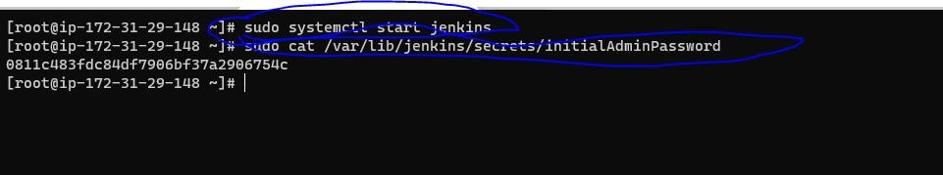

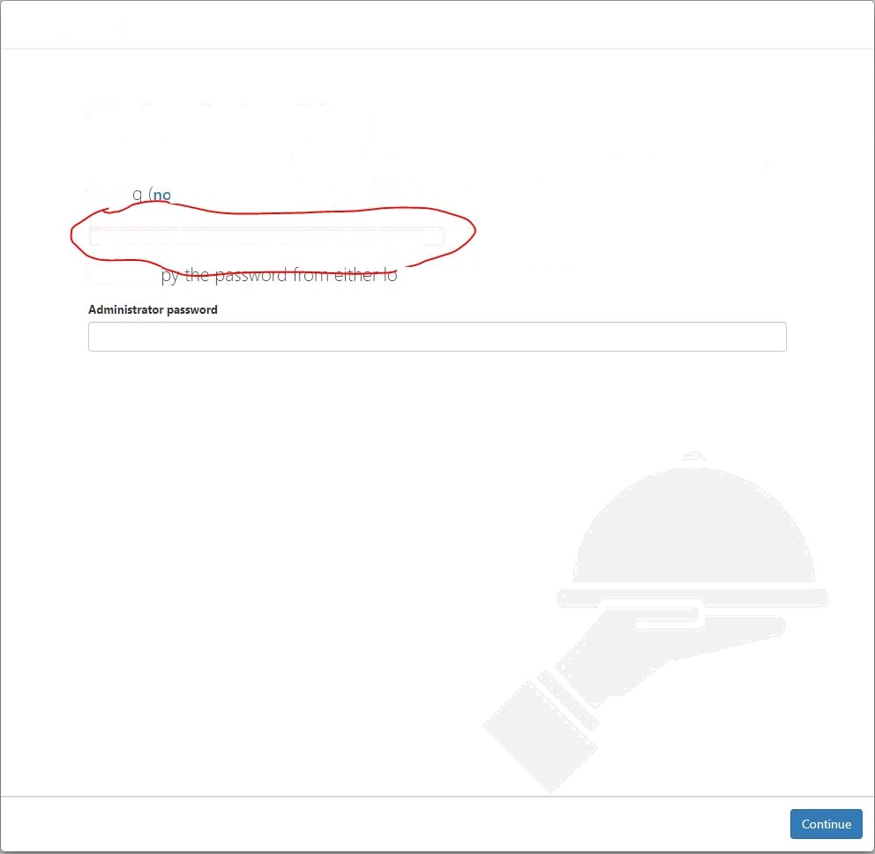
@ Not secure | 52. 7.134.66:8080/login?from=9é2F 

Getting Started

Unlock Jenkins

To ensure Jenkins is securely set up by the administrator, a oassword has been written to

the Io .t sure where to find it?) and this file on the server:

/van/1ib/j enkln s/ s ec nets/in iti a1Adm1nPa s swand

Please co Ation and paste it below.

@ Not secure | 52.7.134.66:8080

Getting Started

Customize Jenkins
Plugins ecend Jenkins with additional features to support many different needs.

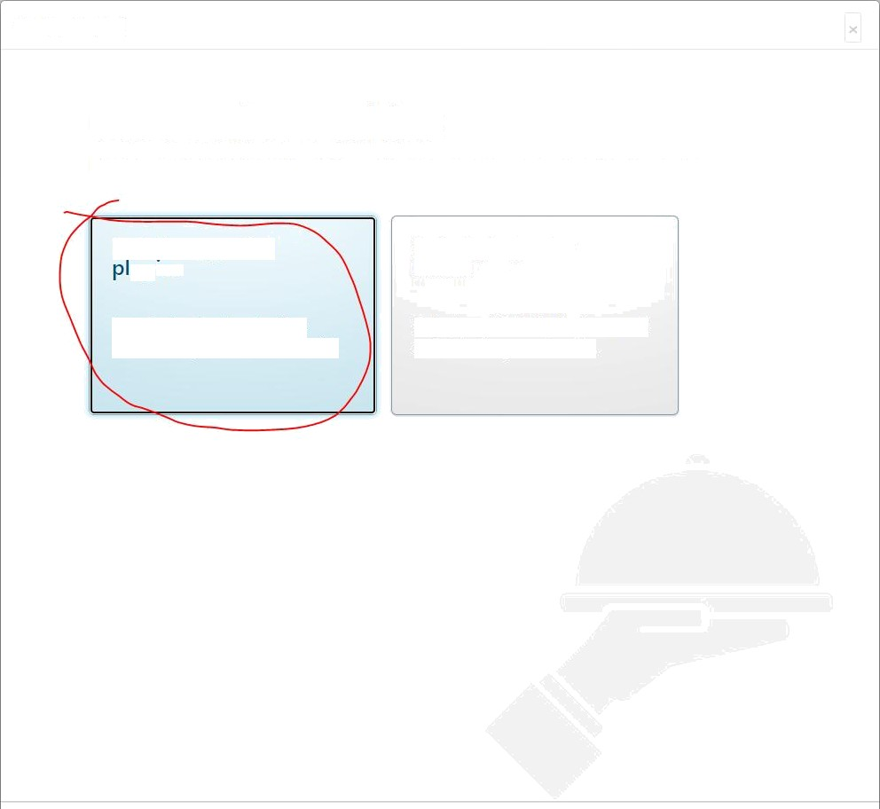
Install suggested

”ugins

Install plugins the Jenkins community finds most useful.

Select plugins to install

Select and install plugins most suitable for your needs.

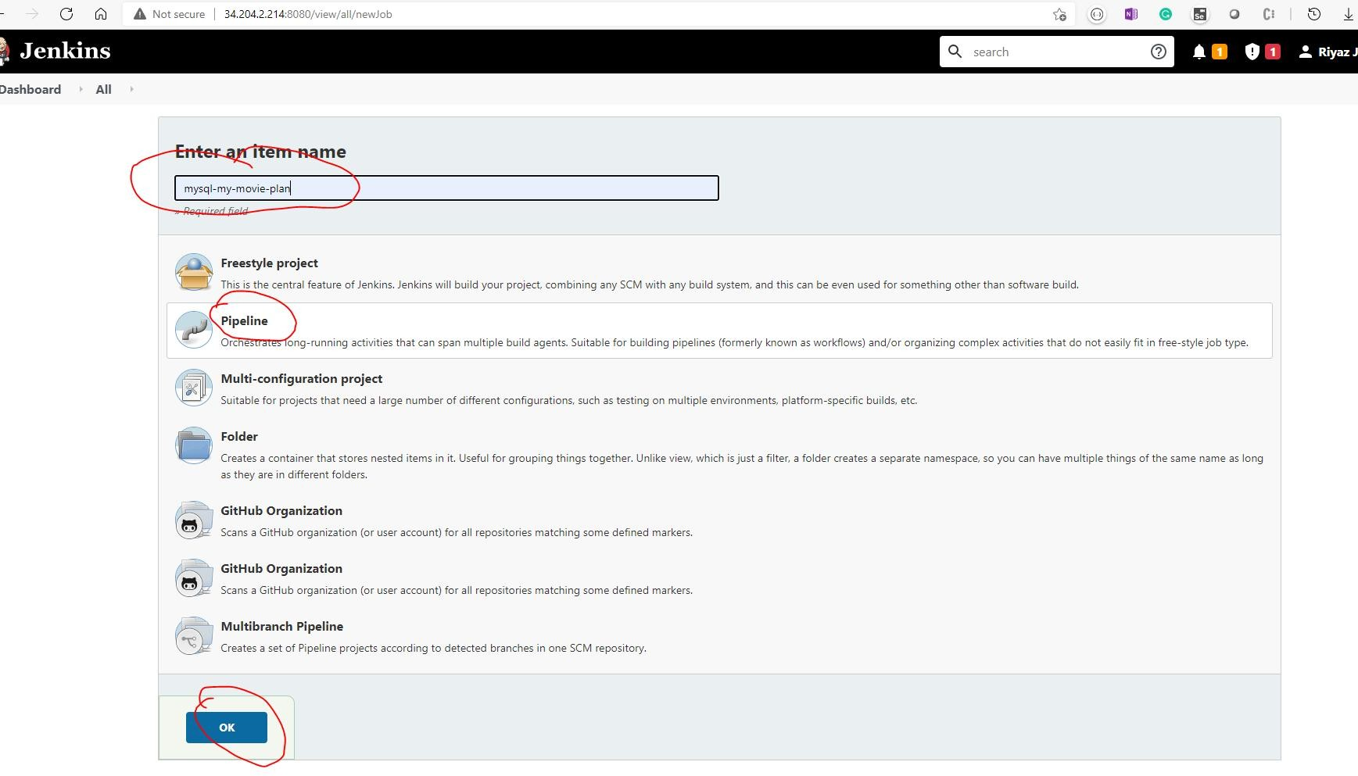

 |  | avaż T adT e | [ | =st adT e ğ
 |  | av adT ab T e | [ | =stabTe ğ
 |  | availab1e | [ | =s table
 |  | avaż T adT e | [ | =st adT e ğ
 |  | avaTI ab1 e | [ | =s table
S6 | we d Ż s 6
ee2— usera źp—1T2—31—86—8 - Ș $
ee 2— user$ źp—1T2—31—86—0 - Ș $

u7 aws - nżt ro -e nc 1 a yes - c1ż avaî1ad ł e [ =s t ad1e
avaII ab1e [ =s table
0 9 keen ed—5 . u ava Stable [ =s table
avaîI ad1e t =s t adI e 2
av adI abI e [ =s table
avaż ł ad ł e ț -s *ad ł e Ș
ec 2-usen ż-p T T 2-3 T -8 6- B d $ smdo is ermod -a -G dock er ec 2-iser

G R @ Not secure | 52.7.134.66:8080/\’iew/all/n=.\'.''ob
search

board All

: e O B O M e C! O


Ent
name
my-movie-plan-backend


Freestyle project
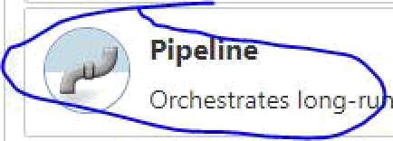This is the central feature of Jenkins. Jenkins will br/iId your project, combining any SCM with any build system, and this can be even Used for something other than software build

Pipe me
Orchestrates long-r

ning activities that can span multiple doild agents. Suitable for building pipelines (formerly known as workflows) and/or organizing complex activities that do not easily fit in free-style job type

Multi-configuration project
Suitable fof projects that need a large number of different configurations, such as testing on multiple environments, platform-specific builds, etc.


Folder
Creates a container that stores nested items in it. Useful for grouping thinps together. Unlike view, which is just a filter, a folder creates a separate namespace, so you can have multipie things of the same name as long as they are in different folders.

' GitHub Organization
 Scans a GitHub organization (or user account) for all repositories matching some defined markers.


Multibranch Pipeline
Creates a set of Pipeline projects according to detected branches in one SCM repository.

If you want to create a new item from other existing, you can use this option:


Copy from Type to autocomplete

o

G D M Not secure | 34.204.2.214:SfiG0,jc b/my-iro\’ie-pIai -backend, config‹i re

hboard my-movie-plan-backend

General Build Triggers Advanced Project Options

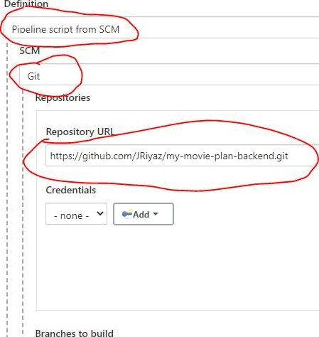

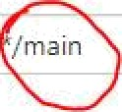Branch Specifies (blank for 'any’)

/main
â O B O 8B O C. $




dd o

e e




Repository browser
; ; Additional Behaviours

- e

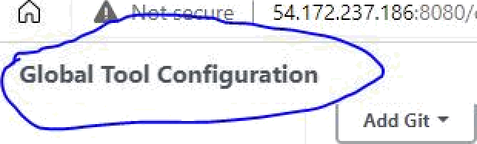 54.172.237.186:8080/configureTools/

Dashboard › Global Tool Configuration

Gradle


Gradle installations
List of BradIe installations on this system

Ant
Ant installations

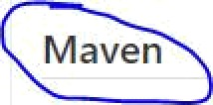List of Ant installations on this system
Maven
Maven installations


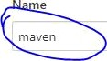
-. - Maven


/usr/share/mave/
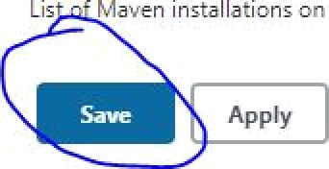
1 sta y


Lis Maven installations on this system

G 0 @ Not secure | 54.172.237.186:8080/’‘ ie’.\’/’aII,’ne’.'.'Job


Jenkins

¥shboard All ^

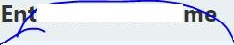
ean item na
y-mov”ie-plan-backend

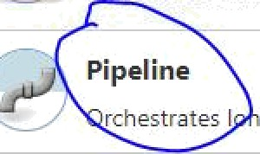Freestyle project
— This is the central feature of Jenkins. Jenkins will build your project. comdini ng any SCM with any build system, and this can be even used for something other than software build.

Pipeline
’ ’ rchestrates I g-runni ng activities that ca n span multiple bu ild agents. Suitable for building pipelines (formerly known as workflows) and/or organizing complex activities that do not easily fit in free-style job type.

f
% Siz able o pro e s that nee d a large num ber of different configurations, such as testing on multipl=. environments, platform-specific builds, etc.

Field s a container that stores nested items in it. Useful for grouping thinps together. Unlike view, which is just a filter, a folder creates a separate namespace, so you can have m ultiple things of the same name as long " as they are in ¢lifferent folders.


GitHub Organization
Scans a GitHu b organization (or user account) for aJl repositories matching some defined markers.

t ’ Multibranch fiipeline
Creates a set of Pipeline projects according to detected branches in one SCM repository.

If you want to create a new item from other existing, you can use this option:

I i Copy from Type to autocomplete

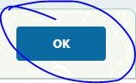

Dashboard my-movie-plan-backend
0 Preserve stashes from completed builds  This project is parameterized e
0 Throttle builds e
Build Triggers
@ BuiJd after other projects are built e
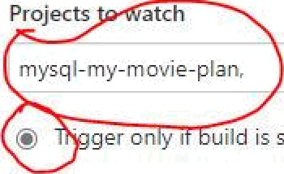
- Projects atch

' mysq I- my-m ovie-plan,

- O• s t on y i ui ld is st able

' Trigger even if the buiId is unstable ' , Trigger even if the build faiIs
0 Build periodic ally GitHub hook trigger for GlTScm polling e
@ Poll SCM e
0 Disable this project Quiet period e
0 Trigger builds remotely (e.g., from scripts) e
Advanced Project Options


Pipeline
Definition


Pipeline scri pt from SCM

› SCM


, Git

Repositories

NMS Cinemas °

RRR
., Telugu l War Romance Action Fantasy | 2021

NOW PLAYING

NMS Cinemas
Login Page

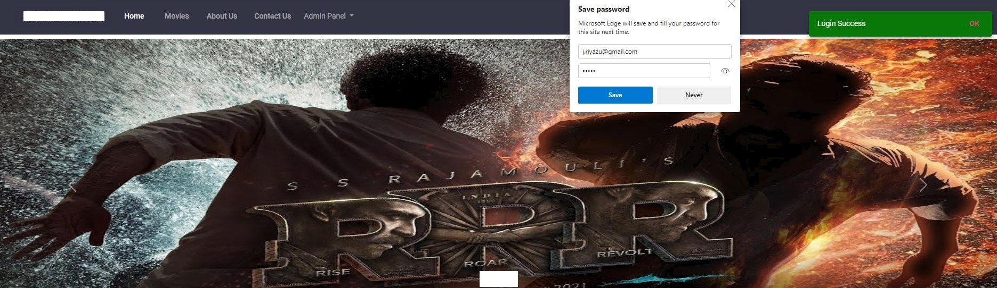
NMS Cinemas
RRR
. Telugu l War Romance Action Fantasy | 2021

NOW PLAYING


NMS Cinemas Reøisier


Register Here

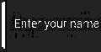 |  | 


NMS Cinemas

Cinema Halls
Shows

INOX
Morning Show Time: J1:00 AM

PVR

GOPALAN GRAND MALL
Matinee

Time: 02:00 PM


Time: 0ó:00 PM






NMS Cinemas

Email
Mobile 8099531318
Male

NMS Cinemas ° °

SHOW

Search for movie, genre or language

No \ Play ing

u oø' PIayîng

Now Playing ”

FILTERS

v Language

v Genre
Clear

Clear

RRR RRR PUSHPA

NMS Cinemas






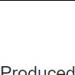
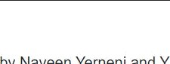


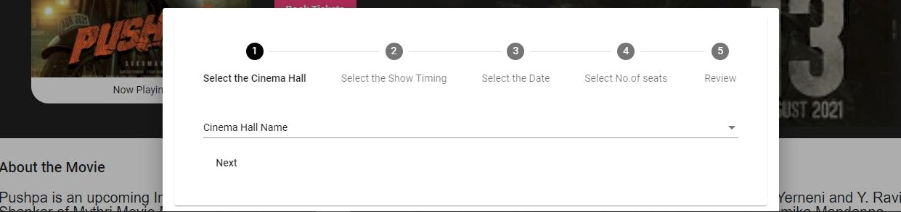

PUSHPA : Pushpa
2H 30M Crime. Action, Romance
W.

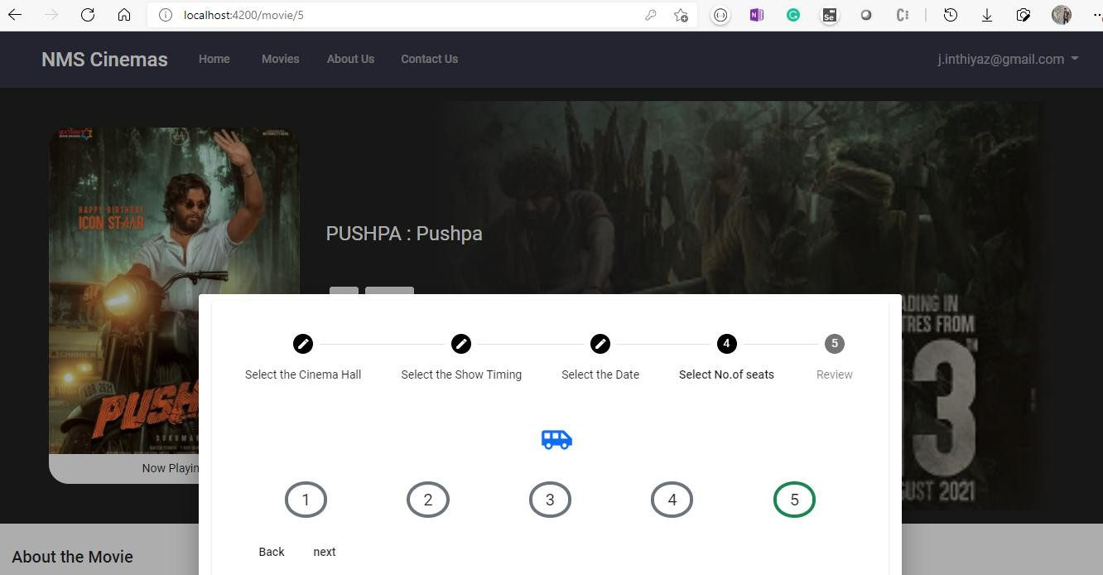

Payment Gateway (do not refresh the pape)

Auditorium

Show
Show Timing Movie Name Movie Lang Date
I¥iOX

16 digit card number
Card Number
Month | Year |  | CW 

Select cald expiry month


select card expiry year

Pay 72,200.00

100

Customer Care Number
Email Id

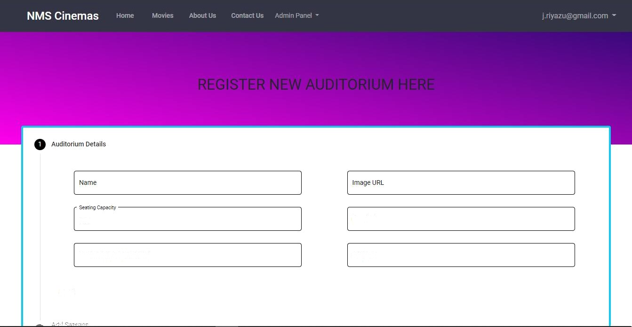
Address

Next

Name

Jmage URŁ

Add Language Add Cast Details

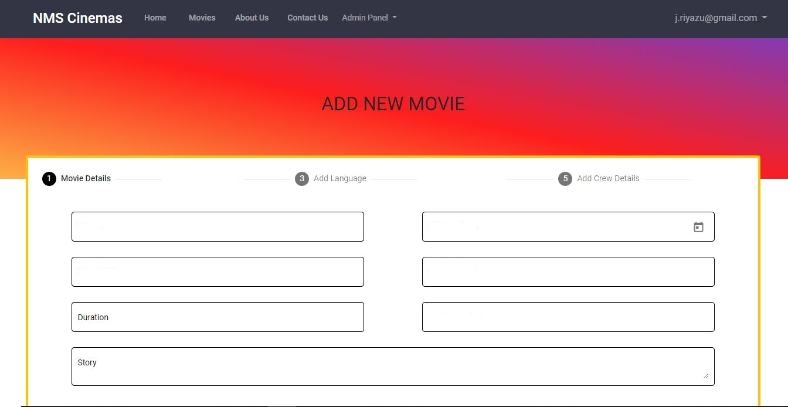
Release Date

Background lmage URL

Movie Caption

Review



Screen
way

NMS Cinemas

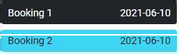Movie Language
Booking 1 202J 06-d 0

1'
'

PUSH°A

Total seats

Seat NO.

Price
r.

Dete

TIme

INOX
Telugu
5
F4, F5, F6, F7, E5 T2,000.00
Jun 1 5, 2021
06:00 PM

NMS Cinemas




NMS Cinemas

Write to us by filling in the form below

Your Name

Email Id

Message
Contact Us

Big Tree Entertainment Private Limited Ground Floor, Wajeda House, @ Gulmahar Cross Road No. 7, Juhu Scheme, Mumbai, Maharashtra -
400049

@ nms@cinemas.com

1800-894-4059



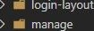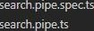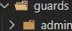< . a T c -s < . CHE K UNT QUE NE 5 5 URL = ' G1 a 6 a 1 Ca n st a nI s . ROOT URL , u s e n ,’ c he c k ;

h fargoI-password h A header

- p. c .

—s e UPDAY E USE ft UR L = > ’ G 1 a6 a L? ansI a n !z s . ROOT UR L y us e i° y upd aI e ;

n T - - < . G ET LOGGE D ZN USER UftL = G1 aba 1 C an sI anI s . RODC UftL / usen/ ge I- usen ;

a ú T c -s < . UNZgUE USE ft UR L = ’ G La6 a LŁ ansI a n Iz s . ROOT UR L ’ u s e n / c he c k ;

h Œ regis ter
h G temp! a Yes

n ú T - - < . DE LE T E AUDS TOR Œ US URL = î ’ G1 a 6a 1 C on s I a n Ł s . ROOT U RL /’ a uń t I a n żu in / fl e Le!z e ;

