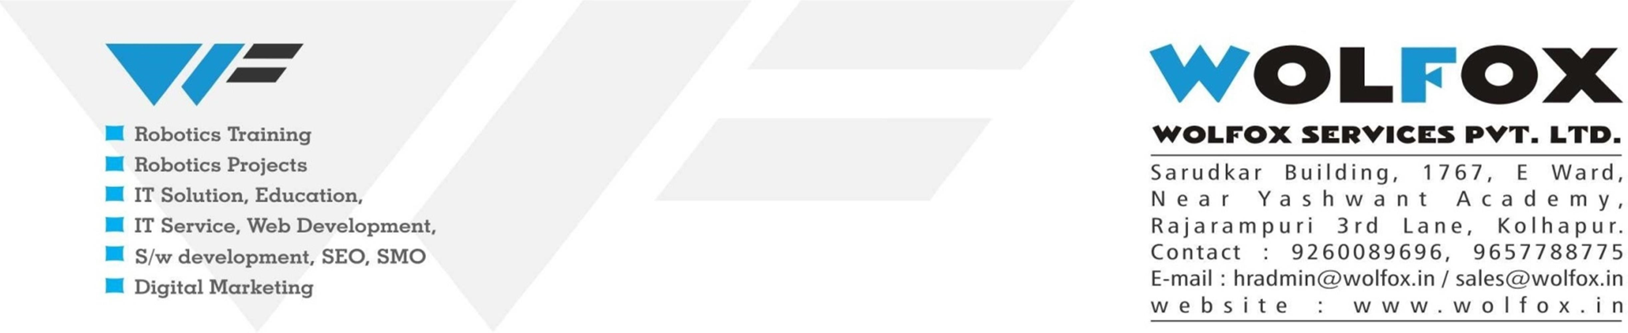
CIN - U80904PN2017PTC1701
Reg. No - 170185
1
Wolfox Services Pvt. Ltd.
1767, E Ward, Rajarampuri 3rd Lane, Kolhapur-416008, Maharashtra, India.
*Tel: 9657788775 * Email: admin@Wolfox.in * URL: www.Wolfox.in

Internship Joining Letter
Date: 12th DEC 2024
TO WHOM IT MAY CONCERN,
Re: Internship Joining Letter. Dear, Mulani Shahid Raju


We are pleased to offer you Internship opportunity at WOLFOX SERVICES PVT. LTD., Kolhapur in the Development Department. As we discussed, you will be scheduled to work approximately 8 (Eight) hours/day, and your internship will begin on 12th DEC 2024. If you accept this Internship offer, you will report all work status to [EMP-010] Bhagyashri S. Khot, CTO & Director (Chief Technical Officer).

Because of this is an Intern position, you may discontinue an Internship in between Internship periodat any time for any reason, only you are not able claim Internship completion or experience certificate from WOLFOX SERVICES PVT. LTD., And company may discontinue the Internship Period for any reason will not prohibited by law. There is no guarantee of continuous employment.

As an Intern Python Developer you will not be a company permanent employee. And you will notable to receive a salary, wages, or other compensation. In addition, you will be eligible for any of the employee benefits that company’s employees are entitled to, but you will not receive health insurance, vacation or sick leave, paid holidays, or any participation in company’s any financial plan.

During your Internship Period you may come across confidential business information. By accepting this internship opportunity offer, you acknowledge that you must adhere to our confidential policy. In addition, upon conclusion of your internship period, you must return all company-owned property, equipment, and documents, including electronic mail or other information.

If you have any questions about the terms of our offer outlined above, please contact us at (+91)9657788775 or admin@wolfox.in/hr@wolfox.in.

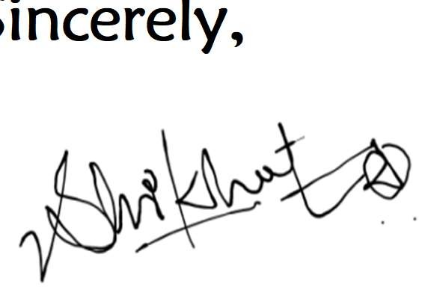
We are very excited about the prospect of you joining our team as an Intern Python Developer at WOLFOX! We look forward to helping you to achieve your expected career growth. To learn or know more about WOLFOX, please visit our website at www.Wolfox.in.
Sincerely,
Shridhar B. Khot, CEO & Director,
WOLFOX SERVICES PVT. LTD.
***My signature below indicates my acceptance of the offer as outlines above.
Mr. Mulani Shahid Raju 12/ 1 2 /2024
……………………………………………………………………… Name of Intern Signature of Intern Date of Signature
***Please return a signed copy via mail or deliver to office.

