- Core working steps of ApexaiQ
Discover:
ApexaiQ first finds all IT assets in the organization automatically and Scans the network (cloud + on-premise)
- Detects:
  - Devices (servers, laptops, routers, IoT)
  - Software & applications
  - Firmware and operating systems
- No agent installation needed (agentless discovery)
Categorize:
After discovery, ApexaiQ organizes assets into groups
Assets are categorized based on:
- Asset type (hardware, software, cloud resource)
- Business function (critical / non-critical)
- Owner or department
- Location
- Environment (production, testing, backup)
Quantify:
ApexaiQ measures the risk and health of each asset.
It calculates:
- Risk score
- Vulnerability severity
- End-of-life status
- Compliance gaps
- Exposure level
This converts raw data into numbers and scores.
Prioritize:
ApexaiQ decides what needs attention first.
Assets are ranked based on:
- Risk score
- Business impact
- Compliance importance
- Exploitability

Act
Take action to reduce risk.
Patch vulnerabilities
- Update or replace outdated assets
- Fix compliance issues
- Automate workflows
- Assign tasks to IT/security teams
Report
ApexaiQ generates clear reports and dashboards.
- Real-time dashboards
- Risk trend reports
- Compliance reports
- Executive-level summaries

How ApexaiQ works

1: Agentless Asset Discovery
ApexaiQ does NOT install agents on devices.
Instead, it:
- Connects with existing systems (network tools, cloud, IT tools)
- Uses APIs, integrations, network data
- Pulls information automatically
So it discovers:
- Laptops
- Servers
- Cloud assets
- Software
- Firmware
- Network devices
Result:
A complete inventory of “what exists” in the company
This already solves:
- Shadow IT
- Unknown devices
- Missing assets

Step 2: Understand Each Asset’s Health
Once assets are discovered, ApexaiQ checks:
- Is the software outdated?
- Is the OS supported?
- Are there known vulnerabilities?
- Is the device compliant with policies?
- Is it near End-of-Life or End-of-Support?
It compares asset data with:
- Vulnerability databases (like NVD)
- Compliance standards
- Vendor lifecycle info
Result:
Each asset gets context — not just raw data.

Step 3: ApexaiQ Risk Score (very important)
Instead of giving 1000 alerts, ApexaiQ calculates:
ApexaiQ Score
This score is based on:
- Vulnerabilities
- Obsolete software
- Missing patches
- Compliance gaps
- Asset criticality (Crown Jewels)
Higher score = higher risk
Lower score = healthier environment
Result:
Managers and security teams can understand risk in one number.

Step 4: Prioritization (What to fix first?)
Not all assets are equal.
Example:
- Printer vulnerability not urgent
- Database server vulnerability VERY urgent
ApexaiQ:
- Identifies Crown Jewel assets
- Tells you what to fix first
- Avoids alert fatigue
Result:
Teams work smart, not hard.

Step 5: Action & Automation
ApexaiQ doesn’t stop at “finding problems”.
It can:
- Trigger patching workflows
- Integrate with ITSM, SOAR, MSP tools
- Support auto-remediation
- Track fixes over time

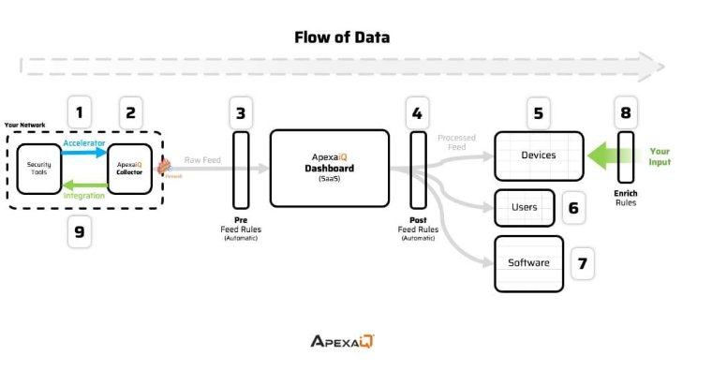
Security Tools: tools your company already uses for security (like firewalls, antivirus,
vulnerability scanners, SIEM systems).
Accelerator: like a scripts that run to get that data.
Collector: data collection engine inside your network.
: Agentless
:Sends the Raw Feed (uncleaned data)
Pre-Feed Rules (Automatic): Remove duplicate records, normalize device names,
remove unnecessary info.
Apexa iQ Dashboard (SaaS): Post-Feed Rules (automatic) are applied to clean,
categorize, and standardize the data further.
Then data gets stored on the inventory present on the dashboard of the ApexaiQ like
devices, users, softwares and so on
IMP NOTE : pre feed rules and post feed rules are only applied on raw data when it
initially comes to dashboard, but enrich rules(add custom rules to enhance the data)
are applied on proceed data at any time.
Integration → Sends processed data back into your existing tools
ApexaiQ Data Flow
ApexaiQ starts by connecting with security tools that the organization already uses, such as firewalls, antivirus software, vulnerability scanners, and SIEM systems. These tools generate security and asset-related data. The Accelerator, which works like scripts or connectors, enables fast, reliable, and secure integration between these security tools and the ApexaiQ platform. This data is then collected by the ApexaiQ Collector, which is an agentless data collection engine installed inside the organization’s network. The Collector gathers asset information and sends it as a Raw Feed (uncleaned data) to the ApexaiQ SaaS platform.
When the raw data first reaches the ApexaiQ dashboard, Pre-Feed Rules (automatic) are applied to remove duplicate records, normalize device and software names, and eliminate unnecessary or noisy information. After this, the data is processed inside the ApexaiQ Dashboard (SaaS), where Post-Feed Rules (automatic) further clean, categorize, and standardize the data and apply risk and compliance logic. Once processed, the data is stored in the ApexaiQ inventory and organized into structured views such as Devices, Users, and Software.
An important point is that Pre-Feed Rules and Post-Feed Rules are applied only once when raw data initially enters the dashboard, whereas Enrich Rules (custom rules added by the organization) can be applied at any time on already processed data to enhance context, such as business criticality or extended EOL status. Finally, through integrations, ApexaiQ can send the processed and enriched data back into existing security or IT tools, enabling automated actions and better decision-making.

Inbound vs Outbound Data in ApexaiQ (Easy Explanation)
Think of ApexaiQ as a two-way system:
- Inbound data → data coming into ApexaiQ
- Outbound data → data going out from ApexaiQ

ApexaiQ Dashboard – YouTube Video Learning Summary
From the YouTube video, I understood that the ApexaiQ dashboard is designed to give a quick, high-level view of the entire IT environment. At the top of the dashboard, three main sections are shown: Asset Summary, ApexaiQ Score, and Asset Hygiene.
Asset Summary provides an overview of all discovered assets in the organization, such as devices, users, and software. It helps teams quickly understand how many assets are present, their types, and their overall distribution across the environment.
Below the asset summary, the ApexaiQ Score represents the overall health and risk posture of the organization’s IT assets. This score is calculated by combining multiple factors such as vulnerabilities, compliance status, asset hygiene, and exposure. A higher ApexaiQ score indicates a more secure and well-managed environment, while a lower score highlights higher risk and the need for immediate attention.
Next, Asset Hygiene shows how clean, updated, and well-maintained the assets are. It focuses on preventive aspects such as patch status, end-of-life or extended EOL software, configuration issues, and known vulnerabilities. Good asset hygiene means systems are up to date and supported, whereas poor hygiene indicates outdated, vulnerable, or misconfigured assets. Together, these dashboard sections help organizations quickly assess asset health, prioritize actions, and improve overall security and compliance.

