Swiggy Sales Analysis Report

1. Project Overview
This project focuses on analyzing Swiggy food delivery data to uncover patterns in customer behavior, sales performance, and operational efficiency. The primary goal is to derive actionable insights that can help improve business decision-making, revenue growth, and customer satisfaction.

2. Objectives
- Understand customer ordering behavior
- Identify peak order times and demand patterns
- Analyze top-performing cities, restaurants, and categories
- Evaluate pricing impact on customer orders
- Study rating distribution to assess customer satisfaction

3. Tools & Technologies
- Excel: Data cleaning and preprocessing
- SQL: Data transformation, querying, and analysis

4. Data Cleaning & Preparation
- Removed null values from key columns such as State, City, Order_Date, Restaurant_Name
- Identified and corrected blank/empty values
- Detected duplicate records using GROUP BY
- Removed duplicates using ROW_NUMBER() to retain unique entries
- Ensured consistency in categorical fields (Category, Location)

5. Data Modeling (Star Schema)
Implemented a Star Schema to optimize analysis:
- Dimension Tables: Date, Location, Restaurant, Category, Dish
- Fact Table: Orders (Price, Rating, Rating_Count)
This structure improves query performance, reduces redundancy, and enhances reporting efficiency.

6. Key Performance Indicators (KPIs)
- Total Orders
- Total Revenue (INR)
- Average Order Value
- Average Rating

7. Key Insights
-Peak order activity is observed during evening hours (8 PM – 10 PM)
- Approximately 60–70% of orders fall within the ₹100–₹300 price range
- Indian and Chinese cuisines contribute the highest share of total orders
- Top-performing cities account for a significant portion of total revenue
- Higher-rated dishes show stronger customer preference and repeat demand

8. Business Analysis
Date-Based Analysis:
- Monthly and quarterly trends show demand fluctuations
Location-Based Analysis:
- Top-performing cities identified based on order volume
Food Performance:
- Popular dishes and categories identified
Customer Spending Analysis:
- Segmentation of customers based on spending ranges
Ratings Analysis:
- Distribution of ratings from 1 to 5 analyzed

ERD DIAGRAM: STAR SCHEMA

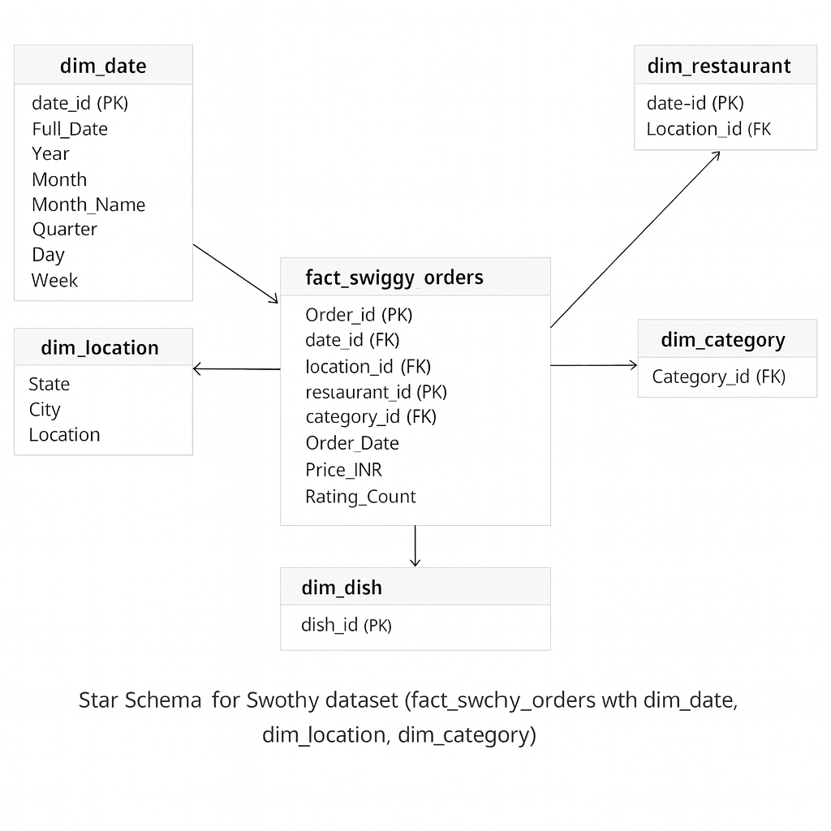

The Star Schema structure connects fact and dimension tables, enabling efficient querying and better analytical performance.

9. Conclusion
The analysis highlights key patterns in customer behavior, pricing trends, and demand distribution. These insights can help businesses optimize pricing strategies, improve customer experience, and focus on high-performing locations and categories.

