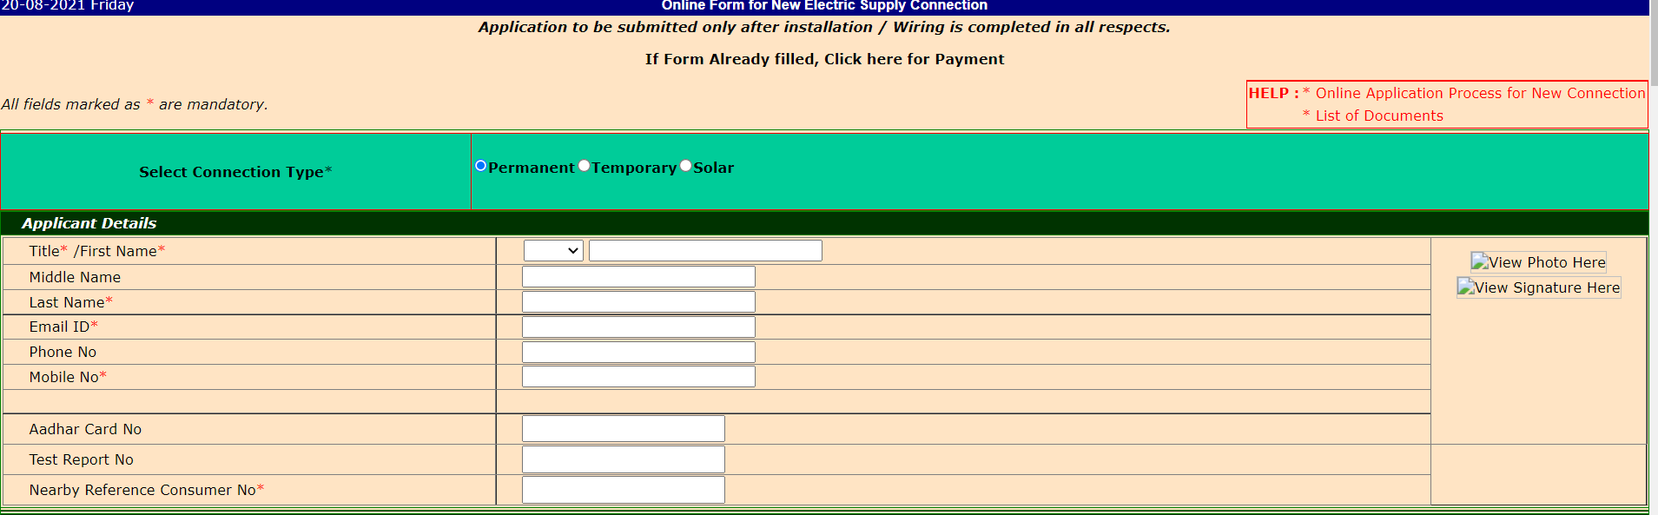
In above given screen-shot, “View Photo Here” and “View Signature Here” should be in different image box

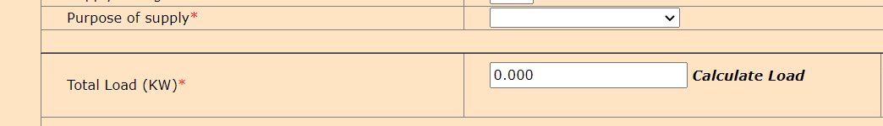
In “Total Load (KW)” when “0.000” is removed and clicked on side, page gets reload and below error is shown
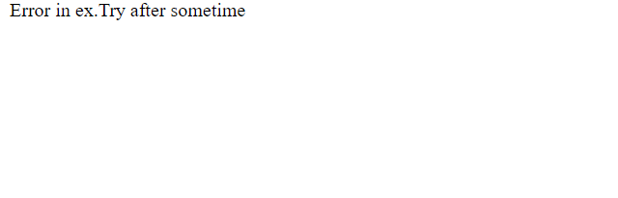

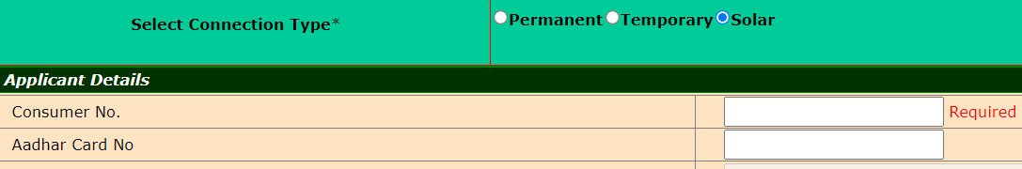
In above given screen-shot, for “Customer No.” is required field but for it starred mark is not given

