**Module 1_SQL**

**HEALTHCARE DOMAIN:**

**NORMALIZATION:**

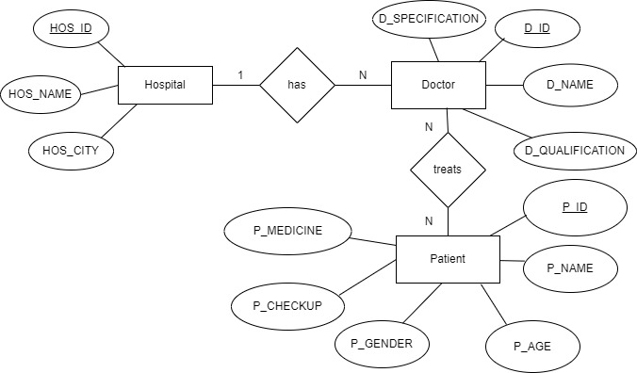

**TABLE HOSPITAL**

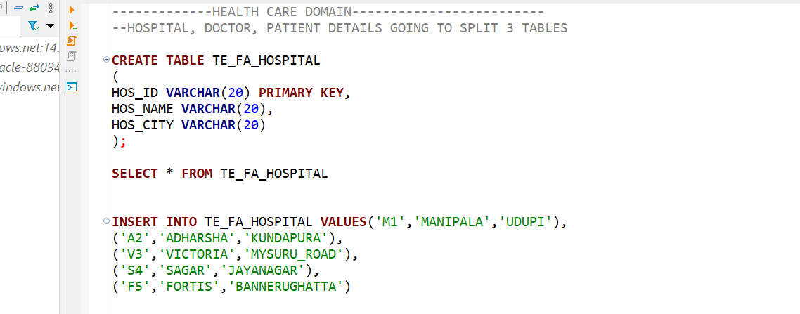

**TABLE DOCT**

**TABLE PATIENT**

**JOIN**

**INNER**

**FULL JOIN**

**LEFT JOIN**

**RIGHT JOIN**

**VIEWS:**

**COMMANDS: DDL,DML**

**USING ANOTHER DATA SOURCE CINEMA**



