**MODULE 2**

**SCD TYPE 1**

**EXCEL TO FLAT LOAN TABLE**

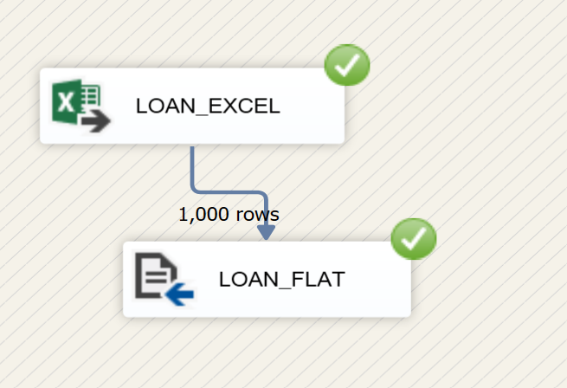

**FLAT TO DB**

**SCD TYPE 1**

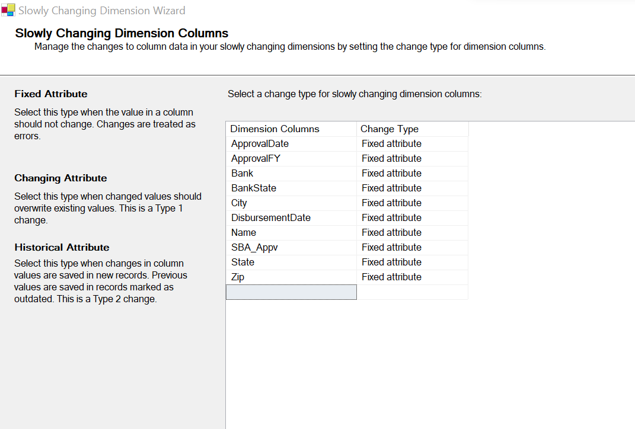

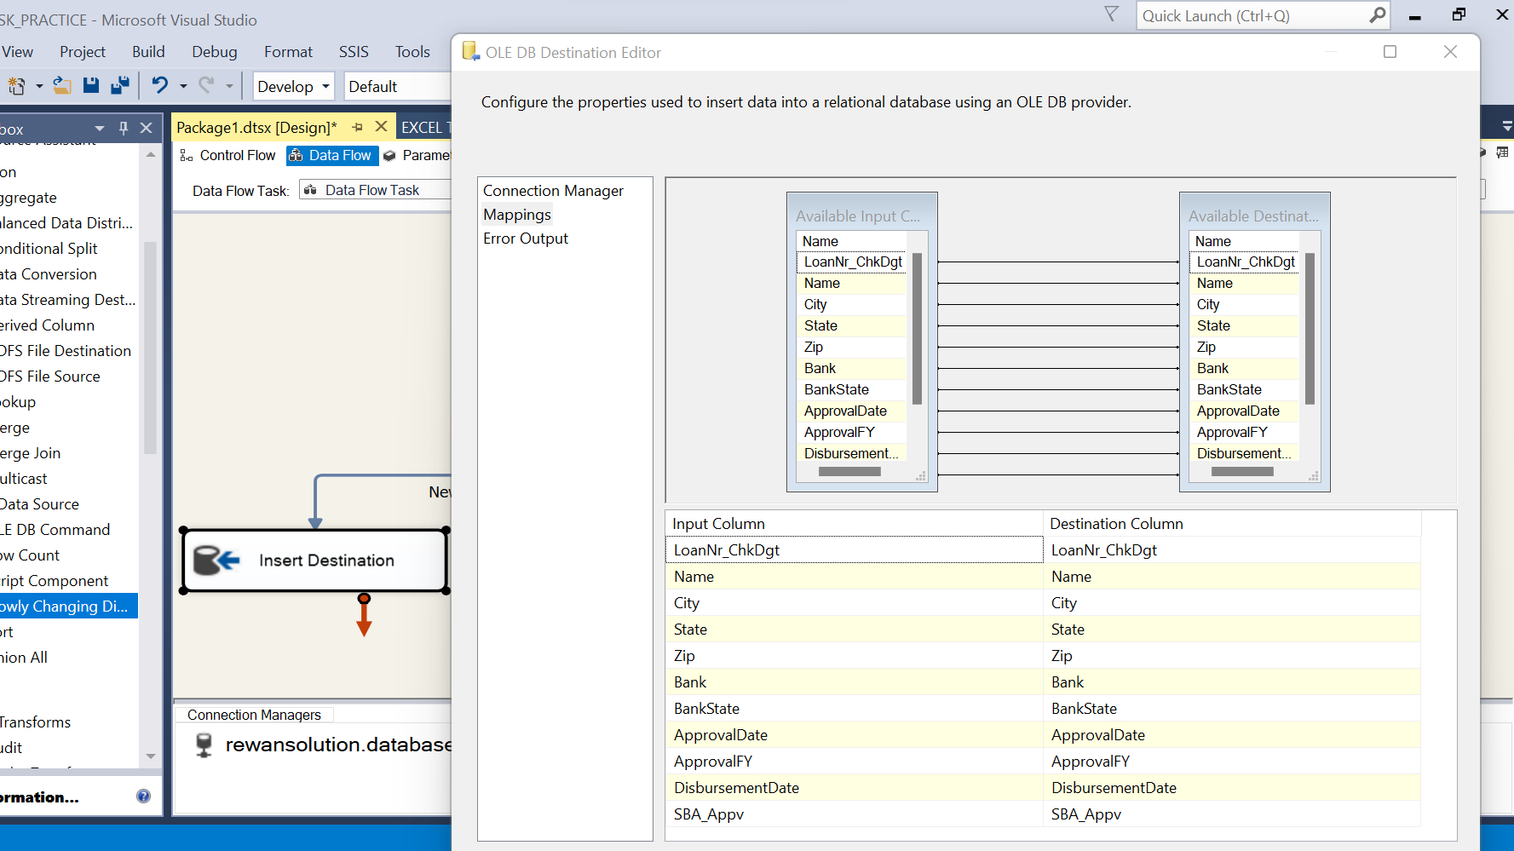

**Target:**

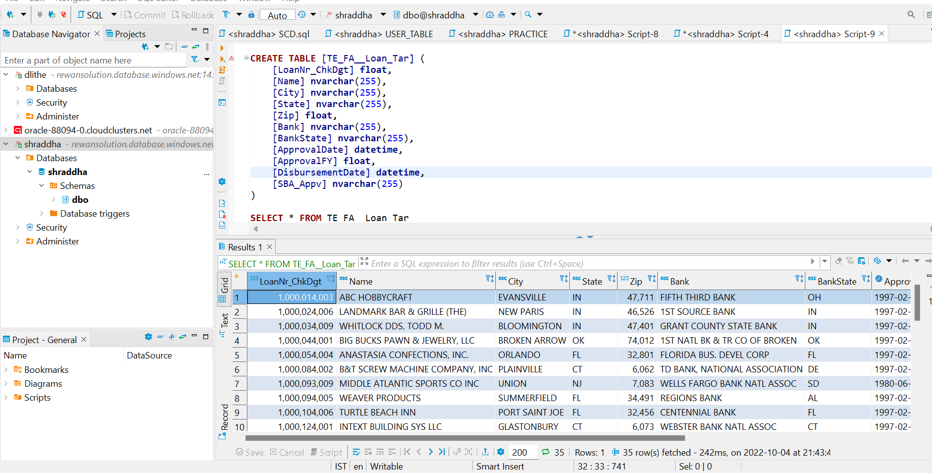

**UPDATE: IN SOURCE**

**RUN IN SSIS**

**HOW TO FIX THIS:**

**CHANGE NAME, STATE ZIP FROM FIXED TO CHANGING ATTRIBUTES**

**CHECK THIS RUN TARGET TABLE //LINE NUMBER 3**

**SCD TYPE 2:**

**SET START DATE AND END DATE :**

**TARGET:**

**UPDATE IN SOURCE:**

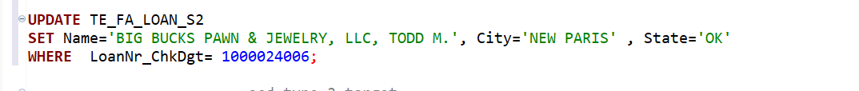

**TARGET:**





**FOR STATUS:**

**UPDATE IN SOURCE**

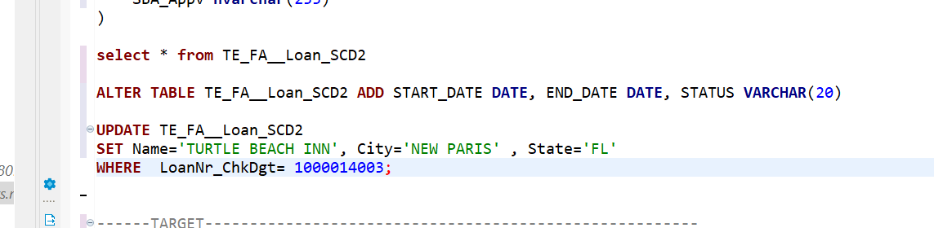

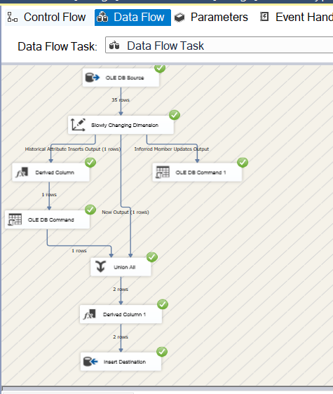

**UPDATED ROW**

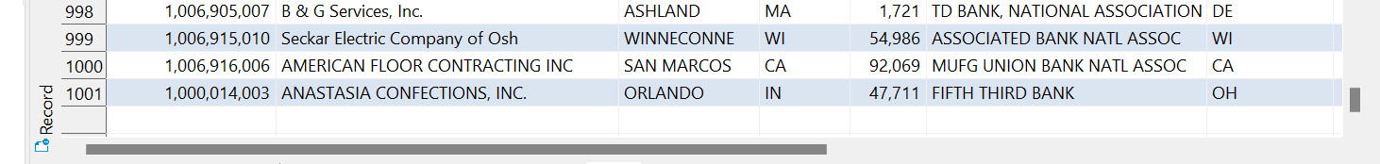



**EXPIRED ROW**

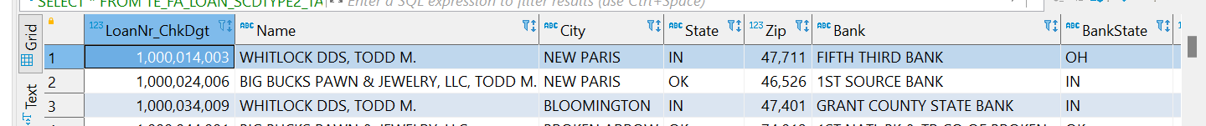

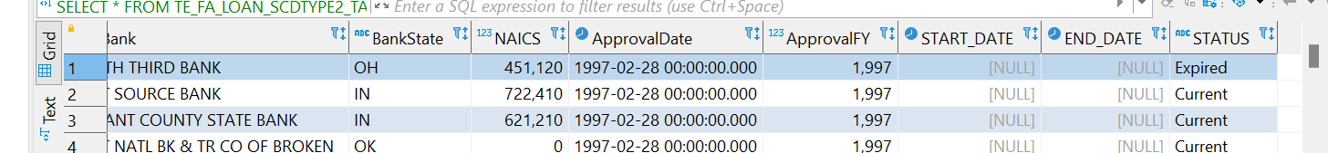

**AGGREGATE**



