**MODULE 3**

1. **EXCEL TO DB**

**DASHBOARD:**

**PREVIEW:**

**REPORT:**

**BANK LOAN DATASET**

SELECT SHARED DATASET AND SELECT THE TABLE , CREATE NEW REPORT

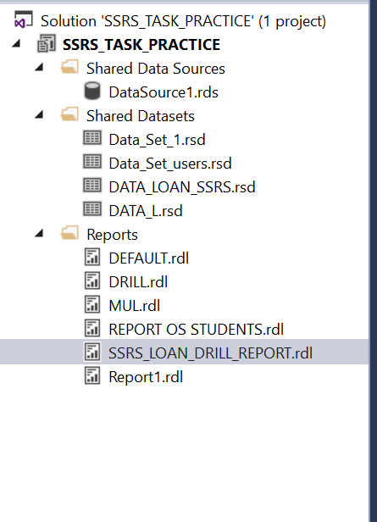

SELECT THE PROPER TABLE DATASET

**DRILL:**

**GROUP BY:**

**PREVIEW:**

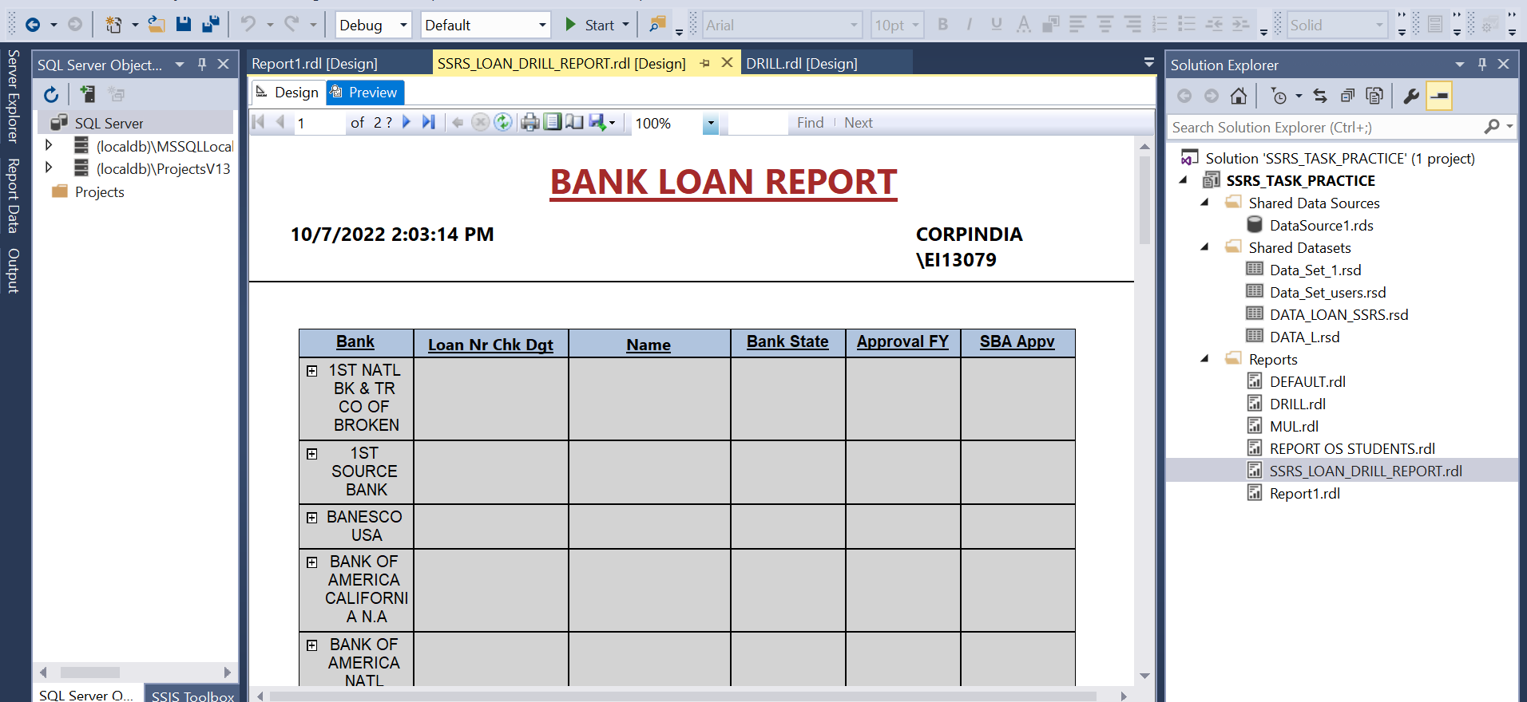

**AFTER THE CLICK OF PLUS SYMBOL IN BANK COLUMN:**

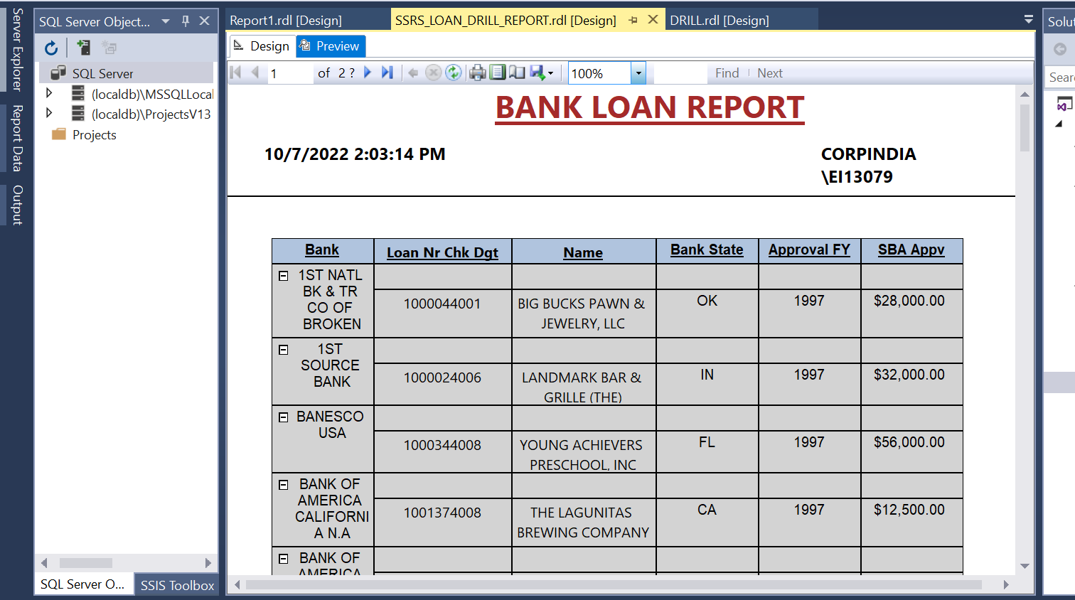

**REPORT 2 – LIST OF VALUES**

**CAR DATA SOURCE:**

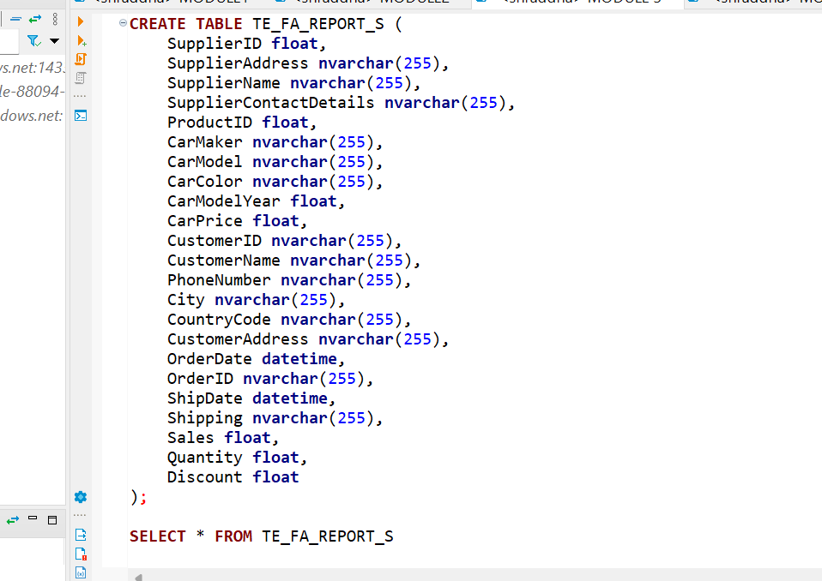

GROUP BY🡪 CAR MODEL, CAR COLOR, SHIPPING

PARAMETR( FOR LIST OF VALUES)

PREVIEW:

SELECT VALUES FROM DROP DOWN LIST THEN CLICK VIEW REPORT

